

Glow and Teams Guide

1. Open a google tab and search RM Glow, select the Glow – Sign In site.

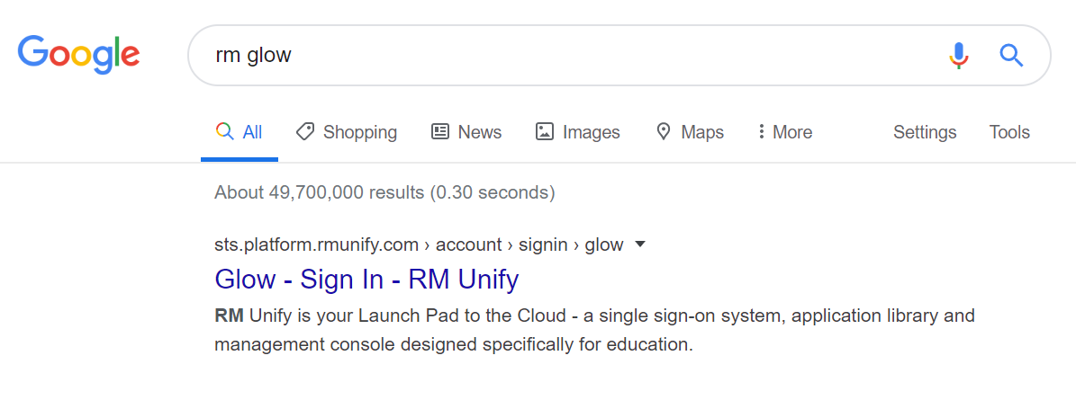

1. Log in using your Glow username and password.

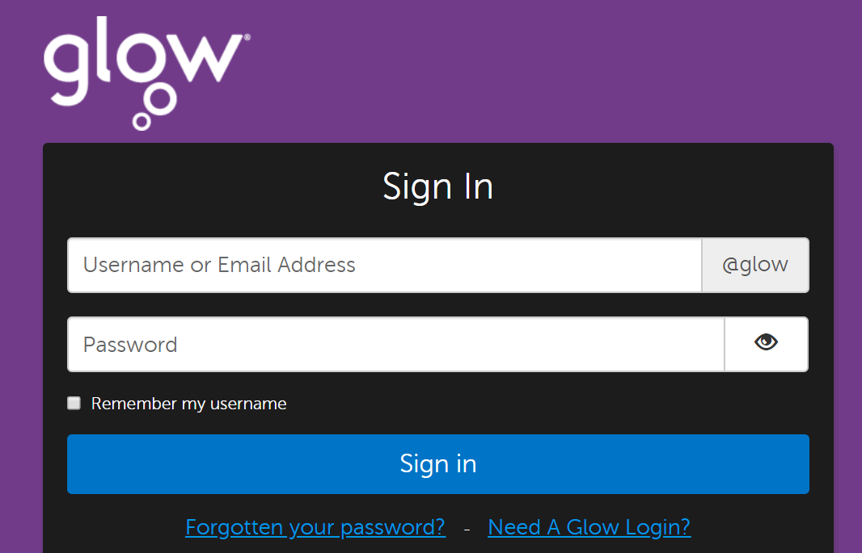

1. Click on the small blue house at the left hand side then click the Microsoft Teams Tile.

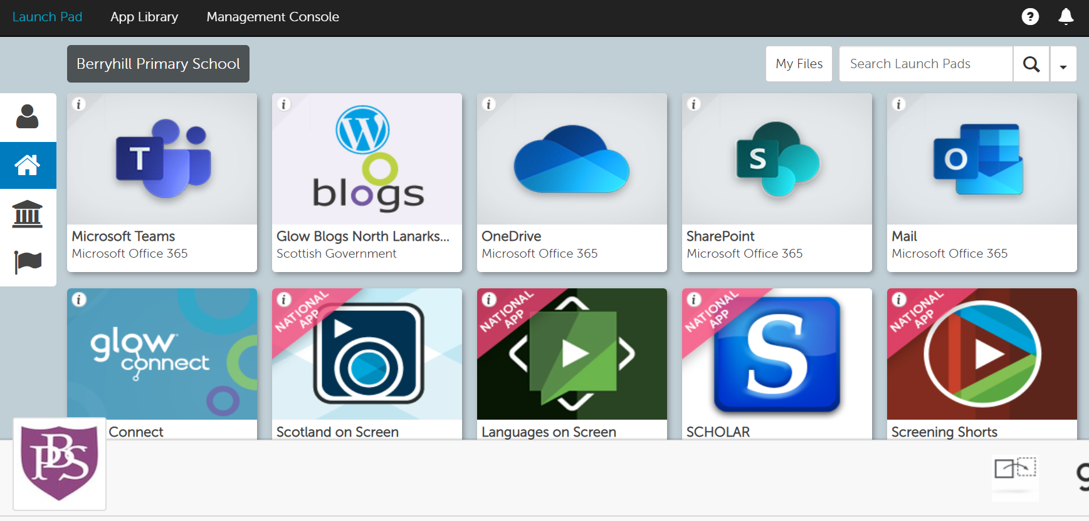

1. Your class team will show up where the ‘Example Team’ is shown in the picture below. Click on your class team to enter.

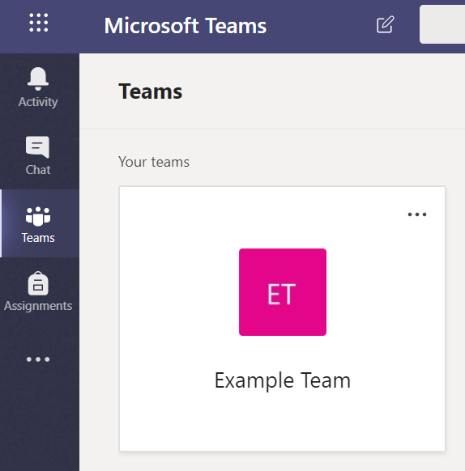

1. Your class team will look like the team below. The class teacher and all other children in the class can chat in the ‘posts’ section. Your teacher may ask you to complete tasks in your team. The files section will be used by your teacher to upload any tasks. Children can also upload files for other class members and the teacher to see e.g. a PowerPoint they have been working on. Mrs Nicol will be a member of every class team so she can see all the fabulous work taking place.

Posts can be found here Files can be found here

