Rights Respecting Charter and Reflection Time

As part of our work to become a Rights Respecting School, our Rights Respecting Pupil Group have worked together to produce a Rights Respecting Charter for our school and Nursery.
These rights will be the focus of work across the school and we hope that they will become embedded in the life and work of the whole school community.
If on occasion however, any of these rights are not respected in school, then your child will be given an opportunity to reflect on their actions, guided by a member of staff. This will take place in the Rainbow Room and will follow the Restorative Justice Approach. (See details below)
A text will be sent home to inform parents and carers that their child has been in Reflection Time that day. This provides the adult with an opportunity to discuss and revisit the rights with their child at home.
Further information can be found at www.unicef.org.uk/rights-respecting-schools
www.restorativejustice4schools.co.uk

“By promoting the values of respect, dignity and non-discrimination, children’s self-esteem and wellbeing is boosted and they are less likely to suffer from stress. A child who understands their rights understands how they and others should be treated and their sense of self-worth is strengthened.”

“Children have better relationships both with their teachers and their peers, based on mutual respect and the value of everyone’s opinion”
“Children have a moral framework, based on equality and respect for all that lasts a lifetime, as they grow into engaged, responsible members of society.” Rights Respecting Schools

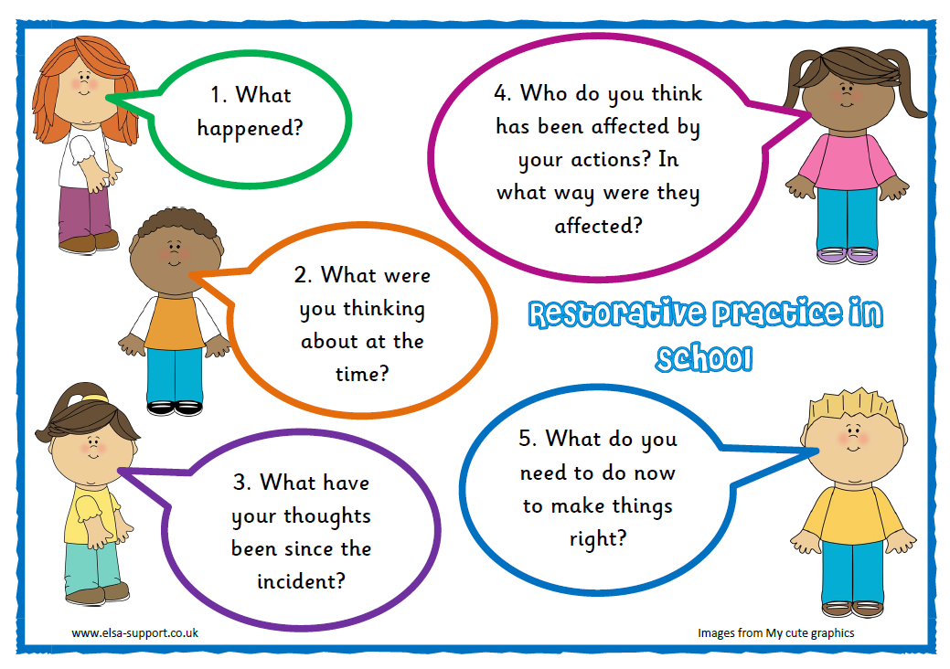
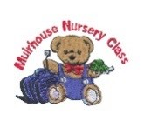
Muirhouse Primary School
and Nursery Class
Our School Charter

We believe that all members of our school and nursery have the following rights:

We all have the right to have a good education
We respect this right by trying our best in our learning

We all have the right to be safe and happy
We respect this right by behave positively towards all members of the school and nursery

We all have the right to give our opinions
We respect this right by listening to all adults and the opinions of others

We all have the right to have good friends
We respect this right by talking to them in the right way and treating them fairly

We all have the right to develop our individuality and talents
We respect this right by valuing and respecting all
cultures, religions and languages

