The four capacities
The purpose of the curriculum is encapsulated in the four capacities - to enable each child or young person to be a successful learner, a confident individual, a responsible citizen and an effective contributor.
The curriculum aims to ensure that all children and young people in Scotland develop the knowledge, skills and attributes they will need if they are to flourish in life, learning and work, now and in the future. The attributes and capabilities of the four capacities are outlined below:
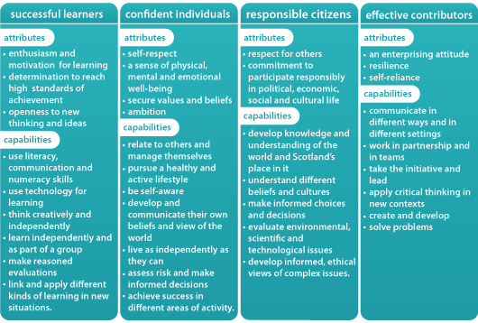
The attributes and capabilities can be used by establishments as a guide to check whether the curriculum for any individual child or young person sufficiently reflects the purposes of the curriculum.

Developing the four capacities
The experiences and outcomes are a set of statements which describe the expectations for learning and progression for each of the eight curriculum areas.
The title ‘experiences and outcomes’ recognises the importance of the quality and nature of the learning experience in developing attributes and capabilities and in achieving active engagement, motivation and depth of learning. An outcome represents what is to be achieved.
The experiences and outcomes for each curriculum area build in all the attributes and capabilities and so develop the four capacities.
Plains Primary School- Pupil Parent Conference
Oct 2016 - Teacher Feedback
Pupil Name:_________________________________________

Successful Learner- Strengths and Progress Made

Responsible Citizen | Effective Contributor
Confident Individual | Next steps

Plan agreed by:

Teacher: _________________________________________________

Pupil:____________________________________________________

Parent/Carer_______________________________________________

Date

