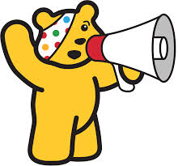
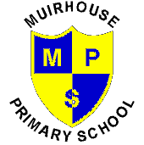

Children in Need
FRIDAY 14th NOVEMBER 2014

This year for Children In Need the school will be selling Pudsey Bear Wrist Bands for £1.50 each and Pudsey and Blush badges for 50p each. We will also be having a RAFFLE for a GIANT PUDSEY BEAR and lots of other Pudsey Bear goodies.
Tickets for the raffle are £1 per strip. Wrist Bands, Badges and Raffle tickets go on sale next week (week beginning 27 October 2014) so please do not buy your wrist bands anywhere else!! We have a limited stock so they will be sold on a first come basis.
On Friday 14th November we will charge £1 per child for Children in Need and they can wear casual clothes.
We will also be selling Pudsey Bear Cupcakes (made by Mrs McGuire) and these can be pre-ordered from now, 4 cupcakes for £2 or individual cupcakes for 50p each. Order form below.
We will also have lots of other activities taking part during the school day on Friday 14th November 2014.
I am sure you will agree this is for a great cause and we will once again try and get our school name to appear on the screen during the television show.
Thank you again for your ongoing support, Mr Lumsden.
I would like to pre-order PUDSEY BEAR CUPCAKES (money with order please)
Quantity:

4 cupcakes £2

Individual Cupcake 50p
Total £___________ (enclosed)
Name of Child:______________________________________________ Class_______________

