Chinese New Year
Chinese New Year falls on Friday 12th February 2021 and it is the year of the Ox.
Try some of these activities.
Do you want to know the story behind the naming of the years in the Chinese myths?  Listen and watch this story from YouTube.  https://video.link/w/1PrOb  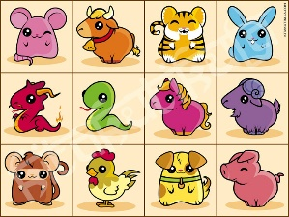 | 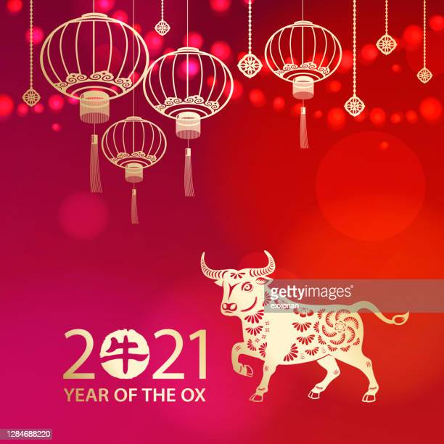 | Listen to thhe story of the Ox in Chinese mythology  https://video.link/w/bQrOb  
Look at this table to find which animal represents you. Take care the Chinese year runs from end of January to end of January so you need to find the table for your month and year. Next research the animal myth. Do you have the characteristics of the animal?  https://www.timeanddate.com/calendar/chinese-zodiac-signs.html | Can you use chopsticks? Try to pick up some beads or blocks before moving on to food!   | Learn how to say hello and some other simple phrases in Mandarin the main Chinese language.  https://video.link/w/CSrOb  
Try some the art activities like making a dragon or a lantern. I have attached some links below.   | Chinese New Year cuisine is as varied, colourful and as exciting as everything else to do with the celebration. There are lots of well- known examples available in the shops, but some items are easy enough for all try out. Oranges and tangerine symbolise wealth, apples are for peace and tangerines are for good fortune.

