St Joseph’s Primary School November Home Learning Grid
Primary 5 – Moonbeam Group

Literacy | Numeracy | HWB and RME
Week 1.  Spelling Revise words:  Monday  Tuesday  Wednesday  Thursday  Friday  Saturday  Sunday  tomorrow  today  yesterday | Week 1 & 2  Multiplication Facts  Practise these facts by using Top Marks Hit the Button – Times Table. Please focus on 2, 5 & 10 times table.  Alternatively write the facts out.  Ask an adult to test you on your recall of facts. Spent 10 to 15 minutes every day on this task. | Complete a Joe Wick’s Workout. Go to the classroom workout section and complete a workout. Challenge - Can you create your own HIIT workout and get your family to join in? Take lots of photos and upload to your class teams page. | Week 1  First Holy Communion preparation  Complete Session 6  Watch Mass from St. Joseph’s and join in with the Mass responses.
Week 2 The Holy Souls
During the month of November we remember all those members of our family and friends who have died.
With an adult say the special prayer for those who have died:
Eternal rest grant unto them, O Lord and let perpetual light shine upon them,
May they rest in peace, Amen.
May their souls and the souls of all the faithful departed rest in peace. Amen.
Week 2  Phoneme of the week  Practise ph phoneme.  Look through a book at home can you find any words with the ph sound?  Make up sentences using these words.  You can take a photograph with a phone and email them to me! | Week 1  Time Analogue and Digital  Revise o’clock and half past times using a clock on a phone or a watch. Go to Topmarks  https://www.topmarks.co.uk/maths-games/5-7-years/measures  You can access these online games via glow. | Create your own ‘home school’ timetable –decide which activities to do each day and when. Include non-school activities such as lunch, TV time, board games and chill time.
Reading for Information  Week 1  Reading task accessed via Twinkl Go. Use the code shown below and choose the one star option.  MH9037  The link is available on Glow. Please note the two reading tasks will only be available for the next 14 days. | Week 2  Time Anglogue & Digital  Practise time language. What is the hour before, hour later/earlier. Time durations in hours – 1pm to 3pm. How many hours?  See Glow for game/online learning links. | Health  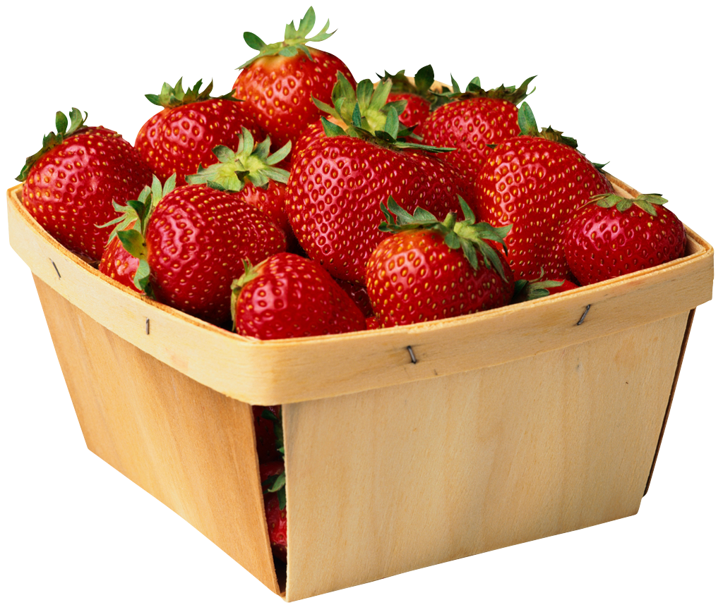  This is a time to think about our lifestyles and the choices we make to keep ourselves healthy. Create a food diary for a day. Discuss with your family could you make better choices about the foods you eat, the snacks you have between meals and the amount of exercise you do? Add any exercise you complete to the bottom of your diary. You can draw your daily food and write each meal or create a poster. Please take photos or upload onto your class glow or teams page.  P.E  Create an obstacle course inside or outside at your home. Time yourself or ask an adult to time how long it takes you to complete the obstacle course.  Mindset/Emotions  Create an Emoji to describe how you feel. If you can write a description of your emjoi and why you have chosen it.
Week 2  Look at the videos posted on famous Victorians – make notes of points you find interesting. Use these notes to help you tell an adult about the famous individual you researched. | Sumdog  Spend 30 minutes on Sumdog- if your teacher has set your class a challenge, complete this first. If not, choose your own games  https://pages.sumdog.com/
Writing Week 1 Imaginative Story – Create a story about a character going on and adventure. Remember to include some speech in your action paragraph. The day after writing – check it over for correct punctuation and
make any changes you want to. Give it to an adult to read.
Week 2 Persuasive Writing
Write a persuasive leaflet about one of these options
Benefits of pets
Benefits of eating fruit and vegetables.
Sumdog
Spend 30 minutes on Sumdog- if your teacher has set your class a challenge, complete this first. If not, choose your own games
https://pages.sumdog.com/.

Go on an autumn walk with an adult and collect some autumn leaves. | Go for a weather walk with an adult and then draw what the weather is like or look out of the window to check what the weather is like. | Create an autumn leaf collage picture. | Print using autumn leaves and autumn colours.
Create fireworks art. Using colour, glitter etc. | Extra Activities |  | Make a Treasure Map  Hide some treasure somewhere in your house and make a map to help find it! You could even test your map by giving it to an adult and seeming if they can find the hidden treasure!
Use tissue paper to make some lovely art for your window, and watch as the sun shines on them. |  |  | Research Guy Fawkes, find out information about him with an adult.
Stem Challenge – what can you make/create from an empty cereal box? | Taste some harvest vegetables. | Dance, jump, play and laugh in a big pile of crunchy autumn leaves! | Road Safety – create a poster to help people stay safe on the roads at night. It is darker much earlier now, how can we keep safe on the roads in the dark?
Go on an autumn scavenger hunt and collect conkers, acorns and crispy autumn leaves. | Collect flat stones and paint them to make some pretty autumn designs. | Kitchen roll art, create a pattern by colouring using crayons patterned kitchen roll. | Take some photographs of signs of autumn.
For additional activities to do online:

All children have a log in for Sumdog &Studyladder, sites which develop mental maths and problem solving skills: https://pages.sumdog.com/ https://www.studyladder.com/

Oxford Owls have a library of free books: https://www.oxfordowl.co.uk/

Free audiobooks for children: https://www.storynory.com/

Lots of free maths games: https://www.topmarks.co.uk/

Daily lessons in literacy, numeracy and health and wellbeing: https://www.bbc.co.uk/bitesize

Learn, create and play through exploring Scotland’s history and heritage: https://www.historicenvironment.scot/learn/

STEM (Science, Technology, Engineering & Maths) with Mr N: https://www.youtube.com/channel/UCxziq4omrQP-EKSLilOIPhw

