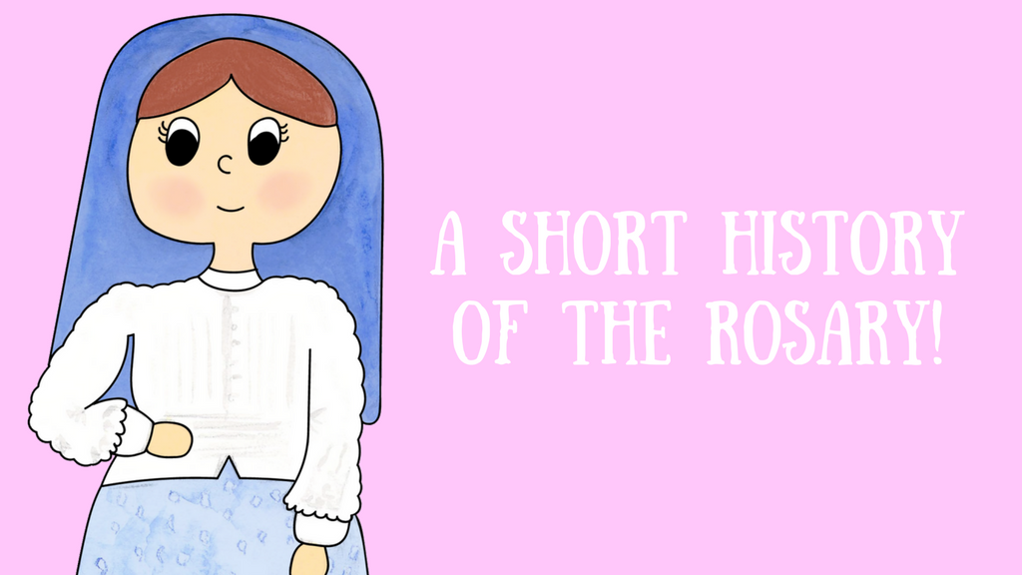

Origins of the Rosary
The history of the Rosary mostly consists of legend and tradition. There is evidence that beads were used to count Our Fathers and Hail Marys in the Middle Ages. The word bead is derived from the Old English word for prayer.
Between the twelfth and fifteenth centuries, the structure of the Rosary included praying fifty Hail Marys together with the Psalms. Our word Rosary derives its meaning from the word rosarium, or rose garden. Saint Louis de Montfort wrote in his book, The Secret of the Rosary,
The word Rosary means “Crown of Roses,” that is to say that ever time people say the Rosary devoutly they place a crown of…roses upon the heads of Jesus and Mary. Being heavenly flowers these roses will never fade or lose their exquisite beauty.

“One day, through the Rosary…Our Lady will save the world.”
Saint Dominic’s words have proven themselves true countless times. The Rosary has been a sign of hope and a source of many graces. There is a tradition that in 1214, Our Lady appeared to Saint Dominic and gave him the Rosary as we know it today.

