38 How trains changed the Victorians

Name ________________________________________________________

Date ___________________________________________________________

Problems involving numbers, money or measures
History: 12. How did life change in our locality in Victorian times?

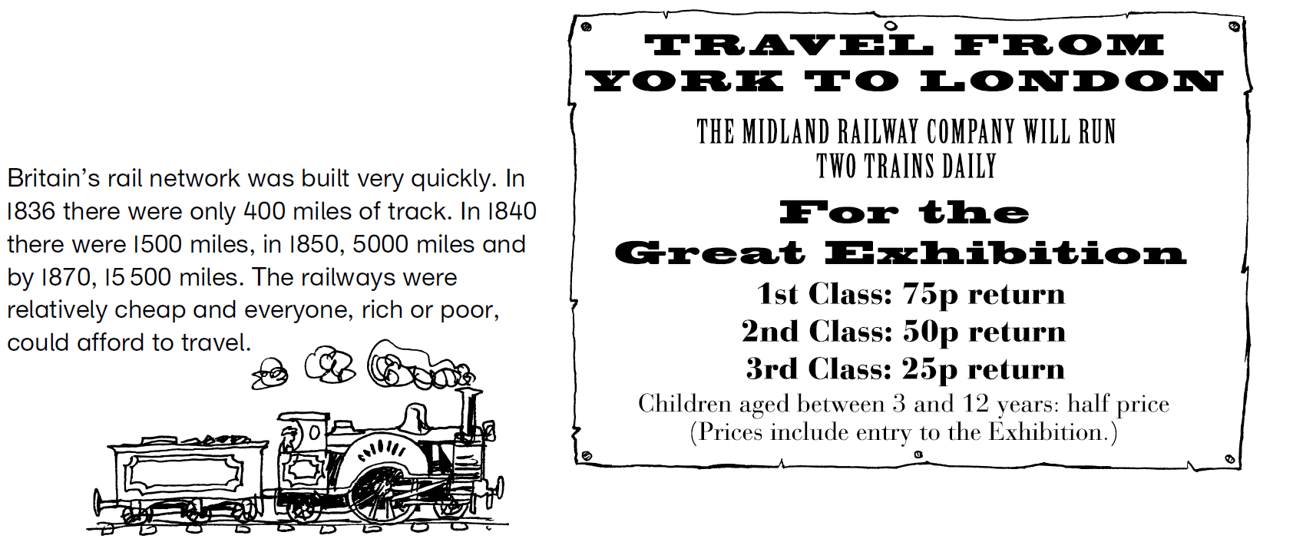

Show any working on the back of this sheet.

1 The amount of railway track in Britain increased from 1500 miles in 1840 to 15 500 miles in 1870. How many miles more was this?
2 How much did it cost a family of 2 adults and 3 children, aged 6, 8 and 10, to travel from York to London second class and visit the Exhibition?
3 The train fare from London to Brighton in 1843 was 18.5p. How much did it cost for 4 people?
4 In Victorian times, a city labourer earned £1 a week. What fraction of his weekly wage would he spend if he bought a 3rd class ticket from York to London to see the Great Exhibition?


1 The first public railway in Britain opened in 1825. 38 years later the world’s first Underground train line opened in London. Which year was this?
2 By 1880, the journey from London to Edinburgh took 10 hours by train. It used to take 69 hours by horse and coach. How much quicker was the journey by train, in days and hours?
3 A farm labourer earned 70p a week in Victorian times. How many weeks would he need to work to take himself, his wife and 4 children under 12 from York to London 3rd class to see the Exhibition?
4 In 1850, 38 million tonnes of goods were carried by rail. By 1900 it was 419.8 million tonnes. By how many tonnes did it increase during this period?


1 In 1842, 24.7 million passengers travelled by rail. By 1900 this had increased to 1114.6 million. How many more passengers was this?
2 In 1887, a yearly ticket from Windsor to Paddington cost £18. If a man travelled to work, 5 days a week, 50 weeks a year, how much did this cost him for each day of travelling?

