Ideal bedroom Collins New Primary Maths: Investigations 6
1b Cost of furniture
- furniture
catalogues
- pencil and
paper
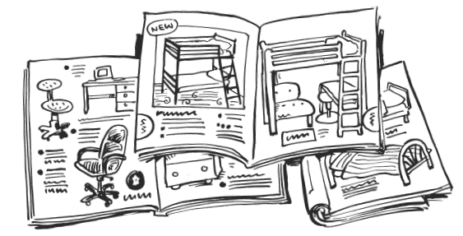
- Choose the furniture you would like for your ideal bedroom.
- How much would this all cost?
- Make sure that the things you choose will fit into your ideal bedroom.

