 | SPELLING | MATHS | R.M.E./Topical | READING | I.D.L. Personal Choice Grid
16th Nov. | Remember | Sumdog | Share your Heartstart knowledge with family members. We have covered the different types of casualty, and what to do if someone has a serious bleed. | Write a summary of a personal novel that you are enjoying at home. | Create an infographic to depict all you have learned of the Hindu festival of Diwali. Remember to record your sources. https://www.bbc.co.uk/newsround/15451833
Use a dictionary to find & record the meanings of five of your words.

Log in to Studyladder
23rd Nov. | Understand | Studyladder. | With his feast day next Monday, your task is to write a personal prayer to Saint Andrew. | Share detail of the Lost Words books with an adult at home. Talk about the spell songs covered so far. | Think over the focus for Anti-Bullying Week. Talk to family members at home about the theme of standing united against bullying. Check out the resources from CBBC https://www.bbc.co.uk/cbbc/curations/anti-bullying-week?dm_i=3YNL,AWMG,3GU73A,149XG,
 | Create a super sentence for each of your words.
30th Nov. | Analyse | Sumdog. | Advent Calendar of Kindness. Jot down 25 random acts of kindness which you could do from December 1st. If you draw it out, take a picture and post it to your blog. | Source a non-fiction text that interests you and post details of it to your blog. | Create an infographic all about the season of Advent. If you choose to do this and email it to me, I will aim to print it off and display it on our class altar.  https://www.topmarks.co.uk/Christmas/Advent.aspx
Rainbow write each of your words to show any words within.
Log in to Studyladder
7th Dec. | Apply | Studyladder. | Favourite winter or Christmas recipes. We all have special treats or meals that we enjoy at this time of year. What’s yours? Name your dish & post the recipe to your blog. | Write a film review. State whether you would recommend this or not and why. Give it a rating. | Make a mind map of detail on Christmas traditions around the world. https://www.whychristmas.com/cultures/
 | Write an acrostic poem for five of your words.
14th Dec | 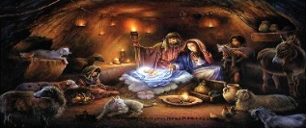 Make use of the Christmas themed homework grid. 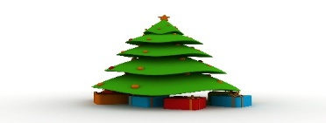  This Photo by Unknown Author is licensed under CC BY-NC-ND  This Photo by Unknown Author is licensed under CC BY

