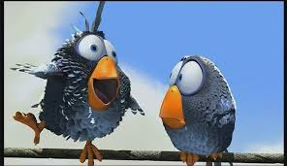

**You see one pupil making fun of another pupil.**

***What would you do?***

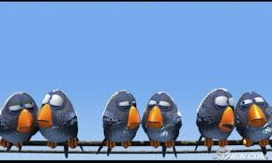

**You hear pupils spreading rumours or gossip about another child in school.**

***What would you do?***

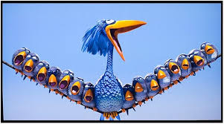

**You hear children complaining about someone in your class.**

***What would you do?***

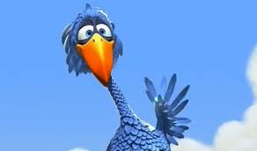

**There’s a new arrival to the school.**

***What would you do?***

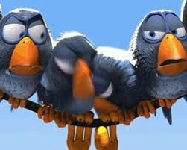

**You see two children getting into an argument.**

***What would you do?***

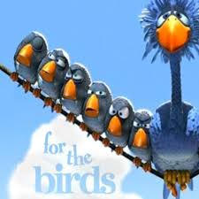

**Primary Seven have studied the short film ‘For the Birds’ by Pixar.**

**We used the animation as a discussion tool for the issues surrounding bullying, here are some of our thoughts for what *we can do*.**

*As I listen or watch, I can identify and discuss the purpose, main ideas and supporting detail contained within the text, and use this information for different purposes.*

***LIT 2-04a***