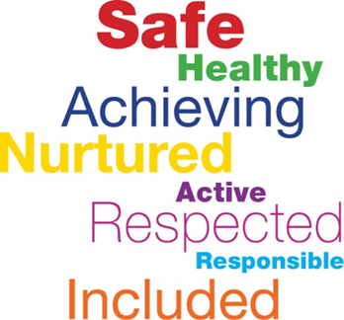
Getting it Right
for Every Child

2021 - 2022
Contents
GIRFEC Guidance 3
GIRFEC Pathway for Planning and Support 3
Class Teacher Role/Responsibility 4
Assessment and Planning 5
GIRFEC 5 key questions: 5
How Good Is Our School 4: 6
2.4 Personalised support 6
Getting It Right for Me Plans Class Teacher Responsibility: 6
Session Timeline: 6
Getting It Right for Me Plans Management Team Responsibility 6
Additional Support: 7
Intensive Support: 7
Useful links: 12
Glossary 12
Appendix 1 13

Version Control
Date | Version | Author | Changes | Next Review Date
April 2021 | Draft | Tracey McCulloch | Creation of draft policy | August 2021.
December 2021 | Final | Tracey McCulloch/Nicola Brownlie | Added UNCRC links | August 2022

GIRFEC Guidance
Getting it right for every child (GIRFEC) is of prime importance at Mossend Primary School and Nursery Class.
Scottish Government Guidance on Additional Support Needs (ASN) -
States: children or young people may require additional support for a variety of reasons and may include those who:
•have motor or sensory impairments
•are being bullied
•are particularly able or talented
•have experienced a bereavement
•are interrupted learners
•have a learning disability
•are care experienced
•have a learning difficulty, such as dyslexia
•are living with parents who are abusing substances
•are living with parents who have mental health problems
•have English as an additional language
•are not attending school regularly
•have emotional or social difficulties
•are on the child protection register
•are refugees
•are young carers

Additional support Needs:

GIRFEC Pathway for Planning and Support
Universal Support:
- Monitor health and wellbeing - within SHANARRI framework.
- Wellbeing concern identified - begin wellbeing assessment, consider views of child and parent.
- GIRFEC 5 key questions.
- Response: begin planning – GIRFme plan (plan/review/assess cycle).
- Wellbeing concern continues – complete wellbeing assessment and start chronology if appropriate.
- Request assistance directly or review wellbeing concerns through HART, update planning (plan/review/assess cycle).
- Child’s network of support.
- Wellbeing concern continues, request assistance to Cluster or other agency/service.
- High quality learning and teaching.
- Robust classroom planning.
- Curriculum rationale.
- Nurturing environment.
- Positive and reflective learning environment.
- In school supports.
- Consultancy, training - Educational Psychologist.
- Advice, signposting, website - Virtual School.
- Advice, sign posting, low level intervention – Social Work.
- Advice, resources, staff training - Health Staff.

Class Teacher Role/Responsibility
“…have knowledge and understanding of the GIRFEC National Practice Model and how to apply this to support teaching and learning.”
General Teaching Council for Scotland

- CT responsible for observing a child they have a concern about and recording information.
- Begin wellbeing assessment to gather information (SHANARRI wellbeing indicators, My World Triangle, Resilience Toolkit/Matrix if required).
- Creating and reviewing the GIRFME plan is the responsibility of the CT.
- Liaise with support staff to ensure planned strategies are implemented as planned.
- Dialogue with support staff will allow CT to monitor impact and make changes where necessary.
- Evidence/action GIRFEC targets in your short-term cycle of plan/review/assess.
- Liaise with MT member responsible for GIRFEC to seek advice or support.
- Attending review meetings.

Assessment and Planning
In line with the national practice model of GIRFEC, the questions below should be asked to help inform how to support a child or young person.

GIRFEC 5 key questions:
- What is getting in the way of this child or young person’s wellbeing?
- Do I have all the information I need to help this child or young person?
- What can I do now to help this child or young person?
- What can my agency do to help this child or young person?
- What additional help, if any, may be needed from others?

There are three main tools to help practitioners answer the key questions:
- The wellbeing indicators
- The My World Assessment Triangle
- The Resilience Matrix
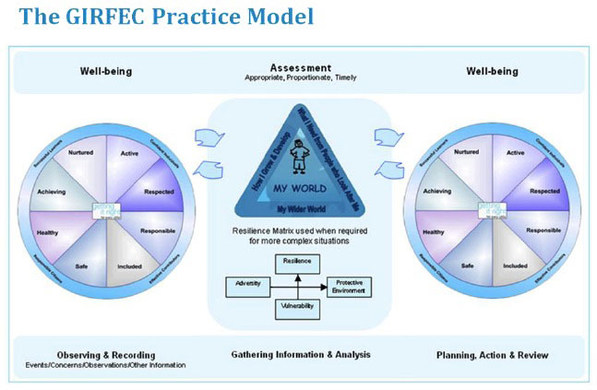

How Good Is Our School 4 (HIGIOS4):

2.4 Personalised support

“Staff make effective use of staged intervention processes and the named person service to ensure children and young people’s needs are met.”
“Relevant support staff are involved in planning and reviewing support for individuals and groups of learners.”

Getting It Right for Me Plans Class Teacher Responsibility:
- Getting it Right for Me (Part I) (education).
- Strategies to help pupils cope in class, classroom environment, support from nurture, SFL, home partnership officer, Nurture, Seasons for Growth, school careers advisor (if enhanced planning is needed to support a pupil to improve wellbeing then they need a (GIRFme plan).
- Getting it Right for me Plan (Part II) (education).
- Targeted literacy, numeracy and health and wellbeing outcomes in line with Es and Os and/or benchmarks.
- Part (II) should be SMART targets, if targets are not being met then they are too wide and should be changed.

Getting it Right for me (I/II) (strategies provided by other agencies should be evident in the plan (SLT, OH, CAMHS) and they should be recorded in child’s network of support.

Session Timeline:
GIRFME draft plans to be submitted to MT by second Friday in September.
GIRFME plan meetings with parents/carers to be completed by October Week.
Review meetings with parents/carers to be completed by last Friday in January.
Review meetings with parents/carers to be completed by last Friday in April.

Review meetings will be set termly, biannually or annually depending on circumstances of each child. This will be reviewed by SMT on a regular basis.

See Appendix 1 – GIRFME 7 Step Guide

Getting It Right for Me Plans Management Team Responsibility
The MT member responsible for GIRFEC is there to manage and have an overview of the plan. This includes:
- Collating GIRFMe plans across the establishment.
- Giving feedback on targets, providing support or advice to make new targets.
- Arranging/co-ordinating review meetings.
- Opening dialogue with other agencies/ Submitting RFAs.
- Seeking support from agencies/putting class teacher in contact with external supports.

Additional Support:
Outcome from your request for assistance:
- (Continue planning within Universal supports).
- Interventions, support agreed - planning updated to reflect this.
- Assessment, planning and review cycle to continue – update:
  - Wellbeing assessment / My World Triangle assessment
  - Chronology
  - Child/young person/parent/carer views
  - Planning
- Wellbeing concern improves return to planning within Universal support when appropriate.
- Wellbeing concern continues, request assistance to Cluster or other agencies/service.
- Additional resources from within cluster.
- In reach/outreach from ASN sector.
- Planning support - Virtual School.
- Partnership working – Psychological Services.
- Consultancy, interventions - Social Work.
- Directory of supports.
- Partnership working Health, 3rd Sector, Skills Development Scotland, etc.

Intensive Support:
Outcome from your request for assistance.
- Continue planning within Additional support.
- Interventions, support agreed.
- Planning updated to:
  - reflect agreed intervention/support.
  - include analysis of integrate assessment and chronology.
  - take account of the views of child/young person/parent/carer.
- When a Child’s plan agreed, lead professional identified from network of support.
- Assessment, planning and review cycle to continue.
- Bespoke packages/flexible support - Virtual School.
- ASN school / ASN base / LCSC.
- Package of support (coordinated/ intensive).

Useful links:

What I Think Tools:
What-I-Think-Tool-Early-Years.pdf (girfecinnl.com)
What-I-Think-Tool-Children.pdf (girfecinnl.com)

Wellbeing Assessment:
Wellbeing-Assessment-Part-1.pdf (girfecinnl.com)
My-World-Assessment-Triangle-Part-2.pdf (girfecinnl.com)

GIRFME Plan:
GIRFME-Plan.pdf (girfecinnl.com)

Sharing of Information:
LDSPB-NLC-interim-Information-Sharing-Guidance.pdf (girfecinnl.com)

Planning Pathway
Children-and-Young-Peoples-Pathway-for-Planning-and-Support.pdf (girfecinnl.com)

NLC GIRFEC
Home Page - GIRFEC in NL

NLC GIRFEC Pathway for Planning and Support
GIRFEC Pathway for Planning and Support June 2020.pdf

Glossary

GIRFEC – Getting it Right for Every Child
ASN – Additional Support Needs
HGIOS4 – How Good is Our School – Version 4

Getting It Right For me plan (GIRFme plan)
The ‘Getting It Right For me plan’ can be used as a single agency or multiagency planning document at any stage of the GIRFEC Pathway for Planning and Support framework.
The GIRFme plan is in six sections with a front page.
- Front cover, is essential and is always completed for each plan and kept up to date
- Section 1, ‘Getting it right for me - organising my learning environment- part (l),
- Section 2, ‘team around the child’, evidencing those supporting the child
- Section 3, My Plan part (ll), evidencing curricular planning, literacy, numeracy, health and wellbeing
- Section 4, Wellbeing Assessment, and analysis
- Section 5, My World Assessment Triangle and analysis
- Section 6, Integrated assessment and integrated chronology

Depending on the level of planning you only require to complete the relevant sections to create a plan for the child to improve their wellbeing.
Section 1. ‘Getting it right for me - organising my learning environment- part (l)

- Should be used to help identify effective teaching and learning strategies and resources that will help the child/young person with additional support needs access the curriculum.
- Where possible, you should plan together with the child/young person and write the Plan from their perspective using ‘I can’ statements.
- If another agency is involved, such as speech and language therapy, please ensure their recommendations, learning approaches, resources etc. are embedded within my plan part (l).
- The child/young person should be encouraged to comment on the Plan, their learning, what makes it successful for them etc.
- The profile section should note the impact the wellbeing concerns/additional support needs may have on the child/young person’s experience and learning. It should be written in positive terms and relate to the wellbeing indicators (SHANARRI).
- Parent/carer comments should focus on the support they give their child to try and bridge a gap between the learning in school and at home.

Appendix 1
Section 2. ‘team around the child’ (formerly ‘my network of support’)

Where other staff members or agencies are contributing to, or supporting the implementation of, the plan, their names should be recorded in ‘team around the child’ along with the class teacher/named person/ lead professional who has written the plan.

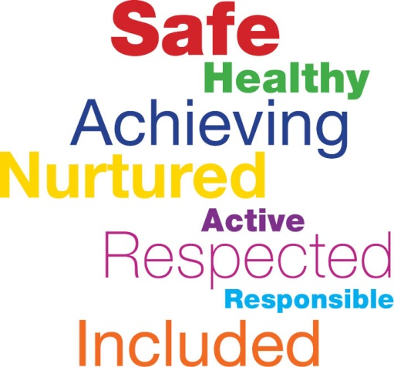
Section 5. My World Assessment Triangle

My World Assessment Triangle would be considered when a fuller understanding of the child’s wider world is required.
The assessment can be completed as a single agency assessment but when working with partners it is important to seek their contributions to the wider assessment for the child. Analysis of the complete assessment would highlight what needs to change for the child and the planning outcomes for the child would be focused to improve those outcomes recorded in section 3, my plan part (ll).

Section 4. Wellbeing Assessment

Wellbeing Assessment should be used when the impact of early strategies and interventions at part (l) are not improving the wellbeing of the child and analysis of a fuller assessment of the child’s wellbeing is required to support planning outcomes within my plan part (ll).

6. Integrated assessment

Integrated assessment and integrated chronology would be completed by the team around the child listed in section 2, overseen by the named person. Analysis of integrated assessment section 6 will highlight the outcomes required to promote the wellbeing of the child. If there is decision to proceed with integrated planning then a lead professional would be identified and the outcomes sought recorded in section 3, my plan part (ll).

Section 3 My Plan part (ll)

- In order for the curricular experiences and outcomes to be met, it may be necessary to individualise the learning and devise short term targets. Therefore, my plan part (ll) should be used.
- Curricular areas targeted are; Literacy, Numeracy and Health and Wellbeing. It may be relevant to focus on one area such as Literacy or relevant to consider all three areas.
- Targets should be S.M.A.R.T (specific, measurable, achievable, realistic and timely).
- Approximately 2-3 targets should be written for each curricular area.
- Targets should be ‘visible’ within class learning and evaluated through current processes.
- Further evaluation of the Plan should be recorded each term (or every 6-8 weeks).
- The child/young person should be able to talk about their targets and Plan (where appropriate).
- The Plan should be shared with parents/carers when initially devised and reviewed regularly (each term with parents).
- If targets are not being met, they are often too wide and should be modified. Use the Curricular Benchmarks to support.
- If part I and II of the Plan is written at the same time, the child/young person and parent/carer should only comment on my plan part (ll) (prevents duplication).
- If another agency/service is supporting the plan, please ensure any targets to support outcomes are embedded within my plan part (ll).
Appendix 1

