School Closure Due To Coronavirus

 | Coronavirus is a new flu bug that is affecting people all over the world. Sometimes it is called Covid-19. | 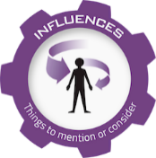

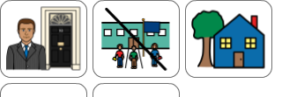 | The Prime Minister has decided that all schools should close and everyone should stay at home. | 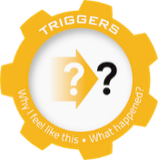

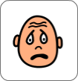 | I am a bit upset about this. | 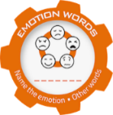

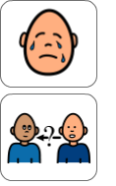 | I may be crying because I want to go to school.  I may be asking lots and lots of questions. | 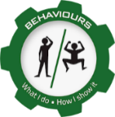

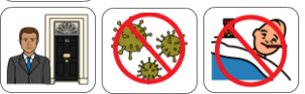  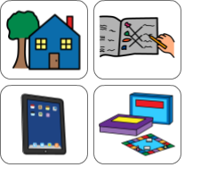  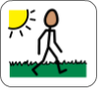  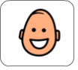 | The Prime Minister has closed the schools to try and stop germs spreading and stop more people becoming sick with the coronavirus.  We have to stay in the house as much as possible. Our teacher will give us some work to do at home, We can also play games, read books, watch TV, play on our ipads or computers.  If we feel well enough we can go outside for a walk.  I must remember that although the coronavirus will be here for a few months, it will go away again and everything will go back to normal. | 