

Driving Equity and Excellence

Improvement Action Plans

Session 2024-25

School: | Mavisbank
Cluster: | Caldervale
Head Teacher: | Helen Delaney

Improvement Plan Summary
Cluster Priority: | By the end of 2025, almost all establishments will have embedded nurture, resilience and trauma informed practices, through robust universal wellbeing systems to support our children, young people and families.
School Priority 1: | All staff will be familiar with current curricular model and pedagogical approaches to the learning and teaching of numeracy.
School Priority 2: | By the end of 2025 all staff will have increased their knowledge and understanding of managing distressed and dysregulated behaviour and embed approaches in their practice in line with school values to ensure pupils rights are respected.

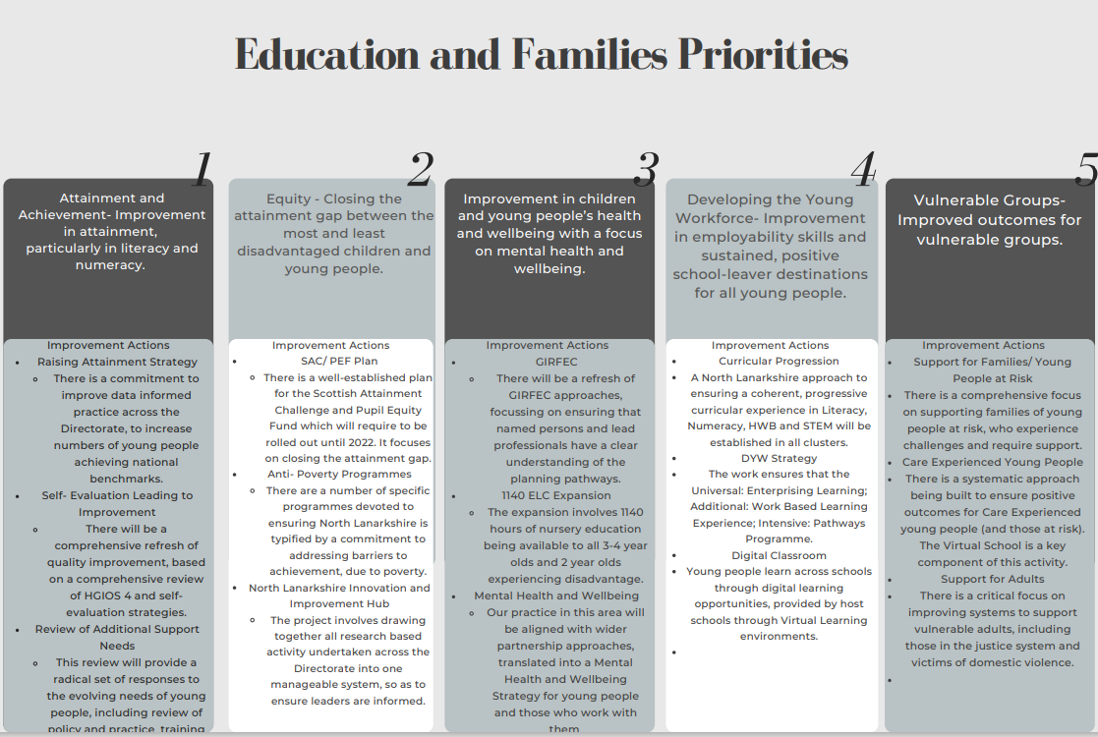

School Vision and Values
Our school vision is to have a safe and inspiring environment where all pupils are respected, nurtured and encouraged to thrive on their individual learning path.
Our school aim is to provide highly structured and fun learning opportunities to enable pupils to achieve their potential as they prepare for the future.
Our school values are to create a working environment that embodies fun, working together, respect, nurture and support.

Audit and Consultation
In arriving at our improvement priorities, the school has taken account of Education and Families’ priorities, an audit of the previous year’s improvement plan and engagement with parents/carers and learners.

Details of engagement (pupils, parents/carers, partners)
Staff were engaged in activity on the in-service day reflecting on where we had reached with the priorities for 23-24 and what things they would like to change or move on for 24-25. This discussion has helped us develop our plan through agreement of which priorities we are developing, and which will remain as part of our general agenda for improvement throughout the year. Parental engagement this year in terms of improvement has been focussed on the proposed move and what supports should be in place to ensure as smooth a transition as possible with limited interruption to learning and progression. This coming academic year we will engage in more direct consultation with parents linked to the improvement agenda.

2024-25 Improvement Plan

Cluster 1: Long Term Outcome  What do you hope to achieve? What is going to change? For whom? By how much? By When? |  | By the end of 2025, almost all establishments will have embedded nurture, resilience and trauma informed practices, through robust universal wellbeing systems to support our children, young people and families.
Person(s) Responsible  Who will be leading the improvement? | CIIL, Cluster Chair, Heads of Establishments, Ed Psych, CL&D,

NIF Priority: |  | 2
NLC Priority: |  | 3
PEF Intervention: |  | N/A
If you used any aspect of your PEF fund to support this priority; please detail the expenditure here:
RATIONALE (WHY?) Why have you identified this as a priority? What data did you have to support this?

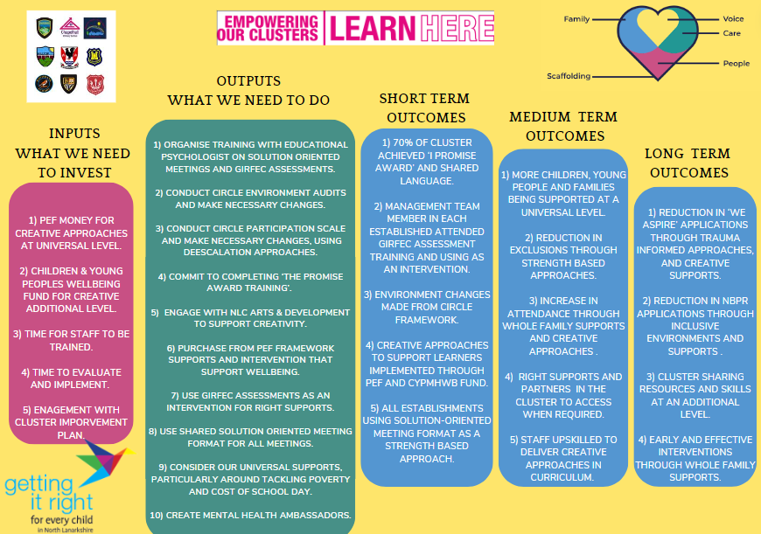
Our rationale is to improve the wellbeing of children and young people, ensuring they are loved, nurtured and empowered to thrive in all aspects of their lives. We will work collaboratively with children, their families and our partners to ensure our children have the best start in life and are supported to their full potential. We will do this by making sure we have the right supports available, at the right time through a strengthening of the GIRFEC staged intervention model and by working together to reduce inequalities and the impact of poverty.
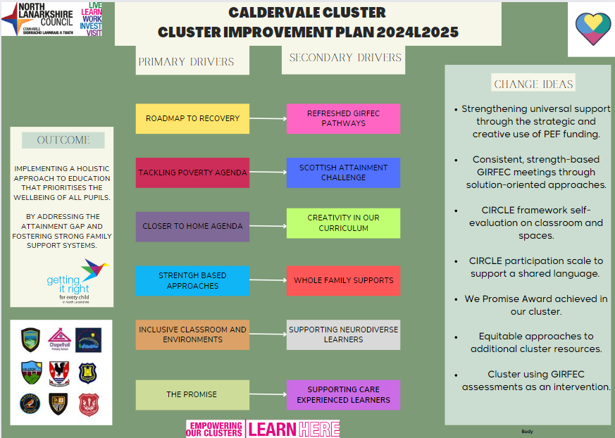

Resources: Please include costs and, where relevant, state where cost is being met from, specifically if using PEF. Please denote PEF/or colour code if preferred, to indicate where PEF spend aligns with targets.
Short-life working party. Children and Young People’s Mental Health & Wellbeing Fund (CYPMHWB), P6-S6 Counselling Budget, P4&P5 Play and Art Therapy Budget.

EXPECTED IMPACT  (SHORT TERM TARGETS) | INTERVENTIONS/ACTIONS TO SUPPORT IMPROVEMENT: HOW? |  | HOW WILL YOU TRACK PROGRESS?  MEASURES | EVALUATION CHECKPOINT 1 (Internal Process) | EVALUATION CHECKPOINT 2  (Internal Process)
What will be the benefit for learners (be specific)? | What are you going to do to make the change? What key actions are required? Consider links to the NIF Drivers. |  | What ongoing information will demonstrate progress? (Qualitative, Quantitative – short/medium/long term data)
By April 2025, almost all establishments will have developed their Additional support level of GIRFEC Planning.  GIRFEC Wellbeing Indicators understood and used by all staff, partners, children and families (HGIOS 3.1, 2.5, 2.7, Roadmap to Recovery). | - Almost all establishment SMT and the majority of PTPS team and wider Core Cluster teams will attend two twilight training sessions on solution-oriented approaches by October 2024.  18th 25th Sep  1:30pm – 4:30pm.  - By December 2024, A cluster portal will be created to frame universal, additional, and intensive supports across Airdrie within the GIRFEC framework.  - Almost all CYP presented to cluster level planning will have followed a solution-oriented approach with shared paperwork being used across the cluster by October 2024.  - A minimum of one key person from every establishment in the training will attend four GIRFEC refresher training by December 2024.  23rd Oct, 6th Nov, 20th Nov, 4th Dec 1:30pm – 4:30pm. |  | Quantitative  + All participants will complete pre and post Microsoft Forms to measure their understanding.  + A sample of minutes from each establishment will be requested in January 2025 for review.  + Track the number of key persons attending GIRFEC refresher training from each establishment.  + Target: 100% of establishments represented at GIRFEC training.  Qualitative  + CIIL, Ed Psych and CL&D colleagues will reflect on the use of solution-oriented meetings at establishment levels in December 2024 and April 2025.
By June 2025, the majority of schools in the cluster will use a refreshed ‘Cost of the school’ day policy to support our families living in poverty holistically.  (Towards a Fairer North Lanarkshire 2023 – 2026 Strategy) | - The cluster working party will collate information on the cost to the school day from the community and schools by December 2024.  - We will link with NLC Tackling Poverty Team and Airdrie Community Board explore financial education programme, Local Outcome Improvement Plan for poverty, MACA and financial awareness sessions in our schools by December 2024.  - A draft ‘Cost of the school day’ policy will be shared across the cluster for consultation, built upon holistic, whole family supports. March 2025.  - Most schools will adopt the policy within their establishment by June 2025. |  | Quantitative  + Policy adoption rates will be monitored.  Qualitative  + Collect qualitative feedback during the consultation phase to understand stakeholder perspectives and suggestions.
By December 2026 staff and partners will have created an environment where all children feel secure, respected and listened to (Roadmap to Recovery, HGIOS 3.1 and 2.7). | - Almost all establishments will complete the Circle Environment Audit in August/September 2024.  - The cluster working party will identify key and recurring themes from the audits and a plan of action by May 2025.  - Almost all Cluster planning meetings, We Aspire or NBPR Applications from October 2024 will include the Circle Participation Scale.  - A short-life multi-agency subgroup, including CL&D and Ed Psych, will be formed by September 2024 to map resources and identify gaps in supporting anxiety at different levels.  - The group will review use of emotional literacy programmes across the cluster and CLPL gaps such as LIAM and trauma informed practice.  - The short-life group will present findings to the wider cluster by March 2025 to target ongoing use of the CYPMHWB funding and alignment to CL&D plan themes of family learning and health and wellbeing.  - Most establishments will introduce school-based peer mentoring models such as Mental Health Ambassadors.  - Almost all staff across the cluster will complete the Stage 1 Time for Inclusive Education (TIE) LGBT CLPL by April 2025.  - Almost all schools in the cluster will complete the self-evaluation using the Forth Valley and West Lothian RIC documentation by October 2024.  - 20% of children and young people who are ‘non school attenders’ (less than 40%) will have a School Refusal Assessment Scale questionnaire (SRAS-R) completed.  - A parent/carer online survey for all will be created by November 2024 and shared across the cluster by February 2025, using Glasgow EBSA survey as a template. |  | Quantitative  + Collate Circle audits and calculate scores for different social, physical, and environmental audits from across establishments.  + Cluster working party to gather feedback from class teachers on changes made to their environment and impact with learners in October 2024 and February 2025.  + % of applications for We Aspire and NBPR recorded and compared to previous years.  + Almost all establishments in cluster will reach their MAP attendance target in session 2024l2025.  + Data from the SRAS-R will be analysed by the working party.  + Data from the EBSA parent/carer survey will be analysed.  Qualitative  + Feedback from the work of the short-life multi-agency working group across the wider cluster and partners.  + Mental Health Ambassadors will provide feedback on their HWB/PSE Programmes within their schools.
Final evaluation:

Priority 1: Long Term Outcome  What do you hope to achieve? What is going to change? For whom? By how much? By When? |  | All staff will be familiar with current curricular model and pedagogical approaches to the learning and teaching of numeracy resulting in pupils making progress towards achieving their numeracy targets within individual planning by the end of 2025
Person(s) Responsible  Who will be leading the improvement? | All staff

(Please insert the relevant information below using the codes above)
NIF Priority: 3, 4 |  | NIF Driver: 2, 4, 6
NLC Priority:1, 2, 4, 5 |  | QI: 2.2, 2.3, 2.4, 3.2
PEF Intervention: |  | Developing in Faith/UNCRC:
If you used any aspect of your PEF fund to support this priority; please detail the expenditure here:

RATIONALE (WHY?) Why have you identified this as a priority? What data did you have to support this?
Due to the complexity of pupil need, engagement and achievement are facilitated by staff skills and knowledge. To ensure that all pupils make progress towards their GIRFMe numeracy targets by the end of 2025 all staff need to engage in a programme of professional development linked to numeracy.
This has been prompted by the changing and diverse pupil population within the school and the need to ensure that all staff are confident in their delivery of the updated curricular model and in particular pedagogical approaches to teaching numeracy.

Resources: Please include costs and, where relevant, state where cost is being met from, specifically if using PEF. Please denote PEF/or colour code if preferred, to indicate where PEF spend aligns with targets.

EXPECTED IMPACT  (SHORT TERM TARGETS) | INTERVENTIONS/ACTIONS TO SUPPORT IMPROVEMENT: HOW? |  | HOW WILL YOU TRACK PROGRESS?  MEASURES | EVALUATION CHECKPOINT 1 (Internal Process) | EVALUATION CHECKPOINT 2 (Internal Process)
What will be the benefit for learners (be specific)? | What are you going to do to make the change? What key actions are required? Consider links to the NIF Drivers. |  | What ongoing information will demonstrate progress? (Qualitative, Quantitative – short/medium/long term data)
All teaching staff will receive training in pedagogical approaches to teaching numeracy to learners with a range of needs. This will then be implemented in planning for individual pupils | Staff training to be delivered through the CAT night schedule.  INSET day dedicated to numeracy training for all staff.  All class planning and GIRFMe plans will show evidence of new approaches to numeracy delivery by June 25 |  | Quality assurance process  - Class visits  - Monitoring of planning  - Peer monitoring  Moderation of GIRFMe plans
All pupils will have access to a range of new resources to support them with their numeracy. This will result in greater engagement in their learning in this curricular area. | New resources to be purchased by October 25  Staff to receive training in new resources where appropriate during the numeracy in service day.  Introduce resources to pupils through play as well as targeted numeracy teaching time. |  | Classroom observations  B Squared assessment data
All pupils will participate in a new secondary based model of curriculum delivery to experience numeracy through a range of different lesson deliveries | Staff will follow the new curricular model ensuring that all pupils have numeracy experiences delivered through a variety of different learning experiences.  Staff will rotate in the afternoons to provide subject specific delivery in their identified specialist areas. |  | SMT to monitor planning and impact of new model of delivery  VI data will support the monitoring of impact on anxiety based behaviours
Almost all pupils will participate in a range of community-based learning to develop their functional numeracy skills for life after school. | All teaching staff to provide alternative contexts to learning numeracy skills within their planning.  DYW lead to monitor this in relation to links with the programme for development of skills for life after school. |  | Lesson observations  Monitoring of planning  Quality assurance activity  Assessment by DYW lead action plan
All pupils will show progress in their numeracy targets by the end of 2025 | SMT to monitor data throughout the year and meet with teachers to look at supports where pupils are experiencing barriers to progress. |  | SMT analysis of connecting steps data
All teaching staff to be trained in standardised assessments.  Most pupils will be assessed using these methods. | DHT to organise training for teaching staff in standardised assessments  By December 24, where appropriate, pupils to be assessed using these. |  | SMT monitoring of standardised assessment to ensure effectiveness
Final evaluation (for submission):

Priority 2: Long Term Outcome  What do you hope to achieve? What is going to change? For whom? By how much? By When? |  | By the end of 2025 all staff will have increased their knowledge and understanding of managing distressed and dysregulated behaviour will and embed approaches in their practice in line with school values to ensure pupils rights are respected.
Person(s) Responsible  Who will be leading the improvement? | HT / DHT and working group

(Please insert the relevant information below using the codes above)
NIF Priority: 1, 2, 4 |  | NIF Driver: 1, 2, 3, 5
NLC Priority:3, 5 |  | QI: 1.3, 1.4, 2.4, 2.6, 3.1, 3.2
PEF Intervention: 2, 3 |  | Developing in Faith/UNCRC:
If you used any aspect of your PEF fund to support this priority; please detail the expenditure here:

RATIONALE (WHY?) Why have you identified this as a priority? What data did you have to support this?
Through the self evaluation process staff have identified that this is an area for development due to the changing needs of the pupils and a gap in process and a need to enhance staff knowledge and confidence. We highlighted the need to develop a cohesive policy with children’s rights at the heart of everything we do. This will also dovetail with work at a local authority level feeding into a national discussion about the use of restrictive practices within schools. Our aim through this piece of work is to ensure a consistent approach across the school when managing and understanding children’s behaviour. This will lead in turn to children who feel more included and respected and therefore with greater opportunities to succeed in their learning.

Resources: Please include costs and, where relevant, state where cost is being met from, specifically if using PEF. Please denote PEF/or colour code if preferred, to indicate where PEF spend aligns with targets.

EXPECTED IMPACT  (SHORT TERM TARGETS) | INTERVENTIONS/ACTIONS TO SUPPORT IMPROVEMENT: HOW? |  | HOW WILL YOU TRACK PROGRESS?  MEASURES | EVALUATION CHECKPOINT 1 (Internal Process) | EVALUATION CHECKPOINT 2 (Internal Process)
What will be the benefit for learners (be specific)? | What are you going to do to make the change? What key actions are required? Consider links to the NIF Drivers. |  | What ongoing information will demonstrate progress? (Qualitative, Quantitative – short/medium/long term data)
Whole school policy to be updated considering the importance of relationships and children’s rights at the heart of how we manage behaviour which challenges. | DHT and working group to develop policy and share with whole on in-service day.  DHT to share progress with parent consultative group. |  | Completion of policy  SMT to monitor implementation of policy through observations of approaches taken to de-escalate pupils at times of high anxiety
Robust and reliable data will be gathered and analysed to look for patterns in behaviour for all pupils. This will identify which children need to targeted approach | Data to be gathered through analysis of violent incidents forms, physical intervention reports, internal requests for assistance, ABC charts, panic alarm records and severity monitoring charts.  DHT and working group will analysis data to identify target group of pupils requiring support.  Development of flow chart to illustrate process for intervention |  | SMT to monitor monthly update on data with lead DHT feeding back progress from working group.  Target group of pupils to be monitored by SMT through staged intervention model to ensure level of support reflects level of need.
All staff will be trained to ensure that they are equipped to de-escalate incidents to avoid crisis. This will result in all pupils having a consistent approach to managing anxiety. This in turn leading to greater levels of engagement | Staff self evaluation to identify training needs  Whole school in service delivered by DHT  Targeted staff to compete CALM training  Develop a CLPL calendar linked under the umbrella of de-escalation and crisis prevention. |  | Classroom observations by SMT  Reduction in the number of incidents  Staff observations of pupils  Connecting Steps recording
All pupils who require a promoting positive relationships plan will have one linked to an understanding of their behaviour through functional analysis. This will support a reduction in anxiety-based behaviour for this target group | Audit of which children require additional planning  Completion of functional analysis  Development of PPR plan in partnership with parents.  PTs to monitor pupils through staged intervention model of support to monitor effectiveness of the plan.  SMT to link with partner agencies when required to support plan.  DHT to identify targeted activities or resources to support the reduction of anxiety based behaviours |  | Analysis of data by SMT will  monitor impact of plans and any evidence of a reduction in incidents  Observation of pupils engaging in targeted activities to study impact in relation to reducing anxiety based behaviours
Staff Health & Wellbeing will be monitored to understand the impact of managing challenging behaviour on this. | Survey staff health & wellbeing  Monthly wellbeing meetings for staff  Ensure system of debrief after incidents  Establish feedback to staff re: violent incident data |  | Audit of survey results  Better response from staff HWB meetings  Reduction in VI
Final evaluation:

PEF ALLOCATION: £17, 000


nOrth Lanarkshire Council
Education & FAMILIES
EQUITY PLAN 2024-25
(Internal recording; random sampling of PEF/Equity Plans
will continue throughout the session).

Rationale for EQUITY (PEF) plan
Please provide below detail around your rationale for the Equity plan. Highlight how PEF expenditure is integrated to support improvement priorities.
For priorities around equity please detail the poverty related gap which you are addressing and the data which supports your rationale.
Consider the following: attainment, health & wellbeing, attendance, exclusion, participation, engagement.

Link to Improvement Plan | Detailed Costings | Priority/Description | Intended Outcome/Impact  Please describe your planned use of SAC resource/PEF allocation and what you intend to achieve. | Evidence/Measures  Please indicate what evidence you are going to collect to show impact and progression.
- Welfare officer shared post  - Purchase resources to support the reduction of anxiety-based behaviours  - Fund experiences to support the reduction of anxiety based behaviours for targeted pupils. | £2700 – Aug - Mar  £1,980 – Apr - Aug  £6,000  £6,000 | This is a shared post to help support families. This will enable us to identify targeted families who may benefit from interventions in the home to help support them.  Resources such as spinning and bouncing toys will be purchased linked to assessment of pupils needs.  Following individual assessment of need linked to the RAG and assessment of wellbeing activities will be sourced to support children who are having difficulty regulating. | Support to families, helping them to better manage and/or understand their children’s needs will increase their ability to support their child’s learning in a wider context through things like play.  Providing children with activities that support their regulation will lead to an increase in pupil engagement in learning and therefore progress against their targets. | Conversations with individual families and feedback from the officer.  Lesson observations  Analysis of connecting steps data  Feedback from pupils through use of talking mats, symbols etc.

Appendix 1:
When considering your Cluster and School Improvement Priorities, you are asked to provide links to the following, as well as the Quality Indicators within HGIOS4 and HGIOELC:
UNCRC | HGIOS 4 & HGIOELCC | National Improvement Framework: priorities and drivers
Article 1 - definition of the child  Article 2 - non-discrimination  Article 3 - best interests of the child  Article 4 - implementation of the Convention  Article 5 - parental guidance and child's evolving capacities  Article 6 - life, survival and development  Article 7 - birth registration, name, nationality, care  Article 8 - protection and preservation of identity  Article 9 - separation from parents  Article 10 - family reunification  Article 11 - abduction and non-return of children  Article 12 - respect for the views of the child  Article 13 - freedom of expression  Article 14 - freedom of thought, belief and religion  Article 15 - freedom of association  Article 16 - right to privacy  Article 17 - access to information from the media  Article 18 - parental responsibilities and state assistance  Article 19 - protection from violence, abuse and neglect  Article 20 - children unable to live with their family  Article 21 – adoption  Article 22 - refugee children  Article 23 - children with a disability  Article 24 - health and health services  Article 25 - review of treatment in care  Article 26 - social security  Article 27 - adequate standard of living  Article 28 - right to education  Article 29 - goals of education  Article 30 - children from minority or indigenous groups  Article 31 - leisure, play and culture  Article 32 - child labour  Article 33 - drug abuse  Article 34 -sexual exploitation  Article 35 - abduction, sale and trafficking  Article 36 - other forms of exploitation  Article 37 - inhumane treatment and detention  Article 38 - war and armed conflicts  Article 39 - recovery from trauma and reintegration  Article 40 - juvenile justice  Article 41 - respect for higher national standards  Article 42 - knowledge of rights | 1.1: Self-evaluation for self-improvement  1.2: Leadership for learning  1.3: Leadership of change  1.4: Leadership and management of staff  1.5: Management of resources to promote equity  2.1: Safeguarding and child protection  2.2: Curriculum  2.3: Learning teaching and assessment  2.4: Personalised support  2.5: Family learning  2.6: Transitions  2.7: Partnerships  3.1: Ensuring wellbeing, equality and inclusion  3.2: Raising attainment and achievement  3.3: Increasing creativity and employability  Specific to HGIOELC  3.2: Securing children’s progress  3.3: Developing creativity and skills for life | NIF Priorities  - Placing the human rights and needs of every child and young person at the centre of education  - Improvement in children and young people’s health and wellbeing;  - Closing the attainment gap between the most and least disadvantaged children and young people;  - Improvement in skills and sustained, positive school leaver destinations for all young people  - Improvement in attainment, particularly in literacy and numeracy.  NIF Drivers  - School and ELC Leadership  - Teacher and Practitioner Professionalism  - Parent/Carer Involvement and Engagement  - Curriculum and Assessment  - School and ELC Improvement  - Performance Information
PEF INTERVENTIONS
- Early intervention and prevention
- Social and emotional wellbeing
- Promoting healthy lifestyles
- Targeted approaches to literacy and numeracy
- Promoting a high quality learning experience
- Differentiated support
- Using evidence and data
- Employability and skills development
- Engaging beyond the school
- Partnership working
- Professional learning and leadership
- Research and evaluation to monitor impact
Education and Families Priorities
- Improvement in attainment, particularly literacy and numeracy
- Closing the attainment gap between the most and least disadvantaged children
- Improvement in children and young people’s health and wellbeing with a focus on mental health and wellbeing
- Improvement in employability skills and sustained, positive school leaver destinations for all young people
- Improved outcomes for vulnerable groups
Developing In Faith
Roman Catholic Schools are required to provide links within their SIP and SIR to the themes contained within ‘Developing in Faith’, as requested by the Bishops’ Conference of Scotland.
1. Honouring Jesus Christ as the Way, the Truth and the Life
2. Developing as a community of faith and learning
3. Promoting Gospel Values
4. Celebrating and Worshiping
6. Serving the common good.

