
Curriculum Rationale

“The curriculum is the totality of experiences which are planned for children and young people through their education, wherever they are being educated. It includes the ethos and life of the school as a community; curriculum areas and subjects; interdisciplinary learning; and opportunities for personal achievement.”
Building the curriculum 3: A framework for Learning and Teaching
NLC Curriculum Vision

We Aspire to support all children and young people to realise their full potential by giving them the tools to make their way in life through quality, exciting, and challenging learning opportunities resulting in improving attainment and closing the poverty-related attainment gap.

School/Cluster Vision
A safe and inspiring environment where all pupils are respected, nurtured and encouraged to thrive on their individual learning path.

Values
CFE | WISDOM | JUSTICE | COMPASSION |  | INTEGRITY
NLC | FAIRNESS | RESPECT | EQUALITY |  | EXCELLENCE
CENTRE | RESPECT | NURTURE | SUPPORT | FUN | WORKING TOGETHER

NLC Aims
All learners will have access to quality learning and teaching, and we will ensure that our schools are inclusive, energetic places which take into account the needs of all our young people, giving them experiences, which last a lifetime and a voice in their own learning. Learners of all ages will be given the skills to take advantage of the employment opportunities our growing economy brings, creating a flexible, resilient, and skilled workforce for the future.

The Big Ideas
All NLC establishments use the seven principles of curriculum design to build around the curricular areas, including literacy numeracy, HWB and digital skills, to develop the four capacities.

In line with the Scottish Government National Improvement Framework our main curriculum driver is to achieve equity for every child or young person in Mavisbank School.

We will achieve this by ensuring that they are equipped with the relevant skills in communication, literacy, cognition, numeracy and health and wellbeing skills to maximise their potential as they prepare for the future.

By offering a range of learning pathways we will ensure that all pupils will become effective contributors within local and wider communities.

Understanding the Learners and Learning Partners

- The curriculum design is based around the core aspects that we aspire to develop in order to help pupils prepare for the future, namely Communication, Cognition, Health and Wellbeing( Physical , Mental and Relationships) Independence and Community Experiences. Through involvement in the development of their GIRFME plans, where possible pupils communicate what they do and do not enjoy and this feedback helps to shape the activities and context for learning within the individual and class plans.

- Parents and carers have shared their hopes and aspirations for their children and what role the curriculum plays in getting them ready to leave school. At points of transition parents and carers are consulted on what they hope their child will achieve in their time within our school.

- As we move forward with our new school plans, we look forward to making use of the vocational offer that will be available within the shared campus in order to create close working relationships with the college and third sector partners. This link will also helping us shape our own curricular offer for the senior phase both within school and in the community.

- In partnership with other ASN schools and officers from the local authority we are involved a piece of work that involves linking with employers. Through this process we will gain feedback on what is required for us to prepare our young people for life in the workplace. This will help us shape our pathways throughout the school.

Practical Approaches

- From 11 – 18 we give age-appropriate experiences across a range of curricular areas in a variety of learning contexts.
- Ensuring that experiences are accessible to all our learners regardless of disability.
- Our pedagogy is based on acknowledging the academic abilities of our learners, recognising the impact of their disabilities and implementing the transactional supports needed to facilitate access to the curriculum.
- Working in partnership with Redburn we have access to a well-developed senior phase programme which offers accredited opportunities to develop skills for learning, life and work.
- The practice in our school is under pinned by the 6 principles of nurture and the United Nations Convention on the Rights of the Child.

- The development of individualised learning pathways for our children and young people provides a wide range of opportunities for interdisciplinary learning and wider achievement both in school and in the local community.

- Our curriculum planning is influenced by our understanding of how disability impacts on our pupils. This includes how they access their learning both in school and in the wider community. Our PEF policy articulates our interpretation of what poverty looks like for our learners and this helps to inform how we target our resources to ensure maximum engagement with their curriculum.

Curriculum Diagram:

“a content-rich curriculum which is knowledge based, skills-orientated and experiences infused.”
Bruce Robertson, The teaching delusion 2

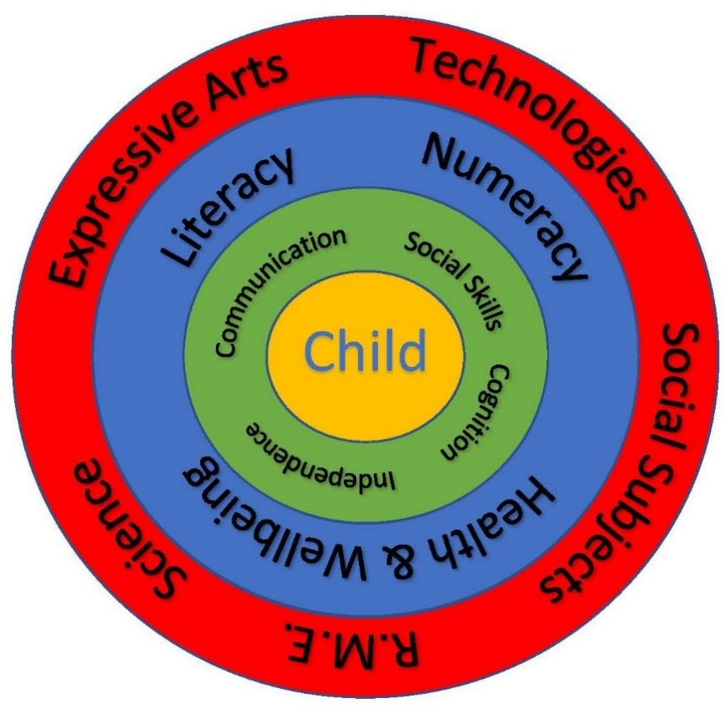

At the core of our curriculum design is the pupil and their individual learning pathways. Permeating through all our daily activities is the development of the communication, cognition, social skills and independence of each pupil. This in turn supports our school aim to enable all pupils to achieve their potential and equip them with the skills needed to prepare them for their future and life after school.
Our learners are assessed using the Curriculum for Excellence foundation stage milestones moving through to C f E levels from early level up. We also use the theory behind the SCERTS model to determine the transactional supports required to support the pupil’s emotional regulation. This includes consideration of the learning environment and communication styles which then informs teaching styles thus planning effectively to meet individual needs.
We use an inter disciplinary or topic based approach to frame the learning experiences offered to pupils, giving us a context within which we can support pupils in achieving their individual priorities for learning. A School based 3 year cycle of themes ensures a broad range of learning experiences are delivered.

All pupils will follow the literacy and numeracy pathways and for most planning for this will be reflected within the thematic planning. Where required additional planning will take place for pupils following curriculum for excellence early level and above.
The context for learning plays a significant role in determining curriculum delivery. The type of learners we support in school require a breadth of experiences within a range of different contexts in order to ensure relevance and progression equipping them with the skills they need to be effective contributors, confident individuals, successful learners and responsible citizens.

Quality Assurance

Three times a year staff engage in support and challenge meetings where they discuss each pupils GIRFMe Plan, along with the content of their IDL delivery. This helps to ensure progression throughout the year and across the years. Following the completion of this activity senior management will pair teachers based on the type of learners in classes to create moderation partnerships.
At the end of each term teachers will meet with SMT to quality assure the evidence collected against the GIRFMe targets and planning.
Staff also have an opportunity for peer observations, selecting an area to observe that will help to develop their own practice.
Pupils, where possible, will have an opportunity to evaluate the terms plan and contribute to the learning experiences in the next terms plan.

Planning of Curriculum Self-Evaluation, Review & Refresh

NLC staff teams are committed to:
- career-long professional learning based around high quality, rigorous professional standards
- meaningful professional review and development
- Belonging to communities of practice and enquiry
- Developing collaborative practice locally, nationally and globally
- Self-evaluation of the work of the school with reference to HGIOS4? Quality indicators
- Annual review of the curriculum offer

‘Our curriculum is regularly reviewed and refreshed by an informed awareness of current education thinking and evolves through ongoing debate within the school community. We work well with partners to ensure creative and innovative approaches to curriculum development are encouraged and support positive outcomes for learners. The development of our curriculum is underpinned by a coherent whole school approach to learning for sustainability.’
How Good is Our School 4, Education Scotland, 2019
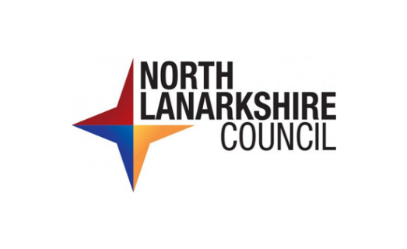
How Good is Our Early Learning Centre, 2016

