Mavisbank School

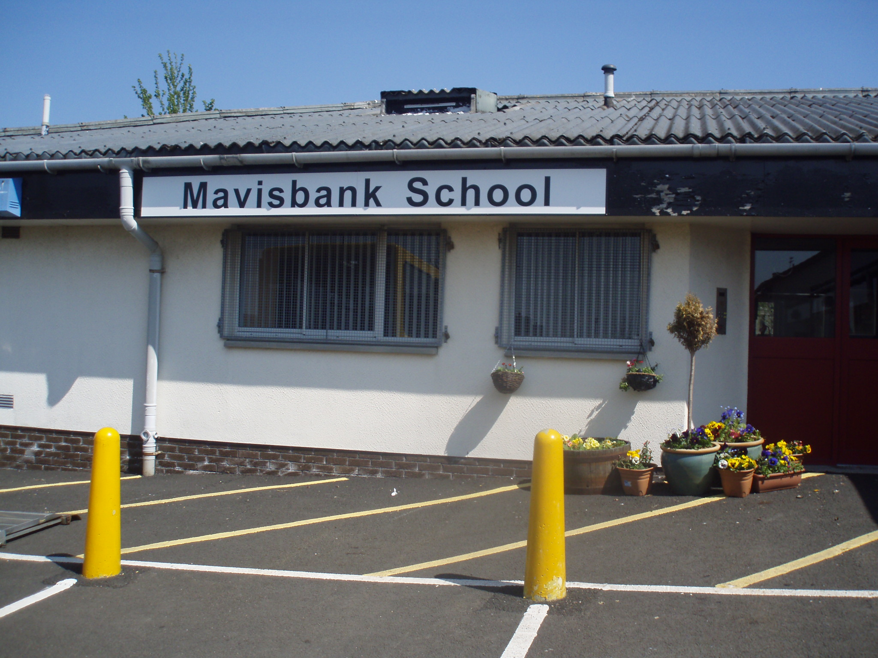

Handbook 2024-25
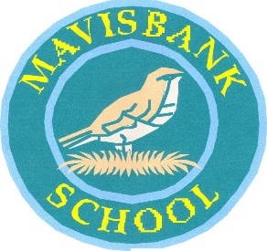

Contents
Welcome 3
Mission Statement 4
School Ethos & Aims 5
School Information 6
Partnerships 7
School Holidays 2024/2025 8
Admissions 9
Equal opportunities and social justice 9
GIRFEC 10
Curriculum for Excellence 11
Learning, Teaching and Assessment 14
Planning to Meet Individual Needs 16
Assessment and Reporting 17
Additional Support Needs 17
Dispute Resolution 18
School Improvement 18
Homework 18
Spiritual, Social, Moral and Cultural Values 19
Home / School Links 20
The Parent Forum 20
The Parent Council 21
School Resources 22
Our School in the Community 23
Freedom of Information 23
Child Protection 28
Attendance at School 29
Clothing and Uniform 30
Meals 31
Placing Requests 32
Transport Arrangements 33
Information in Emergencies 33
Medical and Health Care 34
Important Addresses 35
Useful Phone Numbers 38

Welcome

We welcome you to Mavisbank School. Education Scotland have previously acknowledged the welcoming ethos and excellent relationships between staff and pupils. We extend this welcome to all parents, carers, and visitors to the school.

Parents and carers will support schools best when they feel at ease with the staff and are confident that their opinions and the needs of their young people are respected and valued. It is important to us to build a partnership that is based on shared responsibility, understanding and mutual respect.

The purpose of this handbook is to share with parents and carers background information concerning not only the day-to-day running of Mavisbank School but also what we strive to achieve with our pupils. Mavisbank School is a happy learning community with strong relationships amongst staff, pupils, parents and the wider community.

Should you wish to know anything that is not included in this handbook then do not hesitate to contact the school and we will do our utmost to be of assistance to you.

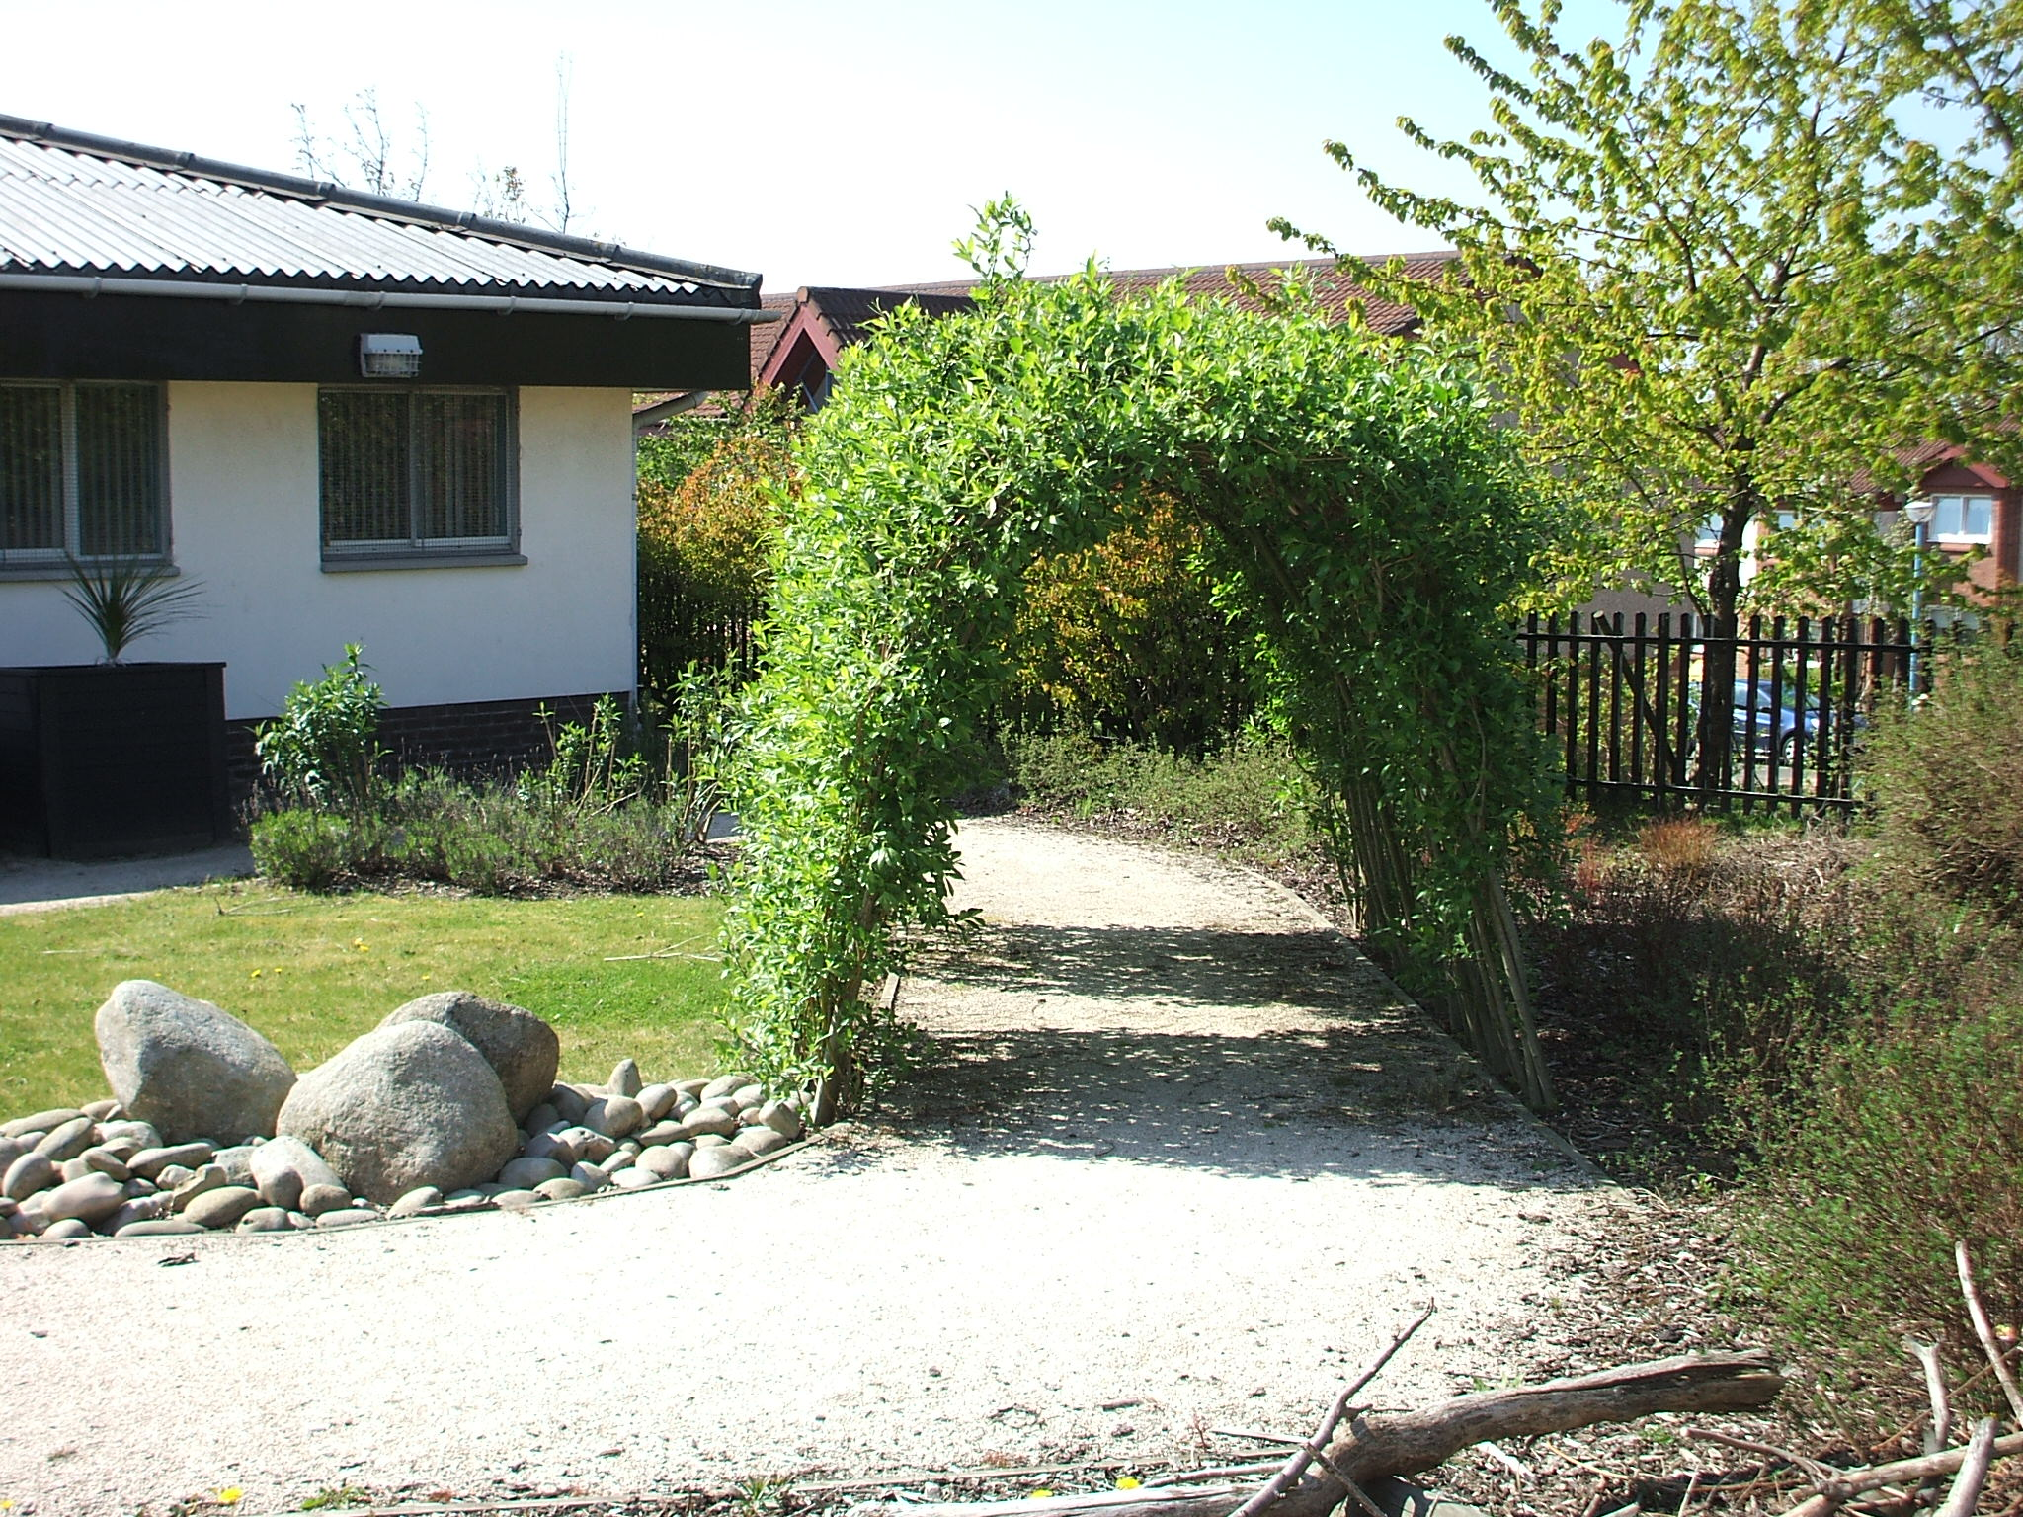

Helen Delaney (Head Teacher)
Mavisbank School
Airdrie
ML6 OEB

Mission Statement

Our mission is to provide a learning
experience where all pupils will
maximise their potential in a happy, caring and supportive environment.

As a Rights Respecting School (RRS), the Vision, Values and Aims of Mavisbank School are reflected through the United Nations Rights of the Child.

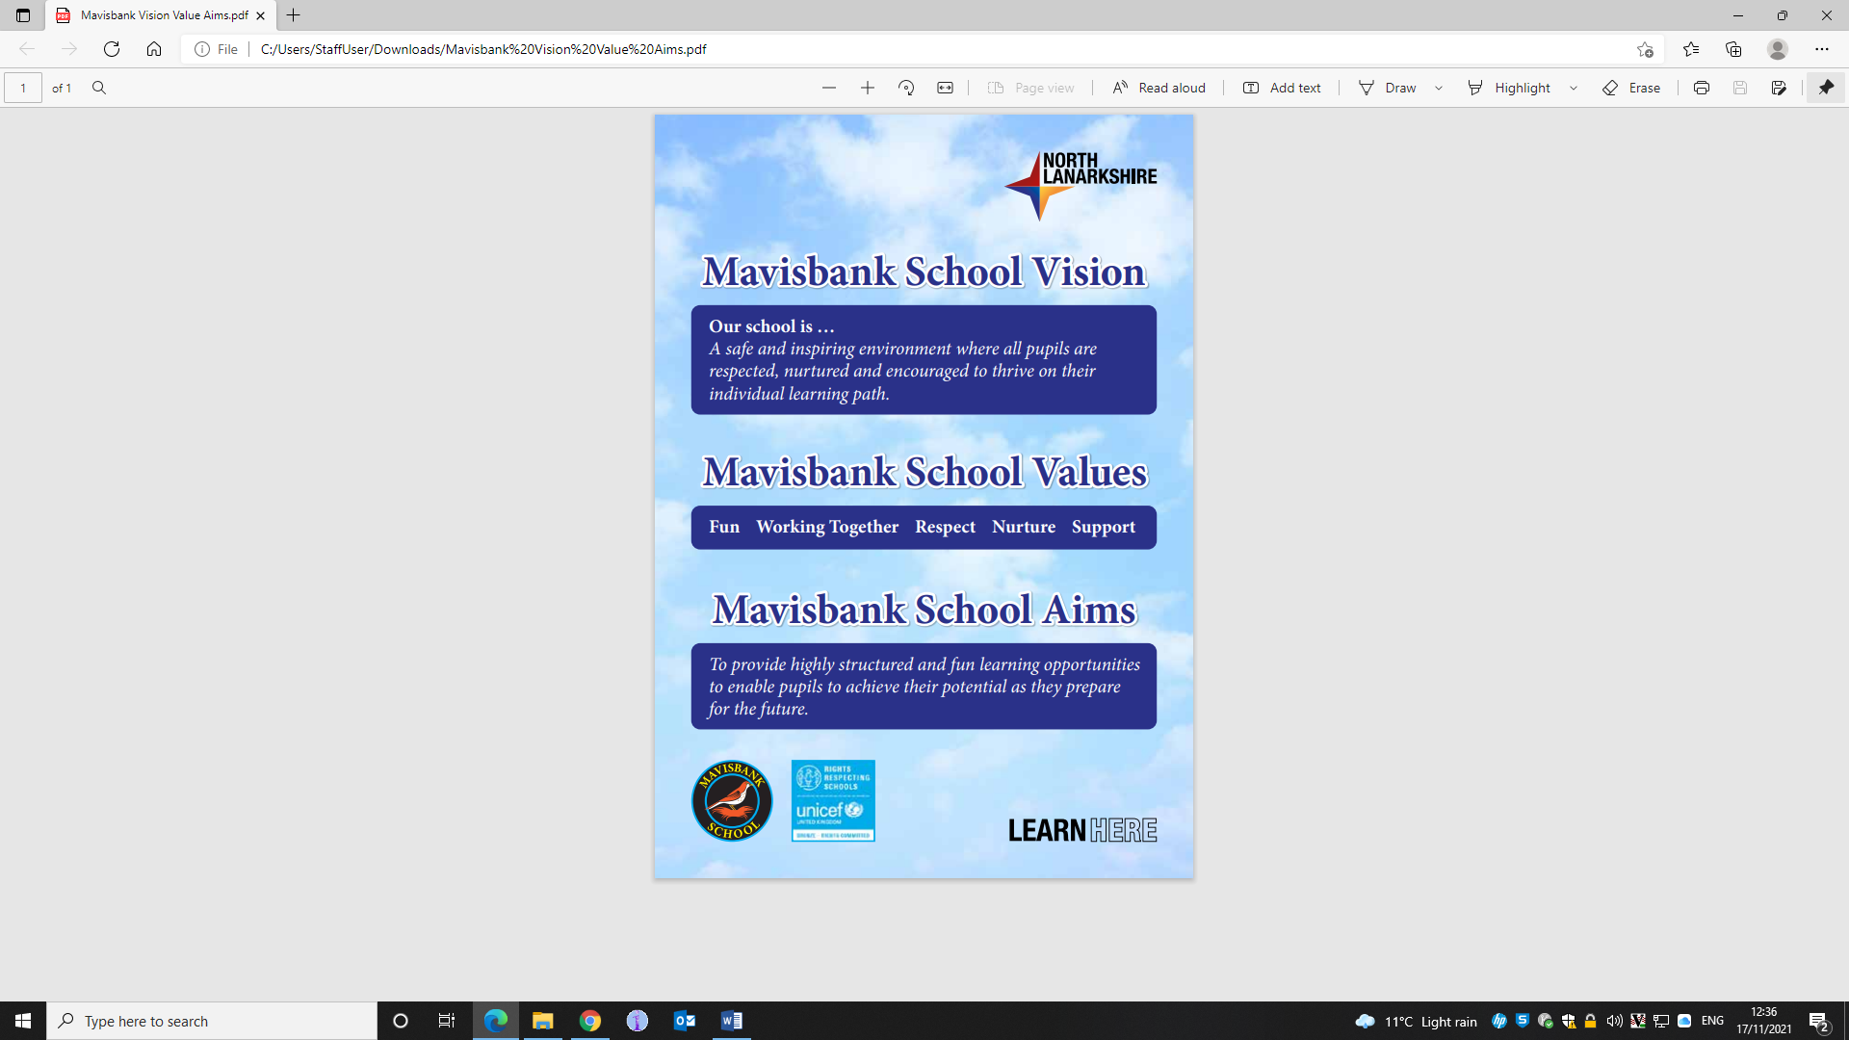



UNCRC Article 6 - I should be supported to live and grow.

School Ethos

A positive, happy and supportive ethos strongly exists within our school. All pupil achievement is celebrated through feedback and home school communication. We have regular Ethos Assemblies where we celebrate each pupil’s achievements within a particular curricular area. At each Assembly, we chose a Shining Star who receives a Shining Star Award to take home and has our Mavisbank Rap sung in their honour.

School Aims

The aims of the school are to:

Curriculum:
Ensure that the additional support needs of our pupils are met through the provision of an appropriately challenging curriculum.

Provide a wide and varied curriculum that is well planned and delivered in an interesting and stimulating way.

Support for Pupils:
Create a safe and caring environment where each pupil’s social and emotional needs are addressed.

Inclusion:
Provide opportunities for relevant integration/social inclusion across the school and link schools within the authority and our community.

Learning Environment:
Provide a well resourced learning and teaching environment.

Our pupils’ voices are sought and encouraged in all aspects of their learning environment and experiences.

Partnership:
Enable staff, parents and other professionals to work in a spirit of inclusion, partnership and collaboration.

Professional Development:
Provide opportunities for staff to further develop their expertise in the field of additional support needs, while acknowledging North Lanarkshire Council’s Policy on Equal Opportunities in the process.

Celebrating Success:
Foster an ethos which acknowledges achievement and celebrates success for all pupils and staff.

School Information

Name of School: Mavisbank School

Address: Mitchell Street, Airdrie, ML6 OEB

Telephone Number: 01236 632108

e-mail Address: enquiries-at-mavisbank@northlan.org.uk

Blog: https://blogs.glowscotland.org.uk/nl/mavisbank/

Present Roll: 30 Agreed Capacity from August 2025: 38

Stages Covered: School catering for children and young people between the ages of 11 and 18 years of age with ASD and a range of additional support needs.
Status: Non-denominational and co-educational

The working capacity of the school will mean maximum class sizes of 8 pupils.

School Hours

09:00 Pupils arrive in school
10.30-10.45 Interval
12:15-1:15 Pupils’ lunch / outdoor learning
15:30 Pupils leave school

Staff

Head Teacher Helen Delaney
Deputy Head Teacher Eileen Smith
Shared Depute Head Teacher Jacqueline McLaughlin
Principal Teacher Shona Aiken

Teaching Staff
Simon Linton
Mary Linden
Steven Colquhoun
Lauren McGowan
Kirstie McGavigan
Harriet Ogilvie

The school is also supported by Enhanced Support Assistants an Additional Support Needs Assistants

Partnerships
The school values the partner agencies who support achievement of positive outcomes for pupils and families.
The school nursing team is fully involved in supporting our Health and Wellbeing agenda.
For identified pupils, our Speech and Language Therapist works alongside teachers and ASNA staff in a holistic approach to communication.
The Physiotherapists implement joint programmes for relevant pupils working on core stability and mobility.
The Occupational Therapist provides support and training to staff and parents regarding sensory processing where appropriate and works to support individual pupils overcome physical barriers within our learning environment.
CAMHS support us to develop skill and expertise in relation to identified pupils and engage in professional dialogue regarding topical local and national issues.
Our pupils may also benefit from input from our Visual Impairment Specialist who will review pupil needs, relevant supports and staff training requirements.
Our external partners enrich the experiences offered to our pupils and support the school to achieve its priorities.


UNCRC Article 3 - Adults must do what’s best for me

School Holidays 2024/2025

August 2024
Monday 12 August 2024 (Return date for Teachers & In-Service Day)
Tuesday 13 August 2024 (In-Service Day)
Wednesday 14 August 2024 (Return date for Pupils)

September 2024
Friday 27 September and Monday 30 September 2024 (September weekend)

October 2024
Monday 14 to Friday 18 October 2024 (October Week)

November 2024
Monday 18 November 2024 (In-Service Day)

December 2024 - January 2025
Schools close at 2.30pm on Friday 20 December 2024
Monday 23 December 2024 - Friday 3 January 2025 (inclusive) (Christmas holidays) Schools return on Monday, 6 January 2025

February 2025
Monday 17 February and Tuesday 18 February 2025 (Mid-term break)
Wednesday 19 February 2025 (In-service day)

April 2025
Schools close at 2.30 pm on Friday 4 April 2025
Monday 7 April- Friday 18 April 2025 (Inclusive)* Spring Holiday (Easter)
*Good Friday 18 April and Easter Monday 21 April 2025

May 2025
Monday 5 May 2025 (May Public Holiday)
Tuesday 6 May 2025 (in-service day)

Friday 23 May 2025 and Monday 26 May 2025 (May Weekend)
June 2025

Schools Close at 1pm on Wednesday 25 June 2025

Admissions
For children with an additional support need, the authority operates a Transition Pathway Review which takes account of Additional Support Legislation and is directly linked to individual need. It ensures transparency and clarity in the appropriate placement of pupils in North Lanarkshire schools.

More information about this process can be sought from Inclusion or Continuous Improvement officer linked to the school.

Placements are reviewed annually to determine whether they are still meeting a pupil’s individual needs. Once a placement has been allocated, parents can make an appointment to visit the school. At that time, visitors can see the learning environment and more detailed information is made available. A comprehensive transition programme is implemented to support the pupils move into Mavisbank School. A post-placement review is also arranged for approximately six to eight weeks after the start date of our pupils.

Equal opportunities and social justice
We seek to promote equal opportunities and social justice by implementing North Lanarkshire’s equal opportunity policy. We ensure the content of the curriculum and resources promote a positive image of men and women who are disadvantaged, of minority religious, racial and cultural groups, or who have additional support needs.

The school ethos reflects Equal Opportunity and Social Justice in our aim to make sure no pupil will be disadvantaged by their disability, level of financial support, gender, race or religion.

We ensure that, within the school, access to the whole breadth of the balanced curriculum is given to all pupils regardless of the extent of their physical or learning disability at an appropriate level to meet their needs.

Awareness of the rights of the older pupils to experience the world of work is given a high priority which includes access to SQA units of work and careers support.

We recognise the importance of advocacy for parents and children at this time in their lives and will support them when asked. Our well established consultative and reporting process is at the heart of our success; developing strong links and support from parents. The school is committed to assessing all policies and practices to ensure there are no negative impacts on any group of people.

The Equality and Human Rights Commission’s Technical Guidance for Schools in Scotland is the essential guide for the school community to promote equality. This information can be accessed at:
http://www.equalityhumanrights.com/news/2013/jume/commission-publishes-equality-guidance-for-schools

GIRFEC
In Mavisbank our pupils are in small classes with a high staff ratio. School staff meet our pupils at the door every morning and ensure they are safe and secure as they enter the school.

Each pupil has a named person in the management team who is responsible for first line communication, supporting parents with raised concerns, leading reviews and developing a positive relationship with parents and family members.

As part of our commitment to pupil’s education, care and welfare, regular opportunities are provided yearly to discuss all aspects of development and progress at a review where the pupil’s network of support are all invited to participate.

In line with the Additional Support for Learning Act and the GIRFEC agenda, pupils are planned for using staged intervention model. The level of planning in place for a child will be determined on an individual basis.


UNCRC Article 23 - If I have a disability, I have the right to special care and education and I have the right to play an active role in the community. I have the right to a full and decent life with dignity and independence.

Curriculum for Excellence
The school provides at all ages a curriculum that is in line with Scottish Government policy. There is a different emphasis in the curriculum for each stage, all of which interlink and allow for progression.

Curriculum for Excellence aims to achieve a transformation in education in Scotland by providing an improved, more flexible and enriched curriculum for all children and young people from 3-18. The curriculum includes all of the experiences which are planned for children and young people through their education, wherever they are being educated. All schools and nurseries in North Lanarkshire are working hard to raise standards so that children and young people will develop all of the skills necessary to continue to be successful when leaving school and entering the world of higher education, training or work.
Curriculum for Excellence is underpinned by the values inscribed on the mace of the Scottish Parliament – wisdom, justice, compassion and integrity. The purpose of Curriculum for Excellence is encapsulated in the four capacities – to enable each child or young person to be a successful learner, a confident individual, a responsible citizen and an effective contributor.
What are the curriculum areas in Curriculum for Excellence? There are eight curriculum areas:-
Expressive Arts Health and Well Being Languages (literacy)
Mathematics (numeracy) Religious and Moral Education Science
Social Studies Technologies

Importantly literacy and numeracy are given added importance because these skills are so vital in everyday life. All teachers will have responsibility to teach literacy and numeracy and Health & Well-being.
Within the school’s context for learning communication, independence and social skill development are extremely important and as such the school provides a wide range of experiences for pupils in their immediate, local and wider communities. This is enhanced through strategies such as PECs and Makaton and the use of Alternative Augmentative Communication devices including iPads, a range of switches and eye gaze.
Learning is divided into two phases.
The Broad Education (BGE) is from Primary to the end of the third year of Secondary School and Senior Phase is from fourth to sixth year of Secondary School. The Broad General Education is divided into Early, First, Second, Third and Fourth levels. The Senior Phase is primarily approached through SQA qualifications.

Early Stage: Pre-school or later.
First: can be from Primary 1 or later.
Second: to the end of P4 but earlier or later for some.
Third: to the end of P7 but earlier or later for some.
Fourth: can be from S1- S3 but earlier for some.
Senior Phase: S4-S6 and college or other means of study.

In the Senior Phase at Mavisbank School (from S4-S6) learning focuses on National 1 and 2 qualifications and increasingly becomes focused on transitions to positive destinations post school.
Throughout, the curriculum is focused on skills for learning, life and work, bringing real life into the classroom, making learning relevant and helping young people apply lessons to their life beyond the classroom. It links knowledge in one subject area to another; helping make connections in their learning and develop skills which can enable children to think for themselves, make sound judgements, challenge, enquire and find solutions.
Ultimately, Curriculum for Excellence aims to improve our children’s life chances, to nurture successful learners, confident individuals, effective contributors, and responsible citizens, building on Scotland’s reputation for great education.
Underpinning our curriculum is the belief that every young person can learn and that it is up to the people who support them through the learning process to ensure that each and every one learns at the pace which is appropriate for them and to meet their needs in the best possible way. Our young people learn in different ways, through listening, watching and doing. Teachers prepare their lessons so that pupils will have the opportunity to experience all ways of learning in the different areas of the curriculum.
Our teaching and learning is focussed and the school has an active learning approach.
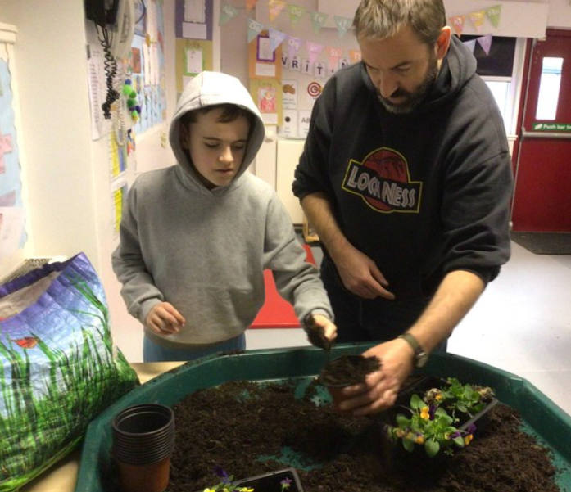As our students progress through school, they continue to be involved in active learning experiences which are engaging and give them ownership of their own learning. These become increasingly linked to providing pupils with opportunities to make choices and develop the skills necessary for interdependent and independent learning ultimately leading to positive and sustained destinations post school.
In Mavisbank we recognise that as a school for pupils with diverse additional support needs, we require an educational environment which includes a wide range of approaches, activities and experiences.

Staff creatively plan lessons and activities that are appropriate for each pupil and each group of pupils. Pupils take part in individual and group sessions, community-based activities, and have opportunities to link with pupils from other classes and schools, as well as take part in various social inclusion initiatives.

Each class timetable provides the framework within which the curriculum is delivered and the emphasis within each class may differ within specific areas of the curriculum. A thematic approach is used to give a cohesive overall framework.

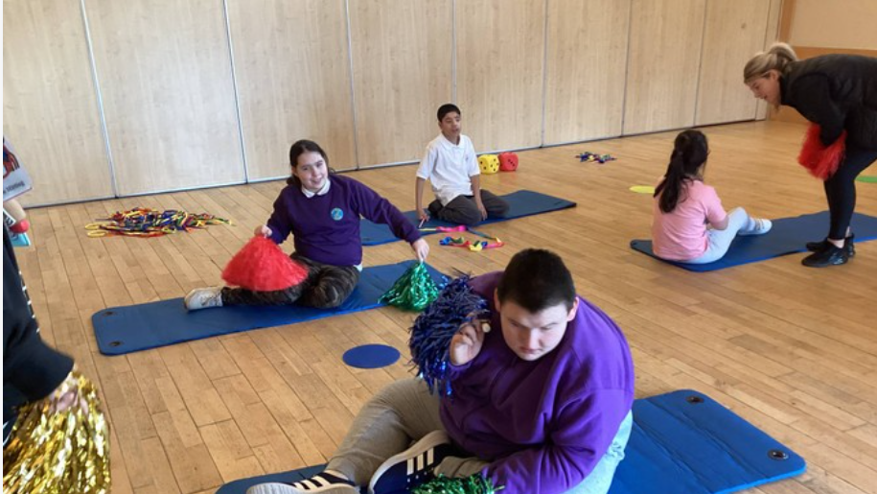

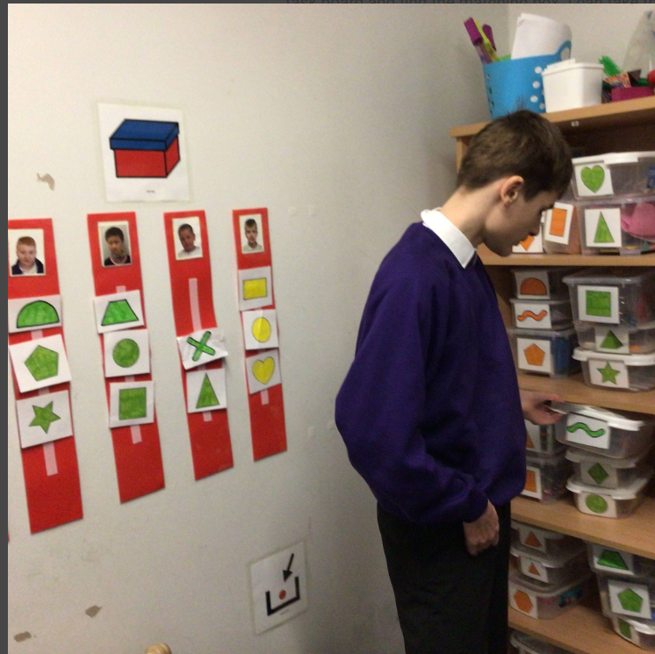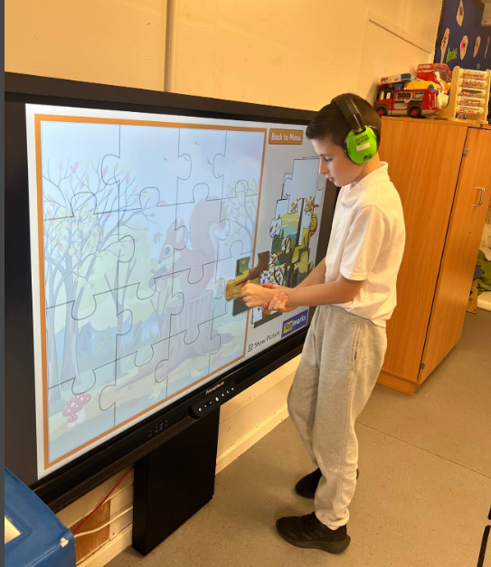

Learning, Teaching and Assessment
Connecting Steps provides teachers with information derived from Curriculum for Excellence which supports them to plan and assess. This on-line assessment tool allows us to measure every small step our pupils make towards their goals as well as recognising and celebrating our pupils' achievements.
In all classrooms, staff use a range of tools to assess children's learning taking account of national and local advice and guidance. Your child’s progress will be reported to you so that you know how well your child is doing.

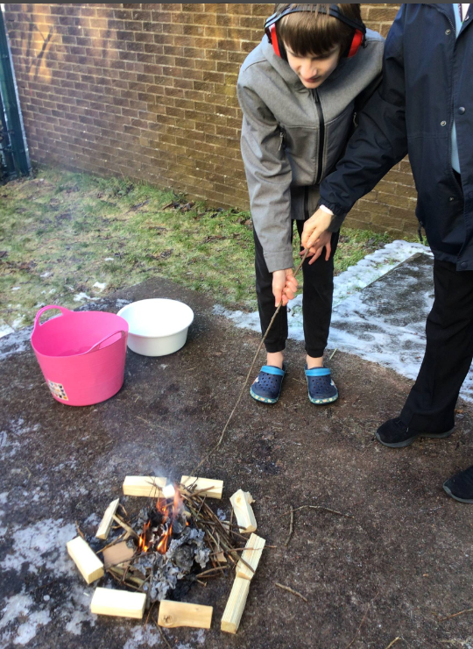Each year the school will let you know what is being done to implement Curriculum for Excellence so that you can be confident that your child is receiving a high quality education. In Mavisbank we are working on further developing our curriculum to ensure that the core skills of communication, cognition, social skills and independence is firmly embedded in class planning. The school utilises the following experiences to engage pupils in learning:

Outdoor Learning
Gives pupils the opportunity to consolidate skills taught in the classroom in a context which is engaging and positive for our pupils.

Leadership Development
Pupils have opportunities to develop independence through taking responsibility for aspects of their learning, involvement in resource management and undertaking roles of responsibility within the classroom, school and into the community. Our pupil council meet monthly and our representatives discuss school issues and feedback to their classmates.
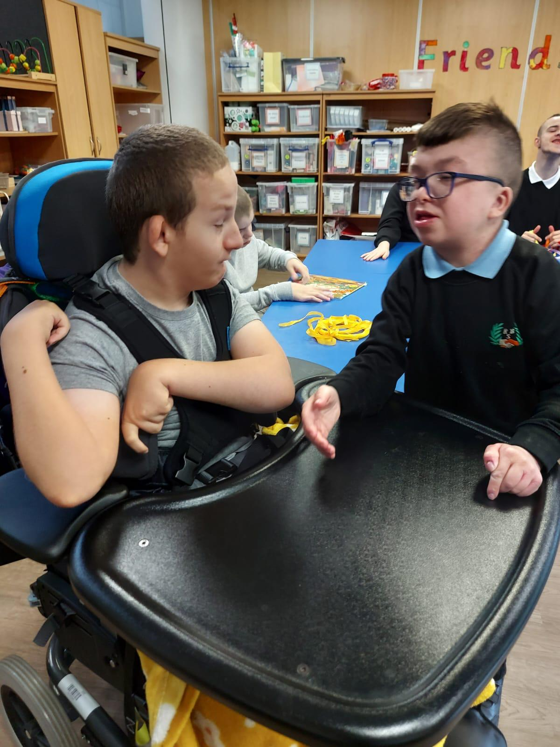
Skills for Work
All pupils have opportunities to participate in learning about the world around them, the world of work and learning about how these experiences influence the transition to positive destinations. This includes learning about people who help us, participating in enterprise, undertaking specific roles in the school and for our senior pupils accessing relevant opportunities to explore the workplace.

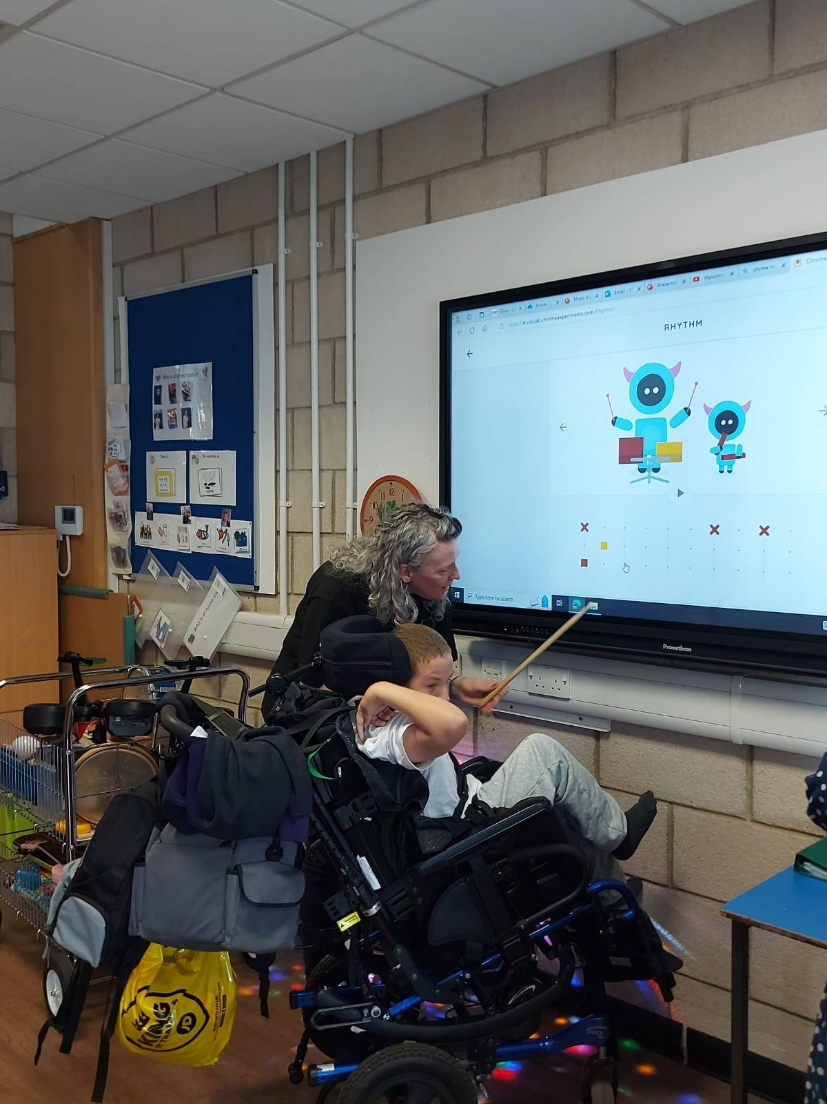Pupils in the Senior Phase participate in vocational learning where they can attend college and Glenburn (our vocational campus), where they can undertake roles of responsibility and are supported to experience a variety of activities such as hospitality and horticulture.
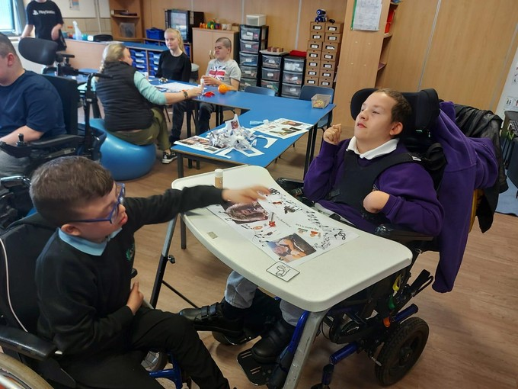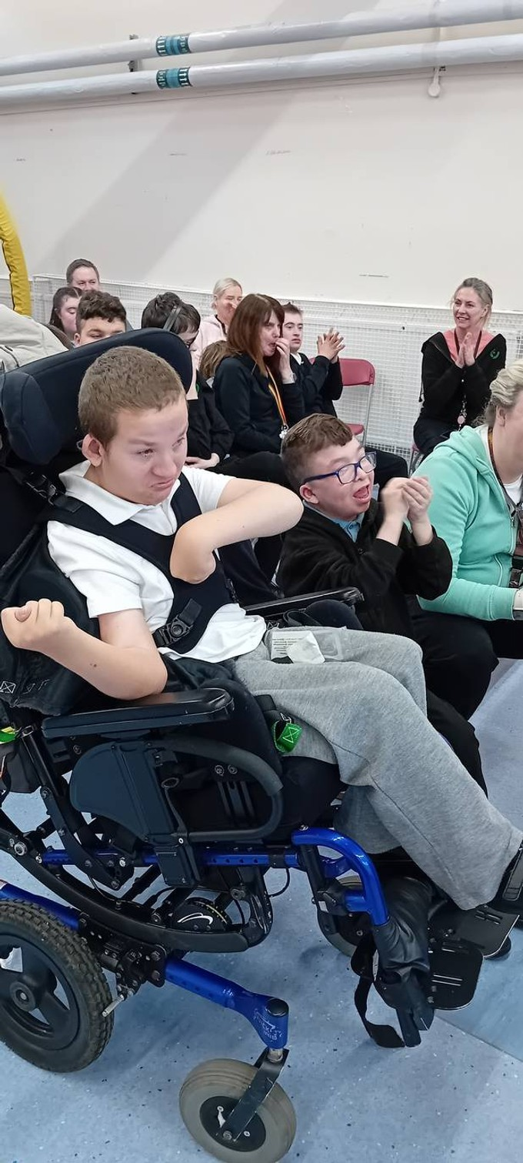

Partnerships
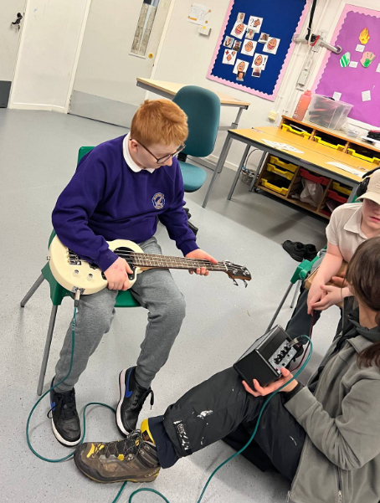We utilise and work with a range of local partners as well as the college to enrich the learning experiences of pupils. These include Scottish Rural Colleges Group, Reeltime Music, Windmill Cafe, Skills Development Scotland and Supported Employment. Our work with these partners also help us to ensure our young people have access to meaningful post-school destinations.

Wider Achievement
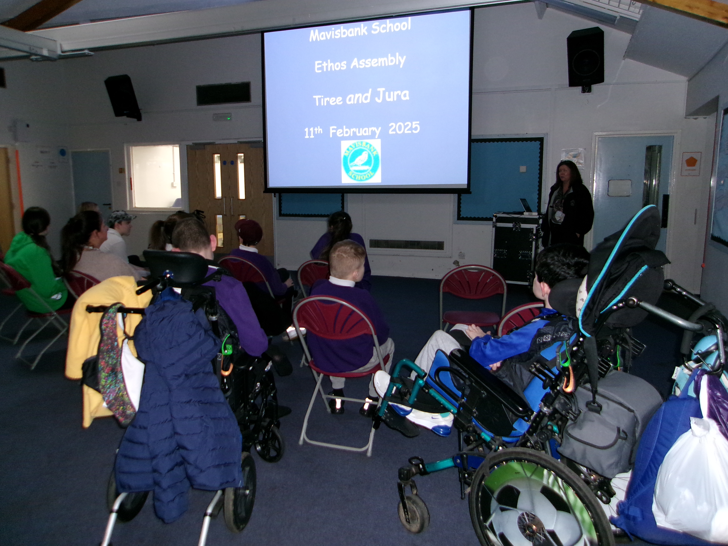The school recognises the importance of achievement and celebrating success at our school assemblies every week. Moving forwards pupil will be able to be involved in Duke of Edinburgh to develop our pupils holistically and provide recognition for their achievement through access to vocational programmes on offer at ‘Glenburn College’ experience.
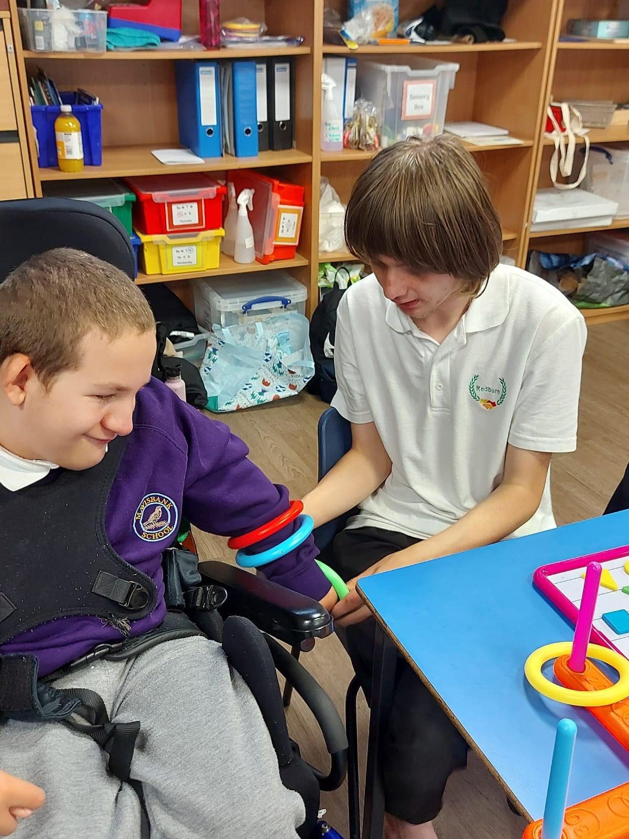

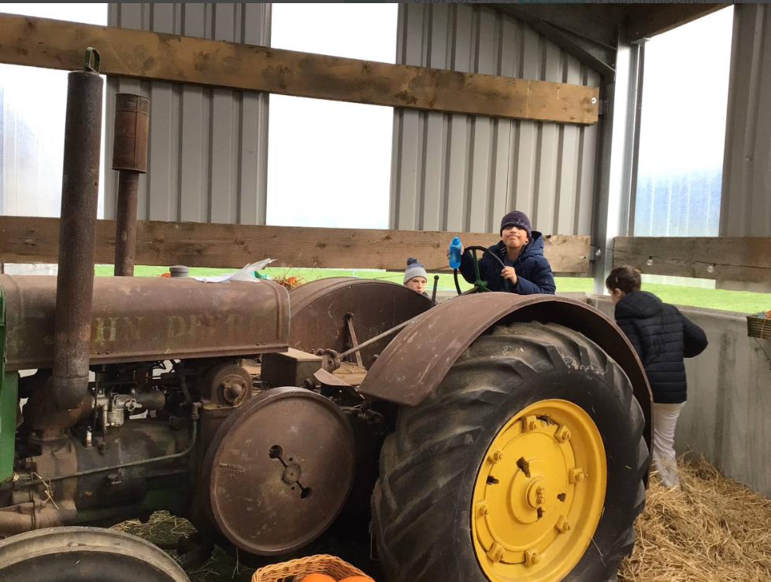Outdoor and Adventurous Opportunities
As part of our commitment to developing the health and well-being of all our pupils including opportunities to develop interdependence, the school utilises a range of facilities in the local community as well as participating in the active schools programme at Strathclyde Park.

National Qualifications
All pupils in the senior phase work towards SQA qualifications at National 1 and 2 levels. This provides them with an opportunity to focus their learning and develop skills and experiences which will benefit them in their post school destination.
We also undertake qualifications related to personal achievement, personal development and skills for work at National 1, 2 and where appropriate level 3. All of these support our young people to develop independence in skills for life.

Community Based Learning
As we develop our senior phase programme the focus of pupils will be centered around community developing experiences which will support them make choices about destinations post school. Links include the Airdrie Leisure Centre, Swimming at John Smith Pool, local supermarkets, cafes, stables and bowling alleys. In partnership with Glenburn the senior phase has a number of minibuses at their disposal which will ensure that they have regular access to these community resources.

Planning to meet individual needs
Mavisbank School complies with the Education (Additional Support for Learning) (Scot-land) Act 2004, as amended.

North Lanarkshire Council’s policy is contained within “Support for Learning Policy into Practice 2” a copy of which is available in the school. The school has a Support for Learning Policy, available from the school on request, which is consistent with North Lanarkshire Council’s guidelines.
Parents and pupils are an essential part of the assessment; planning, review processes, and your views will be actively sought.
Getting it Right for Me Plans (GIRFMe) enable staff to plan effectively for young people with Additional Support Needs.
Some young people may require significant support from education and at least one other agency, such as health, social work or a voluntary agency to help them meet their learning targets.
Where this support requires a high level of co-ordination the opening of a Co-ordinated Support Plan (CSP) may be considered.
A CSP may be initiated by the school or another agency.
Parents and young people can, if they wish, request that a CSP.be considered and would be involved in the process. Parents will receive letters from the Education Authority throughout the CSP process. Parents and young people will be invited to take part in multi- agency meetings and their views will be recorded in the plan.

Assessment and reporting
Assessment is an important part of the Curriculum for Excellence. At all levels, pupils’ progress is closely monitored by teachers and staff.
In turn, teachers and staff work with pupils to reflect on their results, looking at their strengths and learning needs, agreeing next steps and action based on these. As they progress, pupils become more involved in this process, as they develop the skills to make effective judgments on their own learning, developing personal expertise that will be important to them throughout life. Assessment also helps teachers plan learning experiences which are motivating and challenging. Children who may have additional support needs will be assessed using methods best suited to their individual requirements.

Additional Support Needs
Mavisbank School complies with the Additional Support for Learning (Scotland) Act 2004 as amended by the Additional Support for Learning (Scotland) Act 2009 and the Additional Support for Learning: Statutory Guidance 2017.

Getting it Right for Me (GIRFMe) plans enable staff to plan effectively for children and young people when interventions are requires to support their learning a improve outcomes. Parents/carers and pupils are an essential part of the assessment; planning and review processes and their views will be actively sought.
Some children and young people may require significant support from education and at least one other agency, such as health, social work and/or voluntary agency to help them meet their learning targets. Where this support requires a high level or co-ordination the opening of a Co-ordinated Support Plan (CSP may be considered. A CSP may be initiated by the school or another agency.
Parents/carers and young people can, if they wish, request that a CSP be considered and would be involved in the process.
Parents/carers will receive letters from the Education Authority throughout the CSP process.
Parents/carers and young people will be invited to take part in multiagency meetings and their views will be recorded in the plan.
Where more intensive support for a child or young person needs to be planned for, usually when a number of agencies are involved in supporting their wellbeing then a Child’s Plan may be developed. The plan will tell you what actions need to be taken and who will help with each action. It will usually be someone called a ‘Lead Professional’ who will have the job of making sure that the actions outlined in the plan take place and things get better for the child or young person.

Dispute Resolution
North Lanarkshire Council is committed to resolving any differences of views through discussion, dialogue and building on common ground.
If the matter cannot be resolved with the Education Authority you have the right to request mediation. An independent mediation service is available to parents/carers and young people through Resolve (see contact details at the back of this handbook). Mediation is free through Resolve and independent of the Education Authority.
In the event that a disagreement cannot be resolved through mediation, then an ap- plication for Independent Adjudication (see contact details at the back of this hand-book) can be made by parents/carers free of charge. The Independent Adjudicator will make recommendations to the Education Authority about how the dispute should be resolved.
The Additional Support Needs Tribunal has been set up to hear appeals made by parents/ carers or young people on the decisions made by the Education Authority relating to Co- ordinated Support Plans, ASN placing requests and post school transition. If you disagree with any decision relating to your child’s Co-ordinated Support Plan, either the creation of a CSP, or the content of it, you may be entitled to refer to the Tribunal.

School Improvement
All schools in Scotland are required to devise an improvement plan as a tool for managing change and implementing authority and national initiatives. This yearly plan is constructed as a result of consultation with staff and parents and submitted on an annual basis to North Lanarkshire Council (Education and Families) who annually monitor its progress. The school carries out an annual audit of the improvement plan towards the last term of the school year.

Our Improvement Plan Priorities are:

- Ensuring our universal wellbeing systems are robust through embedding nurture, resilience and trauma informed practices.

- All our staff are familiar with the current curricular model and pedagogical approaches to Numeracy.

- We ensure pupils rights are respected through embedding approaches in our practice in line with school values by increasing our knowledge and understanding of managing distressed and dysregulated behaviour.

Homework
We recognise that learning can happen anywhere. We welcome home partnership through learning in and outside of school. Ways that we do so include activity cards and story boxes for families to use at home. A valuable link between the school and home are the daily recorded messages shared during morning group as well as the daily diary on SWAY where teachers detail what your child has been involved in during the day as well as sharing photos.

Spiritual, Social, Moral and Cultural Values
Mavisbank is a non-denominational school. Throughout the year our pupils experience the sensory aspects of many World Religions through collegiately planned lessons. This is complemented with whole school monthly assemblies. Pupils are supported in their spiritual development and ceremonies as appropriate. The school undertakes trips to SPRED (Special Religious Education Development) sessions in Carfin.
The school also has two community leaders:

Rev.Ian MacDonald Fr. Desmond Keegan
Airdrie High Church St Edward’s RC Church
North Bridge Street Lady Anne Crescent
Airdrie Airdrie
01236 620107 01236 897557

Parents /Carers from ethnic minority religious communities may request that their children be permitted to be absent from school in order to celebrate recognised events from their religious calendar. Only written requests will be considered. Appropriate requests will be granted on not more than three occasions in any one school session and the pupil noted as an authorised absentee in the register.

Home / School Links
At Mavisbank we recognise and value the fact that parents / carers have a major role to play in the overall education of their child. In order to achieve parental co-operation and assistance, we welcome as many links as possible between home and school.

There are parents’/carers’ meetings planned across the year to discuss pupils’ individual plans and progress. A report is sent out annually and parents are invited in to discuss their child’s progress.

If you wish to talk to a member of staff, please call in advance. This will help us to ensure you have all the time you need to talk to staff, whilst ensuring the smooth running of the class and school. For security reasons, please report to reception on arrival. Thank you for your co-operation in ensuring the safety of your young person and of course; all our pupils.

Other communication with home is by means of telephone, text and email messages, SWAY diaries and newsletters, school website and personal messages relayed by the bus/taxi escorts. Parents are also free to consult any therapists by telephone and messages from therapists are often relayed in school communication.

At the beginning of the school year, parents/carers are invited to a review meeting to discuss educational targets, to share their own parental targets and discuss any therapy plans and input. Invitations are also extended at various times throughout the school year to attend Whole School events.

A Class Home / school communication is through the daily SWAY diaries. Through this the teacher keeps families up-to-date with pupil's progress, relates any concerns and shares successes.

Our school Community Learning and Development Officer meets parents regularly to empower people, individually and collectively, to make positive changes through learning in their lives, and in their communities.

The Parent Forum
Every parent or carer is automatically a member of the Parent Forum and will be consulted by the Parent Council as appropriate on relevant issues.

As a member of the Parent Forum you can expect to:
- Get information about what your young person is learning.
- Get information about events and activities at the school.
- Get advice/help on how you can support your child's learning.
- Be informed about opportunities to be involved in the school.
- Have a say in selecting the Parent Council which work represents all parents and carers at the school.
- Be invited to identify issues for the Parent Council to work on with the school.

The Parent Council

Parent Councils are composed of parents/ carers, staff and co-opted members with the head teacher as professional adviser. They have duties, rights and responsibilities in relation to the management of the school. The Parent Council meets monthly to support the school.

The Parent Council’s rights and duties include:
- Supporting the work of the school.
- Representing the views of parents.
- Consulting with parents and reporting back to the Parent Forum on matters of interest.
- Promoting contact between the school, parents, pupils, providers of post-school education and the wider community.
- Fundraising.
- taking part in the selection of senior promoted staff.
- receiving reports from the head teacher and education authority.
- receiving an annual budget for administration, training and other expenses.
- improving home school partnership and facilitating parental engagement.

Members of Parent Councils, on a voluntary basis, may also have an advisory role in decisions on placing requests by parents in respect of those situations where the number of placing requests for a particular school or for a particular stage in a particular school exceeds the number of places available.

Parent Council Members

Advisor Helen Delaney Head Teacher
Chairperson Lisa Young
Treasurer Debbie Drummond
Secretary Tracey Reilly
Parent member Claire Armitage
Parent member Joanne Aitken
Parent member Emma Shanahan
Parent member Marie Connolly
Parent member Victoria Black
Any parent / guardian of a pupil at the school can volunteer to be a member of the Parent Council or request items to be raised at the Parent Council meetings.

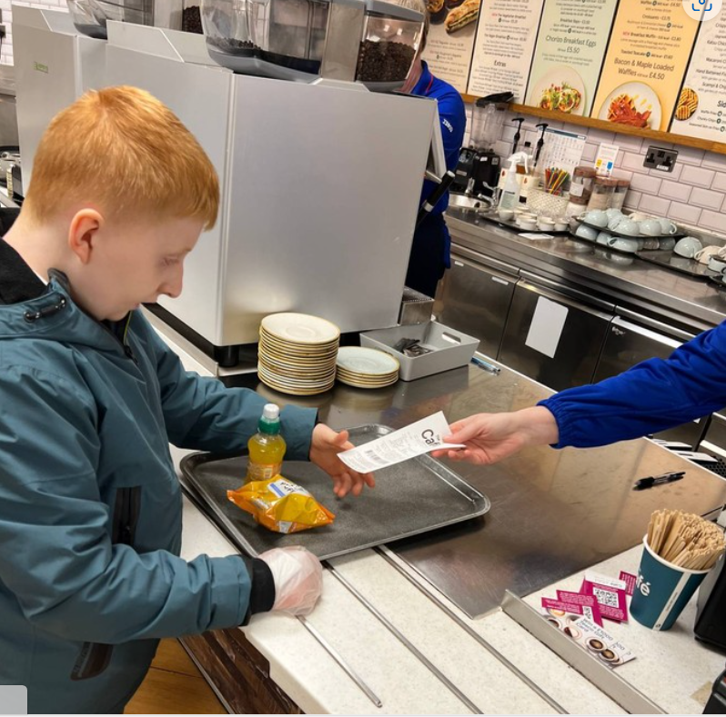School Resources

School Minibus

Our school minibus is extensively used by all pupils in the school to access the wider community. In so doing, our pupils can experience a wide range of opportunities to enhance emotional, personal and social development while at the same time gaining further knowledge of the world outside their immediate environment.

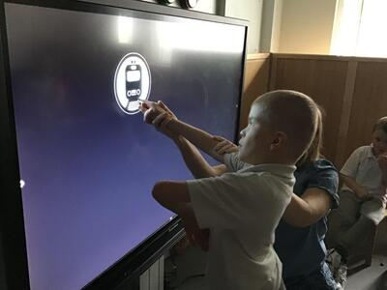ICT

The school has a wide range of information technology equipment available including single switch-activated devices and gadgets, V.I. equipment, and plasma screens - all used to allow access to, and enhance delivery of, the curriculum. We also have a Tilt ‘n’ Touch table, iPads, iPods, sound beams, interactive projector and eye gaze technology.

Outdoor Learning

Our Outdoor learning space is a wonderful resource with specific areas designed for different learning purposes, meet different pupil needs and appeal to the different senses. Outdoor learning at Mavisbank School is one of our school improvement priorities and we look to take every opportunity to develop learning experiences within our grounds.
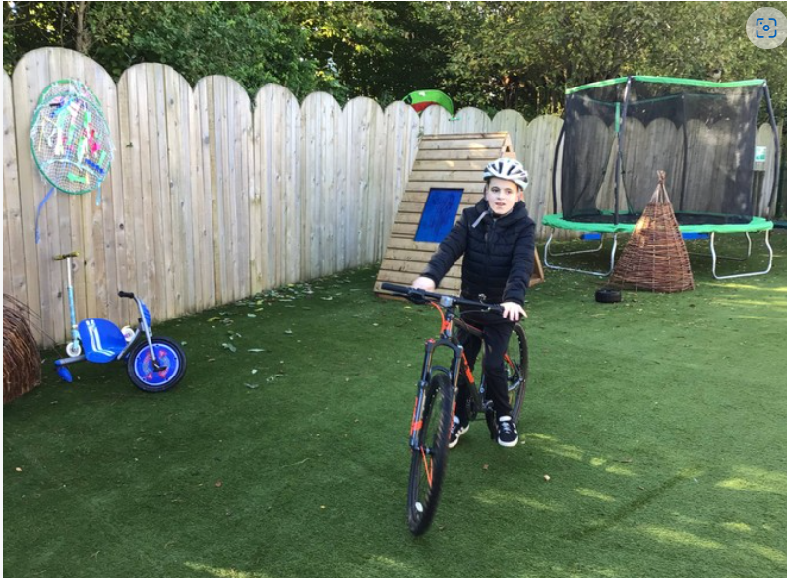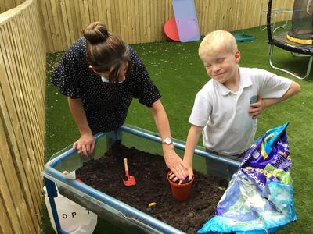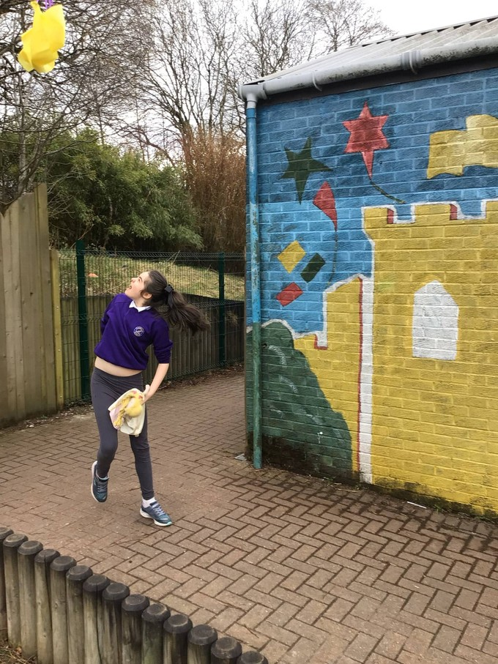

Our School in the Community

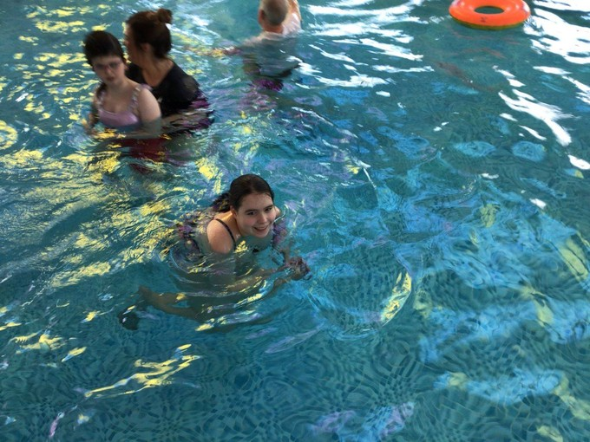

We take every opportunity to extend our highly positive ethos within the community. We support our young people to take part in a wide range of events and to learn to be at ease in the wider community. We have a number of links with local schools, religious bodies, organisations and businesses.

Freedom of Information

The Freedom of Information (Scotland) Act 2002 came into force in 2005. The Act allows anyone to ask for information held by the Council and imposes a time-scale of 20 working days for the Council to respond. To deal with Freedom of Information requests, the Council has appointed a Corporate Freedom of information Officer with the support of an officer in each Service. The Freedom of Information Co-ordinator can be contacted by telephone on 01698 302484.

General Data Protection Regulations (GDPR) Statement for Education

This statement explains when and why we collect personal information about you, your child or young person and how this information is used, the conditions under which it may be disclosed to others and how it is kept secure.

Who are we?
North Lanarkshire Council is a Local Authority established under the Local Government etc. (Scotland) Act 1994. Education and Families is located in Civic Centre Motherwell ML1 1AB.

Why do we need your personal information and that of your child or young person?
The Council has a legal obligation to deliver an effective education service to all children and young people in North Lanarkshire. In order to do this we need to collect personal information about children, young people and their families so that we can help them to learn and keep them safe.

Legal basis for using your information
We provide this service as part of our statutory function as your Local Authority. Processing your personal information is necessary for the performance of a task carried out in the public interest by the Council. If the information we have asked for is not provided, then we will not be able to provide this service to your child or young person.

Your personal information
Education uses the national IT system; SEEMiS, to store personal information electronically. We ask parents/carers during registration and enrolment to provide us with their child’s name, date of birth, gender, address, family contact details (phone/email). We require you to update this information as changes occur and annually.
We may also ask you for information about medical conditions, additional support needs, religion, and ethnicity. We may also record information you might wish to provide about your family circumstances.
We require this information to ensure children and young people are educated appropriately, supported, and that we take account of their health and wellbeing.
During a child’s journey through education a pupil’s record is kept, this core record is mainly paper based and is stored securely in the child or young person’s establishment. If the establishment has requested assistance from educational staff outwith the nursery or school, key staff from these services may also store information securely about your child or young person.

How will we use this information?
Your personal information will be used:
- To enrol your young person in school.
- To provide your young person with an appropriate education.
- For teaching, assessment and planning purposes and to monitor educational progress of young people.
- To support pupil learning, improve outcomes and identify where additional support is needed to help young people.
- To provide appropriate pastoral care to support health and wellbeing of young people.
- To keep young people safe.
- To maintain records e.g. of attendance, absence, attainment and behaviour of young people (including exclusions).
- To support young people during transitions when moving on from primary to secondary and when they move or leave school.
- To enable schools and establishments to process personal data in support of SQA and Further Education.
- To monitor and report on pupil attainment and achievement in relation to the national improvement framework issued by the Scottish Government.
- To assure the quality of our education services in line with national expectations from Education Scotland.
- When we require to contact you by post, email, telephone or text.

Who do we share information with?
To support your young person’s access to appropriate education and meet our legal obligations, personal information may be shared internally between Services of the Council. From time to time, education staff may also need to share information about you, your young person with another person from another agency or service, e.g. Social Work, Health.
We also share information with Scottish Government and bodies such as Education Scotland, Scottish Qualifications Authority (SQA), Skills Development Scotland and other organisations that support children and young people’s learning.
When a child or young person moves or transfers to another school the Council has an obligation to pass on information with regards to pupil records to the new school.
Only identified staff and those who require to have the information to enable them to carry out their job, will have access to your or young person’s information. We care about the information we hold in respect to the education of young people. We will keep this information safe and secure.

How long do we keep your information for?
We only keep personal information for the minimum period of time necessary. Sometimes this is set out in law, but in most cases it is based on what we need to fulfil our function. We maintain a ‘records retention and disposal schedule’ which sets out how long we hold different types of information for. You can view this on our website

Your rights under GDPR
You can:
- Request access to your information – you have the right to request a copy of the personal information that we hold about you, your child or young person. You can ask us to confirm what personal information is being used and with whom it has been shared with.
- Request a correction to your information – we want to make sure that all personal information is accurate, complete and up to date. Therefore you may ask us to correct any personal information that you believe does not meet these standards.
- Request the restriction of processing – this enables you to ask us to suspend the processing of personal information about you, your child or young person, for example if you want us to establish its accuracy or clarify the reason for processing it.
- Request the transfer – you can request the transfer of your information to another party.
- Deletion of your information – you have the right to ask us to delete personal information about you, your young person where:
- you think that we no longer need to hold the information for the purposes for which it was originally obtained.
- you have a genuine objection to our use of personal information.
- Or, use of personal information is contrary to law or our legal obligations.
If you wish to update any personal information, retrieve it, or have it removed from records please contact our head teacher or head of establishment in the first instance.

The Council’s Data Protection Officer
If you have any questions or are unhappy about the way that we use the personal information of your young person or yourself you can contact the Data Protection Officer.
Data Protection Officer (DPO)
Civic Centre,
Windmillhill Street,
Motherwell ML1 1AB
or by email to AITeam@northlan.gov.uk

The Information Commissioner
You also have the right to complain to the Information Commissioner about the way the Council has handled your rights, to enquire about any exercise of these rights or to complain about the way the Council has dealt with your rights (or any other aspect of data protection law).
Information Commissioner's Office,
45 Melville Street, Edinburgh EH3 7HL
or by e-mail to
casework@ico.org.uk

Transferring Educational Data about Pupils
Education authorities and the Scottish Government
Education Portfolio (SGEP) exchange data about pupils either on paper or electronically through the ScotXed programme.
The data collected and transferred covers areas such as date of birth, postcode, registration for free-school meals, whether a pupil is looked after by his/her local authority, additional support needs including disability, attendance, absence and exclusions from school. Pupil names and addresses are collected by the school and the council but they are not passed to SGEP. The postcode is the only part of the address that is transferred. Data is held securely and no information on individual pupils can be published by SGEP
Providing national identity and ethnic background data is entirely voluntary. You can choose the ‘not disclosed’ option if you do not want to provide this data. However, we hope that the explanations contained in this message and on our website will help you understand the importance of providing the data.

Why do we need your data?
In order to make the best decisions about how to improve our education service, SGEP and education authorities need accurate, up-to-date data about our pupils. We are keen to help all our pupils do well in all aspects of school life and achieve better educational outcomes. Accurate and up-to-date data allows SGEP, education authorities and schools to:
plan and deliver better policies for the benefit of all pupils,
plan and deliver better policies for the benefit of specific groups of pupils,
better understand some of the factors that influence pupil attainment and achievement, target resources better.

Your GDPR rights
The collection, transfer, processing and sharing of ScotXed data is done in accordance with the GDPR. We also comply with the National Statistics Code of Practice requirements and other legislation related to safeguarding the confidentiality of data. GDPR gives you the right to know how we will use your data. This message can give only a brief description of how we use data. Fuller details of the uses of pupil data can be found on the ScotXed website: (www.scotxed.net)
SGEP works with a range of partners including Education Scotland and the Scottish Qualifications Authority. On occasion, we will make individual data available to partners and also academic institutions to carry out research and statistical analysis. In addition, we will provide our partners with information they need in order to fulfil their official responsibilities. Any sharing of data will be done under the strict control and prior agreement of the Data Access Panel in SGEP, which will ensure that no subject specific data will be made public as a result of the data sharing and that such data will not be used to take any actions in respect of an individual.
Further details are available on:
https://www2.gov.scot/Topics/Statistics/ScotXed/PrivacyInformation

Any Concerns
If you have any concerns about the ScotXed data collections you can email school.stats@scotland.gsi.gov.uk or write to:
The ScotXed Support Office,
SEGP,
Area 1B,
Victoria Quay,
Leith, EH6 6QQ.

Alternative versions of this page are available, on request from the ScotXed Support Office, in other languages, audio tape, braille and large print.

Want more information?
Further details about ScotXed data exchanges are available on the ScotXed website: http://www.scotxed.net .

Child Protection

Every adult in Scotland has a role in ensuring all our children and young people
are safe and protected from harm at all times and in all situations.

The Head Teacher and Depute Head Teachers are responsible for the schools actions in response to Child Protection concerns.

If there are any Child Protection concerns the Head Teacher or the Child Protection Co-ordinator will follow North Lanarkshire Child Protection Procedures and Guidelines

Child Protection Co-ordinators are: Helen Delaney, Jacqueline McLaughlin and Eileen Smith
Telephone Number: 01236 632108

The council also has a responsibility under the Adult Support and Protection (Scotland) Act 2007 for the protection and support of adults at risk of harm.

The Head Teacher and Depute Head Teachers are responsible for the school’s actions in response to Adult Protection.

Adult Protection
The Council has responsibility under the Adult Support and Protection (Scotland) Act 2007 for the protection and support of adults at risk of harm within North Lanarkshire. Its employees therefore have the responsibility to ensure the welfare of all adults at risk of harm with whom they come into contact, as well as providing the highest possible standard of care for some of the most vulnerable members of our society. If there are any Adult Protection concerns the Head Teacher or the Adult Protection Co-ordinator will follow North Lanarkshire Adult Protection Procedures and Guidelines.

Adult Protection Co-ordinators are: Helen Delaney, Jacqueline McLaughlin and Eileen Smith Tel: 01236 632108

Attendance at School

Section 30 of the 1980 Education Act lays a duty on every parent / carer of a young person of 'school age' to ensure that they attend school regularly. Attendance must be recorded by the school twice a day, morning and afternoon.

Regulation 7 of The Education (School and Placing Information) (Scotland)Amendment, Etc. Regulations 1993 requires each child's absence from school to be recorded in the school register as authorised or unauthorised, as defined by the Scottish Government.

At the start of each school session, parents/carers will be asked to provide contact details including at least one emergency contact number, including where possible, a number that will accept a text message. Parents/carers are required to inform the school if these contact details change during the course of the year.

Parents and carers are asked to inform the school if a pupil is unable to attend from the start of the school day on the first day of absence. Failure to do so will result in school staff accessing all contact numbers provided for the child and may result in the school calling in order to discuss the absence.

Parents and carers are also asked to inform the school either by letter or telephone if their child is likely to be absent for some time.

Extended Leave with Parental Consent

Where most family holidays will be recorded as unauthorised absence (see above), extended leave with parental consent will not be considered the same as a family holiday. Leave in such circumstances will be authorised under circumstances such as:

- Extended overseas educational trips not organised by the school.
- Short-term parental placement abroad.
- Family returning to its country of origin (to care for a relative, or for cultural reasons).
- Leave in relation to the children of travelling families.

Family Holidays during Term Time

Every effort should be made to avoid family holidays during term time as this both disrupts the child's education and reduces learning time. Parents/Guardians should inform the school by letter of the dates before going on holiday.

Absences will be classified as authorised only in exceptional circumstances. Such circumstances may include a family holiday judged to be important to the well-being and cohesion of the family, following serious or terminal illness, bereavement or other traumatic event.

A family holiday classified under the ‘authorised absence' category will not include such reasons as:

- The availability of cheap holidays.
- The availability of desired accommodation.
- Poor weather experienced during school holidays.
- Holidays which overlap the beginning or end of term.
- Parental difficulty obtaining leave (except in cases where evidence is provided by the employer that it cannot accommodate leave during school holidays without serious consequences).

Family holidays with the above similar characteristics will be classified as unauthorised absence. Where the head teacher's prior agreement has not been sought the absence will automatically be classed as unauthorised.

Exceptional Domestic Circumstances

Parents/ carers may request permission for such leave in writing and the school may authorise such requests under the following circumstances:

- The period immediately after an accident or illness.
- A period of serious or critical illness of a close relative.
- A domestic crisis which causes serious disruption to the family home causing temporary relocation.

It should be emphasised that the school investigates unexplained absence, and that the authority has the power to write to, interview or prosecute parents, or to refer pupils to the Reporter of the Children's Panel, if necessary.

Parents / Carers are informed in writing if attendance is causing concern and in some cases, will be invited to meet with the Head Teacher to discuss and set targets for improving attendance at school

Clothing and Uniform

All North Lanarkshire schools must have a dress code which encourages pupils to dress in a way which is appropriate to attendance at school. This dress code must not lead to direct or indirect discrimination on the grounds of race, religion, gender or disability. Prior to drawing up the dress code, the parents and staff were fully consulted. It is the expectation of Education and Families that parents will be keen to support the dress code and written agreement may be sought.

Clothing which is unacceptable in school under any circumstance includes items which:

- Could potentially encourage factions (eg football colours).
- Could cause offence (eg anti-religious symbolism or political slogans).
- Could cause health and safety difficulties such as loose fitting clothing dangling earrings and other potentially dangerous jewellery.
- Are of flammable materials which may be a danger (eg shell suits).
- Could cause damage to flooring.
- Carry advertising in particular for alcohol or tobacco.
- Could be used to inflict damage on other pupils or to be used by others to do so.

Parents in receipt of a clothing grant from the Council will be encouraged to purchase items which are in accordance with the school dress code. Approval of any requests for such grants in other circumstances are at the discretion of the Executive Director of Education and Families. Information and application forms may be obtained from any school or First Stop Shops. Or downloaded from www.northlan.gov.uk. Parents are entitled to receive a clothing grant if they are in receipt of any of the following benefits: Income Support, Job Seekers allowance (income based), Employment and Support Allowance (income related) Universal Credit (with an income below £660 per month, housing benefit, council tax reduction. (Please note that single person’s discount/council tax exemption is not council tax reduction). The deadline for school clothing grants is 31 March 2023.

Whilst in general terms it would not normally be the policy of the authority to exclude a pupil from school solely on the basis of his/her dress, persistent refusal to respond to a reasonable dress code may be deemed as a serious challenge to the head teacher’s authority and to be detrimental to the wellbeing of the whole school community. In such circumstances a head teacher may justify the use of the school discipline procedure.
The council wishes to minimise claims arising from the loss of pupils clothing and /or personal belongings. Parents / guardians are asked to assist in this by ensuring that valuable items and unnecessarily expensive items of clothing, jewellery, etc are not brought to school. Parents should note that any claims submitted to cover the loss of such things are likely to be met only where the authority can be shown to have been negligent.

Meals

All children attending an ASN school are entitled to a meal without charge.

Special Diet Procedures

Diets required as a result of a medical condition (a medically prescribed diet e.g. coeliac disease, diabetes, PKU, food allergy or intolerance) can be provided in school by our catering staff. A medically prescribed diet form 1a must be completed and signed by the child’s Registered Dietician or General Practitioner. Procedures and forms can be accessed online through North Lanarkshire Council’s website, by the school, the catering service or also in some cases by the child’s dietitian or doctor. For some conditions (PKU, coeliac) parents/carers may be asked to supply prescription foods or attend a meeting to discuss the child’s dietary requirements.
For information; a vegetarian meal option is offered on a daily basis.
Some children with additional support needs may require food to be adapted to an appropriate texture and consistency. In this instance the child’s Registered Dietician or Speech and Language Therapist will liaise with the Head Teacher and school catering service including the nutritionist to ensure appropriate food provision. In this case a form will still need to be signed by a medical professional including a Speech and Language Therapist. An ‘Eating and Drinking Profile’ will be completed outlining the pupil’s requirements and staff will receive training individual to that particular pupil and their needs.

It is important that the Head Teacher is aware of any medically prescribed diets within the school and, on occasion, parent/carers may be asked to attend a meeting.
Forms that have not been signed by a medical professional will be rejected. The form will be returned to the parent along with a letter stating the reason for the refusal and also they will be issued with a new form.
Any change in the child’s dietary requirements must be advised through a Registered Dietitian or Medical Practitioner to the Facilities Support Services (FSS) Nutritionist. When children move to a High School or change schools FSS will need to be informed as soon as possible. Special Diets such as Vegan and ethnic diets can also be accommodated. In this case a form b should be completed and can be signed by the parent.
All completed forms should be returned to the email specialdiet@northlan.gov.uk

Placing Requests

You have the right to make a placing request for your child to be educated in a school other than the local school.

In December each year, the authority will advertise its arrangements for placing requests.
There are sound educational reasons for trying to ensure that the transfer or admission of children to a school takes place at the start of a school session. Other than those who are moving home to a new area, parents/carers are advised to time any placing requests so that they take effect from the beginning of the new school session.

Every effort will be made to try to meet the parental wishes, but you should note that it is not always possible to grant every placing request to a particular school.

Further information on placing requests and procedures is available from the school or the council’s website.
Parents/carers and Young People have a right under the Additional Support for Learning Act 2009 to make a placing request for their child or young person to attend a ASN school or ASN class managed by the home authority. In the event of a successful placing request the authority are not required to provide transport. The Act also enables parents/carers and young people to make a placing request to attend a school/establishment belonging to another authority.

Please note that the council does not provide transport for those pupils in receipt of a placing request other than in exceptional circumstances.

Transport Arrangements

The Council has a policy of providing free transport to pupils who live more than one mile from their catchment school by the shortest suitable walking route. This policy is more generous than the law requires. This provision may be reviewed at any time. Parents/carers who consider they are eligible can apply on the council website. Applications should be submitted by the end of February for those pupils beginning school in August to enable the appropriate arrangements to be made.

Applications may be submitted at any time throughout the year but may be subject to delay whilst arrangements are made. There is discretion in certain circumstances to grant privilege transport for pupils to travel in transport provided by the authority, where spare places are available and no additional costs are incurred.

Where free transport is provided it may be necessary for pupils to walk a certain distance to the vehicle pick-up point. Walking distance in total, including the distance from home to the pick-up point and from the drop-off point to the school in any one direction, will not exceed the authority’s limits (see above paragraph).

It is the parent’s/carer’s responsibility to ensure their child arrives at the pick-up point in time. It is also the parent’s/carer’s responsibility to ensure the child behaves in a safe and acceptable manner while boarding, travelling in and alighting from the vehicle. Misbehaviour could result in a loss of the right to free transport.

The council does not provide transport for those pupils in receipt of a placing request other than in exceptional circumstances.
Transport for all pupils attending Mavisbank School is provided by North Lanarkshire Council. All children are supported by an escort during transit and the escort will follow NLC procedures in the event of an incident in transit. For the very few children who have been assessed by NHS as requiring specialist medical intervention during transit escorts will be trained appropriately. This will be discussed as part of Transition Planning or if there are any changes to a child’s health. Details of any interventions required will be contained within the Child’s Health Care Plan Information sheet.

Information in Emergencies
We make every effort to maintain a full educational service, but on some occasions circumstances arise which lead to disruption. For example, schools may be affected by severe weather, temporary interruption of transport, power failures or difficulties of fuel supply. In such cases we shall do all we can to let you know about the details of closure or re-opening. We shall keep you informed by using letters, notices in local shops and community centres announcements in the press on local radio, on the NLC website and Groupcall.

Medical and Health Care

Oral health educators visit the school on a regular basis.

The school has very detailed policies on procedures to be followed if a child takes unwell in school. Action taken in these circumstances may include observation/treatment within school, asking parent to collect child or sending the child to hospital.

Parents are required to provide detailed written information as to their child’s medical conditions and medication requirements and must also inform the school in writing of any changes to these requirements.
On occasions it may be necessary for a child to be taken home due to ill health. In all classes the school will make every effort to contact a parent in the first instance. If a parent is not available, the school will contact the child’s emergency contact for the necessary arrangements to be made. It is essential for the school to have an emergency contact who can be reached to take the child home if necessary

Important Addresses

Chief Executive: Des Murray
Executive Director Education and Families: Andrew McPherson
Senior Education and Families Manager: Alan Henry
Councillors for Airdrie Central: Jim Logue [loguej@northlan.gov.uk], Nancy Pettigrew [pettigrewna@northlan.gov.uk], David Stocks [stocksd@northlan.gov.uk],
Trevor Douglas [douglastr@northlan.gov.uk].
Councillors are based at Civic Centre, Windmillhill Street, Motherwell ML1 1 AB.

Community Learning and Development Office -

Chapelside Community Centre Waddell Street Airdrie 01236 751538

Enquire – the Scottish advice service for additional support for learning. Operated by Children in Scotland, Enquire offers independent confidential advice and information on additional support for learning.
Tel.: 0345 123 2303
Email: info@enquire.org.uk
Website: www.enquire.org.uk for parents and practitioners
www.enquire.org.uk/yp for children and young people

Enquire also provide a range of factsheets as well as information around independent adjudicators:
https://enquire.org.uk/3175/wp-content/uploads/2020/02/independent-adjudication.pdf

Reference to Additional Support Needs Tribunal (Scotland)
ASNTS
Health and Education Chambers
First Tier Tribunal for Scotland
Glasgow Tribunals Centre
20 York Street
Glasgow G2 8GT tel : 0141 302 5860
E-mail: ASNTribunal@scotcourtstribunals.gov.uk
Website: https://www.healthandeducationchamber.scot/additional-support-needs/12

NHS Lanarkshire Health Centres

Airdrie Health Centre | 01698 753200
Bellshill Health Centre | 01698 575700
Coatbridge Health Centre | 01236 432200
Cumbernauld - Kildrum Health Centre | 01236 721354
Cumbernauld - Condorrat Health Centre | 01236 733221
Kilsyth Health Centre | 01236 801677
Motherwell Health Centre | 01698 242610
Wishaw Health Centre | 01698 361716

Social Work Offices:

Airdrie  Coats House  Gartlea Road  Airdrie  ML6 9JA | 01236 757000
Bellshill  303 Main Street  Bellshill  ML4 1AW | 01698 346666
Coatbridge  Municipal Buildings  Kildonan Street  Coatbridge  ML5 3BT | 01236 622100
Cumbernauld/Chryston  Bron Way  Town Centre  Cumbernauld  G67 1DZ | 01236 638700
Motherwell  Scott House  73/77 Merry Street  Motherwell  ML11 1JE | 01698 332100
Wishaw/Shotts  Kings House  King Street  Wishaw  ML2 8BS | 01698 348200

Community Learning and Development

Airdrie CLD Locality Office  Chapelside Community Centre  Waddell Street  Airdrie ML6 6DL | Tel: 01236 638538  E: CLD-Airdrie@northlan.gov.uk
Bellshill CLD Locality Office  Orbiston Business Centre  Babylon Drive  Orbiston  Bellshill ML4 2DN | Tel: 01698 274666  E: CLD-Bellshill@northlan.gov.uk
Coatbridge CLD Locality Office  9 Old Monkland Road  Coatbridge ML5 5EA | 01236 638470  E: CLD-Coatbridge@northlan.gov.uk
Cumbernauld/ Kilsyth CLD Area Office  Baird Memorial Primary School  6 Avonhead Road  Condorrat  Cumbernauld G67 4RA | Tel: 01236 638384  E: CLD-North@northlan.gov.uk
Motherwell CLD Locality Office  Our Lady's High School  Dalziel Drive  Motherwell ML1 2DG | Tel: 01698 403838  E: CLD-Motherwell@northlan.gov.uk
Wishaw/Shotts CLD Locality Office  Coltness High School  Mossland Drive  Wishaw ML2 8LY | Tel: 01698 274331  E: CLD-Wishaw@northlan.gov.uk

USEFUL PHONE NUMBERS

School 01236 632108

Physiotherapists 01698 753737

Occupational Therapist 01236 753707

Speech & Language Therapist 01236 772280

Educational Psychology 01236 856200

Gaelic Provision
Opportunities for Gaelic provision in North Lanarkshire are available at Tollbrae Nursery Class and Condorrat Primary School.

Qualifying Statements

Although this information is correct at time of printing there could be changes affecting any of the matters dealt with in the document before the commencement or during the course of the school year in question and in relation to subsequent school years.
Education Authorities are required by law to issue a copy of the school handbook to certain parents/carers in December each year.

It details the current policies and practices of both the council and the school.

