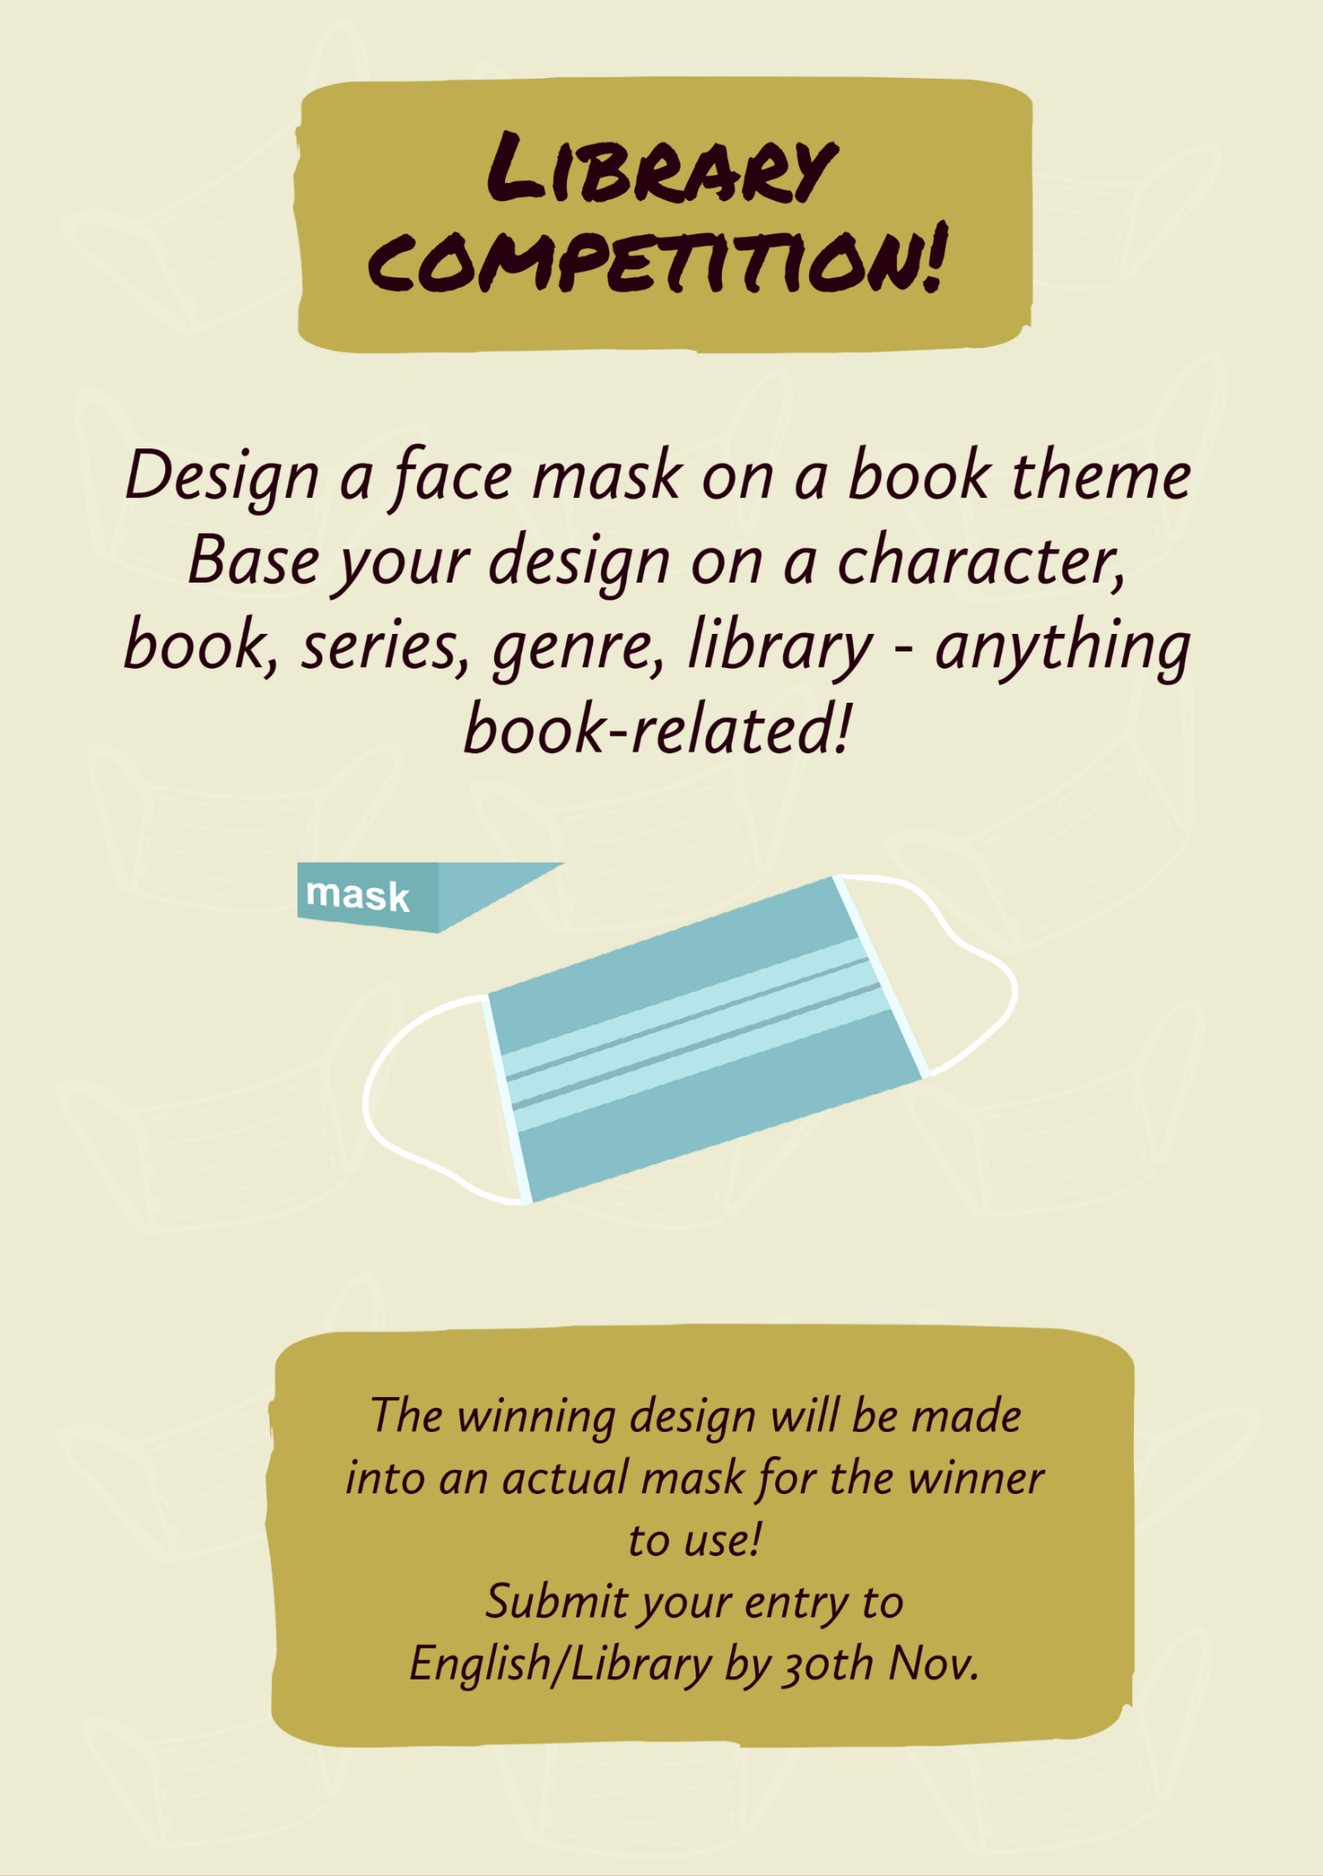
Book Week Scotland 2020
Book Week Scotland 2020 Library competition

Name ……………………………………………………………………..……. English teacher………………………….……………………….
Your design should be book-related. Your face mask could

- be about a fictional character
- be about a book, series or genre
- be about a favourite author
- show a few of your favourite books
- promote the library
- promote reading
Submit your entry by 30th November

