If you love… |  | If you love…
Bellshill Academy Library – recommended reading |  | Finished the last page of a great book? And no idea what to read next? You could try a book with a similar style, feel or setting. These recommendations are similar to some of our more popular books.  Keen to read one of the books? Use the online form to request it or the online library catalogue to reserve it. Or see Ms Boyd in the library!
 |  |  | October 2020

If you love… |  | CHERUB
Bellshill Academy Library – recommended reading | 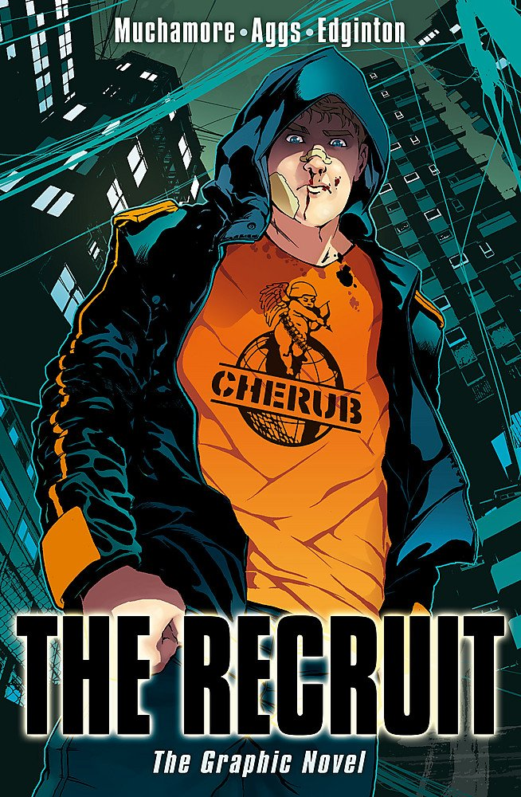 | …then try these:  Black op  by Tom Palmer (Sports zone in Fiction)  Look into my eyes  by Lauren Child (Fiction under CHI)  Silverfin  by Charlie Higson (Fiction & Graphic novel)  Stormbreaker  by Anthony Horowitz (Fiction & Graphic novel)  Cross my heart and hope to spy  By Ally Carter (Young Adult spinner)

If you love… |  | The Hunger Games
Bellshill Academy Library – recommended reading | 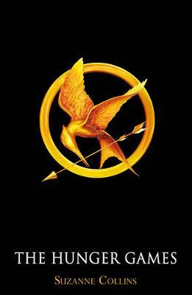 | … then try these:  Children of Icarus  by Caighlan Smith *  The maze runner  by James Dashner *  Gone  by Michael Grant *  The extinction trials  by S.M. Wilson (Fiction under WIL)  Divergent  by Veronica Roth *
 |  |  | * Found in the Young Adult spinners

If you love… |  | Diary of a wimpy kid
Bellshill Academy Library – recommended reading | 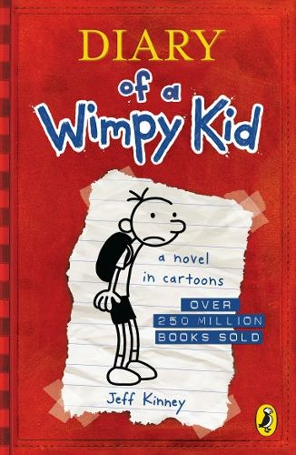 | … then try these:  The world of Norm  by Jonathan Meres  The brilliant world of Tom Gates  by Liz Pichon  Double dork diaries  by Rachel Renee Russell  The private blog of Joe Cowley  by Ben Davis  Donut diaries of Dermot Mulligan  by Anthony McGowan
 |  |  | All found in the Humour zone in Fiction

If you love… |  | Ultimate football heroes
Bellshill Academy Library – recommended reading | 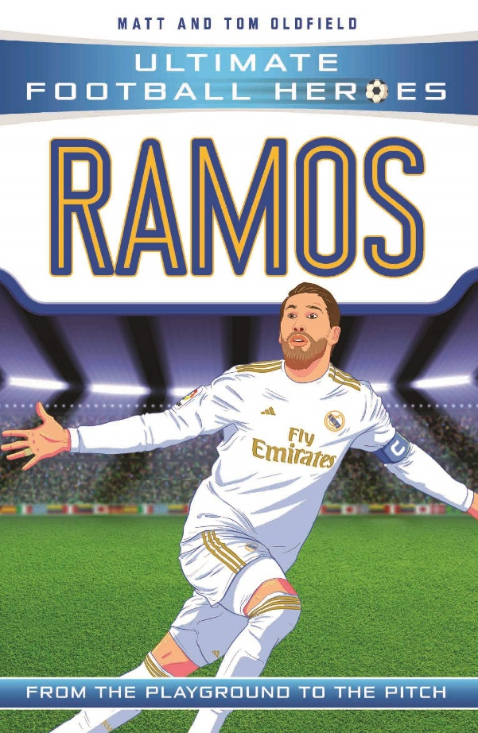 | … then try these:  Kick off  by Dan Freedman (Sports zone in Fiction)  Booked  by Kwame Alexander (Sports zone in Fiction)  Football star players  by Alex Bellos (Non-Fiction at 796.334)  Rok of the reds  by John Wagner (Graphic novel)  Foul play  by Tom Palmer (Sports zone in Fiction)

If you love… |  | Uglies
Bellshill Academy Library – recommended reading |  | … then try these:  Flawed  by Cecelia Ahern *  Only ever yours  by Louise O’Neill *  Matched  by Ally Condie *  The declaration  by Gemma Malley *  Brave new world  by Aldous Huxley (Senior Fiction)
 |  |  | * Found in the Young Adult spinners

If you love… |  | The boy in the  striped pyjamas
Bellshill Academy Library – recommended reading | 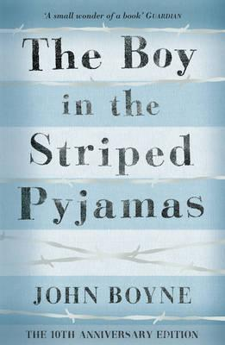 | … then try these:  The diary of a young girl  by Anne Frank  (Non-Fiction at 920 FRA or Graphic Novel)  Once  by Morris Gleitzman (Fiction under GLE)  Maus: a survivor’s tale  by Art Spiegelman (Graphic Novel)  Orphan monster spy  by Matt Killeen (Fiction under KIL)  When Hitler stole pink rabbit  by Judith Kerr (Fiction under KER)

If you love… |  | War horse
Bellshill Academy Library – recommended reading | 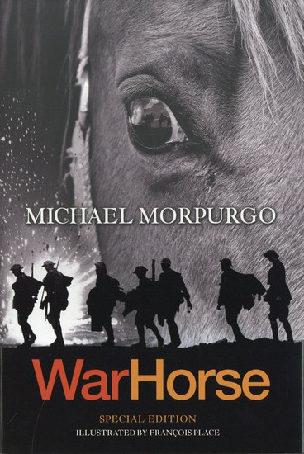 | … then try these:  Line of fire: diary of an unknown soldier  by Barroux (Graphic Novel)  Valentine Joe  by Rebecca Stevens (Fiction under GLE)  Soldier’s game  by James Killgore (Fiction under KIL)  Stay where you are and then leave  by John Boyne (Fiction under BOY)  The skylarks’ war  by Hilary McKay (Fiction under MCK)

If you love… |  | One of us is lying
Bellshill Academy Library – recommended reading | 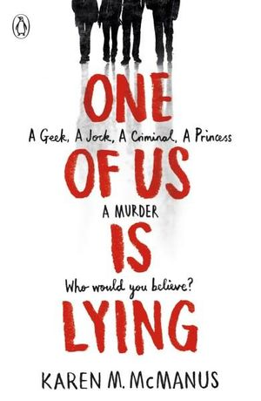 | … then try these:  Dead popular  by Sue Wallman (Young Adult spinner)  Running girl  by Simon Mason (Fiction under MAS)  S.T.A.G.S  by M.A.Bennett (Young Adult spinner)  Butterfly grave  by Anne Cassidy (Young Adult spinner)  Murder in midwinter  by Fleur Hitchcock (Fiction under HIT)

If you love… |  | The hobbit
Bellshill Academy Library – recommended reading | 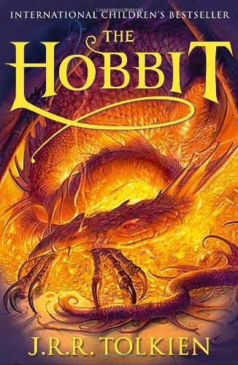 | … then try these:  Northern lights  by Philip Pullman (Fiction under PUL or  Graphic novel)  Children of blood and bone  by Tomi Adeyemi (Young Adult spinner)  The legend of Zelda  by Akira Himekawa (Graphic Novel)  The girl of ink & stars  by Kiran Millwood Hargrave (Fiction under HAR)  First aid for fairies & other fabled beasts by Lari Don (Fiction under DON)

If you love… |  | Girl, missing
Bellshill Academy Library – recommended reading | 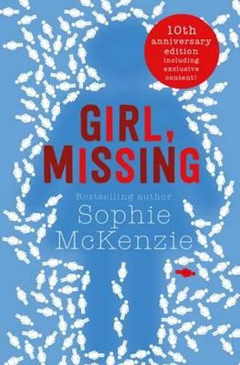 | … then try these:  Moth girls  by Anne Cassidy (Fiction under CAS)  Missing  by Catherine MacPhail (Fiction under MAC)  Wolf Hollow  by Lauren Wolk (Fiction under WOL)  The safest lies  by Megan Miranda (Fiction under MIR)  Between the lies  by Catherine MacPhail (Fiction under MAC)

If you love… |  | Geek girl
Bellshill Academy Library – recommended reading | 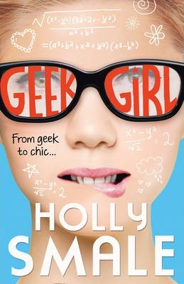 | … then try these:  Cherry crush  by Cathy Cassidy (Fiction under CAS)  Chinglish: an almost entirely true story  by Sue Cheung (Fiction under CHE)  Angus, thongs and full-frontal snogging by Louise Rennison (Fiction under REN)  Girl online  by Zoe Sugg (Fiction under SUG)  Popular: a memoir  by Maya Van Wagenen (Non-Fiction at 920)

If you love… |  | The fault in our stars
Bellshill Academy Library – recommended reading | 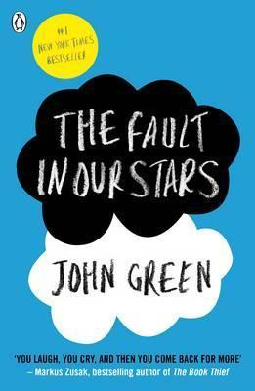 | … then try these:  Five feet apart  by Rachael Lippincott  History is all you left me  by Adam Silvera  Me and earl and the dying girl  by Jesse Andrews  Eleanor & Park  by Rainbow Rowell  Everything, everything  by Nicola Yoon
 |  |  | All found in the Young Adult spinners

If you love… |  | City of bones
Bellshill Academy Library – recommended reading | 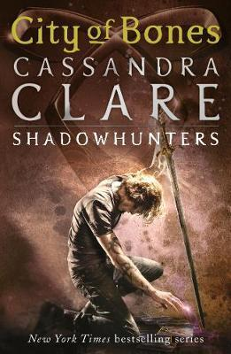 | … then try these:  Beautiful creatures  by Kami Garcia  Black snow falling  by L.J.MacWhirter  Ferryman  by Claire McFall  Throne of glass  by Sarah J. Maas  Shiver  by Maggie Stiefvater
 |  |  | All found in the Young Adult spinners

If you love… |  | The hate U give
Bellshill Academy Library – recommended reading | 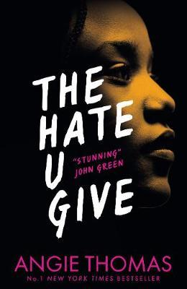 | … then try these:  Dear Martin  by Nic Stone *  The poet X  by Elizabeth Acevedo *  Rebound  by Kwame Alexander (Sports zone in Fiction)  Long way down  by Jason Reynolds *  Orangeboy  by Patrice Lawrence *
 |  |  | * Found in the Young Adult spinners

If you love… |  | Harry Potter
Bellshill Academy Library – recommended reading | 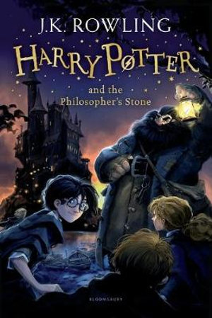 | … then try these:  Miss Peregrine's home for peculiar children  by Ransom Riggs (Fiction under RIG)  The Nowhere emporium  by Ross MacKenzie (Fiction under MAC)  The crooked sixpence  by Jennifer Bell (Fiction under BEL)  Northern lights  by Philip Pullman (Fiction & Graphic novel)  Howl’s moving castle  by Diana Wynne Jones (Fiction under JON)

