Horror stories |  | Horror stories
Bellshill Academy Library – recommended reading |  | Do you dare to be scared by these horrific titles….?  Below are some suggestions for horror fans. Ranging from creepy to truly terrifying, there should be something here to tempt you.  Desperate to read one of the books? Use the online form to request it or the online library catalogue to reserve it. Or see Ms Boyd in the library!

Horror stories |  | Frozen Charlotte
Bellshill Academy Library – recommended reading | 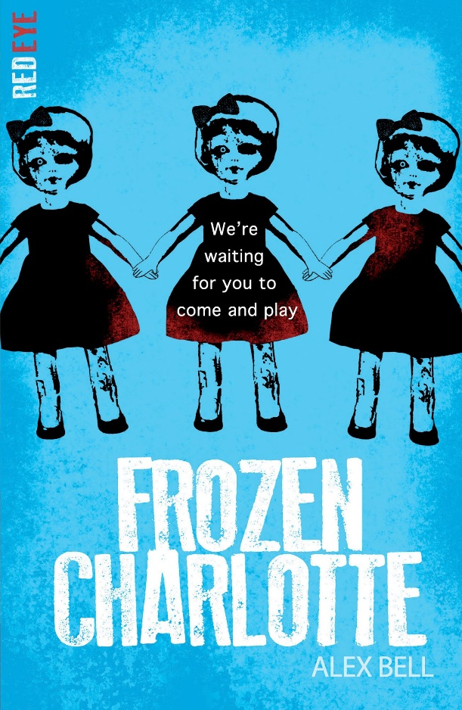 | By Alex Bell  (Young Adult spinner)  Dunvegan School for Girls has been closed for many years. Converted into a family home, the teachers and students are long gone. But they left something behind...  Sophie arrives at the old schoolhouse to spend the summer with her cousins. Brooding Cameron with his scarred hand, strange Lillias with a fear of bones and Piper, who seems just a bit too good to be true. And then there's her other cousin. The girl with a room full of antique dolls. The girl that shouldn't be there. The girl that died.
 |  | The Library also has Charlotte says, set before the events in Frozen Charlotte.

Horror stories |  | Chill
Bellshill Academy Library – recommended reading | 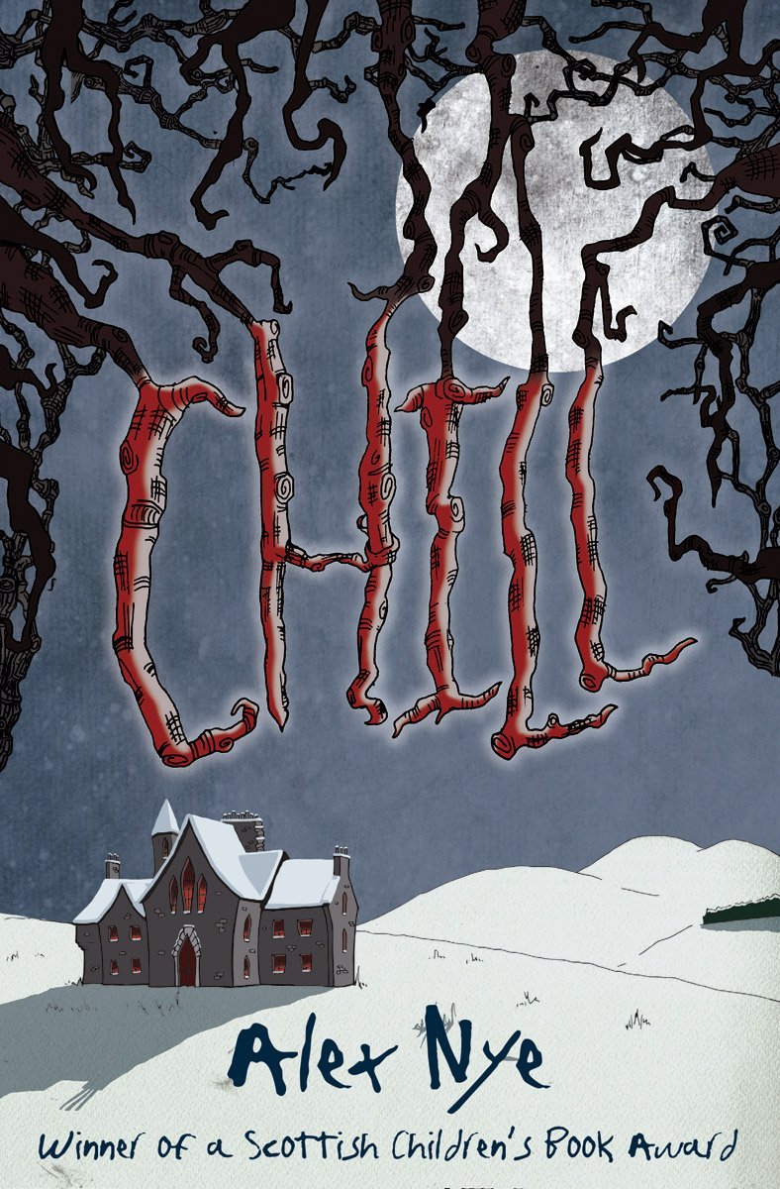 | By Alex Nye  (In Fiction Zone under NYE)  The Morton family are cursed. Their house is haunted by eerie footsteps, a ghostly figure and whispers in the night.  Together, Samuel and Fiona discover a deadly tale of betrayal, revenge, and a family secret long forgotten.  Trapped by snow and ice, can they escape the chill or will the Morton children be doomed to repeat the past forever?
 |  | Shiver is the sequel and is also available in the Library.

Horror stories |  | The piper
Bellshill Academy Library – recommended reading | 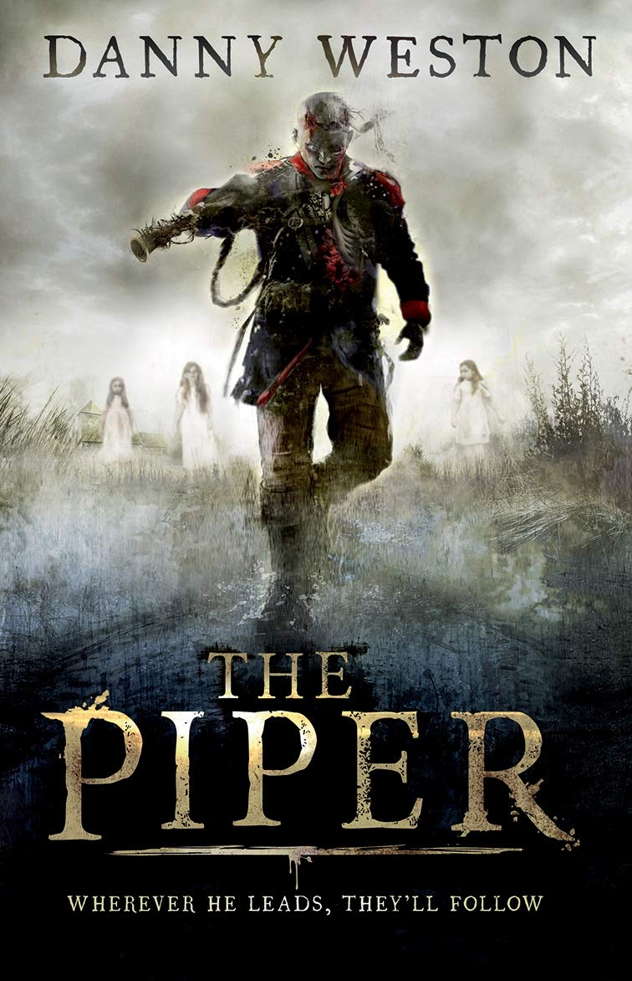 | By Danny Weston  (In Fiction Zone under WES)  Peter and Daisy are evacuated to a remote farmhouse at the start of World War Two.  They soon realise that something evil haunts the place. Who plays the strange music that can be heard at night? And why is Daisy so drawn to it?  When Peter uncovers a dark family secret, he begins to realise that his sister is in terrible danger, and to save her he must face an ancient curse...

Horror stories |  | Black Cairn Point
Bellshill Academy Library – recommended reading | 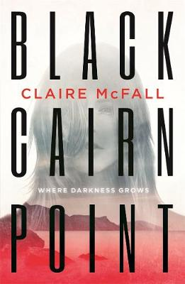 | By Claire McFall  (Young Adult spinner)  Heather agrees to a camping holiday with Dougie and his friends because she's desperate to get closer to him.  But when they disturb a pagan burial site above the beach, Heather becomes certain that they have woken a malevolent spirit.  Something is alive out there in the pitch-black dark, and it is planning deadly revenge.

Horror stories |  | Horowitz horror
Bellshill Academy Library – recommended reading | 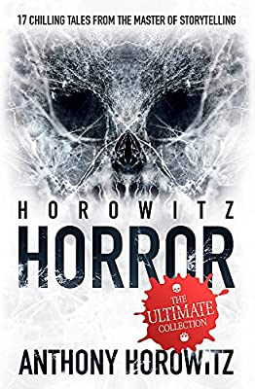 | By Anthony Horowitz  (On Horror shelf in Fiction Zone)  Welcome to a strange and twisted world where the spooky, the shocking, and the positively petrifying are lurking just out of sight.  A bus ride home turns into your worst nightmare. A quaint country cottage has a grisly secret. A man returns from holiday with bubbling skin and bloodshot eyes.  This is a collection of 17 chilling tales. Enter if you dare….

Horror stories |  | Mr Mumbles
Bellshill Academy Library – recommended reading | 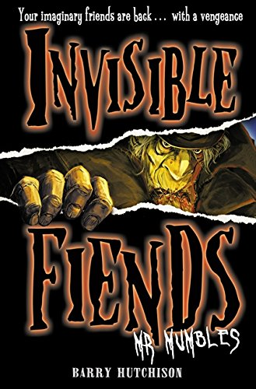 | By Barry Hutchison  (On Horror shelf in Fiction Zone)  Kyle hasn't seen Mr Mumbles in years. And there's a good reason for that: Mr Mumbles doesn't exist.  But now he is back, Kyle doesn't have time to worry about why. Only one thing matters - staying alive.
 |  | This is the first book in the Invisible fiends series.

Horror stories |  | The graveyard book
Bellshill Academy Library – recommended reading | 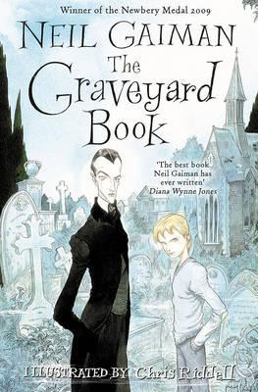 | By Neil Gaiman  (In Fiction Zone under GAI)  Nobody Owens, known as Bod, is a normal boy. He would be completely normal if he didn't live in a graveyard, being raised by ghosts, with a guardian who belongs to neither the world of the living nor the dead. There are adventures in the graveyard for a boy - an ancient Indigo Man, a gateway to the abandoned city of ghouls, the strange and terrible Sleer.  But if Bod leaves the graveyard, he will be in danger from Jack – the murderer who has already killed Bod's family.

Horror stories |  | The evil within
Bellshill Academy Library – recommended reading | 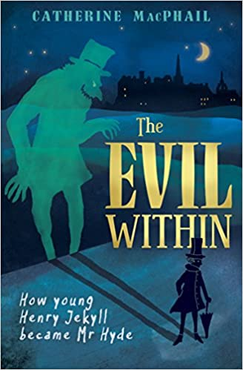 | By Catherine MacPhail  (Shorter Reads spinner)  Scotland, 1850. Night after night, the closes and alleys of Edinburgh's Old Town are alive with horror. Who or what is the beast haunting the dark city?  A few streets away, in his respectable New Town home, young Harry Jekyll wakes from yet another nightmare. His hands are covered in blood....  Inspired by the classic tale of Dr Jekyll and Mr Hyde by Robert Louis Stevenson.

Horror stories |  | The creeper man
Bellshill Academy Library – recommended reading | 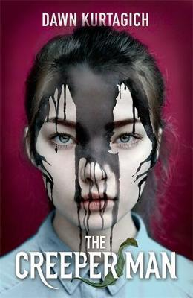 | By Dawn Kurtagich  (Young Adult spinner)  When sisters Silla and Nori escape London and their abusive father, Aunt Cath's country house feels like a safe haven.  But slowly, ever so slowly, things begin to unravel. Aunt Cath locks herself in the attic and spends day and night pacing. Every day the forbidden surrounding forest inches slowly towards the house. A mysterious boy appears, offering friendship. And Nori claims that a man watches them from the dark forest - a man with no eyes, who creeps ever closer…

Horror stories |  | Coraline
Bellshill Academy Library – recommended reading | 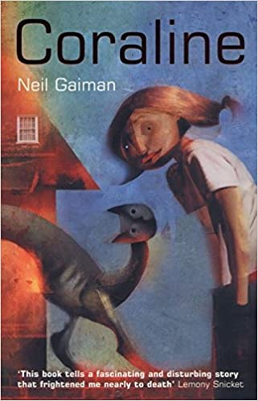 | By Neil Gaiman  (In Fiction Zone under GAI  or in Graphic Novels)  When Coraline steps through a door in her family's new home, she finds herself in another house, strangely similar to her own. But also very different! The food is better, the toybox is full of fascinating things, and Coraline is made very welcome.  But then it becomes clear that the other mother and father who live there want Coraline to stay, and never go back to her real parents…
 |  | Available in both book & graphic novel format

Horror stories |  | The dead house
Bellshill Academy Library – recommended reading | 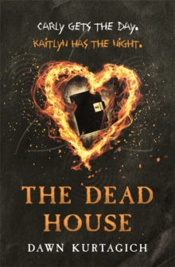 | By Dawn Kurtagich  (Young Adult spinner)  Twenty-five years ago, Elmbridge High School burned down. The blaze killed three and injured twenty, and one pupil, Carly Johnson, disappeared.  For twenty years, little was known about what happened. Until now. A diary has been found in the ruins of the school. In this diary, Kaitlyn Johnson, Carly's twin, tells of the strange and disturbing sequence of events leading to the incident.  But Kaitlyn doesn't exist. She never has.

Horror stories |  | Sleepless
Bellshill Academy Library – recommended reading | 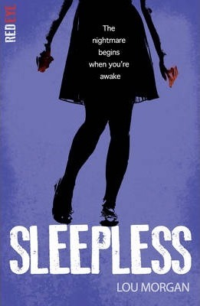 | By Lou Morgan  (Young Adult spinner)  Young, rich and good-looking, Izzy and her friends lead seemingly perfect lives. But exams are looming - and at a school like Clerkenwell, failure is not an option.  Luckily, her friend Tigs has a solution. A small pill that will make revision a breeze and help them get the results they need.  Desperate to succeed, the friends begin taking the study drug. But as the side effects take hold they realize there are far worse things than failing a few exams.

Horror stories |  | A monster calls
Bellshill Academy Library – recommended reading | 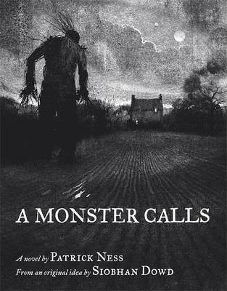 | By Patrick Ness  (Young Adult spinner)  The monster showed up just after midnight. As they do. But it isn't the monster Conor's been expecting. He's been expecting the one from his nightmare, the one he's had nearly every night since his mother started her treatments, the one with the darkness and the wind and the screaming...  This monster is something different. Something ancient, something wild. And it wants the most dangerous thing of all from Conor. It wants the truth.
Horror stories |  | Flesh and blood
Bellshill Academy Library – recommended reading | 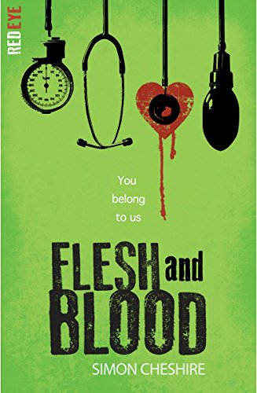 | By Simon Chesire  (Young Adult spinner)  Sam Hunter's neighbours are pillars of the community, the most influential people in town.  But they're liars too. The Greenhills are hiding something and Sam's determined to find out what it is. As his investigation unfolds, he realizes the lies reach further than he ever imagined. Is there anyone he can trust?  Uncovering the horror is one thing - escaping is another.

Horror stories |  | Mr Sparks
Bellshill Academy Library – recommended reading | 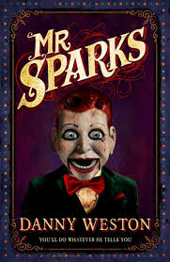 | By Danny Weston  (In Fiction Zone under WES)  Owen lives with his cruel aunt and wishes he could escape his life of drudgery in her small seaside guesthouse. There he meets a mysterious ventriloquist whoe dummy, Mr Sparks, really seems able to speak by himself. And Mr Sparks is looking for a newer, younger puppetmaster, someone who can help him run away from the dark secrets of his past.  This could be the answer to Owen's problems. But just who is controlling who?

Horror stories |  | The tell-tale heart
Bellshill Academy Library – recommended reading | 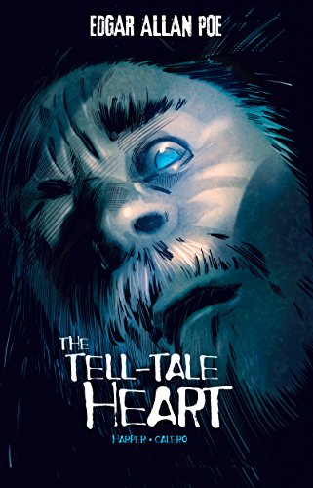 | By Edgar Allan Poe  (In Graphic Novels)  You think I'm crazy, don't you? Well, I'm not! I just hear and see things that others don't. Like the death watch beetles scurrying behind the walls. Or the beating of the Old Man's heart as he sleeps. And his eye... that wretched, pale blue eye burns into my very soul. It haunts me. So you see, I have to kill him. I have no choice.  But I'm not crazy! Just listen to my story and see for yourself...
 |  | This is the Graphic Novel version of a famous short story.

Horror stories |  | Killer camera
Bellshill Academy Library – recommended reading | 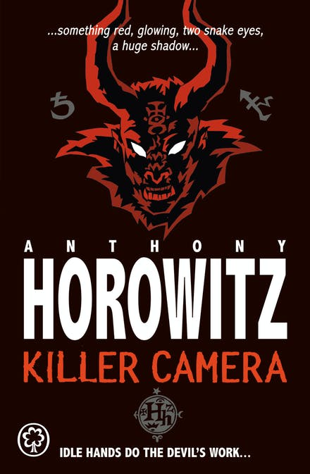 | By Anthony Horowitz  (Short Read spinner or Graphic Novels)  These two spine-chilling short stories are available as a book and a graphic novel.  Jamie is pleased with the camera he finds at a car boot sale - that is until he realises everything he photographs breaks…or dies.  Henry soon finds out that his new computer has a life of its own - and it's not afraid to gamble with people's lives.

Horror stories |  | Night of the living dummy
Bellshill Academy Library – recommended reading | 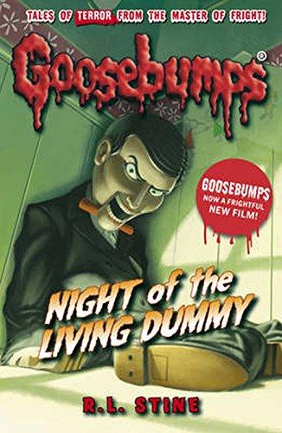 | By R.L. Stine  (On Horror shelf in Fiction Zone)  Kris's twin sister has just found a ventriloquist's dummy and it's all anyone seem to care about. Kris is tired of being ignored so she gets a dummy of her own.  But double the dummies seem to double the trouble... and horror.
 |  | This is part of the Goosebumps Horrorland series.

Horror stories |  | The sacrifice box
Bellshill Academy Library – recommended reading | 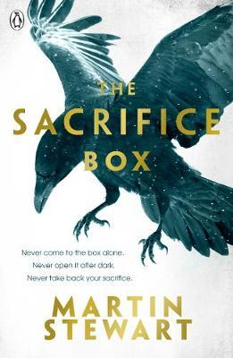 | By Martin Stewart  (On fiction shelves under STE)  Five friends are thrown together one hot, sultry summer. When they discover an ancient stone box hidden in the forest, they decide to each make a sacrifice: something special to them, committed to the box for ever. And they make a pact: they will never return to the box at night; never visit it alone; and never take back their offerings.  Four years later, a series of terrifying events take place. Someone broke the rules, and now everyone has to pay.  But how much are they willing to sacrifice?
Horror stories |  | Stranger things : Six
Bellshill Academy Library – recommended reading | 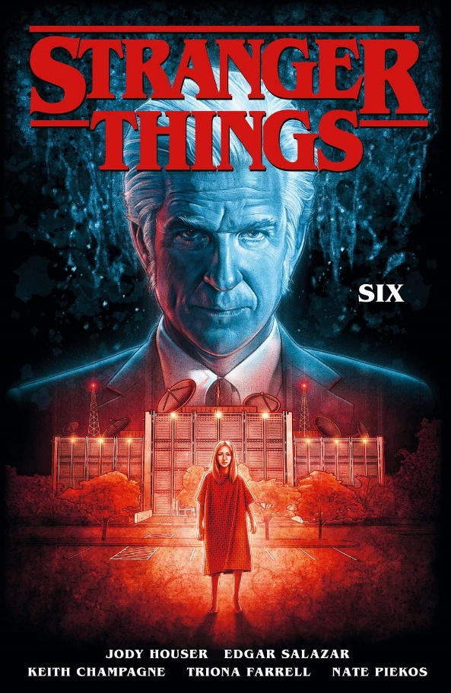 | By Jody Houser  (In Graphic Novels)  Francine, a teenage girl with precognition, has struggled through a lifetime of being exploited: by her parents and then by Dr Brenner of Hawkins Laboratory. Dr Brenner wants to harness her powers as well as those of the other gifted children that they hold captive at the lab. Wracked by increasingly disturbing visions, she sees an opportunity for her and all the children to escape. But at what cost?
 |  | This is a graphic novel and set before the TV series, Stranger Things. The Library has two other titles in the series.

Horror stories |  | The enemy
Bellshill Academy Library – recommended reading | 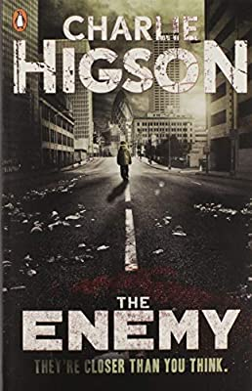 | By Charlie Higson  (Young Adult spinner)  Everyone over the age of 14 has succumbed to a deadly zombie virus and now young people must keep themselves alive. When the sickness came, every adult fell ill. The lucky ones died. The others are crazed – and hungry. Only those under 14 remain, and they're fighting to survive.  Now there are rumours of a safe place to hide. And so a gang of children begin their quest across London, where all through the city, the grown-ups lie in wait. But can they make it there - alive?

