**TOP TIPS FOR OUTDOOR FOOD PREPARATION**

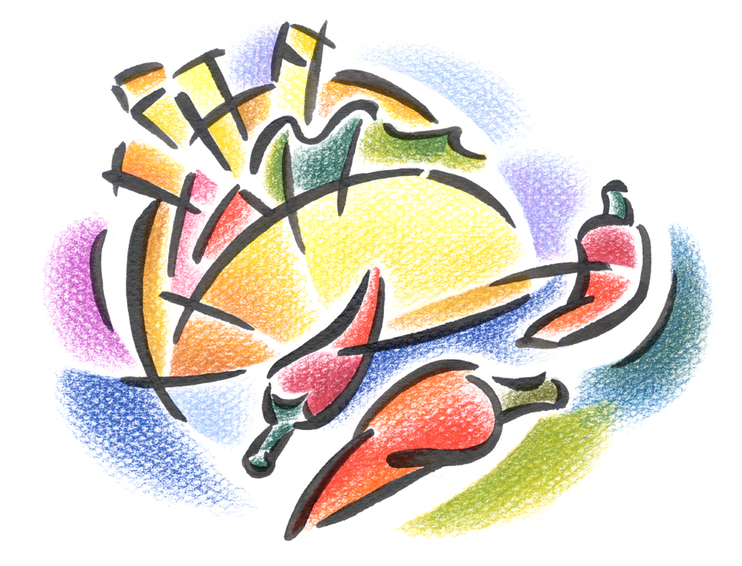

* Follow all existing guidance from environmental health and from food hygiene training courses.
* Follow all guidance from `Nutrition and Oral Health Strategy into Practice in the Early Years`.(2010)
* Plan Ahead-be aware of your chosen location, facilities available, length of time for travel, hand washing procedures etc.
* Calculate the time it will take from food preparation, to venue to consumption.



* Prepare foods as near consumption time as possible.
* Use a food probe on site to check temperature.
* Food is only safe for 4hrs at room temperature, monitor this carefully.
* Use low risk foods unless you are positive that you can prepare alternative foods appropriately.

C:\Users\cairnsma\AppData\Local\Microsoft\Windows\Temporary Internet Files\Content.IE5\B3A2ECXM\MC900388844[1].wmf

* Avoid HIGH RISK Foods- raw meat, rice, fish, shellfish, eggs and egg products, dairy products.
* Use only eggs with the Red Lion symbol.
* Opt for tinned or dried foods, crackers, fruit etc.
* Avoid foods which need refrigeration.
* Checks defrost times so that food is fully defrosted in time for consumption at site.
* Use cool packs. You can also fill used and cleaned orange juice/milk cartons with water, freeze them and use these as they are more effective than cool packs.
* Pack foods directly from the fridge to the cool bag.
* Soup properly heated in flasks is a good hot drink.
* If using raw meat keep this double wrapped at the bottom of the cool bag.
* Avoid using left overs.
* Decide on portion size before travelling to avoid wastage.
* Use one pot whenever possible and reduce ingredients.
*   
* Check if camp fires are allowed at sites or use portable fire bowl, Kelly kettle or camping stove.

C:\Users\cairnsma\AppData\Local\Microsoft\Windows\Temporary Internet Files\Content.IE5\KWJOI433\MC900215687[1].wmf

* Use tin foil to cover foods on or in fires.
* Use airtight containers and re-sealable plastic bags.
* Consider using disposable plates, cutlery, and napkins.
* Keep foods covered, cool, and cook food thoroughly.

C:\Users\cairnsma\AppData\Local\Microsoft\Windows\Temporary Internet Files\Content.IE5\X3GF5CML\MC900383704[1].wmf

* Keep all foods out of sunlight.
* Minimise cross contamination-think carefully about surfaces being used for preparation. Use tin foil, paper towels to cover surfaces.
* Ensure that you have suitable safe hand washing procedures. Running water is best, if not then, hand wipes or hand gels. Use paper towels. Check the `Tippy Tap` website (http://www.tippytap.org/the-tippy-tap) for building your own on-site hand washing system.
* Discard all left overs responsibly.

C:\Users\cairnsma\AppData\Local\Microsoft\Windows\Temporary Internet Files\Content.IE5\LE2M4DPK\MC900325844[1].wmf