

Sand in schools
A briefing paper

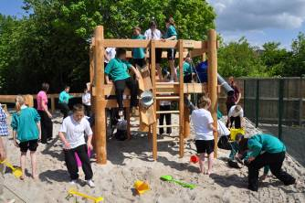

Burnham Park Primary School’s outdoor science park

March 2011

CONTENTS

1 Introduction 3
2 The benefits of sand play for children 3
3 Examples of successful sand play in schools 4
4 Managing Sand Play 7
5 Decision making framework 9
6 Monitoring and evaluation 10

- Introduction

This briefing note:

- outlines the developmental and educational benefits of sand play for children’s learning and development
- highlight examples from Scotland and further afield where sand is successfully managed in school playgrounds
- suggests approaches to dealing with the common management issues that arise with sand in school playgrounds.

- The benefits of sand play for children

We know from beach trips how much children love sand play. This is because it offers such a huge range of possibilities for play, experimenting and learning. In summary:

Motor skills (gross and fine) are developed through digging, constructing, carrying and jumping.

Creativity is developed through offering a wide range of creative possibilities – sand castles and sculptures, sand cities, roads for toy cars, twig structures, tunnels and fantasy worlds. These are often enhanced with the addition of other props such as toy cars, sticks, shells and pebbles.

Mathematical concepts are supported through experimenting with volume, mass, and flow using standard volume measures as well as non-standard volumes (cups, buckets, tubs etc.)

Science and engineering is supported through experimenting with wet sand and dry sand, construction, understanding how water moves through sand, exploring gravity by making a ball run, temperature differentials between sand in sun and sand in shade, burying artefacts and excavating them as a route to learning about archaeology etc.

Social and co-operative skills are commonly developed as children work together on joint projects – building a fantasy world, creating a water channel from A to B, negotiating whose turn it is with the bucket etc. Sand play offers good opportunities for older and younger children to co-operate together – something that’s unusual in many playgrounds.

Language skills are developed – both in terms of words that describe sand and its used and as children discuss what they are doing with adults and each other.

The fundamental softness of sand creates a very different kind of space from asphalt or grass. Its hard to run in a sandpit and so they tend to be quieter, more reflective, co-operative and creative spaces.

- Examples of successful sand play in schools

ROSPA (The Royal Society for the Prevention of Accidents) describes sand play describes it as ‘one of the most developmentally appropriate -pieces of equipment which can be provided on a children’s playground.’ For this reason, it is increasingly a common feature in Local Authority play parks and is also growing in popularity with schools across Europe. A few illustrative school examples from Scotland and further afield are given below.

Riverside Primary School , Stirling Council

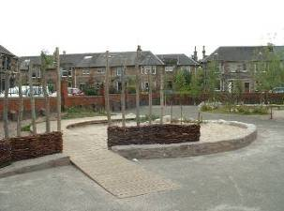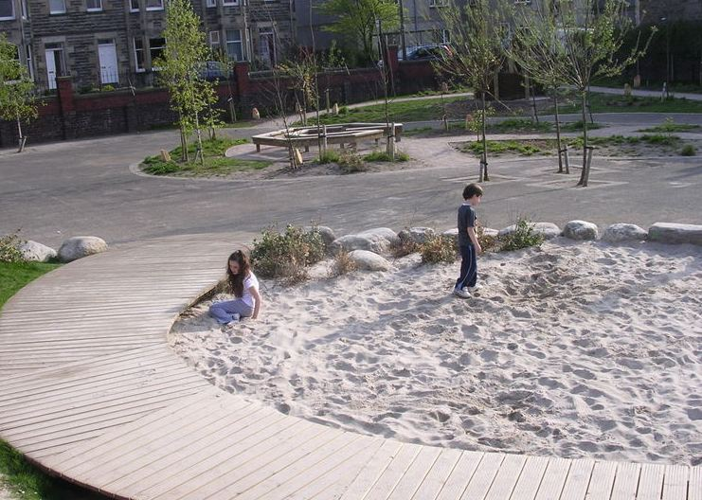

Created in 2007 in an urban school, this large open sandpit has become a central focus for play. The playground is accessed by children for play out of school time and the school had initial concerns about broken glass and other rubbish ending up in the sand. Over time this had proved not to be a significant issue and the sand is raked weekly by learning assistants. Initial problems with cat faeces have also been largely eliminated by using metal cats and embedding glowing cats eye beads in the surrounding wall.

Thornlie Primary School, North Lanarkshire Council
Located in an area of high deprivation, the new play facilities are a key part of the school’s strategy for supporting learning and child development.

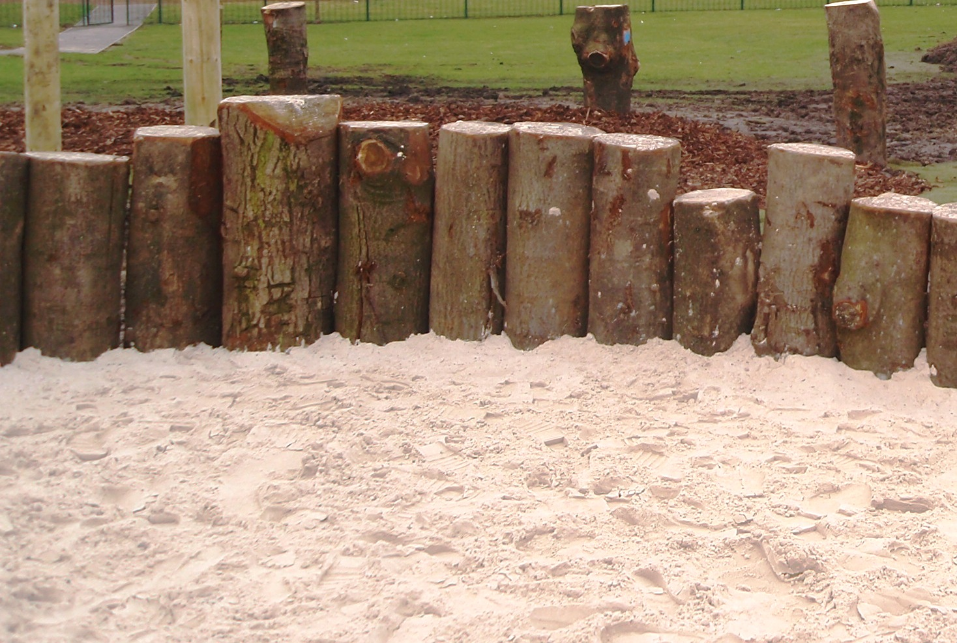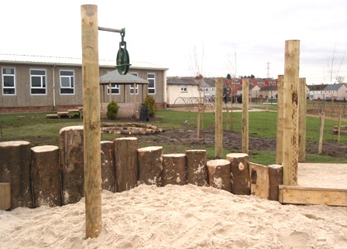

‘Children react to space in an instinctive way. I’m amazed to already see the variety of responses to what we’ve created. Children are exploring, climbing, digging, carrying, jumping. Not only that, they’re having to do each of these in a variety of ways, and often in collaboration.’ Head Teacher

You can’t feel left out, because there’s always something to do’ Pupil

‘It’s been great to see older pupils so motivated to share play space with younger pupils. There’s more to P7 play than either football or nothing, and there’s some real initiative and creativity in the building with loose materials, for instance, from a number of those non-footballers!’ Playground Supervisor

‘I congratulate North Lanarkshire Council, Grounds for Learning and the teachers at Thornlie Primary School for bringing this project together and demonstrating a different attitude to adventurous free play.’ Adam Ingram, Minister for Children and Early Years (who visited the playground in March)
Burnham Copse Primary School, Hampshire County Council

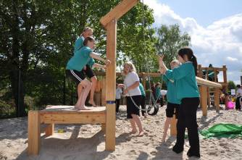
A large open sand area constructed as part of a new-build school in 2007. The sand area forms part of the school’s outdoor science park used ‘to explore forces, filtering and displacement. It also enables the children to practice their team skills and, most importantly, have fun!’ Neighbouring schools visit the school to make use of the science park facilities.

Various primary schools, Berlin
In the 1990s, Berlin City Council significantly re-developed many of their primary schools in response to high levels of playground violence that were linked to boredom and a feeling of imprisonment in tarmac yards surrounded by high fences. The use of large open sand and bark areas is common to all of these schools. The impact on behaviour has been remarkable with lower levels of playground violence now than in any other European country. A more detailed report of this approach is here - with some illustrative images below.

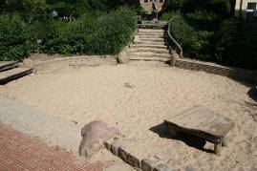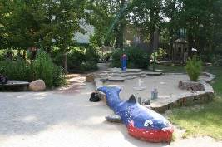

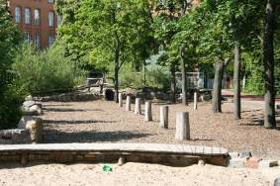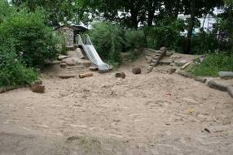
- Managing Sand Play

Sand play can present a number of management issues for schools. These are briefly outlined here, although it is important to recognise, as ROSPA concludes, that ‘practical experience suggests that problems are much less than folk-lore suggests. ‘

Sand blow
In windy sites, sand can blow out of the sand pit and across the rest of the playground. This doesn’t present any particular health and safety issue, but is more an issue of losing sand which will need to be replaced. Well designed sand pits will have considered the site’s windiness and be located in less windy areas. Recessing the sand pit and providing a low boundary wall helps to minimise the issue.

A covering net or tarpaulin will reduce or eliminate sand blow – although once covers are on there is a danger that they stay on and reduce children’s access to the area. For this reason, accepting degree of sand blow and topping up with fresh sand each year may be a better approach. Where the site allows it, planting quick growing shrubs (such as willow) around the sand pit can create a wind break. Hosing down the sand in very dry periods will also minimise blow.

Sand indoors
Sand can travel indoors – in shoes, pockets and sleeves, creating extra work for cleaning staff. The solution is for children to be taught a sand routine of shaking their clothes out before they leave the sand pit. Providing a soft brush for dusting down shoes or a doormat for feet wiping will also help. Children should also be taught simple hand hygiene and wash hands after sand play sessions.

Throwing sand and behaviour issues
This is rarely an issue in practice as the threat of exclusion from the sand play area is usually enough to ensure good behaviour! Because sand play areas are so popular, they may become overcrowded. Schools should assess this risk and if necessary devise appropriate rules and rotas to ensure that everyone has a regular sand play opportunity. With adult support, children are often best placed to devise these rules. If a child gets sand blown or thrown into their eyes, pour cool water over the eye to flush out sand particles. Tears help to remove eye irritants so don’t discourage crying!

Cat or fox faeces
Cats (and foxes if they are present) can be attracted to sand areas as latrines and their faeces and urine can contain worms, parasites and bacteria. These need to be ingested in order to cause health problems (which include toxoplasmosis and E.coli). There are a number of approaches to managing this problem:

Monitoring is important as the situation will change over time as local cat and fox populations change. Cats are most likely to use a sand pit at night, so inspect in the mornings and adapt your inspection frequency to how frequently the problem occurs (daily, weekly or monthly). Rake the sand during inspection as cats will often bury their faeces.

Discourage cats from visiting the site. There are many ways that this can be done. Riverside Primary found that fixing large metal cats to nearby railings – and using marble ‘cats eyes’ in the sand pit wall has helped to deter cats. Other deterrents include high frequency devices that are triggered by animal movement, plants that deter cats, half filled bottles of water and using scents that cats dislike, or which mimic a stronger cat’s territorial boundary.

Hand hygiene is important. Ensure that children wash their hands after sand play.

Covering sand is a common strategy for avoiding this problem, but this is more problematic in a larger sand pit. The main option for covering a large sand pit is to use a tarpaulin with elasticated edges. These can be made to measure – but will generally be less suitable for irregular shaped sand areas. Tarpaulins are also liable to be stolen or damaged in areas where vandalism is a problem.

Dangerous litter
Sand pits may occasionally be used as social spaces in the evening, with a risk of broken glass ending up in the sand. The risk of syringe needles being discarded in sand is commonly cited and yet very rarely reported.

An Australian detailed study of the risk of needle stick injuries from sand pits concluded that the risk was ‘very low’ with no known case of anyone in Australia having contracted an illness through a needle stick injury in a park. The report cites the widespread provision of sand pits in public parks in Amsterdam (which has a liberal attitude to drug use) as evidence of the low risk. Approaches to managing this issue include:

- Citing the sand pit in an area that is publically overlooked and encouraging community access out of hours.
- One Scottish school has created a small social space in a secluded area away from the main playground, which concentrates drinking in a small area away from play facilities.
- Use of CCTV (many school playgrounds will already be covered by CCTV)
- Use of a vinyl / tarpaulin cover
- If there is a known issue of needle use in local green spaces, discuss the issue with community health outreach workers
- As with the faeces issue, decide on levels of monitoring and raking that are appropriate to the level of risk.

- Decision making framework

Decisions about acceptable levels of risk in play provision should be guided by ‘managing risk in play provision’ – guidelines produced by Play England and endorsed by leading national safety agencies, including the Health & Safety Executive, Royal Society for Prevention of Accidents, Play Scotland and Adam Ingram MSP, Scotland’s Minister for Children and Early Years. The guidelines are here:

http://www.playengland.org.uk/media/172644/managing-risk-in-play-provision-implementation-guide.pdf

In summary, the guidelines outline
- That a degree of risk in play is good for children
- Decision making needs to weigh ‘with equal consideration, the duty to protect children from avoidable serious harm and the duty to provide them with stimulating adventurous play opportunities.’
- ‘There is no legal requirement to eliminate or minimise risk, even where children are concerned.’

The guidelines set out a 4 stage approach for making decisions and managing risk in play. We can help you do this!

Stage 1: Draft a school play policy. This should set out the values, understandings, principles and criteria that form the framework for making judgements about play provision. This is the policy that should guide decisions about specific play features, such as sand pits. In its most basic form it would:
- explain why the school thinks play is important
- explain why a degree of risk in play is a good thing
- state that the school uses ‘managing risk in play provision’ as the basis for its decision making.
- You may want to mention how you communicate / discuss this with parents and how you might support your playground supervisors.

Stage 2: Risk-benefit assessment
This document sets out most of what you need to do this - for a large school sand pit. You now need to personalise it for your own school by considering (and writing down)

- The benefits of sand play for children
- The potential risks – what the hazard is, how likely it is to occur and how serious the likely harm would be from the hazard
- What the options are for managing the risks (covers, inspections, cat deterrents etc.) and their pros and cons
- Any relevant expert views or precedents (e.g. other schools, common in parks, kids go to beaches, Australia study etc.)
- Your final decision and the management steps you will take to reduce risks to acceptable levels.

Stage 3: technical inspection
Your risk benefit assessment will decide how often you need to inspect and what you’re looking for so this stage is basically carrying this out.

Stage 4: dynamic risk benefit assessment
This refers to the role of playground supervisors who are managing play. Your RBA will have identified issues such as sand pit rules, rotas, hand washing routines etc. This stage is simply the implementation of these things on the ground, as well as the common sense monitoring and supervising what’s going on in the sand play area at a level that is appropriate to the perceived risk. This might mean, for example, a greater degree of supervision at the beginning, or if there have been problems.

- Monitoring and evaluation

This is a pilot project. By definition it is trialling forms of play that are not common in Scottish schools with the aim of learning about how this kind of play supports school life but also about how feasible or otherwise it is from a management perspective.
A key part of the project is about how schools can manage the various challenges that will inevitably arise and learning from experience. If initial ideas and plans have to be modified or changed, this doesn’t represent failure – but valuable learning. An important part of the project is collecting the thoughts and experiences of pupils, staff and parents, whether they’re favourable or not. We want honest, not ‘correct’ answers!

http://www.hbsc.org/countries/downloads_countries/Scotland/BriefingPaper8.pdf
http://www.rospa.com/leisuresafety/Info/PlaySafety/sand-play.pdf
http://www.kidsafensw.org/docs/PAU/Needlestick%20Report%20Incl%20Attachments.pdf

