LANGLOAN PRIMARY SCHOOL & NURSERY CLASS
NEWSLETTER - OCTOBER 2023
Dear Parent/Carer

October Break – Monday 16th – Friday 20th October (Inclusive)
As we approach the end of Term One I would like to thank all members of staff for their hard work and enthusiastic start to the session. Many of the class teachers, as you may be aware, have changed stage. Whilst a change of stage can be motivating and exciting for some teachers, it can also be daunting, and it certainly brings an added workload as staff remind themselves about different levels within ‘A Curriculum for Excellence’. Our teachers, as always, have worked hard to get it right for every child, fully supported by all non-teaching staff within Langloan PS and Nursery Class, and I am very grateful for the continued efforts and teamwork from everyone.

Class Assemblies – P2 (Room 2) – Thursday 12th October
Room 2 is hosting a Harvest Assembly this coming Thursday, 12th October, at 2.15pm. Room 2 parents and carers are very welcome to join us for this.

Foodbank Donations Wanted – Thursday 12th October
We plan to make a donation to the local foodbank as part of Room 2’s assembly. Pupils in all classes are asked to send in a long-life food, or toiletries item, if possible. Pupils should hand donations to their class teacher on Thursday morning. These will be displayed throughout the assembly, before being uplifted by our local foodbank that afternoon. Thank you in advance for any donations that you are able to make.

Fundraising Events
In order to raise some much-needed funds we plan to host two fundraising events as follows:

- Rags2Riches – Wednesday 25th October – pupils should bring unwanted clothing in the bags provided. Please note that although our collection date is the 25th of October, bags can be handed in on Monday 23rd, Tuesday 24th or NO LATER THAN 8.55am ON Wednesday 25th October, thank you.

- Sponsored Dance-a-thon – Tuesday 31st October - sponsor sheets will be issued on 23rd October, following our October Break.

Therapets
Thanks to Mrs Ryan for arranging ‘Reading with dogs’ sessions for several of our pupils. We believe the calming influence of the dogs will provide support and reassurance to pupils who may find reading challenging.

Refuweegee – Room 8
To link with the learning in Primary 6 – Room 8, the pupils will be visiting Refuweegee which is a charity supporting refugee families. The pupils are really looking forward to their visit and they are extremely keen to support the charity by making donations. Further information regarding this to follow.

Sushi Selection Box – Room 9
Room 9 are looking forward to their visit from Sushi Selection Box this coming Thursday 12th October which will enhance their interdisciplinary learning.

Twitter
Parents are invited to follow us on Twitter (Now called X) to keep up to date with learning which is taking place throughout our school and nursery. Please note this is a closed site. If you request to follow us and your request is declined please call our school office, thank you.
Weather
As our weather is changing and very unpredictable please ensure that your child brings an outdoor jacket and wears appropriate footwear.

Late coming and attendance
We are currently monitoring attendance and late coming and ask all parents to support us with this. Please ensure that your child attends school every day unless they are unwell.
Holidays within school time are marked on the register with a different code. This is currently being closely monitored by NLC. Please see the picture below, created by another school.
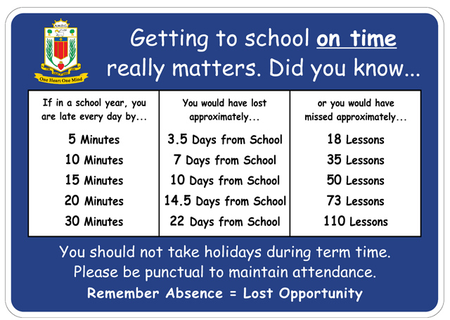

OCTOBER/NOVEMBER 2023 DATES FOR YOUR DIARIES

Wed 11th October Parent Council Meeting
Thurs 12th October Room 2 Assembly
Friday 13th October Sponsored wellie walk in Nursery
16th – 20th October inclusive OCTOBER WEEK HOLIDAY
Wed 25th October Rags2Riches uplift
Thurs 26th October Room 9 Assembly
Thurs 26TH Oct Halloween disco
Tues 31st October Sponsored dance-a-thon
Thurs 2nd Nov Room 5 Assembly
Tues 7th Nov P5 - VUE cinema, Glasgow Fort
Wed 8th Nov 7pm Parent Council Meeting – DATE TBC
Thurs 9th November School photographs for our school and nursery pupils
Friday 10th November P7 - VUE cinema, Glasgow Fort
Mon 13th Nov In-service Day – pupils do not attend
16th November PARENTS’ EVENING
17th Nov Dress down day – Bring an item for our Christmas Fair
21st November P1 - VUE cinema, The Forge
SATURDAY 25TH NOV CHRISTMAS FARYE

Should you require any further information regarding our school or nursery please do not hesitate to contact me on 01236 632092 or enquiries-at-langloan@northlan.org.uk
Yours sincerely
Mrs A Rooney
Head Teacher

