Rules When Using Microsoft Teams
Langloan Primary School
Parent Guidance
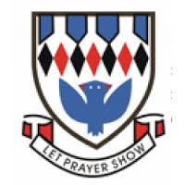
Microsoft Teams is a digital learning platform used in our school to develop ICT skills and to help with the delivery of homework and home learning in cases where pupils have to self-isolate. Please refer to Teams guidance materials on our school blog in the Digital Information Tab for help with setting up, signing in and uploading work to Teams.
Each class has their own team and this space MUST be treated like a virtual classroom. The rules set out below must be followed at all times.
All users must:
- Use appropriate language and an appropriate tone when posting or replying to others in class team pages.
- Keep chat/posts related to their learning. General chat will clog up the post feed and important information may be lost.
- Be kind and respectful to staff and their peers.
- Be aware of appropriate times when using the class team page. Please note that teachers are not obliged to respond out-with working hours, and that any enquiries will be addressed the next day.
- Let members of staff know if they are having any issues so that they can be resolved quickly.
Thank you for your cooperation and understanding with this matter.
Mrs Paterson, Acting DHT
August 2021

