Langloan Primary – Home Learning – Apps and Websites (P1-3)

WEBSITE - OXFORD OWL  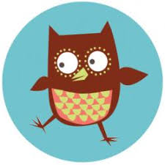  https://home.oxfordowl.co.uk/ | WEBSITE – LITERACY  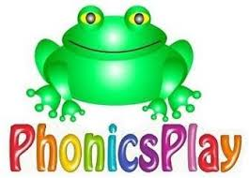  https://www.phonicsplay.co.uk/ | WEBSITE – LITERACY  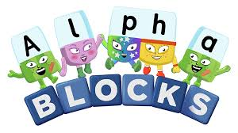  https://www.bbc.co.uk/cbeebies/shows/alphablocks | WEBSITE – CROSS CURRICULAR  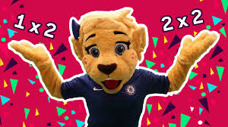  https://www.bbc.co.uk/teach/supermovers/ks1-collection/zbr4scw
APP – LITERACY  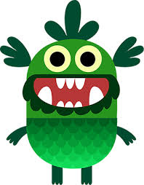  WWW.TEACHYOURMONSTERTOREAD.COM | WEBSITE – MATHS  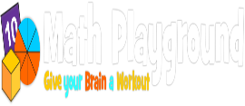  https://www.mathplayground.com/ | APP – SPELLING BEE  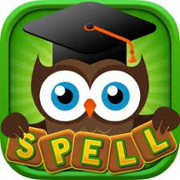  https://apps.apple.com/gb/app/a-spelling-bee-english-words/id721186235 | WEBSITE – CROSS CURRICULAR  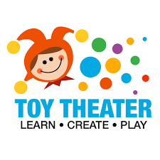  https://toytheater.com/

WEBSITE – CROSS CURRICULAR  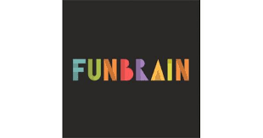  https://www.funbrain.com/ | WEBSITE – MOTOR SKILLS – DANCE MAT TYPING  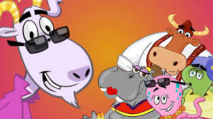  https://www.bbc.co.uk/bitesize/topics/zf2f9j6/articles/z3c6tfr | WEBSITE – CROSS CURRICULAR    https://www.topmarks.co.uk/ | APP – CODING  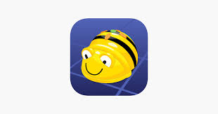  https://apps.apple.com/gb/app/bee-bot/id500131639  https://play.google.com/store/apps/
WEBSITE – CROSS CURRICULAR    https://www.bbc.co.uk/bitesize | WEBSITE – HEALTH & WELLBEING  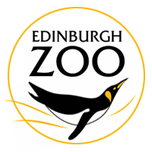  https://www.edinburghzoo.org.uk/webcams/ | WEBSITE – HEALTH & WELLBEING    https://www.gonoodle.com/ | APP – MUSIC  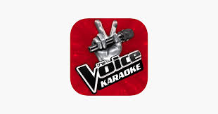  https://apps.apple.com/gb/app/the-voice-sing-karaoke/id1385014271

We have created these grids to help support our children at home. There is no expectation that they are completed but they are here if required.

