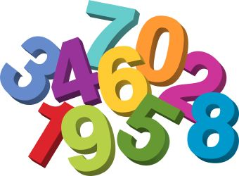
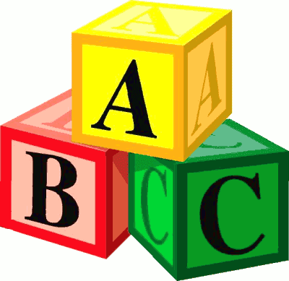
Langloan Nursery Class Home Learning – Week 10

Summer Days and Nights  Use YouTube and find the story  Summer Days and Nights  By Wong Herbert Lee  Who is the story about?  What happened in the story?  Can you retell the story to someone in your family?  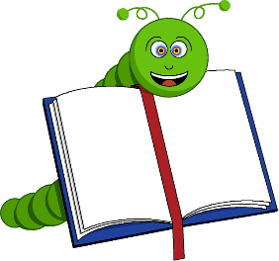 | Take a look at a book.  Look on your book shelf and see if you have any more books about summer.  Talk about what you like and don’t like about summer.  Draw your favourite thing about summer. | Ice-lolly Magic  Make your own ice-lolly using diluted juice, different fruits and lollipop sticks.  Which flavour is your favourite? | Simply Stunning Summer Hats  Design a summer hat.  Does it shade your eyes and cover the back of your neck?  Why is this important?  What else can we do to protect ourselves from the sun?
Make someones day  Find a rectangular piece of card.  Ask an adult to help you cut it into a postcard size.  Draw a fabulous sunny day picture on the front.  Ask a grown up to help you write a message to a family member from another household.  Can you sign it all by yourself?  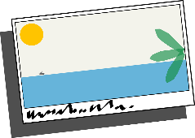 | Five fine flowers  Can you find 5 different flowers?  Explore the flowers and talk about the colours and shapes you see.  Draw a picture of your favourite flower.  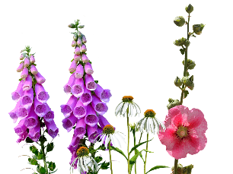 | Nature Detective  Take a walk around your garden, park or outside area. Look for signs of summer.  Draw a picture of some signs of summer.  Go outside and see what the weather is like today.  Talk about how the weather in summer makes you feel.  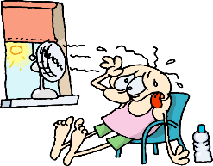 | Ice cream cone counting

