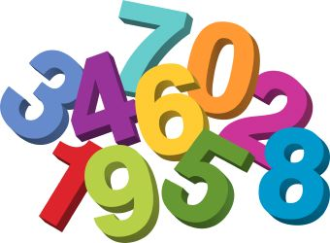
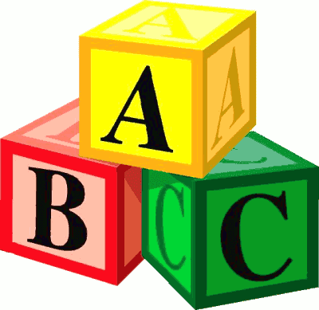
Langloan Nursery Class Home Learning – Week 10

The Very Hungry Caterpillar  Check your book shelf and see if you have a copy of The Very Hungry Caterpillar by Eric Carle.  If not, use YouTube.  Who is the story about?  What happened in the story?  Can you retell the story to someone in your family?  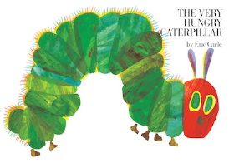 | Food Glorious Food  The Very Hungry Caterpillar loves to eat lots of different foods.  What is your favourite food?  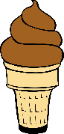  Draw a picture of your favourite food and ask someone to help you write its name.  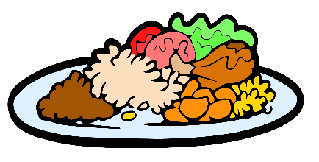 | Adding Up  The Very Hungry Caterpillar eats 2 pears and 3 plums. How many pieces of fruit did he eat altogether? You could use your fingers or draw a picture to help you count.  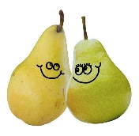  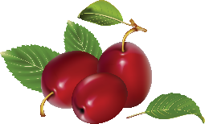 | Taking Away  There are 5 butterflies on a leaf. If 3 fly away, how many would be left on the leaf?  You could use your fingers or draw a picture to help you count.  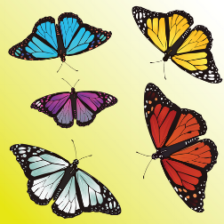
Fruit tasting  Try some of the different fruits mentioned in the story. Which one is your favourtie?  You could also try some other fruits – what other fruit might The Very Hungry Caterpillar like to eat?  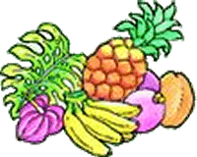 | Little Artists  Draw or paint a picture of a caterpillar or a butterfly. What colours do you need? What different parts do you need to draw? Talk to someone in your family about your picture.  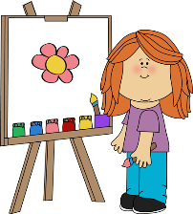 | Nature Detective  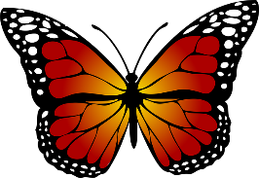  Take a walk around your garden, park or outside area. Can you find any butterflies or caterpillars? Try looking around some plants and flowers or under some leaves. You could draw a picture or take a photo of any you find.  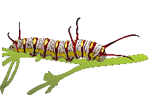 | The Life Cycle of a Butterfly  Use the internet to find pictures or videos of the life cycle of a butterfly. Can you use this to help you describe what happens to someone in your family?  Can you remember things in the correct order?  