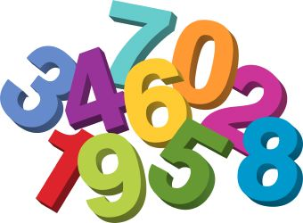
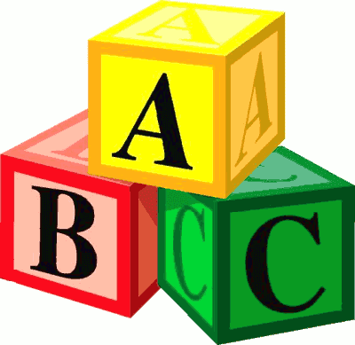
Langloan Nursery Class Home Learning – Week 9

Tiddler  The story-telling fish  Check your book shelf and see if you have a copy of Tiddler by Julia Donaldson.  If not, use YouTube.  Who is the story about?  Where is the story set?  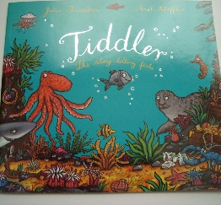  What happened in the story?  What was your favourite part of the story? | Days of the week.  Can you remember our days of the week song?  Can you sing it and sign it to your family?  Remember, it’s to the tune of ‘The Adams Family’.  Days of the week (clap, clap)  Days of the week (clap, clap)  Days of the week, days of the week, days of the week (clap, clap)  There’s Sunday and there’s Monday  There’s Tuesday and there’s Wednesday  There’s Thursday and there’s Friday and then there’s Saturday. | Ordering by size  Which fish is the longest?  Which fish is the shortest?  Can you order them by size?  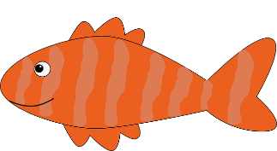  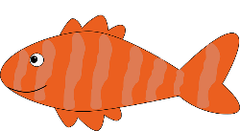  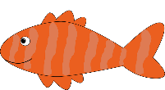 | Telling the time  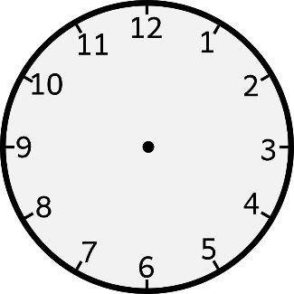  Make your own clock face using a paper plate or circle of paper.  Tiddler was supposed to be at school by 9 o’clock. Can you draw this on your clock?
I can be an author  Tiddler was a little fish with a big imagination. He thought of lots of different, exciting things that might happen to him.  Can you use your imagination to finish this sentence?  “Sorry I’m late. I was …….. | Rhyming Time  Can you match up the rhyming words?  Scales eel  Dab late  Seal face  Skate tales  Plaice crab  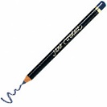 | Time to get Arty  Can you draw a picture of some of the different characters from the story.  Can you use chalks to draw a massive undersea picture on your pavement.  Watch as people walk past and admire your work. | Undersea Counting

