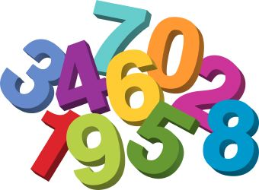
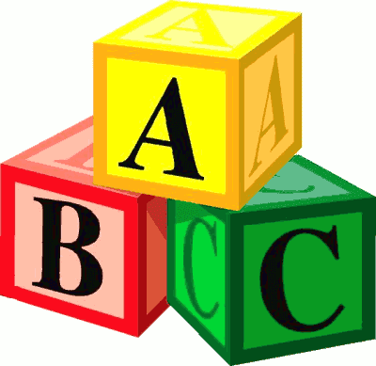
Langloan Nursery Class Home Learning – Week 8

National Children’s Gardening Week  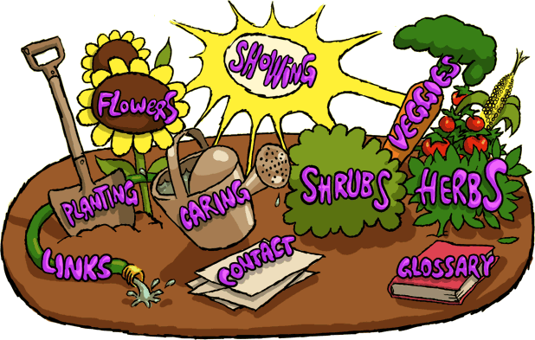  This week is the National Children’s Gardening week.  We thought you might want to take part in some of the activities.  If you don’t have access to a garden, you could ask an adult to help you make a window box.  You can also do lots of different activities when you are on your daily walk outside. | Fairy Pot House  During my daily walks it has been lovely to see lots of Fairy doors.  Can your family help you to make a Fairy House using an upturned flower pot?  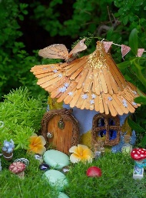  Paint it in lovely bright colours.  Put it in your own garden or in the park for others to find. | Growing something tasty  I would love to see what you’re growing in your garden that you can eat!  We are growing lots of fruit and berries at home.  Did you know that strawberries are a member of the Rose family?  Upload your pictures to the school blog or to me at GLOW  GW09ritchieangela@glow  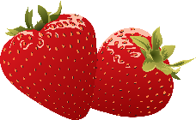 | Cress Heads  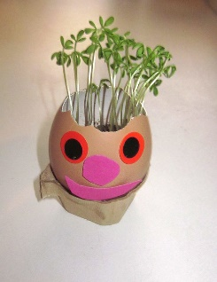  - Draw a face on an eggshell.  - Fill with cotton wool.  - Spray to wet the cotton wool.  - Sprinkle on cress seeds.  - Water and keep moist.  - Watch them grow!
Story time  James McAvoy “Superworm” CBeebies Bedtime stories – YouTube.  Now talk about:  Who is the author of the story?  Who is the illustrator?  Who was in the story?  What happened?  What was your favourite part?  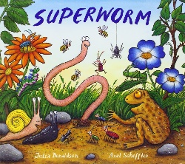 | Rhyming Time  We met lots of different animals and insects in the story.  Can you match up the rhyming words?  Toad …. chant  Fly …. wizard  Ant …………. road  Lizard below  Crow sky  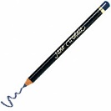 | Time to get Arty  Can you draw a picture of some of the different characters from the story.  Can you use pink playdough to make Superworm.  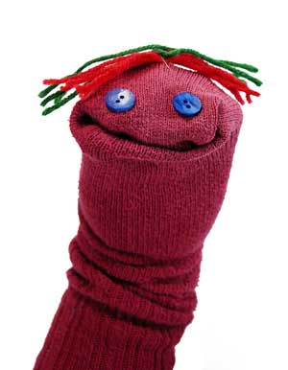  Use an old sock to make Superworm. Add a smiley mouth and eyes. Use it to help you tell the story to your family. | Ladybird Counting  Look in the garden or at the park and find some small rocks.  Paint them to look like ladybirds.  Can you put different amounts of spots on them!  When they are dry, put a coating of varnish over them.  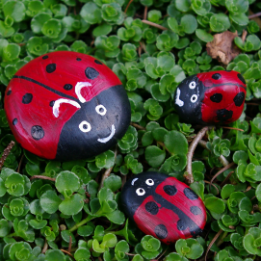  Can you sort them out from the smallest number to the biggest number?

