Home Health Week
Activity Pack
Langloan Primary School

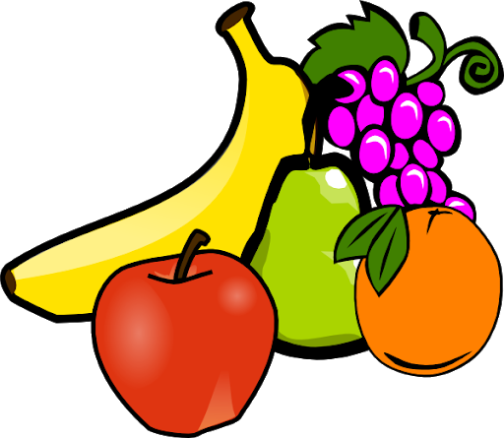
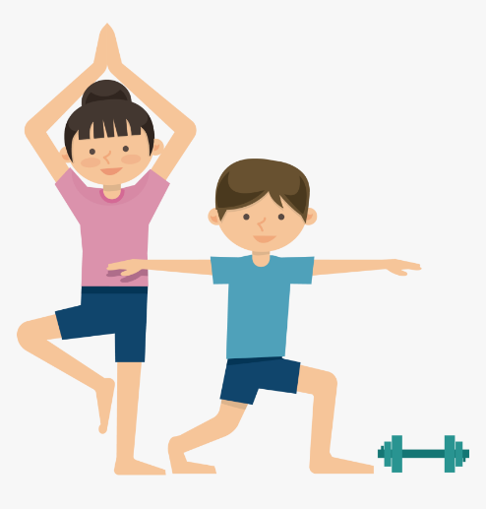

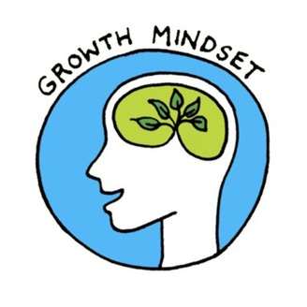

A note for the children of Langloan Primary school.
All of the staff here at Langloan Primary miss you all very much, we are so sad that our health week cannot go ahead as normal this year so this booklet has been created to offer you some fun ideas and activities to carry out whilst we all stay home and stay safe.
Health is about being physically, mentally and emotionally well.
In this booklet you will find many activities that cover these areas. The activities can be carried out indoors or outside in a garden or park.
Parents and carers are also able to use this booklet, if you are unable to print these pages the activities can be written down or carried out actively.
Any videos, pictures and stories you have to share would be greatly appreciated and can be uploaded onto Microsoft Teams or Sharepoint.
Sharepoint will have its own “Health week” folder with a PowerPoint to upload your videos and pictures onto.

Stay safe and have fun
We hope to see you all soon!

Food Diary
For one whole week, try to keep a food diary, here are two examples.
Notice how you feel after certain foods, do you feel full of energy? Tired?
Why do you think this happens? Why do we feel different after different types of food?
Feel free to include the times of which you eat your meals and snacks. By the end of the day how much fruit and veg have you eaten? Shade in how much fruit and veg you have had; did you reach your 5 a day target?
Did you drink enough water each day?
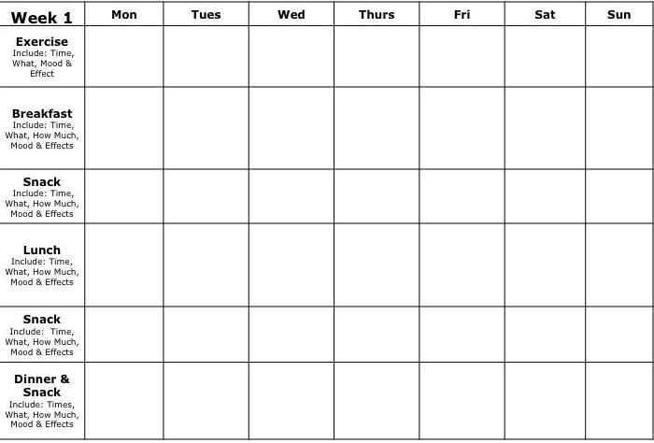
Have you done any exercise? This can be as simple as a walk outside or some Go Noodle videos.

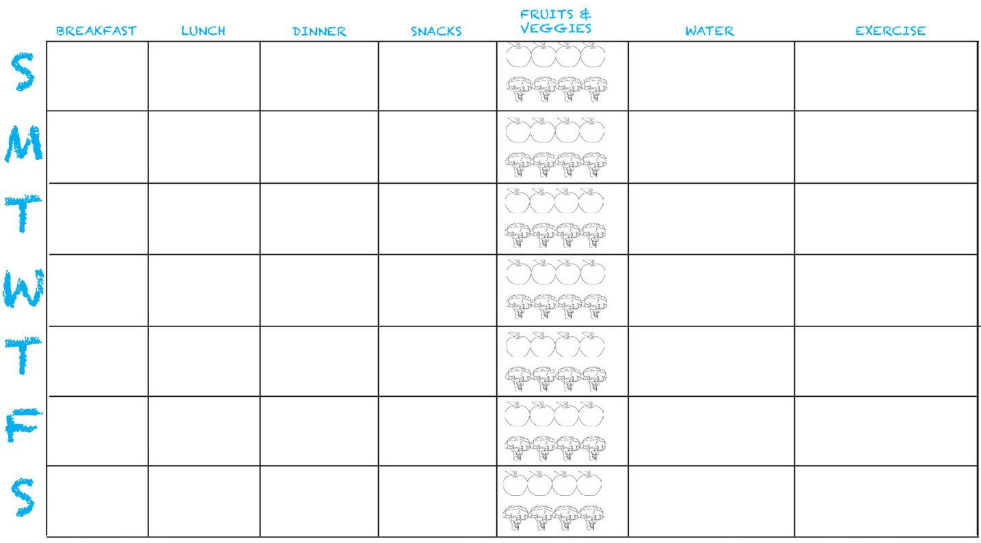
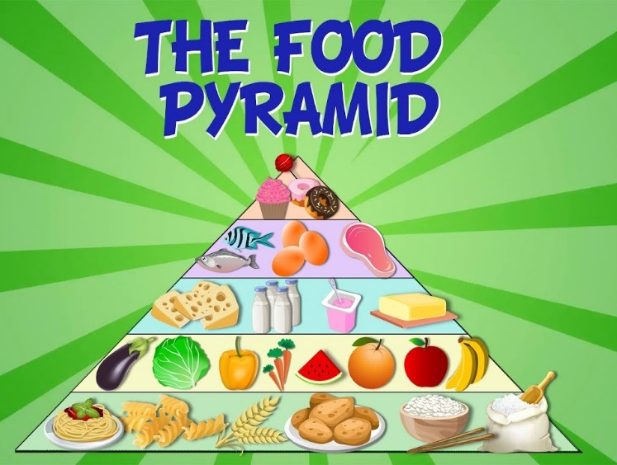
The Eatwell Guide shows how much of what we eat overall should come from each food group to achieve a healthy, balanced diet.

You do not need to achieve this balance with every meal, but try to get the balance right over a day or even a week.

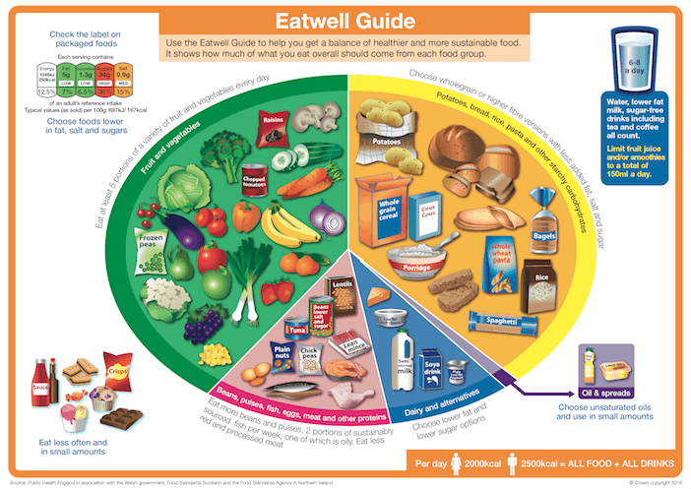

Healthy Eating Activities:
- Make your own healthy plate – draw a balanced meal using the Eatwell guide.
- Design your own lunch box for going back to school – what would it look like? Would it have extra cool features such as a milkshake machine or popcorn maker?
- “Supermarket Sweep” - get someone at home to create a shopping list and hide the food items around the house and/or garden. You must find all of the items on the shopping list in a given time frame!
- Do some research about your favourite foods – can you create a fact file or PowerPoint about the foods you like? For example: Pizza - where does this originate?
- Write an acrostic poem based on healthy eating. Some words you can use are: healthy, vegetables, water, energy…
- Try a food that you have never tried before – record what you think about it afterwards, did you like it? Did it taste how you imagined?
- Make a sandwich at home using bread and a filling.
- Have a go at making your own food – follow the instructions carefully
https://www.bbcgoodfood.com/recipes/collection/kids-cooking

Always have an adult with you in the kitchen when preparing food or ask permission first!

Staying Active
During lockdown we understand that it has been more difficult to get out and moving. There are many things you can do to stay active at home, which we are sure you have been doing. Here are some helpful tips and things to be aware of whilst at home:
- Dance to some music every now and then.
- Check your posture when you are sitting, be aware of your back rounding or becoming sore.
- Stretch your body every hour or so to prevent becoming sore and stiff.
- If you feel you have been sitting down for a long time, stand up, choose 4 movements or exercises and do these 10 times each.
For example:
10 squats
10 star jumps
10 burpees
10 second plank
- Get out each day for at least one block of outdoor exercise. The fresh air will do wonders for your body.
- Set yourself a goal each day. For example – complete 50 squats, hold a plank for 2 minutes, run for 10 full minutes. Achieving goals is a positive thing and you will feel good for it.

Here are a list of some child friendly exercise YouTube links:
https://www.youtube.com/user/SuperMoejones
https://www.youtube.com/results?search_query=joe+wicks+kids+workout
https://www.youtube.com/user/CosmicKidsYoga
https://www.youtube.com/watch?v=5if4cjO5nxo
https://www.youtube.com/channel/UCKE0Xnj818IDaHvIcRiq0Bg
https://www.youtube.com/watch?v=9anvE9BJHoo

At Home Sports Day
Why not host your very own sports day at home using these easy challenges? They can be completed indoors and outdoors.
Or complete them just as a bit of fun!
- Straw “javelin” throw – mark out 4 sections on the ground, throw the “javelin” and see where it lands. 1 point for the straw landing in the closest section, 2 points for the next section, 3 points for the next, increasing the points the further you throw.
- Toilet roll bowling – make a pyramid of toilet roll and try to knock down as many as you can by rolling a tin/full bottle/ball. 1 point for each toilet roll that is knocked over. You can do this with empty water bottles too.
- Egg and Spoon race – make sure the eggs are boiled or that you have something to protect your floor from gooey egg!
- “Washing Basket” ball – sit your washing basket on a chair or something even higher and make sure you have enough space to take AT LEAST 10 steps back. Take 5 shots at throwing whatever item you have into the basket – 1 point each time you get the item into the basket.
- Tik Tok “sock slide” challenge – that’s right, see who can slide the furthest in their socks! This must be done on a hard floor such as kitchen, laminate flooring or toilet. 5 points to the winner.
- Book stack race – you have 40 seconds to stack as many books (or whatever item you have many of) as possible without them falling over! One point for each item.
- Waddle race – Mark out a clear start and finish line, everyone must hold a balloon, ball or even a teddy between your knees and run to the finish line without dropping it! If you drop the item you must go back to the start. If you cannot complete this altogether then time each person separately. Winner takes 5 points
- Long jump – make a clear starting point and jump as far as you can. Make sure to place something down after you jump to compare distances at the end. Winner gets 5 points.

If you have some ideas of your own please share them with your classmates on Microsoft Teams!

Mental Health
Lockdown can be tough, you may feel restless, bored or even stressed. This can be for a number of reasons such as missing family, friends or school amongst many others. If you are feeling down or upset remember there are always people you can talk to be it at home and also through Microsoft Teams. There is always someone to help.
Mindfulness: being aware of our thoughts and feelings.
It is important to be aware of our thoughts and feelings so that we can recognise ways in which to support ourselves if we feel down. Mindfulness can make us feel very positive and content.
Here are 6 helpful mindfulness activities to try out.
Mindfulness colouring
Think about the emotion you are feeling right now, close your eyes and put a pencil down onto some paper, scribble away and let the feeling guide the pencil. Open your eyes and you will see a maze! Colour in all the gaps using colours and patterns. You may also have your own mindful colouring book.
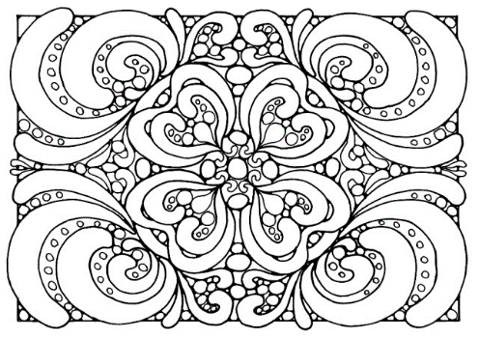

Mindful posing
- The Superman: this pose is practiced by standing with the feet just wider than the hips, fists clenched, and arms reached out to the sky, stretching the body as tall as possible.
- The Wonder Woman: this pose is struck by standing tall with legs wider than hip-width apart and hands or fists placed on the hips

Spidey Senses
Stop and be still – turn on your “Spidey senses,” or the super-focused senses of smell, sight, hearing, taste, and touch that Spiderman uses to keep tabs on the world around him. What do you notice? Can you make a picture of what you sense or describe it to someone?

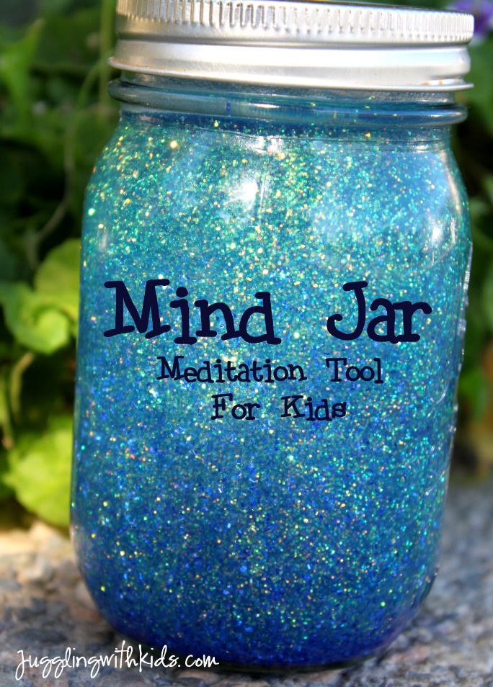
The Mindful Jar
- First, get a clear jar (like a Mason jar) and fill it almost all the way with water. Next, add a big spoonful of glitter glue or glue and dry glitter to the jar. Put the lid back on the jar and shake it to make the glitter swirl.
- The glitter in this jar is like an emotion – it can swirl around in out head and make us feel uneasy. Watch as the glitter settles. This is what will happen to your emotions too, everything will settle down.
“Imagine that the glitter is like your thoughts when you’re stressed, mad or upset. See how they whirl around and make it really hard to see clearly? That’s why it’s so easy to make silly decisions when you’re upset – because you’re not thinking clearly. Don’t worry this is normal and it happens in all of us (yep, grownups too).
After you have placed the jar down…
Now watch what happens when you’re still for a couple of moments. Keep watching. See how the glitter starts to settle and the water clears? Your mind works the same way. When you’re calm for a little while, your thoughts start to settle and you start to see things much clearer. Deep breaths during this calming process can help us settle when we feel a lot of emotions” (Karen Young, 2017).

Body scan
Lie down on your back on a comfortable surface and close your eyes;
Squeeze every muscle in your body as tight as you can.
Squish your toes and feet, squeeze your hands into fists, and make your legs and arms as hard as stone;
After a few seconds, release all of your muscles and relax for a few minutes;
Think about how your body is feeling throughout the activity.
This simple exercise allows you to be present in the moment and accept how you are feeling.
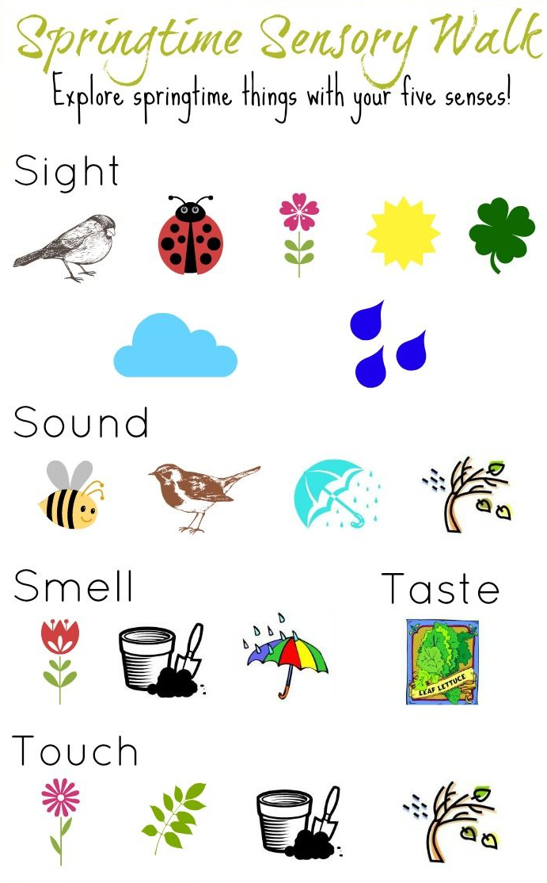
Safari/Mindful walk
If you can walk outside this is great, if not imagine you are outdoors in a safari or in the woods.
Your goal is to notice as many birds, bugs, creepy-crawlies, and any other animals as you can. Anything that walks, crawls, swims, or flies is of interest, and you will need to focus all of your senses to find them, especially the little ones!

Growth Mindset
We are all experiencing something very new just now, everything may seem different and even challenging, especially learning.
It is important to remind yourself that we are all in this together and that you are doing an amazing job just by being at home. Just keep going.
If there is something you are worried about forgetting or struggling with write it down and this can be your next goal. A goal that you will achieve be it now or later.
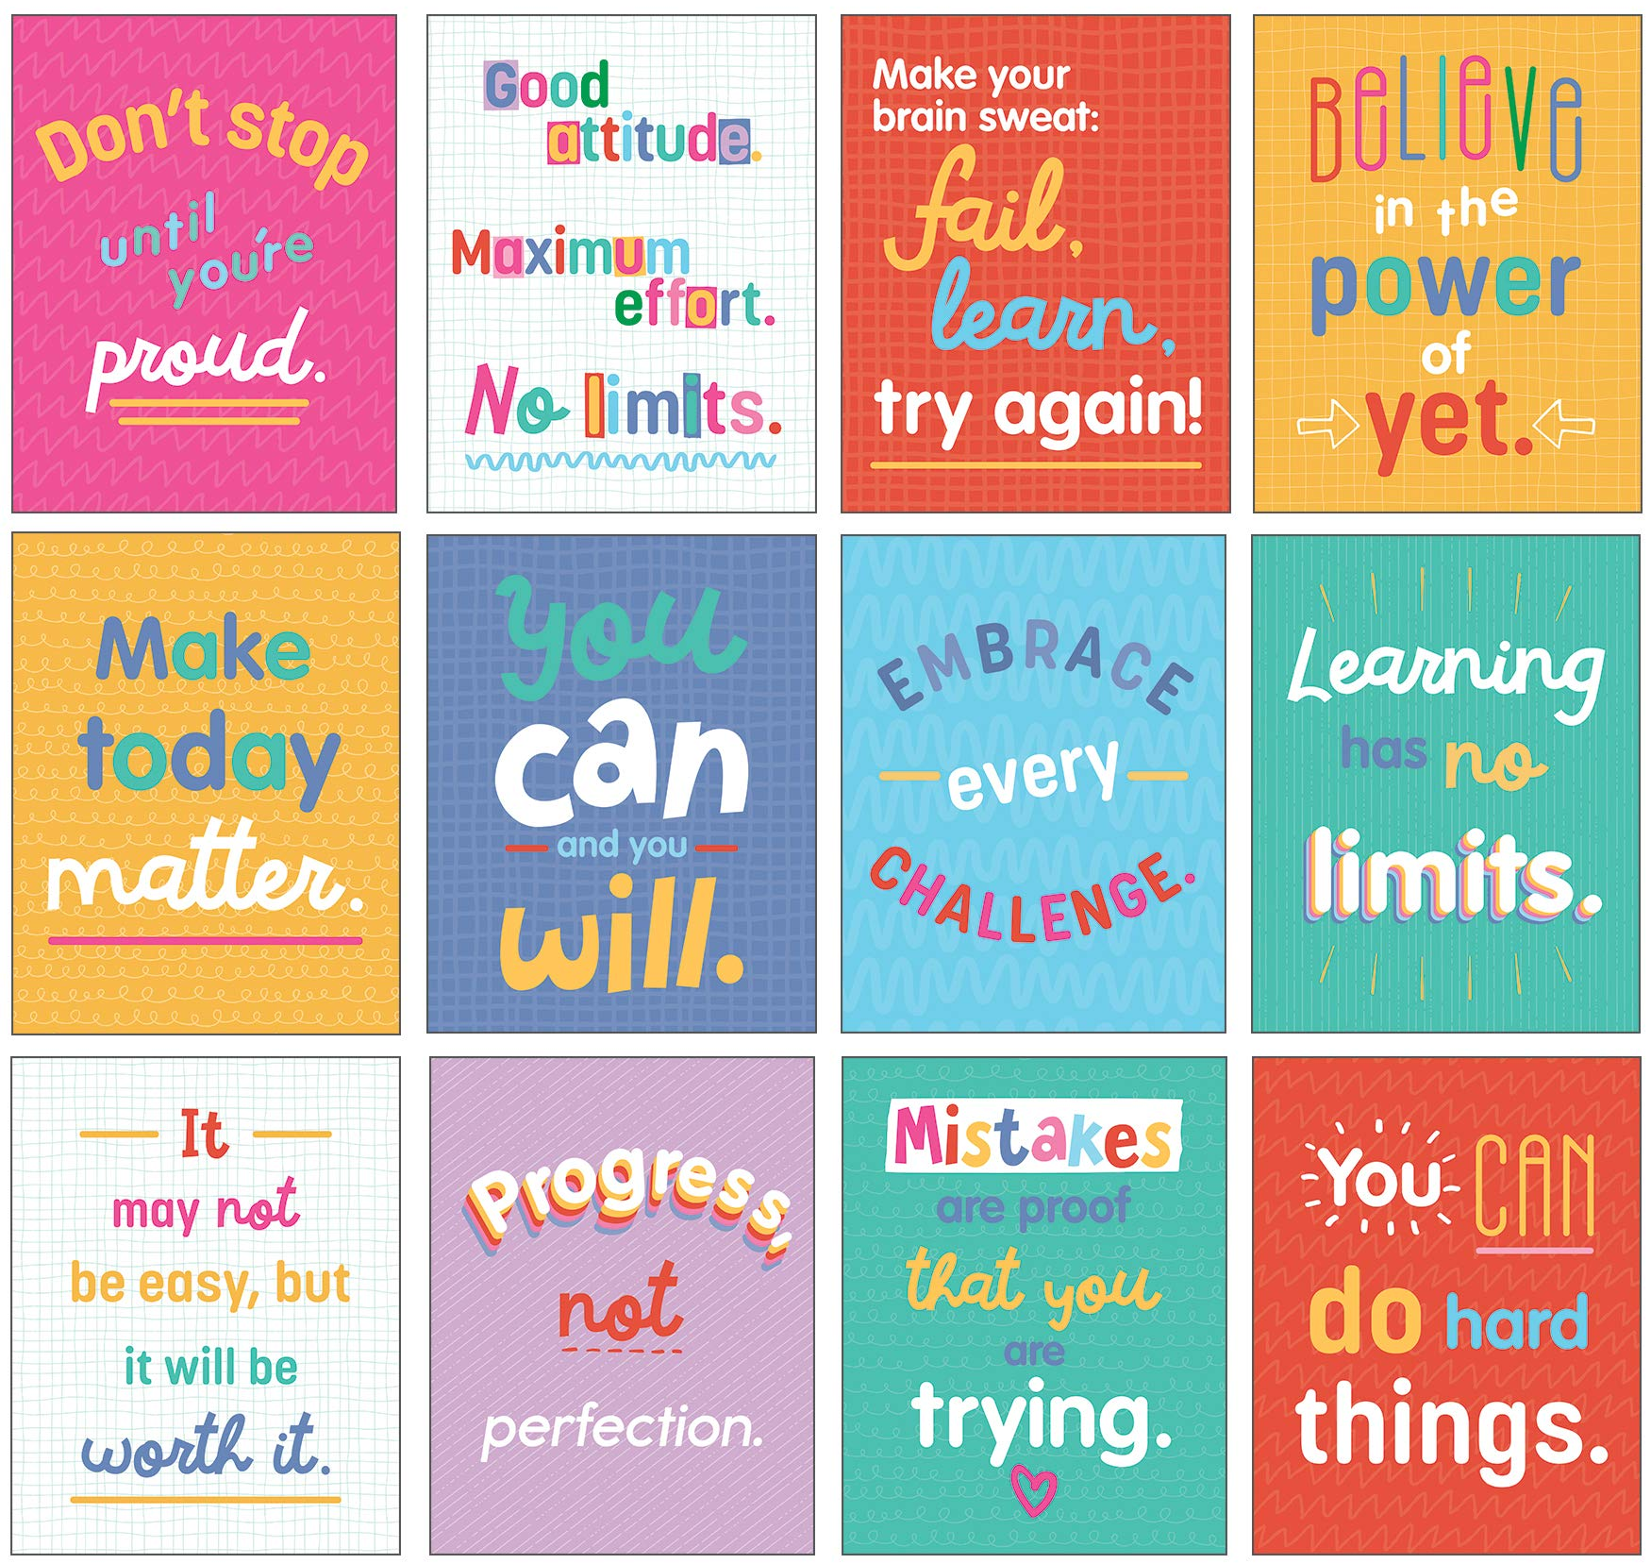

I can
Growth Mindset Activity
___________________________________________________
I can
___________________________________________________
I can
___________________________________________________
I can’t
___________________________________________________
I can’t
___________________________________________________

Yet, but I will one day!
Think of your own growth mindset quote and write it here:
______________________________________________________________________________________________________

SAMH is a mental health charity that have created a great list of simple things that you can do to help you feel less stressed or upset.
- Breathe
Take a long, deep breath in, feel your lungs expand like a balloon, hold for a moment, and then release slowly out through your mouth.

2. Laugh
Laughing increases your blood flow, boosts your ability to fight illness, and it feels really good.

3. Move
Jumping jacks, squats and burpees can all be done quickly. Moving relaxes the muscles, uses up adrenaline and releases chemicals that help feeling down.

4. Smile
Smiling releases chemicals that lower your blood pressure and increase relaxation.

5. Music
Listening to music can improve mood, reduce stress, and boost self-esteem.

6. Stretch
Stress can make us tense. When we stretch our muscles relax, blood flow increases and endorphins (happy hormones that come from out brain) are released.

7. Declutter
Sometimes tidying or giving some things away we do not need helps us feel less stressed.

8. Thankful
Reflect on the things you’re grateful for – people who do this regularly are less stressed and focus on more positive things.

9. Sigh
Relaxing your mouth and shrugging your shoulders sends a message to your brain to turn off stress!

10. Nature
Even if you’re not close to nature, just looking at photos of nature can reduce stress levels and improve self-esteem.
Competition time
Please submit your competition entries into the “Health week” folder on Sharepoint. There will be a separate “Competition” with each class having their own separate folder again.

Design your own healthy meal
*use this template or create your very own, be as creative as you like. You may even want to take a photo of your own meal!
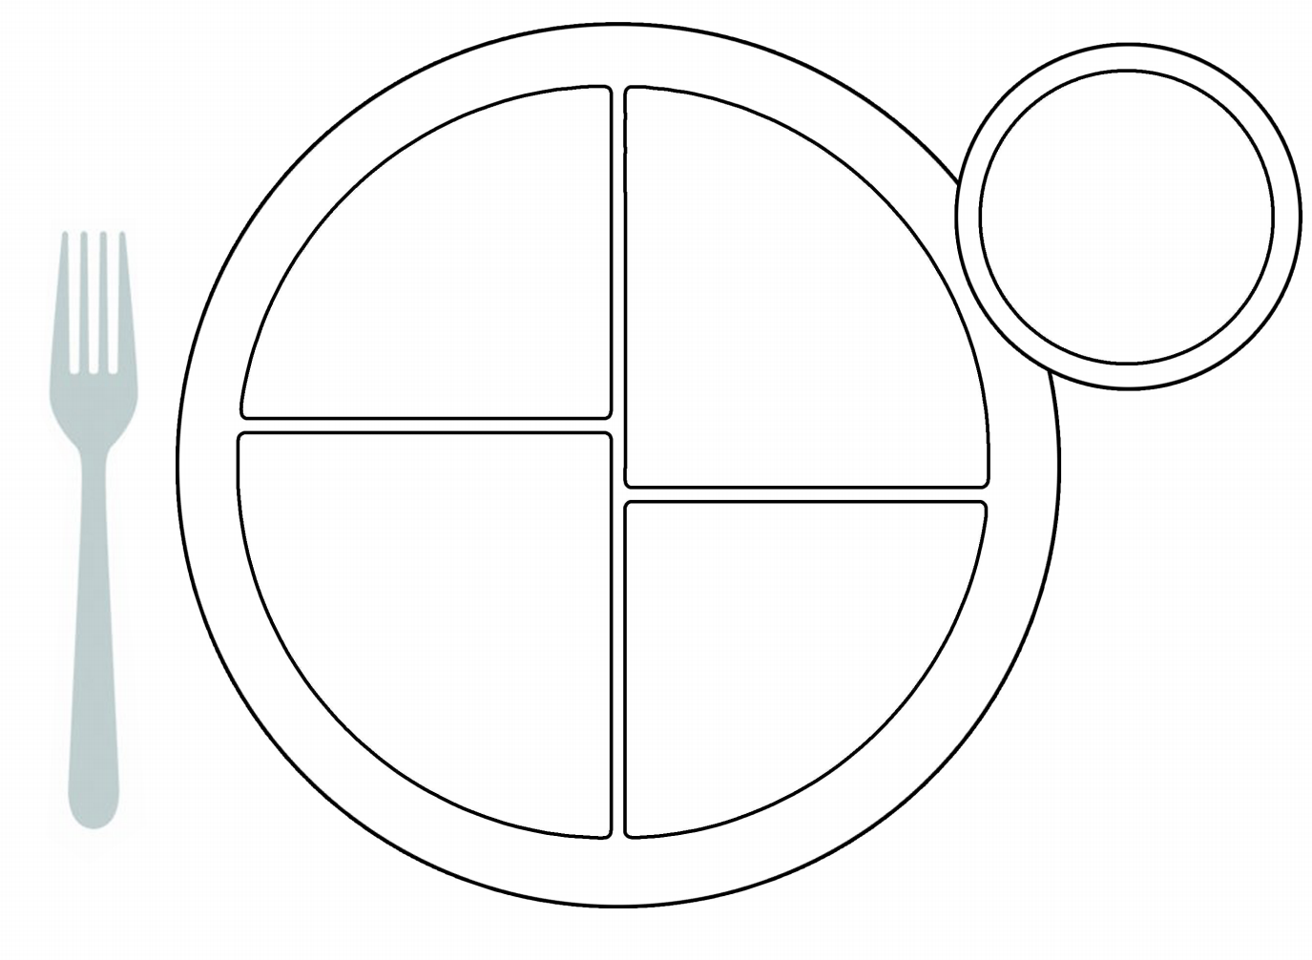

Design a sports day mascot
Here are some examples

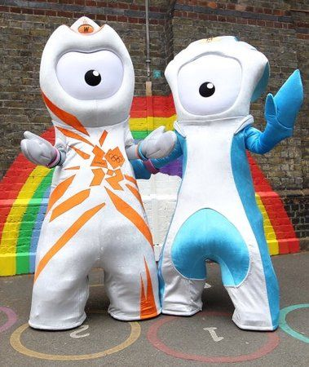

Create your own Positivity Poem
There are many types of poem that you can create.
Acrostic poem – uses the letters of a topic word to begin each line
Free verse – this can rhyme and be as long or short as you like
Limerick – a short and funny poem that is made up of 5 lines that rhyme
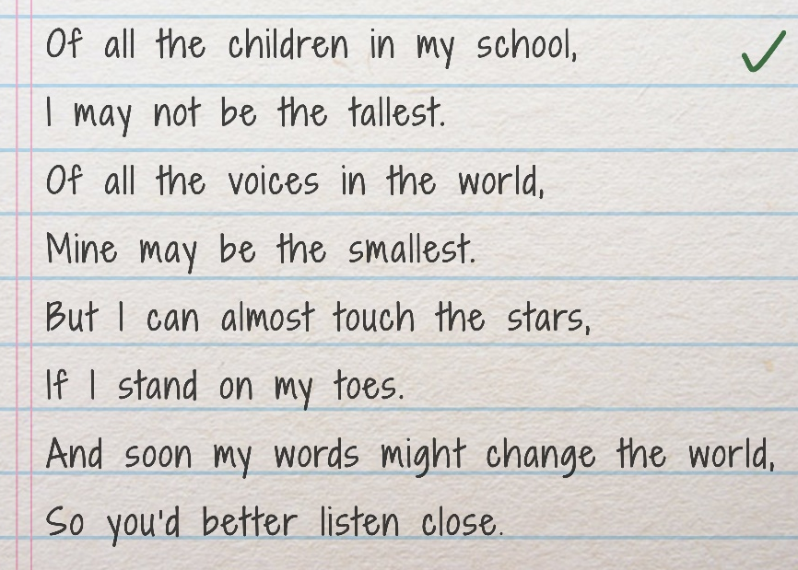
Examples of some positivity poems:

Evaluation/Feedback form P1-3
Please fill out this form and return it to your teacher via Microsoft Teams!
Feel free to complete this in any way you can, any feedback, pictures and stories you have to share will be greatly appreciated.

- Did you enjoy using this Health Week at home pack?

Yes / No

- What was your favourite part?

- What was your least favourite part?

- Extra comments/ what would you change?

Name _______________________________
Date ________________________________

Evaluation/Feedback form P4-7
Please fill out this form and return it to your teacher via Microsoft Teams!
Name _______________________________
Date ________________________________

Did you find this pack easy to use?
Do you have any suggestions to improve this pack?
What activities did you complete from this pack?

What did you like most about this Health Week pack?

