Langloan Nursery Class Home Learning – Week 6

Use YouTube and listen to Michael Rosen reading We’re Going on a Bear Hunt. Now talk about:  Who was in the story?  What happened?  What was your favourite part?  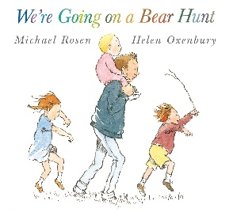 | Family Challenge  Can you go on your own Bear Hunt with your family?  - Where do you and your family like to go on your daily family exercise time?  - Can you think of your own story as you walk along i.e. walking along the pavement, at the park etc. | Fact Finding  Find out 3 facts about real life bears that you can share with your family. You could get an adult to write them down for you to help you remember.  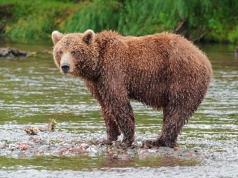 | School Web Page  Have a look at the photos we have posted on the school blog – The Great Outdoors!  Can you spot yourself?  Can you tell your family what is happening in each of the pictures?  How many different types of things are happening outdoors?  How many can you do with your family during your daily exercise?
Sound creation  Can you think of some different sounds for the bear hunt? What sounds would the family make if they went through a thunderstorm, along the beach or through a tunnel? | Sound station  How many things can you find around the house that make different sounds i.e. rice in a tin tray, water pouring from the tap etc. | Budding Artist  Draw a picture of your favourite teddy bear. | Paws to count  Bears have 4 paws. Can you draw a picture of 3 bears? How many paws do the bears have altogether?

