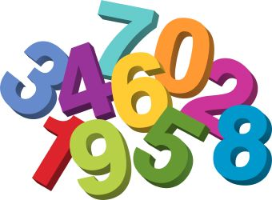
Langloan Nursery Class Home Learning – Week 5

Use YouTube and listen to the story of Elephants Cannot Dance! Now talk about:  Who was in the story?  What happened?  What was your favourite part?  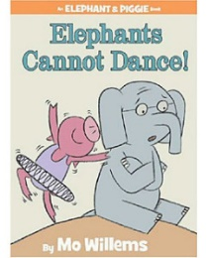 | Family Challenge  Can you make an outdoor dance mat?  - How big should it be?  - What are you going to use to make it i.e. chalks etc?  - Can you give directions i.e. Jump forward.  Jump to the side.  Jump backward.  Spin around. | Modelling Fun  Why don’t you use your Play-doh to make a model of little pig or Gerald the Elephant. | School Web Page  Have a look at the photos we have posted on the school blog – Our Active Bodies.  Can you spot yourself?  Can you tell your family what is happening in each of the pictures?  How many different types of exercise can you see?
Music Making  Use different pots and pans to make your own drum set. Use wooden spoons as drum sticks. Can you play along to your favourite tunes. Your family will love it!!!  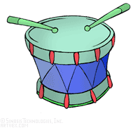 | Dance Night  Do you have a favourite song? Can you and your family make up a silly dance to it.  Have fun and post to your family and friends. Make them smile!  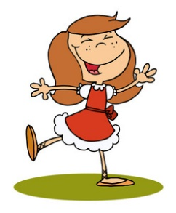 | Budding Artist  Can you draw a picture of Gerald the Elephant and his little pig friend. | Colourful Counting  Can you ask someone from your family to help you draw Craig the Crocs number picture?  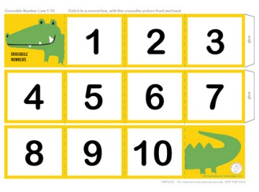  Can you write the numbers in all by yourself?

