Langloan Nursery Class Home Learning – Week 4

Read the story of Little Red Riding Hood. Now talk about:  Who was in the story?  Where was the story set?  What happened?  What happened at the end?  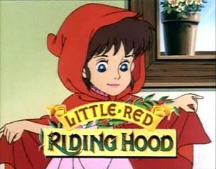 | Family Challenge  Can you make a basket for Little Red Riding Hood?  - How big should it be?  - What does a basket need?  - What are you going to use to make it?  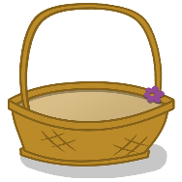 | Category Game  If you were packing a basket to take on a picnic what would you put in? | Memory Game  As a family try this fun memory game.  - Sit in a circle (or opposite each other)  - First person starts.  I went on a picnic and I took… (an apple)  - Next person.  I went on a picnic and I took an apple and some juice etc.  How long can you keep the game going for?
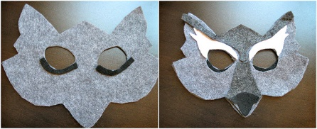  Mask Making  Use some paper plates and string to make masks of Little Red Riding Hood, Granny and the Wolf. | Role play  Can you find things at home to dress up as Red Riding Hood, Granny and the Wolf.  Can you put on a show for your family? | Budding Artist  Why don’t you use your paints or colouring pencils to make a picture of Little Red Riding Hood walking through the wood. | Colourful Counting  