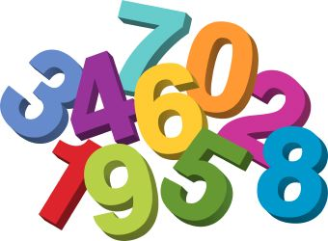
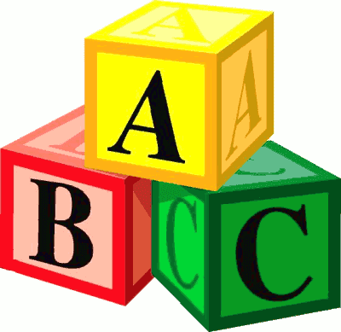
Langloan Nursery Class Home Learning – Week 3

Read the story of The Gruffalo. Now talk about:  Who was in the story?  Where was the story set?  What happened?  What happened at the end?  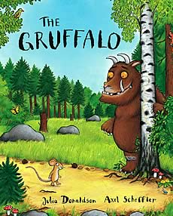 | How many syllables are there in these words?  Fox  Gruffalo  Nut  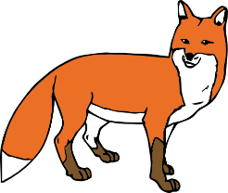  Can you clap them out? | Category Game - In one minute, name as many….  Animals  Colours  Food  …as you can think of | In Language Land we use a Magic Key which opens a Fairy Door. Describe what it might look, feel and smell like. Can you draw it?  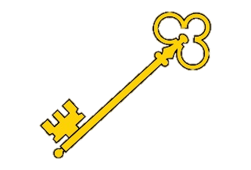  Upload your pictures to the school blog.
Think of as many words as you can which rhyme with:  Claws  Nose  Knees  This means they sound the same at the end, e.g. claws-jaws  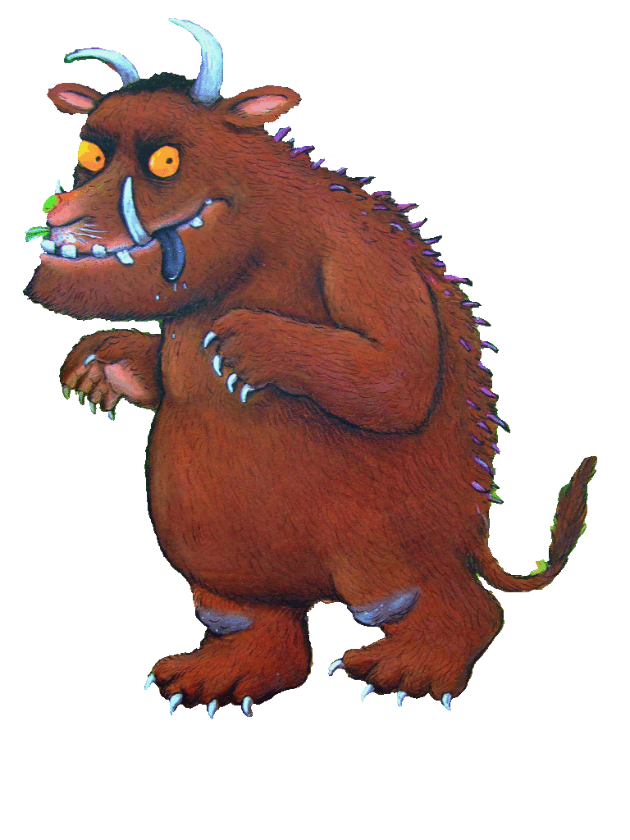 | Can you answer these questions?  Who lived in a logpile house?  Who has wings and a tail?  Who is the smallest person in the story?  Who is the tallest person in the story  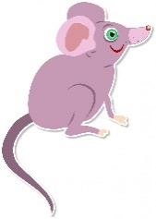 | How many doing words can you think of?  What does the mouse like to do in the wood?  What do you like to do in your garden?  What do you do in your bedroom? | Go around your house and collect a number of items:  What did you collect?  What does it look like?  (colour, shape)  How many items are in your collection?  Can you write the number symbol?

