Langloan Nursery Class
25/03/20
Read the story of Goldilocks and the Three Bears.  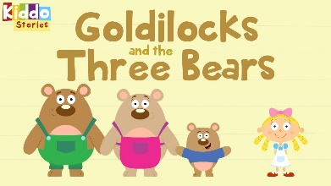 | As you read the book, help your child to use the pictures to try and say what is happening in the story. | Play a game of I Spy using the pictures in the story.
Draw a picture of your favourite part of the story.  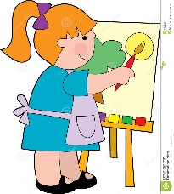 | Can you find things at home that are different sizes i.e. chairs, bowls, spoons and beds. | Make a number line together.  Help your child count forwards using the number line.  Clap, stamp or shout as you go.

