Langloan Nursery Class
01/04/20
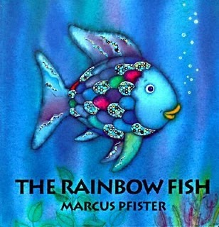  Read the story of The Rainbow Fish  by Marcus Pfister.  If you don’t have a copy at home use Youtube. There are some great versions there. | The Rainbow Fish  Try and answer the following questions.  Where is the story set?  Who is the main character?  Can you use the pictures to help you retell the story to someone in your family.  family? | 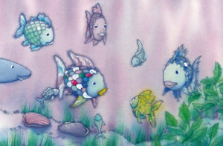  How many fish can you see? Can you write this number?
Rainbow fish hasn’t been feeling well. Can you ask an adult or older sibling to draw this outline? Can you use colourful paints or pens to make him feel better? | When you’re playing in the bath tonight can you find different things that float / sink? What toys would Rainbow fish like to play with? | Make a number line together. Try counting from 0 – 10.  This week play different counting on games i.e. you count 2,3 your child should say 4,5 etc.

