Kirk o’Shotts Primary School

Promoting Positive Behaviour

2016

Promoting Positive Behaviour

At Kirk O’ Shotts Primary School and Nursery Class, we recognise that in order to maximise learning and teaching, children must be taught and encouraged to foster appropriate positive behaviour and mutual respect for all.

Aims:

- Provide a safe and secure learning environment
- Ensure parents are aware of the school’s positive behaviour policy
- Encourage and model high standards of social behaviour
- Promote an ethos of respect for self, others, school property and belongings
- Through praise and encouragement, promote good behaviour
- Adopt a consistent approach to sanctions and rewards

Outcomes:

- Through positive social behaviour, we will show pride in our school
- All children will have the opportunity to reach their full potential without repeated disruption to their learning
- Parents will be encouraged to work in partnership with the school to encourage positive behaviour

Rewards

In addition to classroom awards, children will be rewarded at weekly assemblies for various achievements. One of our challenges to pupils is the four capacities trophies which are awarded weekly to pupils who display the skills and attributes of these capacities.

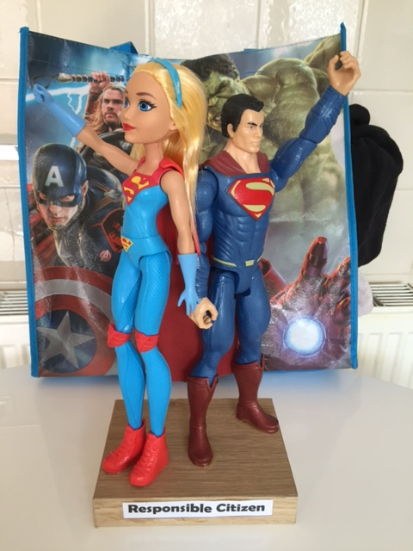 | 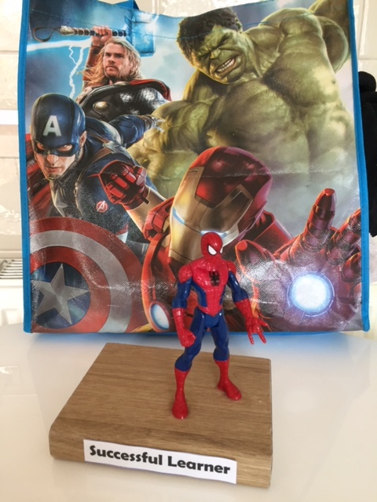
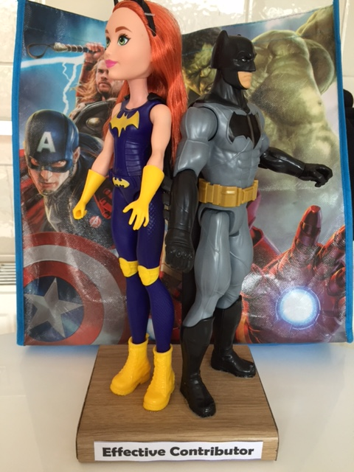 | 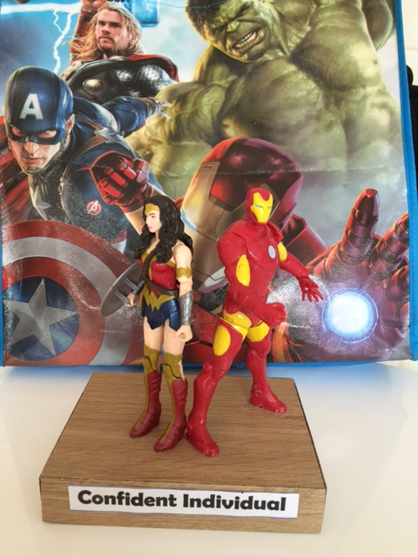

Our Rules

The following rules have been agreed with children in order to create a consistent approach to promoting positive behaviour. Pupils have also developed ideas through Thinking Circles for actions that will be taken if these rules are broken.

School Rules
1. I will walk in an orderly manner.
Walk in a single file line. | No talking when in a line.
Stay one behind the other.

2. I will respect everyone.
I am kind to others. | No rolling your eyes, huffing or puffing.
I treat others the way I wish to be. | No shrugging your shoulders.
I care for other people, places and | No answering back.
Things. | No interrupting when adults are talking.

3. I will not hurt anyone with my words or actions.
I am kind and gentle | No hitting, kicking or physically hurting others.
I can give compliments to others. | No teasing or name calling.
I can say nice things | No spreading rumours.

4. I will show good manners to everyone.
Say please and thank you. | No disrespectful behaviour
When told to stop talking do it immediately.
Hold doors.

5. I will work hard.
Listen carefully to everything. | No chatting about other things when working.
Work at a good pace. | No rushing your work.
Come prepared for every subject.

Take pride in your own work.

Sanctions

Pupils will always be given an opportunity to change their behaviour before they lose Golden Time.
- Children will be given two verbal warnings and then they will lose 10 minutes Golden Time on the third.
- They will then be given another two warnings and will then lose another 10 minutes Golden Time.
- After a further two warnings, they will lose their last 10 minutes of Golden Time.
- Staff will record which rules have been broken on their Loss of Golden Time chart and any child who has lost Golden Time will report to the management team at the beginning of Golden Time.
- SMT will discuss with the children what went wrong and ask them to consider how behaviours can be improved. They will write out the rules that they have broken as a reminder for what they need to work on and perhaps will write a letter of apology depending on the situation.
- A letter will go home so that parents and carers can see which rules have been broken so they are able to reinforce the positive behaviour strategies at home.
Additional certificates for academic achievements or outstanding behaviour/effort will still be given at the teachers’ discretion

