Knowetop Primary School
Knowetop Avenue
ML1 2AG
Twitter: @KnowetopPrimary
Email: Enquiries-at-knowetop@northlan.org.uk

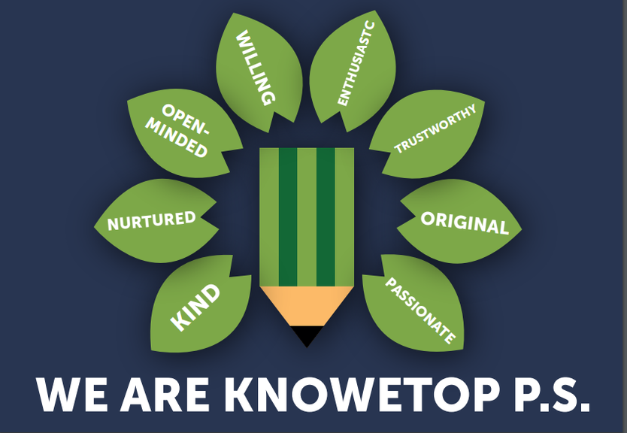
Our Vision: Through education with imagination, we will challenge, achieve, and excel.

Dear Parents and Carers,
It may have been a three-day week for Knowetop but that certainly hasn’t slowed things down. Mrs McClymont has had some of her cross-country runners competing in an event in Shotts, Mr Stewart took Primary 5 footballers to a friendly at Glencairn and pupils have enjoyed after school multi-sports in Primary 4 and Primary 6, tennis for Primary 3 and sewing for Primary 7.
Miss McNamara and her Anti-Bullying group have led activities in school this week for Anti-Bullying Week and Mrs McAlister and Miss Torley continue to prepare for next week’s Rights Respecting Gold accreditation visit. Primary 7 pupils attended the Dalziel High Health Fayre on Wednesday and then a STEM transition event today also at Dalziel High.
Please keep up to date with all our pupil achievements and news featured on our Twitter feed @KnowetopPrimary
I hope this newsletter keeps you well informed and if there is anything we can do to help, please do not hesitate to get in touch.

Mr Gordon Murray
Head Teacher

Primary 1 Workshop
I just wanted to remind you about this offer. My previous message is below.
Our Primary 1 teachers would like to offer a workshop for current Primary 1 parents to go over how we teach reading, spelling and phonics. Now that children are settled in and working through their literacy and numeracy programmes, we feel this would be a good time to go over key aspects of the curriculum. We will be offering this on Friday 1st December at 2pm and it will take place in the Primary 1 extension. We thought this would be a good time as you could then collect children at 3pm. I appreciate it is not always easy to get time off during the day so we will post notes and guidance on class Teams pages afterwards. If you would like to come along to this event, please fill out the form following the link below and Mrs McCallum, Miss Torley and Miss Hendry will look forward to meeting with you.

https://forms.office.com/e/sz6u3yL3S3

Book Week Scotland
Thank you to all our volunteers who have been in this week reading to our children. Pupils have loved having visitors in school and judging by the volunteer comments, they enjoyed the experience as well.

Cross Country
Congratulations to some of our Primary 7 runners who have qualified to take part in the NL Finals in March. We look forward to supporting Orla Sheerin, Luke Geddes, Noah MacGregor and Adam Crane and thanks to Mrs McClymont and Mr McCulloch for leading our running club.

Children in Need
Thank you to everyone for supporting out Children in Need collection today. I am pleased to say that we have raised £532 which will help support children everywhere. Pudsey even popped in today to say thank you.
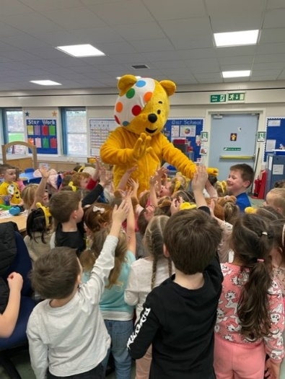
Twitter Feed
We have been working hard to get all of our classes represented on our school Twitter feed and I am really proud of our staff and pupils for the amount of great work they are showcasing on Twitter. Over the last few weeks, it is clear that we have a wide variety of experiences happening at Knowetop and we plan to continue to develop our curriculum offer further throughout the session. If you get a chance, please have a look at the many things we have going on both in classes and in the wider school community.

In-Service and By-Election
All staff have been working hard this week on various aspects of school development. We had a follow up session with our school psychologist, Elaine Reid on using the resilience toolkit to further develop the quality of our Getting it Right for Me (GIRFme) plans. We spent some time updating and analysing our tracking and monitoring of attainment and planned our next steps in this area. Mrs Smith led us in a session using the Meta-skills Toolkit which allowed us to asses our current curriculum offer and think about how we would identify and develop the key skills that children will require in the future workforce.

Flu Immunisation
I have copied the message below sent out earlier in the week from Mrs Clark as a reminder.
The Flu Immunisation Team will be coming into the school on the 21st November. They have advised that they will NOT be contacting any parents, on the day, of the children who they do not have forms for. If you have lost or not handed in the Form by that date then please contact:
Tom Morrison
School Immunisation Team
07966 296 416

Primary 7 Enterprise
I wanted to remind you that any Christmas order for the P7 enterprise products need to be in by the end of next week to ensure everyone gets what they have ordered. The catalogue is now live for anyone to order from so please follow the link below to browse their products. All profit from this venture will be going towards supporting the P7 residential trip after Christmas.

https://glowscotland-my.sharepoint.com/:b:/g/personal/nlthame_glow_sch_uk/EfEavv6W4oFDrUQdLRx32zwBZvPWNwq0XYtpvUWdB8YKoA?e=VzExUh

Raffle Tickets
Thank you for sending in raffle ticket money and I just wanted to share what some of the children’s prizes are, so you know what you are buying tickets for. Please see below for some of the prizes.

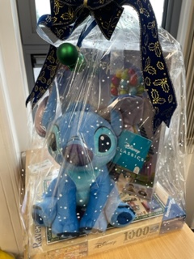 | 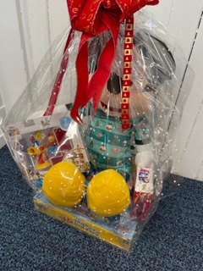 | 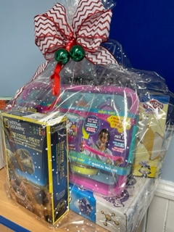

Adult prizes will be available to view on the Parent Council Facebook page as part of the online Christmas fayre starting on 19th November.

Knowetop Uniform Shop
Items can be requested from the shop through their Facebook page Knowetop Uniform Shop or by emailing suzannemagowan@hotmail.co.uk. All items are pre-loved or nearly new and are completely free to anyone who wishes. Help us to reduce, reuse and recycle at Knowetop.

Knowetop Parent Council
https://www.facebook.com/KnowetopPC
Co-Chairpersons: Mrs Ali Holmes and Mrs Laura Arthur

Christmas Fundraising
We wanted to remind you that the order window for the Christmas products children designed will reopen from 17th-24th November for any last orders to be placed.

Online Christmas Fayre
🎄🎉 The Knowetop Primary Parent Council invite you to join in the festive fun at our Virtual Christmas Fair, going live THIS SUNDAY (19th November) and running until Sunday 3rd December. Please make sure to join our separate facebook group where the fair will be held - https://m.facebook.com/groups/421288359393678/🎅✨

Every day, a different stallholder will be showcasing their festive gifts, sweet treats, and services. The Parent Council will also be hosting a day with specially crafted Christmas items; as well as a special day hosted by our P7 enterprise project. 🎁🛍

As well as the fair, we also have our festive raffle. Please return your raffle envelopes to the school, sent a couple of weeks ago in school bags, by Friday 24th November. The raffles will be drawn in school on Friday 1st December. The adult raffle will be recorded and posted on our facebook group later that day.

A heartfelt thank you to our incredible stallholders, as well as the other local businesses, and generous parents who have contributed to our raffle prizes. Your support ensures that all funds raised will, as always, provide our school and the pupils with exciting activities, experiences, and essential equipment. 🙏🎊

Please spread the holiday cheer and invite your friends and family to the virtual fair group, to help raise as much money as we can for our school. Thank you.

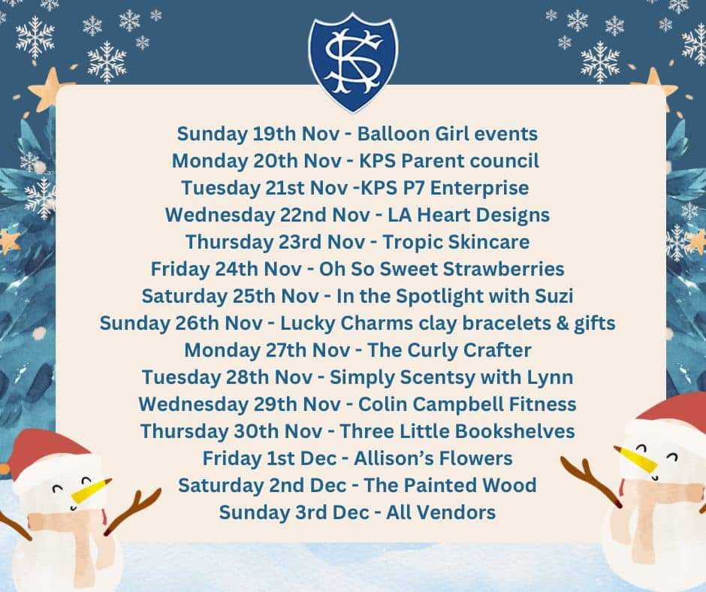

Flashback Photo
We found some old photos this week and thought it may be nice to share some. Here is one from early 90’s. We think we can spot a few current parents. Enjoy.

