Knowetop Primary School
Knowetop Avenue
ML1 2AG
Twitter: @KnowetopPrimary
Email: Enquiries-at-knowetop@northlan.org.uk

Our Vision: Through education with imagination, we will challenge, achieve, and excel.

Dear Parents and Carers,
We have been very proud of our Primary 7 pupils this week who have been preparing and presenting their House Captain speeches. Votes were counted throughout Thursday and Friday and children were informed today during assembly of the successful candidates. We are looking forward to seeing everyone next week during our Open Day on Tuesday and also at our disco on Wednesday night.
Please note that next week is a four-day week due to the September Weekend. School will be closed to all on Friday 22nd September and Monday 25th September.
Please keep up to date with all our pupil achievements and news featured on our Twitter feed @KnowetopPrimary
I hope this newsletter keeps you well informed and if there is anything we can do to help, please do not hesitate to get in touch.

Mr Gordon Murray
Head Teacher

Attendance
We have had a great start to this session with regards to attendance and here are our percentages for the first few weeks back. Hopefully we can work together to maintain this high level of attendance.

There can be issues around why children are not attending school and Knowetop are committed to finding the best ways possible in supporting attendance of pupils at school. I have attached an attendance guide to this email which details supports available from North Lanarkshire Council.

Open Day
We are looking forward to seeing our parents and carers pop in next week on Tuesday to visit our classrooms. Thank you to everyone who has signed up for a session and if you haven’t had a chance yet then please follow the link here. On Tuesday, please come to the main entrance when you are attending. There will be a QR code for you to scan on entry and this is simply to register that you are in the building in the event of a fire.

When you arrive, you will be directed to your child’s class where you can pop in and let them show you around and see what they have been working on. The teacher will be there for you to meet and say hello with the children working at their desks. There won’t be an opportunity to have a discussion with the class teacher as she/he will have lots of parents in class in addition to their pupils. Parental meetings will be coming up soon which will provide an opportunity for this. There will be space outside the classroom to leave any buggies as we won’t be able to have these in classrooms.

All lost property which we have collected will be available in the gym hall for you to have a look through and see if anything belongs to you. Representatives from our uniform shop will also be available in the hall to help organise any uniform items you need.

If you are still having trouble accessing Teams or GLOW, Mr McCulloch will be available in our Digital Technologies room to help support getting you logged in and set up. Mrs Clark from the office will also be available with any Parents Portal questions you may have.

When you have finished your classroom visit then please make your way to the main entrance to exit. As mentioned previously, if you are coming to the afternoon slot you are welcome to take children away early to save you coming back at 3pm.

House Captains
Well done to all our Primary 7 pupils who prepared a House Captain speech. They all put in an incredible amount of effort, and we are very proud of them. Congratulations to all successful candidates and there will be lots of opportunities for all pupils who want to be involved in the life and work of the school. Our captains elected today are.

Allan House Captain: Lucy Campbell
Allan Vice-Captain: Millie Clarkson
Prefects: Greg Barclay and Calvin Arthur
Inglis House Captain: Luke Geddes
Inglis Vice-Captain: Ben Hamilton
Prefects: Imaan Hussain and Emily Kippen
Preston House Captain: Noah MacGregor
Preston Vice-Captain: Anthony Mollon
Prefects: A.J Milton and Sophie McGrath
Ritchie House Captain: Freya Sullivan
Ritchie Vice-Captain: Aria Stewart
Prefects: Fraser Watt and Manal Siddiqui

Wall Panels
We are really pleased with our new wall panels which have been installed by our friends at Miyo Apparel to help improve areas around the school. The children designed these and here is a sneak peek at a few of them.

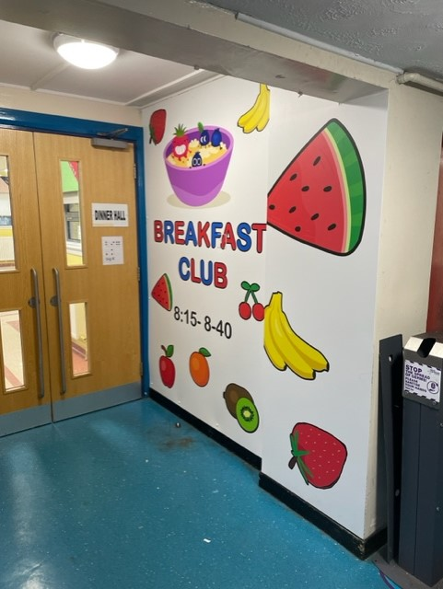 | 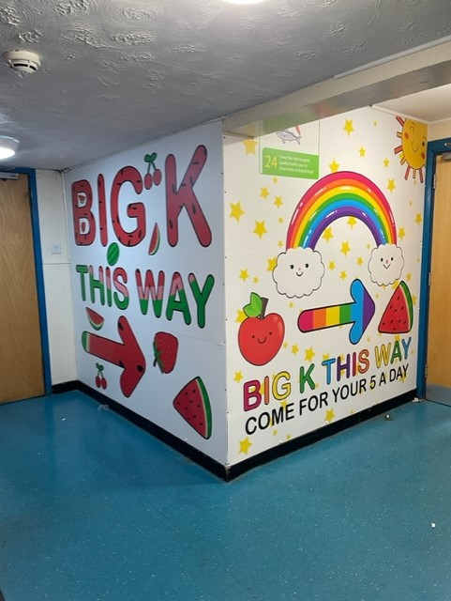

Welder
I just wanted to acknowledge a really nice example of kindness in our community this week. We are having issues with our bin area as often our bins are damaged – lids broken etc and we had to replace one this week which would have cost around £600. However a local welder, John McDade of George McDade and Sons Ltd, repaired it for us for free as we are a school and I really just want to say a big thank you and that we appreciate this gesture.

Playground Parents
One of our parents, Mr Fraser Irving, has volunteered to help improve aspects of our infant playground. He will be doing some repairs to our train and repairing/ creating a new playhouse. He has pallets to help with this work but is looking for any donations of outdoor paint, spare wood and any artificial grass. If you have anything which maybe of use, could you please contact the Parent Council Facebook page or school enquiries.

Knowetop Parent Council
https://www.facebook.com/KnowetopPC
Co-Chairpersons: Mrs Ali Holmes and Mrs Laura Arthur

Children have all completed their Christmas card design and they are now being send away. We will be in touch with order dates and pricing for you soon.

We are looking forward to our first disco of the year taking place on Wednesday 20th September. Entry is free and all pupils will receive juice and crisps free of charge.

Disco Arrangements

P1-3 Disco
Please bring children to the main entrance where you will find a QR code to scan. Please scan this before entry and put in your child’s name and class to register their attendance. Children will be taken from the main entrance through to the gym hall and adults will be asked to make their way out via the extension door. If any children are unsure or feeling overwhelmed, we will have a quiet room where they can have a play, colour in, speak to friends etc.
When you come to collect children at the end of the disco, please come to the main door. We will show you through to the gym hall where you can collect your child and exit through the door nearest the carpark.

P4-7 Disco
Please bring children to the main entrance where you will find a QR code to scan. Please scan this before entry and put in child’s name and class to register their attendance. Children will be asked to go to a holding area until we get the younger children out of the hall. At this point we ask adults to exit through the extension doors or make your way to the gym hall if you are collecting a younger pupil.
When you come to collect children at the end of the disco, please come to the main door. We will show you through to the gym hall where you can collect your child and exit through the door nearest the carpark.

Knowetop Uniform Shop
Items can be requested from the shop through their Facebook page Knowetop Uniform Shop or by emailing suzannemagowan@hotmail.co.uk

Parent Council Message
Please see a message below from the Parent Council.

Hi Everyone,

A new term brings a new start and some new names onto the Parent Council. The role of Chair is being shared by myself (Ali Holmes) and Laura Arthur and we wanted to introduce ourselves to you...

I (Ali) have two children, one who has just taken the step into High School and my youngest is in Primary 5. I'm a part time lecturer at New College Lanarkshire where I work with students with additional support needs and mainly teach Music and Drama. Those who know me will testify to the energy and fun that I bring and hope to put into the Parent Council events this year! These events aren't possible without the help from the current team and also all the parents who get involved throughout the year and from experience, they are always great fun!

Laura also has 2 children, one in 3rd year at Dalziel and her youngest is in his last year of primary. Laura is a service manager in Adult and Older peoples social work and has been a member of the parent council for quite a few years, she is delighted to be sharing the chair role for her last year around the school!! Whilst she may have a very professional job, she admits to being a tad disorganised and flying by the seat of her pants. Don't worry, it will all be fine because....

Joanne Hogg who was our Chair last year has stepped down into the Vice Chair role so is very much still a part of the Parent Council. Thank goodness she is so organised as she will have her hands full keeping Laura and I on track!!

We already have some events in the calendar and will be updating you all soon on other exciting plans that we hope you will get involved with.
Knowetop Primary is a great school and with a role of almost 500 we want to make sure EVERY child benefits in some way with the money we raise. Last year we raised a very healthy amount and were able to donate £6000 to the school to buy much needed digital equipment. Lets smash that this year and raise even more money!! We have also been able to run the disco's at no cost to the children - other than the tuck shop!

Please follow the Knowetop Parent Council Facebook page if you are able to. This is NOT just for Parent Council Members but a page where key information is regularly shared. We also have our fabulous Knowetop Uniform Shop page where you can ask for any school clothing and if Suzanne has it in stock she will happily co-ordinate with you. I've used the shop for many years now and encourage other parents to do the same, the cost of living is squeezing us all so we should use this wonderful facility to the full. The shop is always there to accept donations of your pre-loved school clothing that still has some life in it although with the rate boys go through the knees of trousers it's understandable if you can't donate them! If you are not on social media but are looking for something specific or have a general question then please email the parent council using the following address - knowetoppc@gmail.com and someone will get back to you ASAP.

Please remember we are all volunteers doing this. We are giving up our own time to give all the children at the schoool as many opportunities as we can and we need your help to run and support these events. The meetings aren't too bad either.... maybe the parent council could stretch to a box of biscuits at the meetings this year?? On a serious note, the meetings are roughly 2 per term and are usually pretty slick with some good discussions to be had. I have to say, Joanne ran a very tight ship during the meetings with her amazing organisation skills and Laura and I hope we can continue this level of professionalism.....we can hope!!

I do hope to see some more faces at the meetings and if you have any questions please don't hesitate to get in touch.

Thanks,

Ali and Laura

