Knowetop Primary School
Knowetop Avenue
ML1 2AG
Twitter: @KnowetopPrimary
Email: Enquiries-at-knowetop@northlan.org.uk

Our Vision: Through education with imagination, we will challenge, achieve, and excel.

Dear Parents and Carers,
Thanks to everyone for continuing to sign up to Parents Portal and getting children signed back into GLOW and Maths Factor. As always if you are experiencing any issues with these systems then please email us and we will get to it as soon as we can. We had a great assembly today with participation from a few of our classes and we enjoyed celebrating wider achievements and Weekly Wonders. Pictures from assembly will be added to Twitter soon.
Please keep up to date with all our pupil achievements and news featured on our Twitter feed @KnowetopPrimary
I hope this newsletter keeps you well informed and if there is anything we can do to help, please do not hesitate to get in touch.
Mr Gordon Murray
Head Teacher

Meet the Teacher
We will have an open day on Tuesday 19th September where parents will be invited in for a brief visit to their child’s class. Children can show their adult around and you will be able to say a quick ‘hello’ to the teacher. Parents and carers can pop in anytime between either 9.30-10.30am or 1.30-2.30pm and staff and older pupils will direct you to the correct class. If you have more than one pupil at the school then you can spend a few minutes in one class and then move on for a visit to the next. Please note this won’t be a face to face discussion with the teacher as we have lots of pupils in our classes but is just an opportunity to let you in to see where children are working. If you decide on the 1.30-2.30pm slot then you are welcome to take children away a little earlier that day if you wish. We will have a space where staff can support any issues or access to GLOW, Maths Factor etc.
We will send out a Form link in next week’s newsletter so that you can sign up for one of the sessions. This will help us control the number of adults we have around the building for each session.

TEAMS
I know various people have had difficulties getting logged into Microsoft Teams and part of the issue seems to be if you have various users in the one household using the app. If parents and children are all using Teams then it seems to work more effectively web based rather then using the app to switch between accounts.

First News Digital Newspaper
As part of our work on developing our range of reading materials, we have subscribed to First News Digital which is a weekly newspaper produced online aimed at children. We will be using this in class to promote discussion and learning around key events happening around the world. Children are welcome to login at home each week to have a look through the latest news and you are welcome to look through and read with younger pupils. The newspaper goes live each Friday and you will find it on login.firstnews.co.uk. It will then ask you for a code and the following code should be entered - UCAL2289.

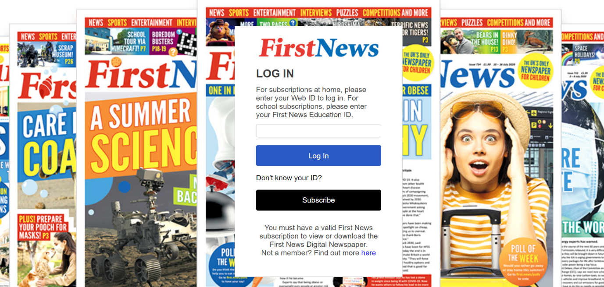

Respecting Staff and Pupils
I wanted to remind everyone that when adults are in school collecting children from our office (or anywhere) that our staff should be treated respectfully. We have had an incident with parents/ carers using inappropriate language directed towards staff which is not acceptable. The school office is also the central hub of our school so often pupils will be in and around this area and they should not be subjected to this kind of language. As always, if there is anything you are unhappy about or require assistance with then please contact myself and I will deal with your concerns.

Knowetop Parent Council
https://www.facebook.com/KnowetopPC
Chair Person: Mrs Joanne Hogg

Please see below the details of our Parent Council AGM. Everyone is welcome to attend.
Knowetop Parent Council Meeting - AGM
Thursday 7th September 2023
Knowetop Primary School – Knowetop Avenue, Motherwell 7-8.30pm
Knowetop Uniform Shop
Items can be requested from the shop through their Facebook page Knowetop Uniform Shop or by emailing suzannemagowan@hotmail.co.uk

