Knowetop Primary School
Knowetop Avenue
ML1 2AG
Twitter: @KnowetopPrimary
Email: Enquiries-at-knowetop@northlan.org.uk

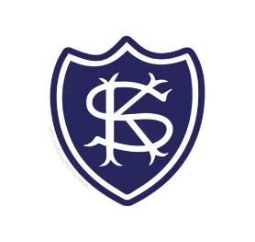
Our Vision: Through education with imagination, we will challenge, achieve, and excel.

Dear Parents and Carers,
It has been another fun, busy week at Knowetop and with the sun shining, we have had more classes making use of the outdoor space throughout the week. Our Primary 7 pupils are working hard on their House Captain speeches and we look forward to their election next week. We have started a ‘Line of the Week’ award this week to try and work on lining up outside and getting ourselves organised quickly. Check Twitter later on to find out who our first winners were.
Please keep up to date with all our pupil achievements and news featured on our Twitter feed @KnowetopPrimary
I hope this newsletter keeps you well informed and if there is anything we can do to help, please do not hesitate to get in touch.
Mr Gordon Murray
Head Teacher

TEAMS
We are still experiencing quite a lot of Primary 1 pupils unable to log into GLOW. If you are having these issues (or any other year group) please email our Enquiries and we will reset passwords as soon as possible.

Communication
Over the next few weeks we will update our communications policy as we have had changes due to the School App being removed and now the use of Parents Portal instead. I think an old email address for the school went out to a group of parents so just to clarify the school email address is Enquiries-at-knowetop@northlan.org.uk.

House Captains
We will be electing a House Captain, Vice-Captain and two Prefects for each house to widen the leadership team for each house. Pupils have been working hard preparing their speeches and we look forward to our election next Friday. Children will all be involved in creating a motto, choosing an animal for their house and a song to be their house anthem. We will be purchasing more house pin badges in the coming weeks and will give one to every pupil in school. Children are organised into houses by surname using the following breakdown.

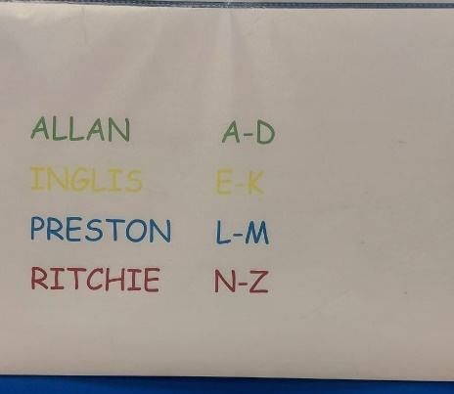
Primary 6
Primary 6 pupils will be attending an outdoor sports event at Calderhead High School on the 5th October. More details to follow.

Music Specialists
We have our brass, woodwind, and Kodaly instructors all back in school now for this session and we look forward to future performances from pupils during assemblies.

Article of the Week
We had some Primary 7 pupils talk to us today about Article 28 – the right to an education which links well to the work we are doing in refreshing our curriculum.

Knowetop Parent Council
https://www.facebook.com/KnowetopPC
Co-Chairpersons: Mrs Ali Holmes and Mrs Laura Arthur

AGM
I want to thank Mrs Joanne Hogg for all her work and dedication over the past few years as Chairperson of the Parent Council. She has decided to take a step back to due other commitments but we really appreciate all the work she has done in building a successful team. She will remain as Vice-Chairperson and will fully support the new Co-Chairs, Mrs Ali Holmes and Mrs Laura Arthur, who were elected last night. Mr David Boyle will continue on, for now, as Treasurer and Mrs Donna Caldwell will continue to coordinate social media activity including the Parent Council Facebook page.

Our Parent Council have organised the Christmas fundraiser for us again this year which is always a very successful venture for the school. Children have been busy designing their Christmas cards and once these are sent away, order forms will be available for your child’s design at some point in October. We will give you more information nearer the time.
We are looking forward to our first disco of the year taking place on Wednesday 20th September. Entry is free and all pupils will receive juice and crisps free of charge. We will send out arrangements for drop off and pick up next week. Please note adults will drop children off at the school entrance where children will be welcomed by school staff and parent council members so the only adults coming into the building are the volunteers for the disco.

Knowetop Uniform Shop
Items can be requested from the shop through their Facebook page Knowetop Uniform Shop or by emailing suzannemagowan@hotmail.co.uk

