Knowetop Primary School
Knowetop Avenue
ML1 2AG
Twitter: @KnowetopPrimary
Email: Enquiries-at-knowetop@northlan.org.uk

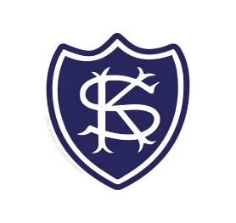
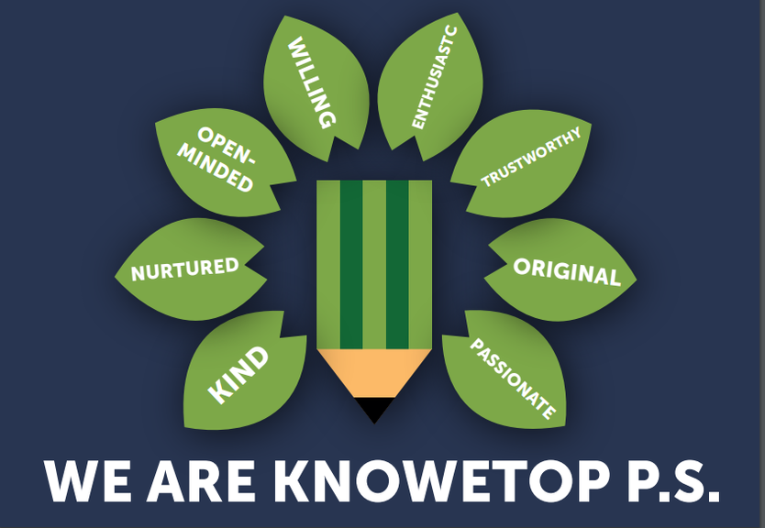
Our Vision: Through education with imagination, we will challenge, achieve, and excel.

Dear Parents and Carers,
We have had a brilliant week with lots of health-based activities happening in classes and around school. We have had various visitors in supporting our health week and some children have visited Strathclyde Park for a rowing experience while others have been to the local bowling club. I want to thank Miss Davies for all her work in the planning and preparation for the week.
Please keep up to date with all our pupil achievements and news featured on our Twitter feed @KnowetopPrimary
I hope this newsletter keeps you well informed of the things we have happening and, in the meantime, if there is anything we can do to help, please do not hesitate to get in touch.

Mr Gordon Murray
Head Teacher

Meet the Teacher
We are still waiting on all staff being confirmed from NLC for next session but, as always, we are going to do a Meet the Teacher session next week on Thursday afternoon. Children will be told their class for next year and will spend 45 minutes with their new teacher. Not all teachers will be available that day but you will receive a note of which class children are in and the name of their teacher(s).

St Andrews Hospice

We wanted to say a huge thank you and well done to all our Primary 1 and Primary 7 pupils and families for raising an outstanding £4000 for St Andrews Hospice. What a fantastic achievement and we are very proud of everyone.

P7 Leavers Service
Primary 7 pupils have been working hard on preparations for their final performance on Thursday at 11am. Each child will be issued with two tickets for family members to attend. Everyone else will be able to watch from home using the live link below.
https://www.youtube.com/live/hEtYt3Rtokw?feature=share

Pupil Improvement Survey
We are looking to further develop our pupil group opportunities next session and are looking for the views of our pupils. We have had discussions during assemblies and some classes regarding this, but we have a short survey for children to complete to support this. There is a link to the survey below and it is also on class Teams pages.
Pupil Views on School Improvement Planning 2023 (office.com)
Packed lunches and Snack to Go
From Monday, we will be having all packed lunches and Snack to Go lunches in the gym hall together. We now have more dinner hall seating which will be brought into the gym hall and set up for both lunches. This means children will all be together and will be easier for supervision. Depending on numbers, Snack to Go lunches may need to eat in the Big K sometimes. We will try this next week and see how it goes.

Nut-free Zone
Just a reminder to please make sure children do not bring in any food items containing nuts as we have pupils with severe nut allergies.

Wonderful Weather
The sunshine has been great, and we are enjoying using the outdoors as much as possible just now. Please remember hats and suncream for children as the weather continues. We have bottles of suncream available in the school office if you have forgotten to apply.

Dates to Remember

Date | Activity | Time
Tuesday 20th June | P7 attend Choral Shield | 12.30pm
Thursday 22nd June | P7 Leavers Service | 11am
Thursday 22nd June | Meet the Teacher | 1.45pm
Wednesday 28th June | School closes 1pm | 1pm

Knowetop Parent Council
https://www.facebook.com/KnowetopPC
Chair Person: Mrs Joanne Hogg

Knowetop Uniform Shop
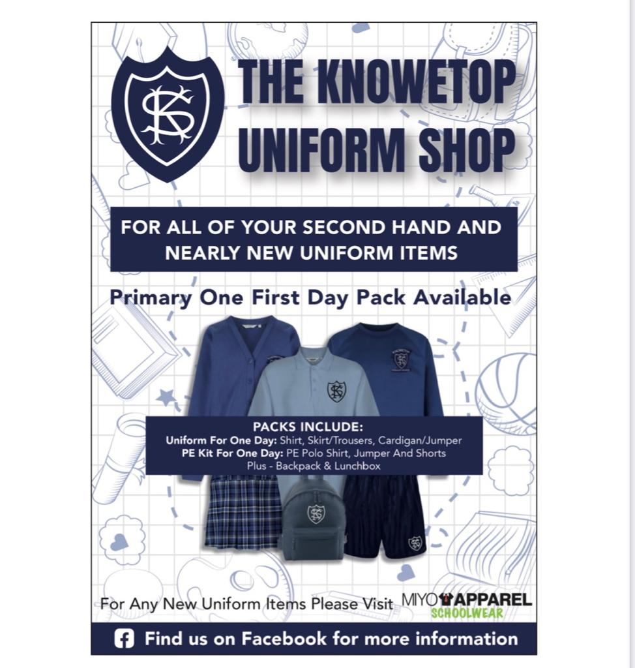

The Knowetop Uniform Shop are seeking donations of pre-loved uniform. If your child has grown out of any uniform items or you have items you no longer need, please donate these by handing them into the school.

Uniform Shop Open Day Dates

Sun 25th June
Mon 17th July
Sat / Sun 29th and 30th July
*Venue to be confirmed
All uniform items currently in stock will be available on these dates. Children can be brought along to try on and take home any items you need for free. There are no limits to how many you may take. Uniform can be handed in on these dates but is not a requirement of using the shop.
More details to follow.

Items can be requested from the shop through their Facebook page Knowetop Uniform Shop or by emailing suzannemagowan@hotmail.co.uk

