Knowetop Primary School
Knowetop Avenue
ML1 2AG
Twitter: @KnowetopPrimary
Email: Enquiries-at-knowetop@northlan.org.uk

Our Vision: Through education with imagination, we will challenge, achieve, and excel.

Dear Parents and Carers,
As we head in to the final few weeks of the session, we are incredibly busy with lots of things happening each week. Primary 7 pupils continue to take part in various transition activities with most pupils having their two day visits either this week or next week. We will be welcoming our new Primary 1 pupils on Tuesday afternoon with their families for their final visit.
This week we said goodbye to Miss Robertson who has been with us for the last few sessions as she heads off to her new school. We are sad to see her go but wish her the best of luck.
Please keep up to date with all our pupil achievements and news featured on our Twitter feed @KnowetopPrimary
I hope this newsletter keeps you well informed of the things we have happening and, in the meantime, if there is anything we can do to help, please do not hesitate to get in touch.

Mr Gordon Murray
Head Teacher

Wear Yellow Walk
All Primary 7 pupils will take part in the annual Wear Yellow Walk for St Andrews Hospice on Wednesday 7th June. They will be given a sponsor form and will walk as a year group down to Strathclyde Park to take part in some fundraising. We require some adult helpers to support with this due to our large numbers. We will walk from the school down to the park, round the park and back up so if this is something you can help with then please contact the school office or email using the above email address. We would really appreciate your support with this.

P7 Rowing
We are also looking for some volunteers to walk down to Strathclyde Park (again) on either 14th/ 15th June with Primary 7 to attend a rowing activity. If you are able to help then please get in touch with the school office. We are just doing our bit to help you boost your daily steps.

Rights Day
Our Rights Respecting Schools group have planned a Rights Day for Friday 9th June. This is not a dress down day so children will come to school in their usual uniform. There will be activities such as scavenger hunt, logo competition, quiz and other tasks which are all free of charge. The group are asking for pupils to donate £1 if they wish to which will be going to the Make a Wish foundation. We appreciate there have been various collections over the past few weeks so like other events, this is optional.

New Primary 1 Visit
Our New Primary 1 pupils will be coming to visit on Tuesday afternoon with their parents/ carers. The children will make their way to the extension to meet with staff and enjoy exploring various activities. Mrs McCallum and myself are looking forward to meeting with all parents in the gym hall where we will give a short presentation and we will have visitors from Miyo and Be Schoolwear so you can organise uniform. We will also have Suzanne Magowan who runs our uniform shop and Carol Jones from the Parent Council who are looking forward to speaking to our new parents. Tea and coffee will be available in the hall on arrival. We aim to open doors from 1.30pm with the presentation starting at 1.45pm.

Nut-free Zone
Just a reminder to please make sure children do not bring in any food items containing nuts as we have pupils with severe nut allergies.

Community
Our friends at Motherwell South Parish Church are having a plant sale on Saturday 3rd June and everyone is welcome to pop along.
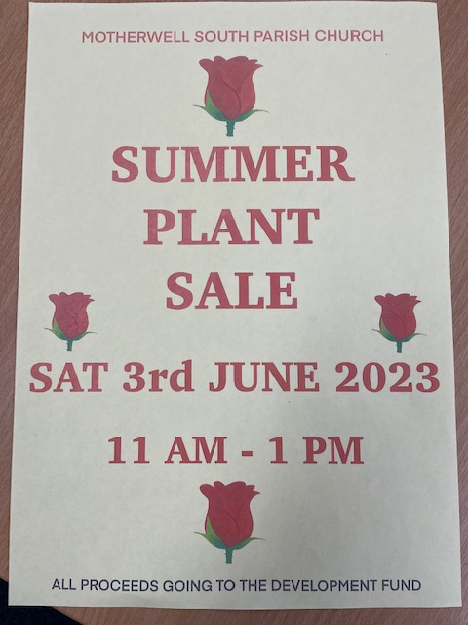

Dates to Remember

Date | Activity | Time
Tuesday 6th June | P1 Pre-entrant Visit 2 | 1.45-2.30pm
Wednesday 7th June | P7 Wear Yellow Walk | All day
Friday 9th June | Football team playing at New Stevenston. | PM
Friday 9th June | P7 Relay Team to Dalziel Park | 11am
Mon 12th- Fri 16th June | Health Week (physical health) | All week
Thursday 22nd June | P7 Leavers Service | 11am
Wednesday 28th June | School closes 1pm | 1pm

Knowetop Parent Council
https://www.facebook.com/KnowetopPC
Chair Person: Mrs Joanne Hogg

Knowetop Uniform Shop

The Knowetop Uniform Shop are seeking donations of pre-loved uniform. If your child has grown out of any uniform items or you have items you no longer need, please donate these by handing them into the school.

Uniform Shop Open Day Dates

Sun 25th June
Mon 17th July
Sat / Sun 29th and 30th July
*Venue to be confirmed
All uniform items currently in stock will be available on these dates. Children can be brought along to try on and take home any items you need for free. There are no limits to how many you may take. Uniform can be handed in on these dates but is not a requirement of using the shop.
More details to follow.

Items can be requested from the shop through their Facebook page Knowetop Uniform Shop or by emailing suzannemagowan@hotmail.co.uk

