Knowetop Primary School
Knowetop Avenue
ML1 2AG
Twitter: @KnowetopPrimary
Email: Enquiries-at-knowetop@northlan.org.uk

Our Vision: Through education with imagination, we will challenge, achieve, and excel.

Dear Parents and Carers,
We have had another brilliant week at Knowetop with our Primary 7 pupils giving full effort to the planning and presentation of their science projects. All pupils and staff throughout the school were able to share the learning with pupils today which was a great way to end for the holiday weekend.
We had the pleasure of meeting our new Primary 1 pupils yesterday who came in for a visit after school. They had a great time and we are really looking forward to welcoming them back soon with their families.
I hope everyone enjoys the holiday weekend and fingers crossed the sun stays out.
Please keep up to date with all our pupil achievements and news featured on our Twitter feed @KnowetopPrimary
I hope this newsletter keeps you well informed of the things we have happening and, in the meantime, if there is anything we can do to help, please do not hesitate to get in touch.
Mr Gordon Murray
Head Teacher

Knowetop Science Fayre
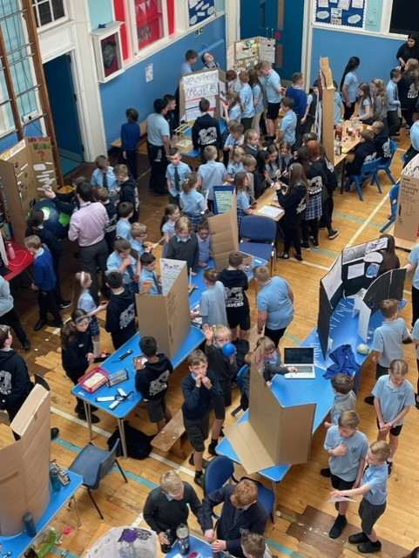
As you can see, we had a very busy day today with children showcasing their science projects to the rest of the school. All pupils really enjoyed this experience and got t o ask our experts lots of interesting questions. Thanks to Mr Moir from Dalziel High School who spent the whole afternoon with our pupils and had the difficult job of choosing a winner. The winners were The Dream Team who spent time informing us all about the science of sleep. Well done to Alex, Rachel and Violet and we wish them the best of luck as they represent Knowetop at the Dalziel Science Fayre in the coming weeks.

Primary 7 Dalziel Science Fayre
All Primary 7 pupils will attend the Dalziel Science Fayre on Thursday. Could all P7 parents please complete the form on the link below to register how children will get home after the event.
https://forms.office.com/e/crL3K743w7

Relationships, Sexual Health and Parenthood (RSHP)
This is just a reminder that this content will be covered during our health week coming up soon so please have a look beforehand so you are aware of what will be taught.
As part of our health week, teachers will be covering the RSHP content with their classes. This is a national resource which has been created in partnership with agencies across Scotland and is the recommended resource that all Scottish schools use. This resource is accessible for all and you can have a look by following this link RSHP Link.
If you click on levels at the top of the page it will allow you to select either Early, First or Second level. Early level is for Primary 1 pupils, First level covers Primary 2-4 and Second level is for Primary 5-7 pupils. In order to see the content that will be specifically taught to your child, each level has been broken down into ‘To begin’ ‘Progression 1’ and ‘Progression 2’ sections. The breakdown below shows you which sections will be taught to each class. For example, when you click on First Level for each plan the breakdown appears down the right-hand side. If your child is in Primary 2 you will see they will be covering everything in the ‘To begin’ section. If you click on the lessons below where it says ‘To begin’ this will let you see all the content that will be covered.

P1 - EARLY
P2 - FIRST - To begin
P3 - FIRST - Progression 1
P4 - FIRST - Progression 2
P5 - SECOND - To begin
P6 - SECOND - Progression 1
P7 - SECOND - Progression 2
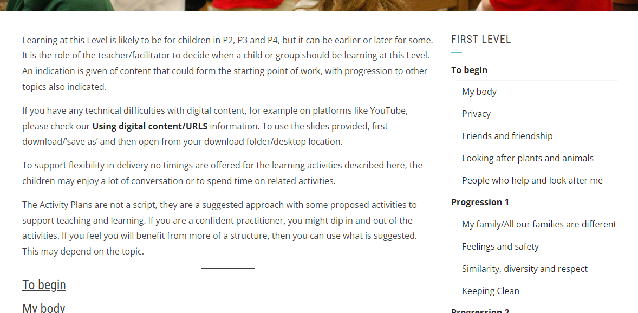

Please take time to have a look through the content as there has been a change in the last few years with the resource. I have also attached some information sheets with tips on how you can support children at home with the content and all information is available to access through the website. If you have any questions or concerns, please contact myself or Mrs Smith and we will be happy to discuss.

Teddy Bear Picnic
Thank you to all Primary 1 pupils who have raised money for St Andrews Hospice through the Teddy Bear Picnic event. So far, we have raised £2241.10 which is an outstanding amount. Well done everyone. We will wait until Primary 7 have completed their Yellow Walk and we will pass on all our money at the one time.

Wear Yellow Walk
All Primary 7 pupils will take part in the annual Wear Yellow Walk for St Andrews Hospice on Wednesday 7th June. They will be given a sponsor form and will walk as a year group down to Strathclyde Park to take part in some fundraising. More information will follow.

Nut-free Zone
Just a reminder to please make sure children do not bring in any food items containing nuts as we have pupils with severe nut allergies.

Community
Our friends at Motherwell South Parish Church are having a plant sale on Saturday 3rd June and everyone is welcome to pop along.

Dates to Remember

Date | Activity | Time
Friday 26th May | Holiday (school closed) | All day
Monday 29th May | Holiday (school closed) | All day
Tuesday 6th June | P1 Pre-entrant Visit 2 | 1.45-2.30pm
Wednesday 7th June | P7 Wear Yellow Walk | All day
Mon 12th- Fri 16th June | Health Week (physical health) | All week
Thursday 22nd June | P7 Leavers Service | 11am
Wednesday 28th June | School closes 1pm | 1pm

Knowetop Parent Council
https://www.facebook.com/KnowetopPC
Chair Person: Mrs Joanne Hogg

Please find below the agenda for the final meeting of the session. As always, all parents/ carers are welcome.

Knowetop Parent Council Meeting
Tuesday 30th May 2023
Knowetop Primary School – Knowetop Avenue, Motherwell 7-8.30pm
AGENDA
- Welcome and Previous Minutes Approval
- Chair update
- Treasurer Update
- Accounts audit
- Agree donation figure

- Headteacher Update

- Self Evaluation Discussion with leadership team

- Dates for Diary – 2023/2024 term (proposed)

- AGM – Thursday 7th September 2023
- Autumn Disco – Wednesday 20th September 2023 (committee to be agreed by early August 2023)
- Parent Council Meeting – Tuesday 24th October 2023
- ??Winter Disco – November 2023??
- Parent Council Meeting – Thursday 11th January 2024
- Social event (TBC) – 2/3rd February 2024 out with school (no let required)
- Parent Council Meeting – Tuesday 27th February 2024
- Spring Disco – Wednesday 27th March 2023
- Parent Council Meeting – Thursday 25th April 2024
- Parent Council Meeting – Tuesday 28th May 2024
- ??summer event??

Christmas events
- personalised cards and merchandise – commences September 2023
- Santa visit and gifts – commences November 2023 (earlier booking required?)
End of year events
- Primary 1 gift packs and ties – commence April 2024
- Primary 7 ties – commence April 2024
- Primary 7 leavers event/other costs – Donation agreed January 2024 (£5 per head)
Any other events to propose?
- AOB – residential school week p7
- Vote of Thanks

Next meeting: Thursday 7th September 2023 AGM

Knowetop Uniform Shop

The Knowetop Uniform Shop are seeking donations of pre-loved uniform. If your child has grown out of any uniform items or you have items you no longer need, please donate these by handing them into the school.

Uniform Shop Open Day Dates

Sun 25th June
Mon 17th July
Sat / Sun 29th and 30th July
*Venue to be confirmed
All uniform items currently in stock will be available on these dates. Children can be brought along to try on and take home any items you need for free. There are no limits to how many you may take. Uniform can be handed in on these dates but is not a requirement of using the shop.
More details to follow.

Items can be requested from the shop through their Facebook page Knowetop Uniform Shop or by emailing suzannemagowan@hotmail.co.uk

