Knowetop Primary School
Knowetop Avenue
ML1 2AG
Twitter: @KnowetopPrimary
Email: Enquiries-at-knowetop@northlan.org.uk

Our Vision: Through education with imagination, we will challenge, achieve, and excel.

Dear Parents and Carers,
Thank you to everyone who came along to be part of Sports Day this week, I hope you all had a brilliant time and enjoyed seeing our amazing young people giving it their best effort.
We continue to work with all pupils on their Crest Award activities which have been going really well over the past few weeks and you will see regular updates regarding their progress on our Twitter feed.
The Leadership Team are looking forward to visiting every class this week to work with staff and pupils during numeracy time and after what will be another busy week, staff are looking forward to enjoying Mrs Nicholls’ retirement dinner at the end of the week.
Please keep up to date with all our pupil achievements and news featured on our Twitter feed @KnowetopPrimary
I hope this newsletter keeps you well informed of the things we have happening and, in the meantime, if there is anything we can do to help, please do not hesitate to get in touch.
Mr Gordon Murray
Head Teacher

Sports Day
It was a competitive morning on Wednesday with all four of our houses competing to be Sports Champions 2023. Children worked incredibly hard to build up as many points as possible and in then end it was Inglis house who were the overall winners. All Inglis pupils received their medals during assembly today. However, it wasn’t only our pupils who were having a great time as many of our parents and friends joined in with Tug of War which was great fun and the children loved seeing everyone getting involved.

Health Week 2
Thank you to all who have offered to come along on our health walks so far. As part of our Health Week starting on June 12th, we will be doing our local walks again and Miss Davies (Health and Wellbeing Champion) is looking for some volunteers to help us. The dates and times of the walks are below.

Monday 12th June – P6, P5/6, P6/7 and P7
Tuesday 13th June – P2, P2/3 and P3
Wednesday 14th June – P1 and P1/2
Friday 15th June – P4 and P5

We are planning on the walks taking place at 11 – 11.45am each day so if you are free on any of the dates and would like to join us, you would be most welcome. Please phone or email the school office on Enquiries-at-knowetop@northlan.org.uk to register your interest.

Relationships, Sexual Health and Parenthood (RSHP)
As part of our health week, teachers will be covering the RSHP content with their classes. This is a national resource which has been created in partnership with agencies across Scotland and is the recommended resource that all Scottish schools use. This resource is accessible for all and you can have a look by following this link RSHP Link.
If you click on levels at the top of the page it will allow you to select either Early, First or Second level. Early level is for Primary 1 pupils, First level covers Primary 2-4 and Second level is for Primary 5-7 pupils. In order to see the content that will be specifically taught to your child, each level has been broken down into ‘To begin’ ‘Progression 1’ and ‘Progression 2’ sections. The breakdown below shows you which sections will be taught to each class. For example, when you click on First Level for each plan the breakdown appears down the right-hand side. If your child is in Primary 2 you will see they will be covering everything in the ‘To begin’ section. If you click on the lessons below where it says ‘To begin’ this will let you see all the content that will be covered.

P1 - EARLY
P2 - FIRST - To begin
P3 - FIRST - Progression 1
P4 - FIRST - Progression 2
P5 - SECOND - To begin
P6 - SECOND - Progression 1
P7 - SECOND - Progression 2
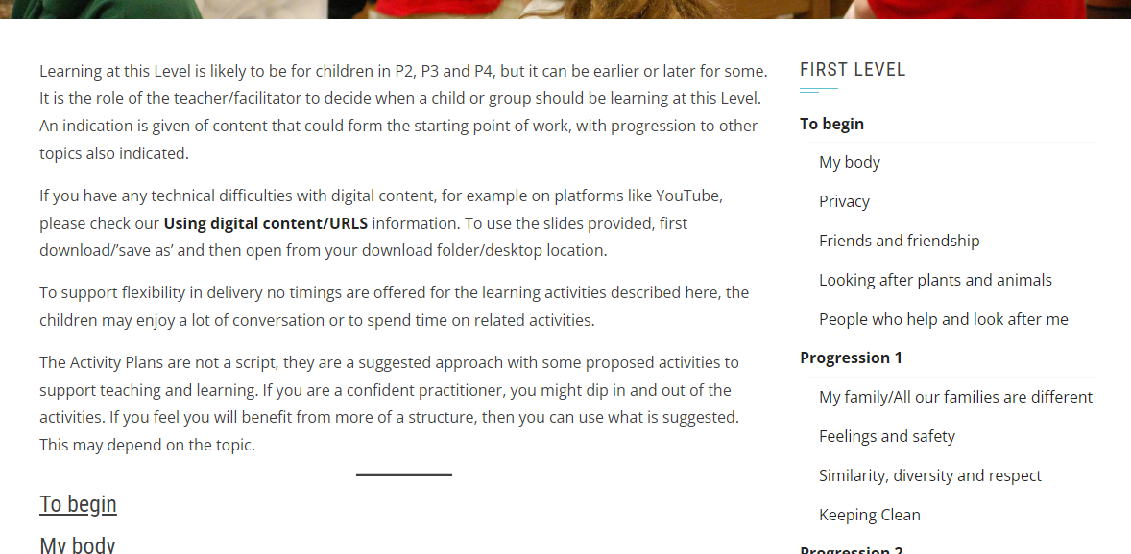

Please take time to have a look through the content as there has been a change in the last few years with the resource. I have also attached some information sheets with tips on how you can support children at home with the content and all information is available to access through the website. If you have any questions or concerns, please contact myself or Mrs Smith and we will be happy to discuss.
Dress Down Day
We have our last dress down day on Friday this week and again I wanted to say a big thank you for everyone’s support with these. The donations throughout the year have allowed us to buy four brand new iPads which have made a big difference in our classrooms. We are aiming for one more this week so our target for Friday is £400. As always children are welcome to bring in a small donation for wearing casual clothes but there is never any pressure to do so.

School Outings
We have been trying to get as many experiences organised as possible for our children and have had recent outings for pupils to Sky Academy and CPI Mortars. However, I know some of our Primary 2-4 classes haven’t been out on a trip this year and we had provisionally booked workshops based on dinosaurs and Ancient Egypt. The problem is there is no availability of buses for any of the dates planned after contacting all bus companies we work with. We will continue to look for opportunities but if not possible then these year groups will be prioritised next session.

Teddy Bear Picnic
Primary 1 pupils will enjoy a Teddy Bear Picnic on Monday 15th May to raise money for St Andrews Hospice. Children should wear PE kit and a waterproof jacket, and they can bring a small teddy to school. Remember, there will be no hot food due to timings so please bring a packed lunch or a snack to go will be provided.

Nut-free Zone
Just a reminder to please make sure children do not bring in any food items containing nuts as we have pupils with severe nut allergies.

Primary 7
A reminder for all Primary 7 parents to complete the following link.
https://forms.office.com/e/8w1ni58FxB

Community Homework (optional)
We have been doing a little research about the history of our school and have been finding out some information about the people who our houses were named after. We know a little about James Preston, William Allan and Andrew Inglis. However, we are looking for any photographs and information about Mr Ritchie who was a previous Head Teacher here and who our fourth house was named after. We are working with Miyo Apparel to update the reception area of the school and we would like to incorporate a little about the school’s history. We are also looking for the following.
- Any photographs of the canteen when it used to be where the Astro turf now is.
- The names of Head Teachers who were here between Mr Ritchie and Mrs Miller.
- Photographs of any other buildings or spaces which used to be part of the school but are no longer here.
Any photographs will be scanned and returned to their owners.

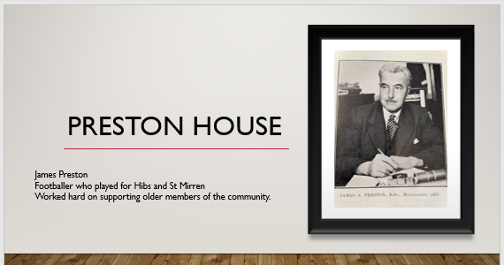 | 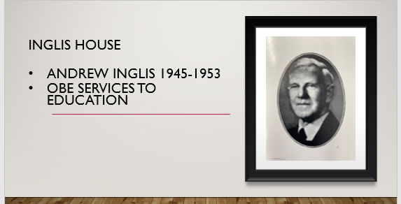
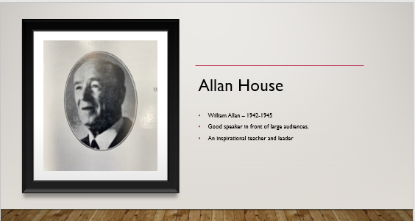

Dates to Remember

Date | Activity | Time
Monday 15th May | P1 Teddy Bear Picnic
Friday 19th May | Dress Down Day | All day
Wednesday 24th May | New P1 Pre-entrant Visit | 3.15-4pm
Friday 26th May | Holiday (school closed) | All day
Monday 29th May | Holiday (school closed) | All day
Tuesday 6th June | P1 Pre-entrant Visit 2 | 1.45-2.30pm
Mon 12th- Fri 16th June | Health Week (physical health) | All week
Thursday 22nd June | P7 Leavers Service | 11am
Wednesday 28th June | School closes 1pm | 1pm

Knowetop Parent Council
https://www.facebook.com/KnowetopPC
Chair Person: Mrs Joanne Hogg

As always if you have anything you would like to add to future Parent Council agendas then please contact Joanne and the team using the details above.

Knowetop Uniform Shop

The Knowetop Uniform Shop are seeking donations of pre-loved uniform. If your child has grown out of any uniform items or you have items you no longer need, please donate these by handing them into the school.

Uniform Shop Open Day Dates

Sun 25th June
Mon 17th July
Sat / Sun 29th and 30th July
*Venue to be confirmed
All uniform items currently in stock will be available on these dates. Children can be brought along to try on and take home any items you need for free. There are no limits to how many you may take. Uniform can be handed in on these dates but is not a requirement of using the shop.
More details to follow.

Items can be requested from the shop through their Facebook page Knowetop Uniform Shop or by emailing suzannemagowan@hotmail.co.uk

