Knowetop Primary School
Knowetop Avenue
ML1 2AG
Twitter: @KnowetopPrimary
Email: Enquiries-at-knowetop@northlan.org.uk

Our Vision: Through education with imagination, we will challenge, achieve, and excel.

Dear Parents and Carers,
I hope you have all had a fantastic break and that everyone is re-energised and looking forward to our last term of the session. We have lots coming up this term so I have added a dates list to the bottom of this newsletter, and I will continue to update each week as more dates are confirmed.
I would like to say a big thank you to everyone for all the kind, supportive messages I have received since being appointed Head Teacher. It is a privilege to take on this role and I look forward to working closely with everyone in our wonderful school community.
Please keep up to date with all our pupil achievements and news featured on our Twitter feed @KnowetopPrimary
I hope this update keeps you well informed of the things we have happening and, in the meantime, if there is anything we can do to help, please do not hesitate to get in touch.

Mr Gordon Murray
Head Teacher

Staff update
We had to say goodbye to Mrs Mackle (Room 20) as a few members of staff are due back from maternity leave soon. Mr Carline will be staying with us temporarily and will take over in Room 20 when we return to school. This means that Miss McNamara will resume teaching Room 13 Wednesday-Friday and will remain teaching Room 7 at the beginning of the week.

Depute Head Teacher
We now have a vacancy for our DHT post and this will be filled on an acting basis temporarily. We will keep you updated with this once the recruitment process has been completed.

Sciences
This term will be our science focus across the school with the following topics being covered.
Early Level (Primary 1)
Identifying Animals

First Level (Primary 2-4)  Health and Movement | 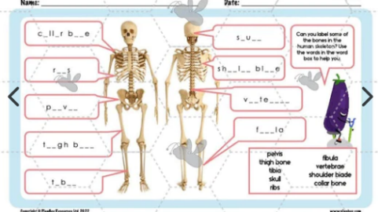

Second Level (Primary 5-7)  Space | 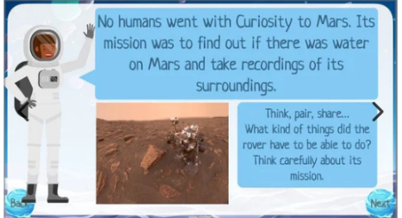

Parents and Friends
As always, we are keen for parents and friends to be involved in the life and work of the school and if you have any expertise in any of these science topics it would be great to have you involved. This could be speaking to a class/ classes, carrying out an activity or a question and answer session about your science related job. If this is something you would be interested in, then please email us or phone the school office.

Crest Award
As part of our science focus, every pupil across the school will complete 8 practical experiments and activities in order to achieve their Crest award. We hope to have all activities completed so that pupils can be presented with their award in June. Miss McNamara has been working hard getting all activities ready and we are looking forward to getting started.

Wider Achievements
We love to hear about pupil achievements out of school so children are welcome to bring in any achievements from clubs, charity events etc they attend on a Friday and we will celebrate with them during assemblies.

Lunches
There will be a switch around of lunches next week between Monday and Tuesday. As the burgers won’t be delivered until later in the day, these will now be Tuesday’s option. Monday will be macaroni or pasta.

Current Primary 1 Workshop
Following on from the leaflet issued at Parents Night, Mrs McCallum would like to invite any Primary 1 parent who would like to attend a workshop to go over the Active Literacy programme. If you would like more information on how reading, writing and phonics are taught then feel free to come along. The session will be on Wednesday 19th April from 1.30pm-2.30pm.

Pre-entrant Visits
We have two dates coming up for pupils joining us in Primary one in August 2023. The first of these is Wednesday 24th May from 3.15-4pm. This session is for pupils only and parents can drop children off and collect them from the main entrance. The second date is Tuesday 6th June and will be for both children and parents. Children will spend time in their class while parents attend a meeting in the gym hall where they will get a chance to find out key information about the school and uniform. This session will run from 1.45 – 2.30pm.

Sports Day
We have been informed that the Astro turf is unavailable this term as it is undergoing an upgrade. This means we will have to rethink the plan for Sports Day. We will let you know as soon as we have details confirmed.

Dates to Remember

Date | Activity | Time
Thursday 27th April | Parent Council Meeting | 7-8.30pm
Friday 28th April | Dress Down Day | All day
Monday 1st May | Holiday (school closed) | All day
Tuesday 2nd May | In-service Day (school closed to pupils) | All day
Monday 8th May | King’s Coronation (school closed to all) | All day
Friday 19th May | Dress Down Day | All day
Wednesday 24th May | New P1 Pre-entrant Visit | 3.15-4pm
Friday 26th May | Holiday (school closed) | All day
Monday 29th May | Holiday (school closed) | All day
Saturday 3rd June | School Summer Fayre | 10-12pm
Tuesday 6th June | P1 Pre-entrant Visit 2 | 1.45-2.30pm
Mon 12th- Fri 16th June | Health Week (physical health) | All week
Thursday 22nd June | P7 Leavers Service | Tbc
Wednesday 28th June | School closes 1pm

Knowetop Parent Council
https://www.facebook.com/KnowetopPC
Chair Person: Mrs Joanne Hogg

Disco
Thank you to everyone who attended our disco and supported the Parent Council by helping to supervise the event. Our children had a fantastic time and it was a great way to finish off the term. Thanks to Kevents again for providing outstanding entertainment.

The next Parent Council meeting will be on Thursday 27th April at 7pm.

