National 5 Maths: Unit 2 Summary

[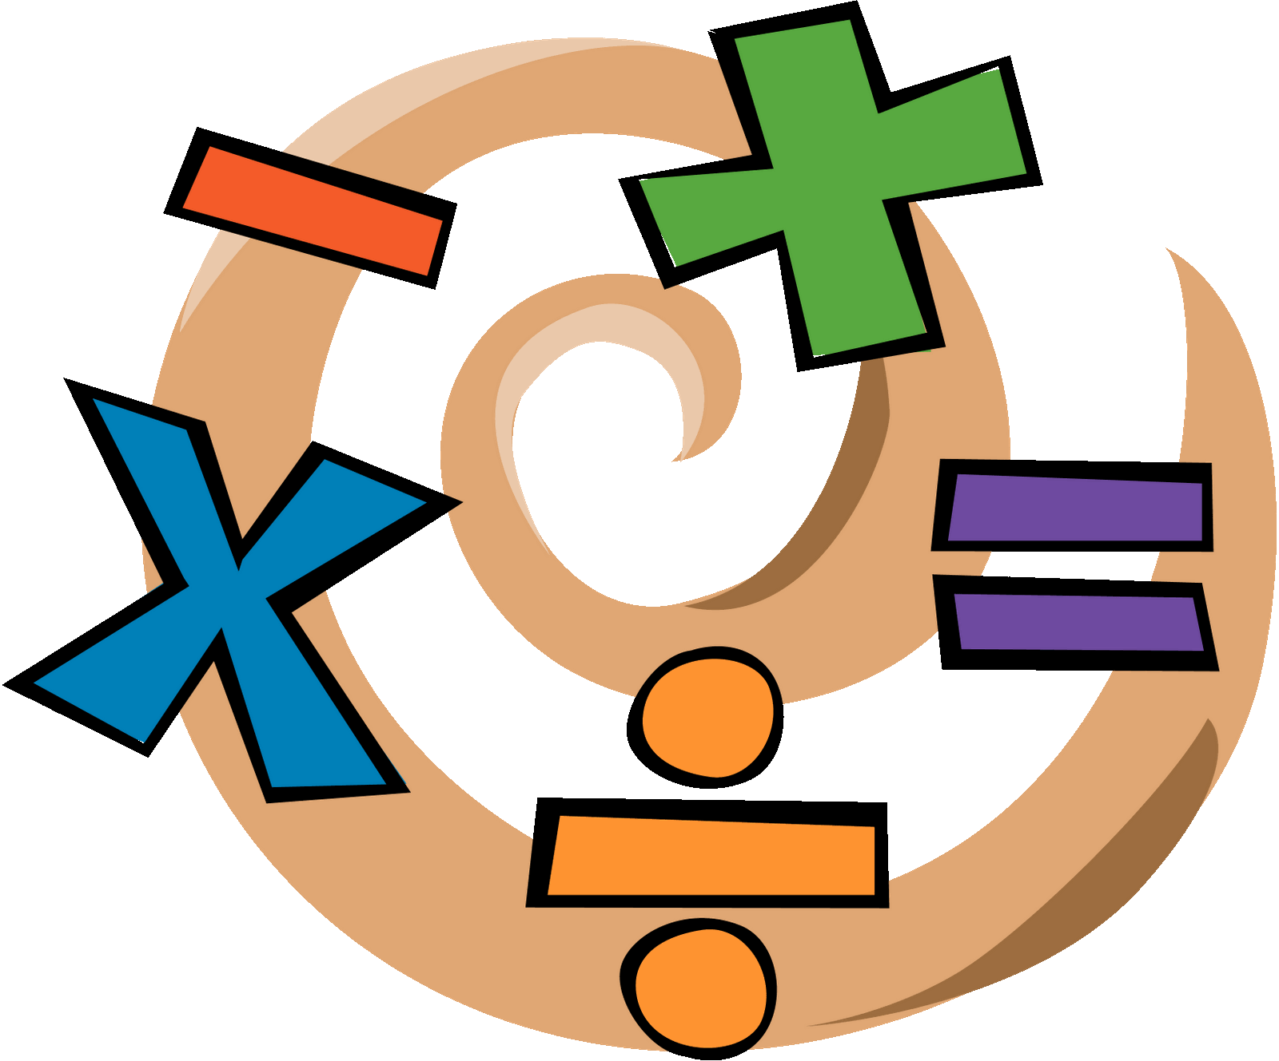](https://www.google.co.uk/url?sa=i&rct=j&q=&esrc=s&source=images&cd=&cad=rja&uact=8&ved=0ahUKEwjMkYuJkfjVAhUFuRQKHSDZBh8QjRwIBw&url=http://www.e-hackney.co.uk/2016/07/gcse-maths-adults/&psig=AFQjCNHa2mqSgiuuYZNDjbgsnxWSkA4wQg&ust=1503947776778371)Hh

By Jack Leslie

Contents

Page Number

* Percentages 04
* Vectors 08
* Fractions 16
* Trigonometry 20
* Statistics 26

Percentages

Compound Interest

Interest is normally added on once a year. This means that each year interest is calculated on the amount at the start of that year. This is known as compound interest.

Eg

David deposits £150 in a bank offering 6.5% p.a. interest rate.

How much will David have after three years?

Method 1

Year 1 -> 6.5% of £150 = £9.75

£150 + £9.75 = £159.75

Year 2 -> 6.5% of £159.75 = £10.38

£159.75 + £10.38 = £170.13

Year 3 -> 6.5% of £170.13 = £11.06

£170.13 = £11.06 = £181.19

Method 2

100% + 6.5% = 106.5%

= 1.065 <- multiplier

(1.065)3 x 150

= £181.19

Finding the Original Amount

If a % has been added on or taken away from an amount, you must remember that the original amount is 100%

Eg If an item is reduced by 25%, it will be 75% of the original price.

If an item is increased by 25%, it will now be 125% of the original price.

Eg A house priced at £52,000 has risen by 15%. What is the original price?

115% -> £52,000

1% -> £452.1739

100% -> £45,217.39

Vectors

A vector is a variable that requires both length (magnitude), and direction.

A good example is the force used to hit a snooker ball with a cue, (direction and speed). You can represent a vector using a directional line segment.

Eg AB

Vectors can also be represented by a single letter underlined or in bold, eg AB = u

B

A

The magnitude of a vector is represented by the length of the line and the direction is represented by the arrow.

A vector is only the same as another vector if it has the same length and the same direction.

D

A

Eg

AD = BC

AB = DC

C

B

Adding Vectors

Vectors must be added in the correct direction, so you must add them ‘nose to tail’ to allow the directional line segment to flow.

The new single journey vector is called a+b and is also known as the resultant vector.

b

a

a+b

Multiplying by a Number

Vector length can be changed by multiplying. The directional line segment will simply change accordingly.

[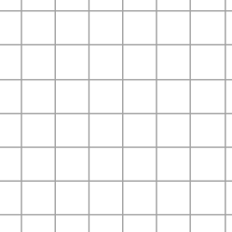](https://www.google.co.uk/url?sa=i&rct=j&q=&esrc=s&source=images&cd=&cad=rja&uact=8&ved=0ahUKEwi90aGf4L7XAhXFKewKHT0ADsEQjRwIBw&url=http://primaryclass.co.uk/pages/mathspaper.html&psig=AOvVaw19DUmWbefcxlug-THLi4WS&ust=1510772484359326)

u

2u

-3u

If the number is negative, the direction will change.

3u

Subtracting Vectors

If you are asked to subtract a vector, it is easier to think of adding a negative vector.

b

-b

a

Eg a-b = a+(-b)

-b

a-b

a

Representing Vectors in Component Form

Using numerical values for vectors is similar to coordinates. You call the number components and must write them vertically.

horizontal component

Eg AB = x

vertical component

y

Adding, subtracting, or multiplying in component form is as you would expect.

Eg 6 1 1

5

-5

-5

4

+

5

=

7

-25

-1

=

Position Vectors

To find the component form of a vector,

AB = b-a

Eg

Q is the point (3,5,-1) and P is the point (6,1,5)

PQ = q-p

1

6

-

5

3

=

5

-1

-3

4

-6

=

*Note*

0

0

=

o

0

Magnitude of a Vector

You can find the magnitude of a vector by considering Pythagoras.

[](https://www.google.co.uk/url?sa=i&rct=j&q=&esrc=s&source=images&cd=&cad=rja&uact=8&ved=0ahUKEwi90aGf4L7XAhXFKewKHT0ADsEQjRwIBw&url=http://primaryclass.co.uk/pages/mathspaper.html&psig=AOvVaw19DUmWbefcxlug-THLi4WS&ust=1510772484359326)Alternative Vector Journeys

Magnitude of a Vector

=

(5,5)

(1,2)

a

=

=

=

=

=

5

a

With vector journeys, the important thing is that you start from the appropriate point and end at the appropriate point. How you get there is important as far as direction goes, but there can be many ways to make the same journey.

-2u

2u

EgVectors in 3D

DM = 2u - v

AD = u + v - 2u

u

v

M

C

B

A

D

An extra axis can be added to the x and y axes called the z axis.

Eg If P=(1,2,3) and Q=(3,2,1)

PQ = q-pFractions

2

0

-2

=

3

1

2

-

3

1

2

=

Adding and Subtracting Fractions

When adding and subtracting fractions, you must have a common denominator.

Eg

=

=

=

Multiplying Fractions

To multiply fractions, you change the fraction into a ‘top-heavy’ fraction, and then simply multiply the numerators and then the denominators.

Eg

=

=

=

=

Dividing Fractions

To divide fractions, you change the sum to multiply and flip the second fraction.

Eg

=

=

=

=

Trigonometry

Simple Trigonometry

Simple trig only works with right angled triangles.

SOH - CAH - TOA

Tanx =

Sinx =

Cosx =

H

O

x

A

Area of a Triangle

Up until now you have found the area of a triangle using A = of bxh.

There is another formula to find the area of a triangle using two sides and the angle in between.

A

A = ab sinC

b

c

a

B

C

Eg Calculate the area of the triangle:

A = su sinT

= 12 x 8.4 x sin49

= 38.03736…

= 38.0 cm2 (to 1dp)

S

u

t

7.3cm

8.4cm

49˚

U

s

12 cm

T

The Sine Rule

You can use the sine rule to find missing sides and angles in any triangle.

The Sine Rule = =

Eg Calculate the length of EF

=

=

= 138.5640646

d = 0.7660444 x 138.5640646

d = 106.1462317

d = 106.15 (to 2dp) km

E

f

120km

d

60˚

50˚

D

e

F

*Note*

If you are finding an obtuse angle, you must do the calculation as normal and then subtract your angle from 180˚

The Cosine Rule

The cosine rule can only be used to find a missing side or angle.

To use the cosine rule, you need to have two sides and the angle in between involved in the calculation to find the other side.

To find a side a2 = b2+c2-2bcCosA

To find an angle CosA =

Eg 1 Calculate x

x2 = y2+z2-2yzCosX

x2 = 32+52-((2x3x5)xCos35)

x2 = 34 – (30x0.819152044)

x2 = 9.425438671

x =

x = 3.07008…

x = 3.1 (to 1dp) cm

Y

z

5cm

x

35˚

3cm

X

Z

y

Eg 2 Calculate ABC

CosB =

Cosx =

Cosx =

Cosx = 0.939655172

x = Cos-1 0.939655172

x = 20.00627247

x = 20.006˚ (to 3dp)

A

8cm

x

7.5cm

B

14.5cm

C

Deciding Which Formula

A = ab sinC to find the area 2 sides and the angle in between

= = to find a side or pairs of things angle .

a2 = b2+c2-2bcCosA to find a side 2 sides and the angle in between

CosA = to find the area all 3 sides

Statistics

Quartiles

Quartiles are values that split the data you have into four sections.

You already know that the median splits the data into two equal parts.

The upper quartile and the lower quartile are the names given to the values which, along with the median (or middle quartile), split the data into four.

Eg 1 Split this data into quartiles:

8, 11, 10, 9, 8, 7, 11, 12, 9, 10, 8, 9

7, 8, 8, 8, 9, 9, 9, 10, 10, 11, 11, 12

Q1 = 8 Q2 = 9 Q3 = 10.5

Eg 2 Split this data into quartiles:

3, 6, 5, 4, 2, 3, 5, 6, 4

2, 3, 3, 4, 4, 5, 5, 6, 6

Q1 = 3 Q2 = 4 Q3 = 5.5

Interquartile Range

IQR = Q3-Q1

Semi-Interquartile Range

SIQR =

Boxplots

To draw a boxplot, you first need to produce a five-figure summary of the data.

The five-figure summary consists of:

L - lowest value

Q1 - lower quartile

Q2 - middle quartile

Q3 - upper quartile

H - highest value

You can then draw a boxplot from these figures:

Q3

Q2

Q1

L

H

Scale

A suitable scale should be decided and the five figure summary values plotted as shown above.

Eg Draw a boxplot from these values:

10, 11, 11, 12, 12, 13, 14, 15, 17

L – 10

[](https://www.google.co.uk/url?sa=i&rct=j&q=&esrc=s&source=images&cd=&cad=rja&uact=8&ved=0ahUKEwi90aGf4L7XAhXFKewKHT0ADsEQjRwIBw&url=http://primaryclass.co.uk/pages/mathspaper.html&psig=AOvVaw19DUmWbefcxlug-THLi4WS&ust=1510772484359326)Q1 - 11

Q2 - 12

Q3 - 14.5

H - 17

9 10 11 12 13 14 15 16 17 18 19

Standard Deviation

Standard deviation is a measure of the spread of data which is much more accurate than the range, as the range does not account for any outlying values.

The standard deviation looks at each value and finds out how much, on average, each piece of deviates from the mean.

There are two methods, and two formulae (both are given in the exam)

sd = or sd =

sum of n number of numbers

x each piece of data mean

If the standard deviation is low, it means that the data is less varied and more consistent, (and vice versa).

Method 1

Using sd = Data: 70,72,75,78,80

Start by calculating the mean:

= = 75

|  |  |  |
| --- | --- | --- |
| Data | Deviation | Deviation |
| 70 | -5 | 25 |
| 72 | -3 | 9 |
| 75 | 0 | 0 |
| 78 | 3 | 9 |
| 80 | 5 | 25 |
|  | = 68 | |

sd =

=

=

= 4.12310…

= 4.1 (to 1dp)

Method 2

Using sd = Data: 70,72,75,78,80

|  |  |
| --- | --- |
|  |  |
| 70 | 4900 |
| 72 | 5184 |
| 75 | 5625 |
| 78 | 6084 |
| 80 | 6400 |
| = 375 | = 28193 |

sd =

=

=

=

= = = 4.1 (to 1dp)