National 5 Maths: Unit 1 Summary
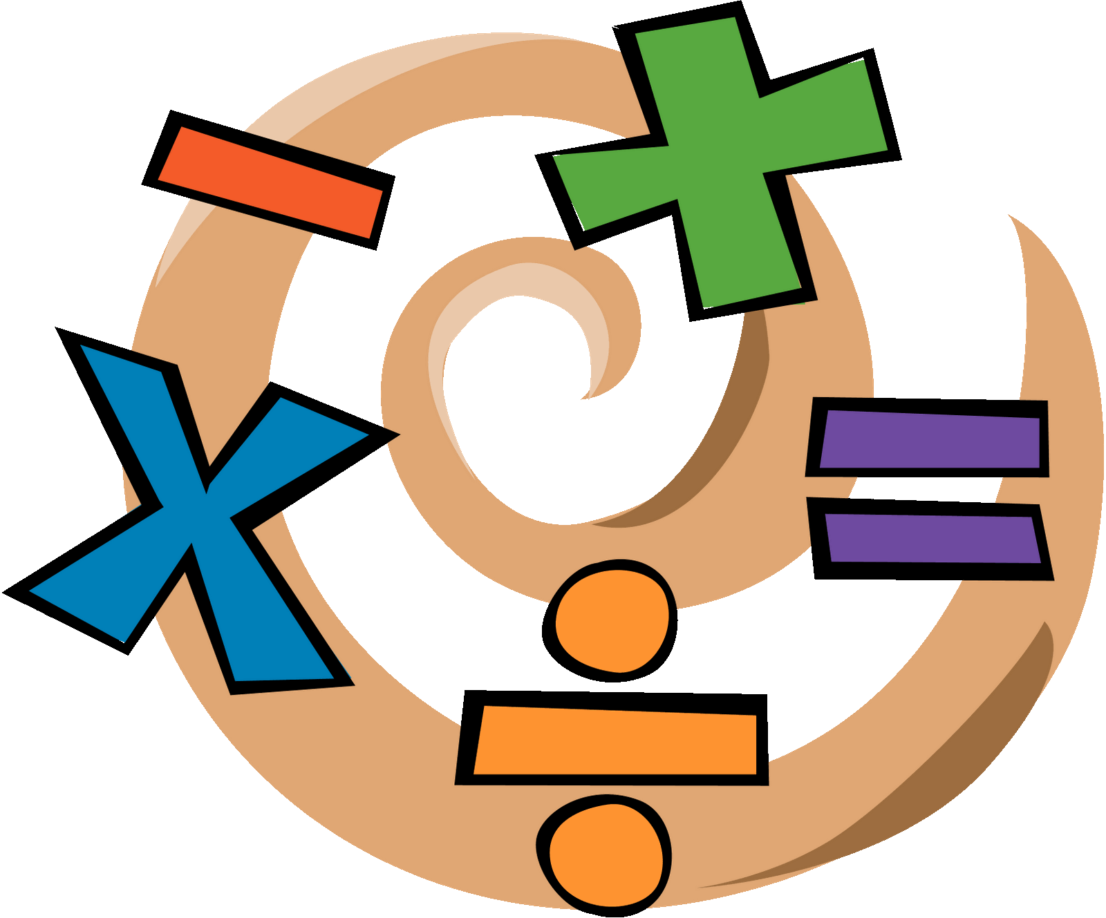
Hh
By Jack Leslie

Contents
Page Number

- Scientific Notation 04
- Significant Figures 05
- Volume 06
- Arcs and Sectors 08
- Gradient 12
- Straight Line 14
- Inequalities 16
- Surds 18
- Indices 22
- Algebra 26
Scientific Notation

Scientific Notation, (also called Standard Form), is an easier way of writing large, or small numbers.
This is written in the form of:
n × 10^{x}
n being a number between 0 and 10, and x being any integer.

Eg
3 × 10⁸ = 300,000,000
6 × 10⁻³ = 0.006
Significant Figures

Significant Figures (sf) are used to round numbers to varying degrees of specified accuracy.
Zeros at the end of a number do not count unless it is a decimal.
In decimals, zeros at the front do not count.

Eg Round to 2 significant figures
- 27,628 b) 0.03089
= 28,000 = 0.031
Volume

Cube V = l³

Cuboid V = l × b × h

Cone V = $\frac{1}{3}$ π r² h

Sphere V = $\frac{4}{3}$ π r³

Cylinder V = π r³ h

Prism V = A_{base} × h

2D Shapes

Square A = l²

Rectangle A = l × b

Triangle A = $\frac{1}{2}$ (b × h)
h
b

Circle A = π r²
h
Parallelogram A = b × h
b

Kite A = $\frac{1}{2}$ (d1 × d2)
d2
d1
Rhombus A = $\frac{1}{2}$ (d1 × d2)
a
Trapezium A = $\frac{1}{2}$ (a + b) × h
h
b
Length of an arc

C = πd A = π r³
An arc is a section of the circumference.
Arc

Length of an arc = $\frac{angle}{360}$ × πd

Eg Calculate the length of the minor arc
a) Length of an arc = $\frac{angle}{360}$ ×πd
3 cm
48˚
= $\frac{48}{360}$ × π × 3
= 0.1333… × π × 3
= 2.513274123
= 2.51 (to 2 dp)cm
Finding an Angle

Eg Calculate the size of the angle given . the arc length is 12.4cm

b) Length of arc = $\frac{angle}{360}$ × πd
12.4 = $\frac{x}{360}$ × π × 10
x˚
5 cm
$\frac{12.4}{(π×10)}$ = $\frac{x}{360}$
$\frac{12.4×360}{(π×10)}$ = x
x = 142.0935332˚
x = 142.09˚ (to 2 dp)

Area of a Sector

Eg Calculate the area of the sector

a) Area of sector = $\frac{angle}{360}$ × π r²
= $\frac{48}{360}$ × π × 3²
= 0.1333… × π × 9
= 3.769911184
= 3.77 (to 2 dp)cm²
Finding an Angle

Eg Calculate the size of the angle given the sector area is 20 cm², and the diameter is 10 cm

b) Area of sector = $\frac{angle}{360}$ × π r²
20 = $\frac{x}{360}$ × π × 5²
x = $\frac{20×360}{(π×25)}$
x = 91.67324722
x = 91.67˚ (to 2 dp)

Gradient

Gradient is a measure of steepness.
It has no units and the higher the number, the steeper the line (and vice versa).
A horizontal line has a gradient of 0
A vertical line has an undefined gradient
m = $\frac{y_{2}- y_{1}}{x_{2}- x_{1}}$ Points (x₁,y₁) (x₂,y₂)
We use m to stand for gradient.
m = 2
m = $\frac{1}{2}$
m = 1
m = -1
Eg

a) O (0,0) P (6,4)
x₁,y₁ x₂,y₂

m = $\frac{y_{2}- y_{1}}{x_{2}- x_{1}}$
= $\frac{4-0}{6-0}$
= $\frac{4}{6}$
= $\frac{2}{3}$

b) A (2,5) B (6,13)
x₁,y₁ x₂,y₂

m = $\frac{y_{2}- y_{1}}{x_{2}- x_{1}}$
= $\frac{13-5}{6-2}$
= $\frac{8}{4}$
= 2
Straight Line

y = mx + c
gradient
y - intercept

This is the general form of the equation of a straight line.
Identify the gradient and y-intercept
Eg

1)a) y = 3x+5 b) y+x = 0
gradient = 3 y = -x
y–intercept = (0,5) m = -1
pt = (0,0)

2)a) Write down the equation of a line passing through (0,-2), with a gradient of 2
y = 2x-2
3)a) Find the equation of the lining joining (0,1) to (-3,3)
m = $\frac{y_{2}- y_{1}}{x_{2}- x_{1}}$
= $\frac{3-1}{-3-0}$ y = $\frac{2}{-3}$x+1
= $\frac{2}{-3}$
Before we can identify the gradient and the y-intercept, we must rearrange the equation to look like y=mx+c using algebra.

Eg Find the gradient and y-intercept:

4)a) 3x-y+5 = 0 b) 2y-5x-3 = 0
3x+5 = y 2y = 5x+3
m = 3 y = 2.5x+1.5
pt = (0,5) m = 2.5
pt = (0,1.5)

Inequalities
> Greater than < Less than
≥ ≤
Less than or equal to
Greater than or equal to

Inequalities (inequations) are solved in the same way as equations with only one difference.

Eg Solve for x

a) 2x+3 ≤ 17 b) 5x-6 ≥ -21
2x ≤ 14 5x ≥ -15
x ≤ 7 y ≥ -3

The only difference between inequalities and equations is when we divide by a negative number we must flip the sign.

Eg Solve for y

2)a) 10-2(x-4) > 32
10-2x+8 > 32
10-2x > 24
-2x > 14
x > $\frac{14}{-2}$
x > -7
Surds

A surd is a special number. It is a square root, cube root etc which does not work out exactly.

Eg
$\sqrt{25}$ = 5 so $\sqrt{25}$ is not a surd.

but $\sqrt{26}$ is a surd as it will have a remainder.

Simplifying Surds
We can simplify surds using square numbers: 1,4,9,16,25,36,49,64,81…
Eg
1)a) $\sqrt{32}$ b) $\sqrt{8}$ c) $\sqrt{75}$
=$\sqrt{16×2}$ =$\sqrt{4×2}$ =$\sqrt{25×3}$
= 4$\sqrt{2}$ =5$\sqrt{3}$ = 5$\sqrt{3}$
Multiplying Surds
When multiplying surds, we simply multiply the number underneath the sign and then simplify.
Eg
2)a) $\sqrt{6}$×$\sqrt{3}$ b) 3$\sqrt{2}$×2$\sqrt{3}$
= $\sqrt{18}$ = 6$\sqrt{6}$
= 3$\sqrt{2}$
d) (3+$\sqrt{2}$)(3-$\sqrt{2}$)
c) $\sqrt{7}$×$\sqrt{7}$ = 9+3$\sqrt{2}$-3$\sqrt{2}$+$\sqrt{4}$
= $\sqrt{49}$ = 9 - $\sqrt{4}$
= 7 = 7
Addition and Subtraction of Surds
We can add or subtract surds if they have the same number under the root.
Eg
3)a) $\sqrt{2}$+7$\sqrt{2}$ b) $\sqrt{27}$+$\sqrt{12}$
= 8$\sqrt{2}$ = 3$\sqrt{3}$-2$\sqrt{3}$
= $\sqrt{3}$
Rationalising the denominator
To rationalise a surd, we get rid of the surd on the denominator.
The easiest way to do this is to multiply the surd by itself.
Eg
4)a) $\frac{1}{\sqrt{2}}$×$\frac{\sqrt{2}}{\sqrt{2}}$ b) $\frac{3}{2\sqrt{5}}$×$\frac{\sqrt{5}}{\sqrt{5}}$
= $\frac{\sqrt{2}}{2}$ = $\frac{3\sqrt{5}}{2×5}$
= $\frac{3\sqrt{5}}{10}$

c) $\frac{2+\sqrt{6}}{\sqrt{2}}$×$\frac{\sqrt{2}}{\sqrt{2}}$
= $\frac{2\sqrt{2}+\sqrt{12}}{2}$
= $\frac{2\sqrt{2}+2\sqrt{3}}{2}$
= $\sqrt{2}$+$\sqrt{3}$
Harder rationalising
To rationalise a denominator in the form of a±$\sqrt{b}$ or $\sqrt{b}$±a we need to use conjugates.
a+$\sqrt{b}$ has a conjugate of a-$\sqrt{b}$
$\sqrt{b}$-a has a conjugate of $\sqrt{b}$+a etc…
Eg
5)a) $\frac{2}{3-\sqrt{5}}$×$\frac{3+\sqrt{5}}{3+\sqrt{5}}$
= $\frac{6+2\sqrt{5}}{9+3\sqrt{5}-3\sqrt{5}-5}$
= $\frac{6+2\sqrt{5}}{4}$
= $\frac{3+\sqrt{5}}{2}$
Indices

Rules of Indices

Rule 1 a^{m} × a^{n} = a^{m+n}

Rule 2 $\frac{a^{m}}{a^{n}}$ = a^{m-n}

Rule 3 (a^{m})^{n} = a^{mn}

Rule a⁰ = 1

Rule 5 a^{-m} = $\frac{1}{a^{m}}$

Rule 6 $a^{\frac{m}{n}}$ = $\sqrt[n]{a^{m}}$ * $x^{\frac{1}{2}}$ = $\sqrt[2]{x^{1}}$ = $\sqrt{x}$

In your calculator, you can put in powers using y^{x} 4⁵ = 1024

Rules of Indices

Rule 1 a^{m} × a^{n} = a^{m+n}

When you multiply terms with the same base, simply add the powers.
Eg
1)a) 4¹⁰×4² b) x³×x⁶ c) 3a²×2a⁴×4a
= 4¹² = x⁹ = 24a⁷

Rule 2 $\frac{a^{m}}{a^{n}}$ = a^{m-n}

Eg
2)a) $\frac{n^{7}}{n}$ = n⁶ b) $\frac{{3a}^{2}×4a}{2a}$ = $\frac{{12a}^{3}}{2a}$ = 6a²

Rule 3 (a^{m})^{n} = a^{mn}

Eg
3)a) (y⁴)³ b) (a⁻²)⁵ c) (2x²)²
= y¹² = a⁻¹⁰ = 4x⁴

Rule 4 a⁰ = 1

Eg
4)a) x⁰ = 1 b) 4⁰ = 1

Rule 5 a^{-m} = $\frac{1}{a^{m}}$

Eg Write with a positive power
5)a) x⁻³ = $\frac{1}{x^{3}}$ b) 6a⁻² = $\frac{6}{a^{2}}$ c) $\frac{p^{-3}}{4}$ = $\frac{1}{{4p}^{3}}$

6) Write with a negative power
a) $\frac{1}{a^{2}}$ = a⁻² b) $\frac{3}{x^{4}}$ = 3x⁻⁴
Rule 6 $a^{\frac{m}{n}}$ = $\sqrt[n]{a^{m}}$ * $x^{\frac{1}{2}}$ = $\sqrt[2]{x^{1}}$ = $\sqrt{x}$

Eg Write with a root sign
7)a) $x^{\frac{-4}{3}}$ = $\sqrt[3]{x^{-4}}$ b) $x^{\frac{3}{4}}$ = $\sqrt[4]{x^{3}}$
or $\sqrt[3]{\frac{1}{x^{4}}}$

8) Write with a power
a) $\sqrt[4]{x}$ = $x^{\frac{1}{4}}$ b) $\sqrt{x^{6}}$ = $x^{\frac{6}{2}}$ = x³
Algebra

Breaking Brackets

When multiplying two brackets, we use a process called FOIL.

First Outside Inside Last

Eg
1)a) (x+5)(x-3) b) (2x-1)(3x+4)
=x²+2x-15 = 6x²+5x-4

Squaring Brackets
A quicker method to square a bracket is this:
(x-2)²
-4x
+4
x²
Factorising

When asked to factorise, we must always check for three things:

1) Common Factor

2) Difference of Two Squares

3) Trinomial

They should be checked in this order
Common Factor

A factor is something which divides into the term you have with no remainders.
The first thing we do when factorising is look for the highest common factor in the expression.

Eg
1)a) 3a+12a² b) 24-8y²
= 3a(1+4a²) = 8(3-y²)
Difference of Two Squares

Square numbers: 1,4,9,16,25,36,49…

If we have an expression consisting of two squared terms being subtracted, we follow this method to factorise:
4a²-b²
= (2a-b)(2a+b)
Eg
1)a) 25-9x² b) 49x²-36y²
= (5+3x)(5-3x) = (7x-6y)(7x+6y)

Sometimes we need to combine common factor and difference of two squares.

Eg
2)a) 2x²-32 b) 5x³ – 125x
= 2(x²-16) = 5x(x²-25)
= 2(x-4)(x+4) = 5x(x+5)(x-5)

Trinomials

If we have an expression with three terms (x², x, and a number) we must reverse the process of FOIL.

First take out the first term and think what multiplied to give it:
x²+7x+12
= (x )(x )
Next, we look at the last term. Think of the different combinations that could have multiplied to give it:
x²+7x+12
12×1
6×2
3×4
=(x+3)(x+4)

Out of the possibilities, think which pair could add or subtract to give the middle term.

We can check our answer using FOIL
Eg
1)a) x²+6x-7 b) x²-10x+24
= (x-1)(x+7) (x-4)(x-6)

If we have a coefficient of x², other than 1, we must think a bit more.
Eg
2)a) 3x²+7x+2
=(3x+1)(x+2)
Be careful where you put the 2 and 1 as one of these will be multiplied by three to give the middle term.
Outsides and insides combine to give the middle.

Completing the Square

An example of the form ax²+bx+c is known as a quadratic.
We can change this into a square term + a constant:
(x±a)²±b

This can be useful later when we move on to drawing quadratics and identifying maximum and minimum values.

Method
Balance up
x²+bx+c
= (x²+bx+${(\frac{b}{2})}^{2}$)+c-${(\frac{b}{2})}^{2}$
= (x²+$(\frac{b}{2})$)²+(c-${(\frac{b}{2})}^{2}$)

Eg
1)a) x²+6x-3
= (x²+6x+9)-3-9
= (x+3)²-12

b) x²-4x
(x²-4x+4)-4
(x-2)²-4

Algebraic Fractions

Simplifying
A fraction can be simplified by finding the hcf of the numerator and denominator.
The same rules apply to algebraic fractions.
Eg
1)a) $\frac{10x}{15y}$ b) $\frac{8xy^{2}}{4x}$
=$\frac{2x}{3y}$ = $\frac{2y^{2}}{1}$ = 2y²

Factorise and Simplifying
Sometimes algebraic fractions need simplified before we can simplify.
We look at the numerator and denominator separately and determine if they need to be factorised.
Eg
2)a) $\frac{2a+14}{6}$ b) $\frac{{2x}^{2}+xy}{x}$ c) $\frac{x^{2}-6x+5}{x^{2}-1}$
= $\frac{2(a+7)}{6}$ = $\frac{x(2x+y)}{x}$ = $\frac{(x-5)(x-1)}{(x-1)(x+1)}$
= $\frac{(a+7)}{3}$ = 2x+y =$\frac{(x-5)}{(x+1)}$

Multiplying and Dividing Fractions
We still use the same rules for multiplying and dividing fractions.
Eg
3)a) $\frac{x^{2}}{y}$ × $\frac{2y}{3}$ b) $\frac{6a}{1}$ × $\frac{2}{3a}$
= $\frac{x^{2}}{1}$ × $\frac{2}{3}$ = $\frac{2}{1}$ × $\frac{2}{1}$
= $\frac{2x^{2}}{3}$ = 4

4)a) $\frac{2a^{2}}{3b}$ ÷ $\frac{a}{b}$ b) $\frac{x}{x+1}$ ÷ $\frac{4x}{{(x+1)}^{2}}$
= $\frac{2a^{2}}{5b}$ × $\frac{b}{a}$ = $\frac{x}{x+1}$ × $\frac{{(x+1)}^{2}}{4x}$
= $\frac{2a^{2}}{5b}$ × $\frac{1}{1}$ = $\frac{1}{1}$ × $\frac{x+1}{4}$
= $\frac{2a}{5}$ = $\frac{x+1}{4}$
Adding and Subtracting Fractions
We must have a common denominator before we add or subtract fractions.
Eg
5)a) $\frac{2x}{5}$ + $\frac{9}{y}$ b) $\frac{3}{x}$ + $\frac{1}{x+5}$
= $\frac{2xy+45}{5y}$ = $\frac{3\left(x+5\right)-x}{x(x+5)}$
= $\frac{3x+15-x}{x^{2}+5x}$
= $\frac{2x+15}{x^{2}+5x}$

