National 5 Homework

Exercise 15 Angles in Circles

*Section A (Non-calculator)*

1. Work out – a) (−8) × (−70)

b) 25% of £74

c) 7∙2 + 5∙36 − 4∙8

d) 8 + (−17)

*Section B (Knowledge)*

2 O is the centre of each circle. Work out the sizes of the marked angles.

**·**

O

*c*

54º

**·**

O

*a*

62º

**·**

O

*b*

37º

3 O is the centre of each circle. Work out the radius of the circles.

(a) (b)

**·**

O

16cm

**·**

O

34º

8cm

13cm

40cm

Q

**·**

28cm

P

C

4 A mirror is shaped like part of a circle.

The radius of the circle, centre C, is 28 centimetres.

The height of the mirror is 40 centimetres.

Calculate the length of the base of the mirror, represented in the diagram by PQ.

National 5 Homework

Exercise 16 Pythagoras Theorem

*Section A (Non-calculator)*

1. Work out – a) 0∙037 × 400 b) (7 – 3)2

c) 59 × 17 d) 

*Section B (Knowledge)*

2 Work out x, y, z.

12 cm

a) b) c)

11 cm

17 cm

*y*

*x*

6 cm

7 cm

10 cm

*z*

4 cm

3 Baird and Loan are two small towns 8 kilometres apart.

A by-pass is being built to reduce the traffic passing through the two towns as shown in the diagram.

by-pass

by-pass

by-pass

5 km

9 km

7 km

Loan

Baird

Calculate the total length of the by-pass.

4. Prove that this triangle is right angled.

A

B

C

26 cm

10 cm

24 cm

*Section C (Revision)*

5. Solve the equations -

a) 3*t* + 18 = *t* + 26 b) 9*m* + 8 =5*m* − 12

National 5 Homework

Exercise 17 Simultaneous Equations

*Section A (Non-calculator)*

1 Evaluate –

a) 70% of £24 b) 23 – 4∙2 ÷ 7

c) *x*2 +  where *x* = −4 and *y* = −2 d) 

**Only use your calculator if you need to!**

*Section B (Knowledge)*

2 Solve these simultaneous equations by drawing their graphs on squared paper:

*x* – *y* = −1

*x* + 2*y* = 8

3 Solve these pairs of equations by substitution.

a) *y* = *x* b) *y* = 3*x*

*y* = 2*x* + 4 *x* + *y* + 12 = 0

4 Solve these simultaneous equations by elimination.

a) *x* + 3*y* = 3 b) 2*p* + *q* = 17 c) *a* + 2*b* = 8 d) 2*c* + 3*d* = -5

*x* – 3*y* = 9 *p* + *q* = 9 2*a* – *b* = 1 3*c* + 2*d* = 0

5 The tickets for a school show cost £2 for children and £3 for adults.

**SCHOOL**

**SHOW**

CHILDREN £2

ADULTS £3

a) *x* tickets were sold to children and *y* tickets were sold to adults.

The total money collected for tickets was £460.

Use this information to write an equation involving *x* and *y*.

b) 190 people bought tickets for the disco.

Write down another equation involving *x* and *y*.

c) How many tickets were sold to adults?

*Section C (Revision)*

6 A newspaper report stated – “Concorde has now flown 9∙5 x 107 miles”.

This is equivalent to 400 journeys from the earth to the moon.

Calculate the distance from the earth to the moon.

Give your answer in scientific notation correct to 2 significant figures.

7 Sacha buys a laptop costing £438 which **includes VAT at the rate of 20%**.

How much did the laptop cost before the VAT was added on?

Exercise 18 Changing the Subject of the Formula

*Section A(Non-calculator)*

1 Carry out the following calculations

a) 15% of £90 b) 17 – 12∙05 + 16∙1

c) 0∙48 ÷ 40 d)  – 

2 a) Evaluate 5*pq* when *p* = –2 and *q* = 3

b) Evaluate  when *s* = 6 , *t* = 2 and *u* = –3

**Only use your calculator if you need to!**

*Section B (Knowledge)*

3 Change the subject of each formulae to *x*:

a) *x* – *b* = *t* b) *p* = 4*x*

1. *w* = 5*x* + *y* d) 

e)  f) 

4 The formula for finding the volume of a cylinder is .

1. Rearrange  to make *r* the subject of the formula.
2. Calculate *r* when *V* = 140 cm3 and  *h* = 8·5 cm.

*Section C (Revision)*

5 a) Ryan goes on holiday to Spain.

**EXCHANGE RATE for £1 Sterling**

AMERICA $1·63

AUSTRALIA $2·49

CANADA $2·21

SWITZERLAND 2·14 francs

SPAIN €1·12

He buys a camera costing €50·40.

How much is this in pounds sterling?

b) The same camera costs $70·09 in

America and $119·52 in Australia.

In which of the three countries is the

camera cheapest?

6 Expand and simplify where appropriate:

(a)  (b) 

7 Factorise these expressions:

(a)  (b)  (c) 

National 5 Homework

Exercsie 19 Similar Figures

*Section A (Non-calculator)*

1 Work out – a) 0·083 × 600

b) (3*x* – 4)2

c) 

d) 40 × 6 − (1 + 2)3

e) Calculate the time taken for a bus to travel a distance of 280 miles going at an average speed of 40 mph.





*Section B (Knowledge)*

20 cm

*x*

2 These paintings are similar.

Find *x*, the missing side on the large painting.

16 cm

34 cm



3 These candles are similar.

The volume of the large candle is 720 cm3.

Work out the volume of the small candle.

3 cm

6 cm

*Section C (Mixed)*

4. Work out the gradient of the line passing through:

1. (−2 , 5) and (8 , −1) b) (1, 5) and (5, -8)

5. Factorise:

a) 7*x* + 42 b) *a*2 – 49 c) *x*2 – 2*x* – 15 d) 3*x*2 – *x* – 2

6 Change the subject of each formulae to *h*:

1. *T = 4h*  (b) 

National 5 Homework

Exercise 20 Trig Graphs

*Section A (Non-calculator)*

1. Simplify:

(a)  (b)  (c)  (d) 

2. Rationalise the denominator and simplify where possible:

(a)  (b) 

**Only use your calculator if you need to!**

*Section B (Knowledge)*

3. Write down the period of the graph of 

4. Write the equations of the following trigonometric functions:

(a) (b)

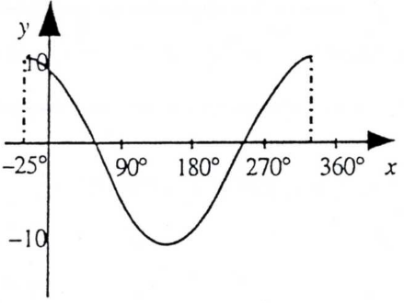

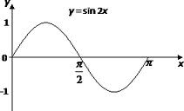

**5**

**90**

**180**

**–5**

5. Make a sketch of the following trigonometric functions, for :

a)  b)  c) 

*Section C (Revision)*

6. Solve, algebraically, these equations

a) 3*x* + 4*y* = 13 b) 2*y* + 3*x* = 9

2*x* – 4*y* = 2 5*y* + 2*x* = 17

8. Fiona and Ross each book in at the Sleepwell Lodge.

(a) Fiona stays for 3 nights and has breakfast on 2 mornings. Her bill is £230. Write down an algebraic equation to illustrate this

(b) Ross stays for 5 nights and has breakfast on 3 mornings. His bill is £380. Write down an algebraic equation to illustrate this.

(c) Find the cost of one breakfast.

National 5 Homework

Exercise 21 Trig Equations

*Section A (Non-calculator)*

1. Break the brackets (i) 

2. Factorise (i)  (ii)  (iii) 

3. Simplify the following surds: (a) (b)

*Section B (Knowledge)*

4. Solve these trigonometric equations where 0 ≤ *x* ≤ 360, answers to 3 significant figures –

a) sin *x°* = 0∙528 b) tan *x°* = 1∙724 c) cos *x°* = – 0∙714

5. Solve the following trigonometric equations in the range 0 ≤ *x* ≤ 360

a)  b)  c) 5tan *x°* + 3 = 0 d) 3sin *x°* + 2 = 0

6. Prove the following trigonometric identities:

a)  b) 

*Section C (Mixed)*

7. A railway goes through an underground tunnel. The diagram below shows the cross-section of the tunnel. It consists of part of a circle with a horizontal base.

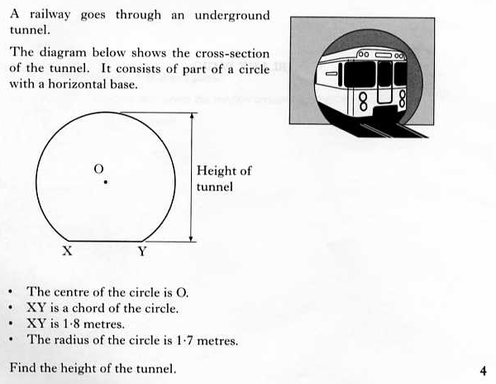

* The centre of the circle is O
* XY is a cord of the circle
* XY is 1.8 metres
* The radius of the circle is 1.7 metres

Find the height of the tunnel.



National 5 Homework

Exercise 22 Quadratic Graphs

*Section A (Non-calculator)*

1. Evaluate –

a) 80% of 72g b) 

c)  d) 

*Section B (Knowledge)*

2. The diagram shows the parabola with equation 

What is the value of *k*?



3. The equation of the quadratic function whose graph is shown below is of the form *y* = (*x* + *a*)2 + *b*, where *a* and *b* are integers. Write down the values of *a* and *b*.

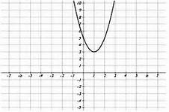

-22 100 d) 1∙757

-1

4. Sketch the graph *y* = (*x* - 2)(*x* + 4) on plain paper.

Mark clearly where the graph crosses the axes and state the coordinates of the turning point.

5. A parabola has equation *y* = (*x* + 3)2 − 5.

(a) Write down the equation of its axis of symmetry.

(b) Write down the coordinates of the turning point on the parabola and state whether it is a maximum or minimum.

*Section C (Revision)*

6. Work out the size of the side marked *x* in this triangle.

*x*

75º

10·9 cm

6 cm

National 5 Homework

Exercise 23 Quadratic Equations

*Section A (Non-calculator)*

1. Evaluate –

a) 2½ % of £140 b) 

c)  d) 

*Section B (Knowledge)*

2. Solve the following equations by factorising:

a) 5*x*2 – *x* = 0 b) *y*2 – 49 = 0 c) *t*2 + 8*t* + 15 = 0

d) *w*2 + *w* – 6 = 0 e) *x*2 – 6*x* + 8 = 0 f) 2*y*2 – 11*y* + 15 = 0

3. Solve this equation algebraically: *y*(*y* – 4) = 2*y* − 5

4. Use the quadratic formula to solve these equations giving your answer to 1 decimal place:

a) *x*2 − 7*x* + 2 = 0 b) 3*x*2 + 2*x* − 4 = 0 c) 2*y*2 – 11*y* – 15 = 0

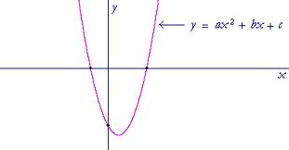

5. Find where the following curve with equation

*x*2 − 4*x* − 12

*y* = *x*2 − 4*x* − 12 cuts the x axis.

6. By calculating the discriminant, determine the nature of the roots of the following quadratic equations:

1. *x*2 + 6*x* + 9 = 0 b) 3*x*2 − 4*x* + 2 = 0 c) 4 – 2*x* − *x*2 = 0

*Section C (Mixed)*

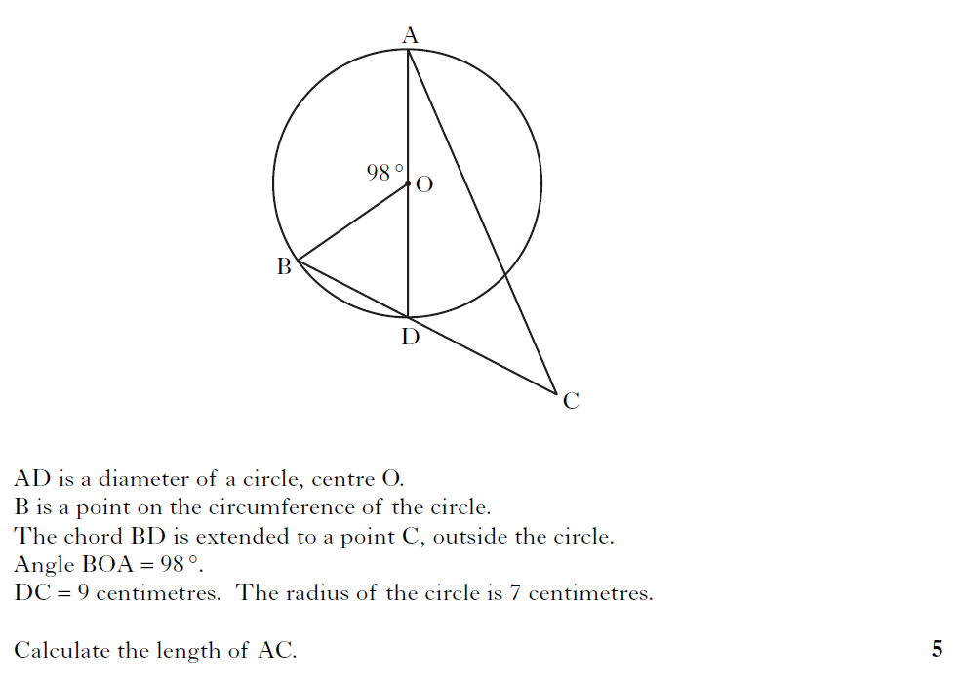7. AD is a diameter of a circle, centre O.

B is a point on the circumference of the circle.

The chord BD is extended to a point C, outside the circle.

Angle BOA = 98°

DC = 9 centimetres.

The radius of the circle is 7 centimetres.

Calculate the length of AC.