Exercise 10 Fractions and Percentages

*Section A (Non-calculator)*

1 Work out – a) 30 × (-70) b) 66 ÷ (8 + 3)

**BODMAS** c) 1∙836 ÷ 9 d) (10 ÷ 2)2

e) 6 x 23 f) 6 + 27 ÷ 3 – 5

*Section B (Knowledge)*

2. Work out –

a) b)  c) 

d)  e)  f) 

g)  h)  i) 

3. A mobile phone can be purchased at a cost of £342 plus VAT at 17∙5%.

Find the total cost of the mobile phone.

4. Sacha buys a laptop costing £438 which **includes VAT at the rate of 20%**.

How much did the laptop cost before the VAT was added on?

5. The Computer Store buys this computer for £480 and

sells it to make a profit of 30%.

a) What is the selling price of this computer?

b) The Computer Store adds 25% to the **selling price**

when a customer buys the computer on Hire Purchase.

H.P. terms are a £30 deposit followed by 24 equal

monthly payments.

Calculate the customer’s monthly payment.

6. A new car costs £14000.

The value of the car depreciates by 15% after the first year and by 8% after the second year.

Calculate the value of the car after two years?

*Section C (Revision)*

7. The number of people at a concert was 18 716.

Round this number to 2 significant figures.

National 5 Homework

Exercise 11 Percentage Calculations

*Section A (Non-calculator)*

1 (a) 30% of £420 (b) 0∙028 × 50

(c)  (d) 

*Section B (Knowledge)*

2 Keith buys a mobile phone which costs £124∙80 including VAT at 20%.

Find the cost of the mobile phone before VAT was added on.

3 Amy monitors the height of a young tree in her garden.

The height of the tree is found to increase by 12% to 42 cm.

Find the height of the tree when Amy started to monitor it.

4 A new car costs £14000.

The value of the car depreciates by 15% after the first year and by 8% after the second year.

Calculate the value of the car after two years?

5 Ms Black puts £6500 in a bank account which pays 4% interest.

She makes no withdrawals.

How much money will be in the account after 3 years?

*Section C (Mixed)*

6 a) Work out *x* b) Work out *y*

*x*

12 cm

17 cm

5∙2 m

*y*

67º

Exercise 12 Statistics

*Section A (Non-calculator)*

1. Evaluate – a) 35 − 1⋅8 × 3 + 9

b) *x*2 − *y*2 where *x* = -4, *y* = 3 and *z* = -2

3*z*

1. 0⋅344 ÷ 40
2. 

*Section B (Knowledge)*

1. a) The boxplot, drawn below, shows the daily sales of a popular brand of coffee over a one month period following an advertising campaign.

20

60

31

39

43

State the median and range of the data in this boxplot.

b) The boxplot, shown below, shows the daily sales of a similar type of coffee over the same period, without any advertising campaign.

19

28

37

41

55

Comment on the effectiveness of the advertising campaign.

3 The midday temperatures, in °C, for 13 cities around the world are:

7 8 9 11 16 19 20 22 24 28 31 32 36

a) Make a 5 figure summary.

b) Use these values to draw a boxplot.

4 Laura recorded the number of text messages she sent over 5 days:

11, 17, 12, 16, 14

Work out the mean and standard deviation.

*Section C (Mixed)*

5 Write down the equation of the line with gradient ½ and which passes through the point (0 , 7).

1. Factorise these expressions:
2.  (b)  (c)  (d) 

National 5 Homework

Exercise 13 Trig Calculations

*Section A (Non-calculator)*

1 Work out – a) 70 × (-80) b) 77 ÷ (8 + 3)

c)  d) 

*Section B (Knowledge)*

98º

7 cm

10·2 cm

2 Work out the area of the triangle.

?

5·2 m

A

81º

37º

B

1. Use the sine rule to find side AB in this triangle.

C

4 Use the sine rule or the cosine rule to calculate the value of the letter in each triangle.

*q*

48º

39 cm

a) b) c)

1·8 m

3·5 m

3·7 m

*r*

23 mm

41º

*p*

19 mm

36 cm

5 Lauren is a jewellery designer and the triangle

*x*

38 mm

96º

shown is part of an ear-ring design.

Work out the size of angle x in the triangle.

42 mm

*Section C (Mixed)*

6 Priscilla recorded the number of text messages she sent over 5 days:

14, 18, 16, 20, 17

Work out the mean and standard deviation

Exercise 14 Vectors

*Section A (Non-calculator)*

1. Solve for *x*: (a) 3*x* – 2 > 2*x* + 7 b) 2*x* + 3 ≤ 6*x* – 9

2. Break the brackets and collect like terms: (3*x* + 2)(*x* – 5) + 8*x*

*Section B (Knowledge)*

3. The diagrams below show 2 directed line segments ***u*** and ***v*.**

Draw the resultant vector of 2***u*** + ***v***

|  |  |  |  |  |
| --- | --- | --- | --- | --- |
|  |  |  |  |  |
|  |  |  |  |  |
|  |  | **u** |  |  |
|  |  |  |  |  |
|  |  |  |  |  |

|  |  |  |  |  |
| --- | --- | --- | --- | --- |
|  |  |  |  |  |
|  |  |  |  |  |
|  | **v** |  |  |  |
|  |  |  |  |  |
|  |  |  |  |  |

4. If ***u* =** and ***v* =** , work out ***u* – *v* .**

5. If ***a*** =  and ***b* =** , calculate .

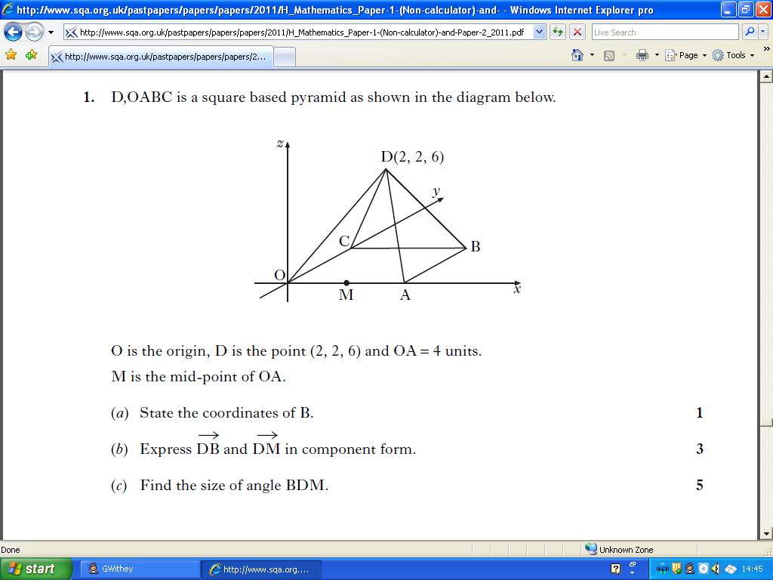

6. The diagram below shows a model of a pyramid.

It is a square-based pyramid of height 8 centimetres.

Square OABC has sides of length 6 centimetres.

The coordinates of A are (6,0,0) and C lies on the *y*-axis.

Write down the coordinates of D.

(6, 0, 0)

7. ***u* = , *v* = ** and ***u* = *v*.** Find *x*, *y* and *z*

*Section C (Revision)*

8. Prove that this triangle is right angled.

A

B

C

26 cm

10 cm

24 cm