

Driving Equity and Excellence

Improvement Action Plans

Session 2025-26

School: | Kildrum Primary School
Cluster: | Cumbernauld Academy
Head Teacher: | Kate Watt

Improvement Plan Summary
School Priority 1: | Learning, Teaching and Assessment – Year 2 of 3  By June 2027 almost all pupils will experience high-quality learning, teaching and assessment which, alongside robust tracking and monitoring, will help to raise attainment.
School Priority 2: | Curriculum Content – Year 2 of 3  By June 2027 almost all pupils will experience a coherent curriculum which includes opportunities to develop the knowledge, skills and attributes they need to adapt, think critically and flourish in today’s world.

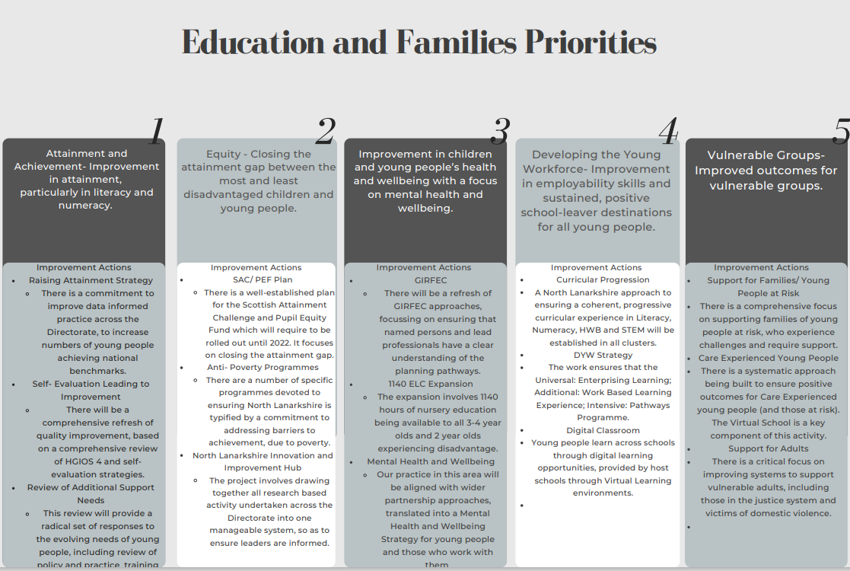

School Vision and Values

"Inspiring children to grow, learn and thrive together"
Respect, Learning, Responsibility, Inclusion, Creativity and Nurture.

This will be launched with the whole school community in August 2025.

Audit and Consultation

In arriving at our improvement priorities, the school has taken account of Education and Families’ priorities, an audit of the previous year’s improvement plan and engagement with parents/carers and learners.

Details of engagement (pupils, parents/carers, partners)

Parents are consulted throughout the session, through the Parent Council and audits. Last session, end of session audit results were, again, very positive. In particular, another increase in the percentage of parents/carers stating that they felt that school staff dealt effectively with incidents of bullying behaviour.

Learners are consulted through the annual pupil survey, Talking Mats sessions, Show off Your Work Day discussions and Class Showcase meetings.

2025-26 Improvement Plan

Priority 1: Long Term Outcome  What do you hope to achieve? What is going to change? For whom? By how much? By When? |  | Learning, Teaching and Assessment  By June 2027 almost all pupils will experience high-quality learning, teaching and assessment which, alongside robust tracking and monitoring, will help to raise attainment.  Focus this session - Develop effective use of Learning Intentions and Success Criteria across all classes.
Person(s) Responsible  Who will be leading the improvement? | Pamela Johnston and Jen Wright (Principal Teachers)

(Please insert the relevant information below using the codes above)
NIF Priority:  - Closing the attainment gap between the most and least disadvantaged children and young people;  - Improvement in attainment, particularly in literacy and numeracy. |  |  | NIF Drivers:  - Teacher and Practitioner Professionalism  - Curriculum and Assessment  - School and ELC Improvement  - Performance Information
NLC Priority:  - Improvement in attainment, particularly literacy and numeracy  - Closing the attainment gap between the most and least disadvantaged children  - Improved outcomes for vulnerable groups |  |  | QIs:  1.1: Self-evaluation for self-improvement  2.3: Learning teaching and assessment  2.4: Personalised support
PEF Intervention:  1. Early intervention and prevention  4. Targeted approaches to literacy and numeracy  5. Promoting a high quality learning experience  6. Differentiated support  7. Using evidence and data  11. Professional learning and leadership  12. Research and evaluation to monitor impact |  |  | Developing in Faith/UNCRC:  Article 3 - best interests of the child  Article 28 - right to education  Article 29 - goals of education  Article 31 - leisure, play and culture
If you used any aspect of your PEF fund to support this priority; please detail the expenditure here:

RATIONALE (WHY?) Why have you identified this as a priority? What data did you have to support this?

In line with North Lanarkshire’s commitment to excellence and equity in education, this plan supports our aim to improve learner outcomes through consistent and purposeful use of Learning Intentions (LIs) and Success Criteria (SC). Research and feedback from Quality Improvement visits and self-evaluation (HGIOS 4 QI 2.3 & 1.1) have identified variability in how LIs and SC are understood and applied across the school. By deepening staff understanding and improving consistency, we aim to empower learners, promote engagement, and raise attainment.

Extract from VSE visit report, April 2024:
- Developing on from the strong, positive relationships, staff should now engage with continuous lifelong professional learning to ensure practice is in line with the most up to date research and advice. This would promote increased pace and challenge, and appropriate differentiation within classes and across the school.
- The school should continue to build and further develop consistent, high-quality approaches to learning, teaching and assessment which, alongside robust tracking and monitoring approaches, will help to raise attainment for all. This should include further work on developing consistent use of Learning Intentions and Success Criteria in all classes. Work on structure of learning sessions should also be considered eg what a ‘Kildrum Lesson’ looks like. This will ensure consistency of learning and teaching across the school.
- Staff should use more evaluative language when writing termly evaluations, the impact of interventions etc., to ensure there is a clear picture of progression of learning and skills. The approaches to quality assurance should be developed further by the leadership team to support the continued focus on outcomes for learners.

Resources: Please include costs and, where relevant, state where cost is being met from, specifically if using PEF. Please denote PEF/or colour code if preferred, to indicate where PEF spend aligns with targets.
EXPECTED IMPACT  (SHORT TERM TARGETS) | INTERVENTIONS/ACTIONS TO SUPPORT IMPROVEMENT: HOW? | HOW WILL YOU TRACK PROGRESS?  MEASURES |  | EVALUATION CHECKPOINT 1 (Internal Process) | EVALUATION CHECKPOINT 2 (Internal Process)
What will be the benefit for learners (be specific)? | What are you going to do to make the change? What key actions are required? Consider links to the NIF Drivers. | What ongoing information will demonstrate progress? (Qualitative, Quantitative – short/medium/long term data)
- Most all learners will understand what they are learning and how to succeed.  - All staff will demonstrate a shared understanding of how to plan, share, and use LIs and SC effectively across the curriculum.  - Almost all classroom practice will reflect consistent, high-quality use of LIs and SC to support formative assessment and pupil progress. | August/September  Analyse whole-school audits of 2024/2025 practice around LIs and SC (learning walks, planning samples, learner conversations, jotter samples, classroom visits). | - Learning visits and moderation show increased consistency in the use of LIs and SC.  - Pupil voice indicates improved understanding of what they are learning and how to be successful.  - Planning and assessments shows clear, progressive, and appropriately matched LIs and SC.  - Staff confidence and competence increase, as measured through professional dialogue, classroom visits and CLPL evaluations. |  | .August/September  Evidence showed that some teachers were using LI and SC regularly in Literacy and Numeracy. Some children were able to explain how the LI and SC helped their learning.  Learning Ladybird and Successful Spider introduced in all Primary 1-3 classes, order to give consistency across the school.  Use of LI and SC discussed in all attainment tracking meetings.  October  LI and SC CLPL session took place. All staff now more able to form LI and SC.  November/ December  Children in some classes have started to co-constructed SC.  Staff from pedagogy team worked with four teachers.  January/February  CLPL session took place, covered effective questioning and feedback.  Additional Next Steps:  Update Assessment timetable  Complete updated LTA policy
October
Teaching staff CLPL session, led by Leigh Anne Brown: Purposeful use of LIs and SC (co-constructed, linked to skills/knowledge).
November/December
Introduce a phased approach to co-constructing success criteria with pupils (starting in literacy and numeracy)
January/February
Teaching staff CLPL session, led by Leigh Anne Brown.
In-class peer moderation of LI/SC use; focus on aligning to planned learning and assessment.
March/April
Teaching staff CLPL session, led by Leigh Anne Brown.
Pupil Learning Conversations to evaluate pupil understanding of LIs and SC.
May
Teaching staff CLPL session, led by Leigh Anne Brown.
Suggested professional reading:
Shirley Clarke
Dylan Williams
John Hattie
Bruce Robertson
Final evaluation (for submission):

Next Steps for 2026–2027
- Extend co-construction of SC into interdisciplinary and wider curriculum areas.
- Deepen pupil self-assessment using SC.
- Embed digital tools to support sharing and reflection on LIs and SC.

Priority 2: Long Term Outcome  What do you hope to achieve? What is going to change? For whom? By how much? By When? |  | Curriculum Content  By June 2027 almost all pupils will experience a coherent curriculum which includes opportunities to develop the knowledge, skills and attributes they need to adapt, think critically and flourish in today’s world.  Focus for this session - Design and develop high-quality, relevant, and progressive curricular content across all stages, aligned with the school’s developing curriculum rationale.
Person(s) Responsible  Who will be leading the improvement? | Kate Watt (Head Teacher)

(Please insert the relevant information below using the codes above)
NIF Priority:  - Closing the attainment gap between the most and least disadvantaged children and young people;  - Improvement in attainment, particularly in literacy and numeracy. | NIF Drivers:  2. Teacher and Practitioner Professionalism  4. Curriculum and Assessment  5. School and ELC Improvement  6. Performance Information
NLC Priority:  - Improvement in attainment, particularly literacy and numeracy  - Closing the attainment gap between the most and least disadvantaged children  - Improved outcomes for vulnerable groups | QIs:  1.1: Self-evaluation for self-improvement  2.2: Curriculum  2.3: Learning teaching and assessment  2.4: Personalised support  2.7: Partnerships  3.2: Raising attainment and achievement
PEF Intervention:  1. Early intervention and prevention  4. Targeted approaches to literacy and numeracy  5. Promoting a high quality learning experience  6. Differentiated support  7. Using evidence and data  11. Professional learning and leadership  12. Research and evaluation to monitor impact | Developing in Faith/UNCRC:  Article 3 - best interests of the child  Article 28 - right to education  Article 29 - goals of education  Article 31 - leisure, play and culture
If you used any aspect of your PEF fund to support this priority; please detail the expenditure here:

RATIONALE (WHY?) Why have you identified this as a priority? What data did you have to support this?

Building on last year’s review of the school vision and values, there is a need to update the school Curriculum Rationale and implement bespoke curricular content that reflects our local context, learner voice, and school vision.
While the core experiences and outcomes (Es and Os) provide structure, we recognise the importance of personalising learning pathways to provide depth, breadth, coherence, and progression. Recent self-evaluation has shown inconsistencies in interdisciplinary learning, use of digital technologies, enquiry-based learning and a lack of outdoor learning. This plan will ensure we deliver a high-quality curriculum that is relevant, coherent, and engaging.

Extract from VSE visit report, April 2024:
- The school should continue to review their curriculum rationale to ensure it is meaningful and relevant to the Kildrum context. This should include increased engagement with digital approaches across learning and more opportunities for outdoor and enquiry-based learning.

Resources: Please include costs and, where relevant, state where cost is being met from, specifically if using PEF. Please denote PEF/or colour code if preferred, to indicate where PEF spend aligns with targets.

EXPECTED IMPACT  (SHORT TERM TARGETS) | INTERVENTIONS/ACTIONS TO SUPPORT IMPROVEMENT: HOW? | HOW WILL YOU TRACK PROGRESS?  MEASURES | EVALUATION CHECKPOINT 1 (Internal Process) | EVALUATION CHECKPOINT 2 (Internal Process)
What will be the benefit for learners (be specific)? | What are you going to do to make the change? What key actions are required? Consider links to the NIF Drivers. | What ongoing information will demonstrate progress? (Qualitative, Quantitative – short/medium/long term data)
- All learners will have access to rich, relevant cross-curricular experiences.  - Almost all learners will be able to engage in real-world, interdisciplinary learning which enhances their skills for life-long learning.  - Most learners will be engaged in their learning through their teacher's use of consistent and progressive planning and assessment. | August  Audit current curricular content across all stages, with a focus on literacy, numeracy, HWB, and IDL.  SLT analyse:  ACEL results  Attendance data  Exclusion data  Secondary school leaver destinations  Local employment data  and prepare the 'Why' of the curriculum rationale. | - Audits and data analysis will show gaps, overlaps and opportunities.  - Planning across the school will show greater consistency and progression.  - Classroom visits and pupil conversations will show rich, relevant cross-curricular experiences.  - Classroom visits and pupil conversations will show enhanced pupil engagement | August  - Data analysis ongoing.  - New vision and values launched.  - Celebration of outside achievements improved.  September-November  - Teacher staff completed professional reading. – articles provided in NLC Curriculum Content Toolbox.  - Play CLPL session took place, based on Enquiry Led Learning.  - Enquiry Based Learning activities piloted in one class.  - Additional member of staff trained in outdoor learning  - Outdoor learning area completed (trees to be planted by Gardening Club and Countryside Rangers 23/02/2026).  - Primary 1 classrooms showcased across NLC and one teacher asked to present at two NLC training sessions.  - Outdoor Learning after school club took place.  - Kildrum Crews (leadership groups) introduced. All children are part of a group.  - Meta Skills introduced through assemblies and Meta Skills Land resource.  December/January  - HT attended Enquiry Based Learning overview session.  - Two teachers have begun EBL training.  - Improvement of classroom environments continues.  - Bronze Sport Scotland School Sport award achieved.  - Breakfast Club activities improved.  Additional Next Steps:  - ICT Room and Cook Room to be adapted for EBL.  - Additional £6,120 provided by NLC Education to be used to fund this.
September - November
Teaching staff take part in professional reading and dialogue.

Play CLPL session led by the NLC Pedagogy Team.

In house training on outdoor learning.
December/January
Design meaningful IDL planners that reflect local context, learner voice and Es & Os across all curricular areas.
February/March
Pilot 2–3 bespoke school-wide IDL contexts (e.g. local history, sustainability, enterprise).
April/May
Review and revise school progression pathways to ensure appropriate depth and challenge across all stages.
Final evaluation (for submission):

PEF ALLOCATION: £101,675


nOrth Lanarkshire Council
Education & FAMILIES
EQUITY PLAN 2024-25
(Internal recording; random sampling of PEF/Equity Plans
will continue throughout the session).

Rationale for EQUITY (PEF) plan
Please provide below detail around your rationale for the Equity plan. Highlight how PEF expenditure is integrated to support improvement priorities.
For priorities around equity please detail the poverty related gap which you are addressing and the data which supports your rationale.
Consider the following: attainment, health & wellbeing, attendance, exclusion, participation, engagement.

Link to Improvement Plan | Detailed Costings | Priority/Description | Intended Outcome/Impact  Please describe your planned use of SAC resource/PEF allocation and what you intend to achieve. | Evidence/Measures  Please indicate what evidence you are going to collect to show impact and progression.
Learning, Teaching and Assessment | 2.4 FTE  1.2FTE NLC match funding  Cost TBC | Additional staffing will be used to reduce class sizes and allow Principal Teachers more time out of class in order to run interventions. | - Most children, across all stages will be on track to achieve CfE Numeracy levels.  - The most children, across all stages will be on track to achieve CfE Literacy levels. | - YARC, PM Benchmarking and MALT assessments will help to form professional judgment data.  - Professional judgement tracking, updated at the end of every term, will be used to measure impact.
Learning, Teaching and Assessment | PIPS Assessments  Cost TBC | - PIPS assessments will be completed by all Primary 1 pupils in August and June in order to identify next steps and measure progress. | - Data will provide information which will allow improvement in attainment over the course of the session.to be measured.  - Data will be compared with previous year’s in order to help evaluate the impact of increased opportunities for learning through play. | - Analysis of PIPS data

